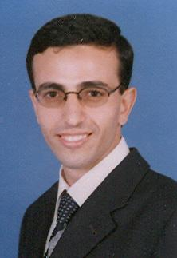 Mohammed El-Shambakey received a BS in computer engineering from Mansoura University in 2002, and a MSc in electrical engineering from Alexandria University in 2008. From 2004 to 2005, he was a computer engineer in Medical School, Mansoura University. From 2005 to 2008, he was a research assistant in City of Scientific Research and Technological Applications. Since 2008, he has been an associate researcher in the same institute. Since 2009, he has been a PhD student in ECE Department, VirginiaTech University.