10/18/2018



***Adama science and technology university***

***school of electrical engineering and computing  
department of computer science and engineering program***

**Name:** shambel mebratu

**ID:** R/1055/08

**Advisor:** Ashenafi Diguma

**Hosting organization:** Mizan-Tepi university

**Duration period of the internship:** 2 month(July 1st - August 30th)

**Report submission date:** Oct 18 2018;

Executive summery

This report is to summarize my internship experience at mizan-tepi university. I started my internship work on the first week of July, and I start work on library management system development. My adviser told me use my interested programming language then I choose php.

After completing requirement gathering from librarian I started coding.

Contents

**Chapter one** 3

**1.1** **Introduction** 3

**1.1.1** **Objective of the internship** 3

**1.1.2** **Scope of work expected** 3

**1.1.3** **Output expected** 3

**1.2** **Background of the organization** 3

**1.2.1 description of the organization** 3

**1.2.2 mission of the organization** 4

**1.2.3 service of the organization** 4

**Chapter 2** 6

**Management, training and employee information** 6

**2.1** **major duty** 6

**2.2** **procedure I have used to develop my project** 6

**2.3****benefit gained from the internship** 6

**2.4 challenge I have faced during internship period** 6

**2.5 development tools for my project** 6

**Chapter 3** 8

**My final project (library management system)** 8

**2.6** **conclusion** 20

Recommendation 21

# **Chapter one**

## **Introduction**

### **Objective of the internship**

The general objective of the internship is share experience from different compony based on my knowledge

### **Scope of work expected**

I choose system development team and they give me a project title called library management system. Then I started gather information from librarian how they did manually.

After all this I started the implementation.

### **Output expected**

Expected output After finish my project is.

User:

* Library catalog i.e. search book by using title, author or year of publication.
* Circulation service
* Loan service
* Give comment

Admin:

* Insert new book, update, delete
* Check loan and borrowed status
* Update news
* See comment and delete unwanted or old news

## **Background of the organization**

### **1.2.1 description of the organization**

Mizan-Tepi University is one of the Universities in Ethiopia which is found in south nation, nationalities and peoples region.It is located at Mizan-Teferi, where the main campus is, and Tepi town 565kms & 578kms respectively at southwest of Addis Ababa, in the deep and unique natural and anthropogenic diversity.

The university is founded on 52 hectares of land to each of both campuses. The enormous potentialities and gifted natural resources of the southwest, those exist in and around Mizan & Tepi towns offers among other things, a huge opportunity to the University to venture in to new territories of education, and research development.

The University started teaching and learning in 2006 by sharing building for University administration offices from Mizan Agriculture technical and vocational college by admitting few regular students in college of social science and humanities at Mizan Campus. By the time the university started its operation, there were only 215 students attending their first degree classes. Among this number of students, for the first time, 138 students had graduated colorfully in July 2008/09.

### **1.2.2 mission of the organization**

Vision

Mizan-Tepi University aspires to be the leading higher educational institution being center of excellence in education and research in areas of natural resources and cultural value utilization for development.

Mission

Mizan-Tepi University has a mission of supporting the development endeavors of the people by tackling the insistent problems by utilizing natural resources and cultural values, through inculcating scientific knowledge and skills relevant to the country and assuring quality education. Core Values Pursuit of truth and freedom of expression of truth; Institutional reputability based on successful execution of mission; Competitiveness in scholarship and cooperation with other institutions; Institutional autonomy with accountability; Participatory governance and rule of law; Justice and fairness; A culture of fighting corruption; Quality and speedy service delivery; Economical use of resources and effective maintenance of assets; Democracy and multiculturalism;

### **1.2.3 service of the organization**

* uphold the objectives of higher education and the guiding values of the institution; and ensure that it is an institution of scholarship;
* develop programmers’ of study and provide higher education; prepare and supply qualified graduates in knowledge, skills, and attitudes on the basis of needs of the country; and award academic qualifications in accordance with its programmes;
* undertake and encourage relevant study, research, and community services in national and local priority areas and disseminate the findings as may be appropriate; undertake, as may be necessary, joint academic and research projects with national and foreign institutions or research centers
* recruit and administer its personnel and manage its finance and property
* establish cooperation relations with industries and other institutions in pursuit of its mission
* give recognition or award prizes or honorary degrees to persons of outstanding achievements or contributions to society;
* provide support to primary and secondary education and provide support and cooperate with preparatory and technical and vocational schools as may be appropriate;

# **Chapter 2**

## **Management, training and employee information**

## 

### **major duty**

* Major duty given to me was to develop library management system

### **procedure I have used to develop my project**

* collect requirement
* I read text books and watch some video tutorial.
* Install xampp server.
* Start codding

### **benefit gained from the internship**

* Have personal growth experiences.
* Increase self-confidence in the workplace
* Ease transition from being a student to entering the workforce
* Face problems
* have vast knowledge of Industry.
* Build your own network:
* Management of Time: Time management is crucial in any profession, whether it is presentations, meetings, finishing tasks at the scheduled time etc. Internship in a professional environment teaches a person to value time and to become adept at time management which adds to the personal and professional growth of the intern.

### **2.4 challenge I have faced during internship period**

* I don’t have Id(they don’t give me), some campus police who don’t know me ask me Id then I explained who am I and I am on internship and show my ASTU ID to pass the main gate.

### **2.5 development tools for my project**

hardware:

* laptop
* flash drive

software: (technical knowledge and skill from my course)

* php programming language
* HTML, CSS, bootstrap…..
* xampp server
* sublime text editor
* MySQL database
* Mozilla Firefox Internet Browser.

## **Chapter 3**

## **My final project (library management system)**

1. home page

* this home page display news for user

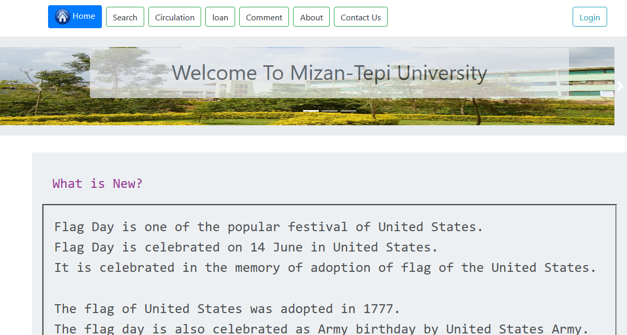

1. catalogue (search page)

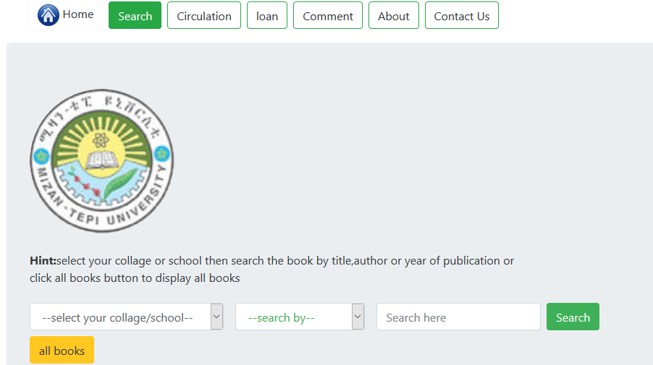

1. How to display book for user from selected collage.

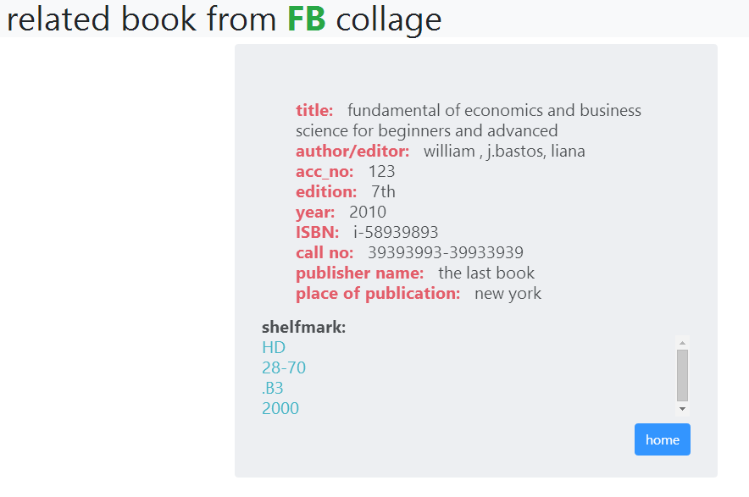

1. take book from circulation (circulation page)

* search book by title, author or year of publication and click take book button what you want to take.

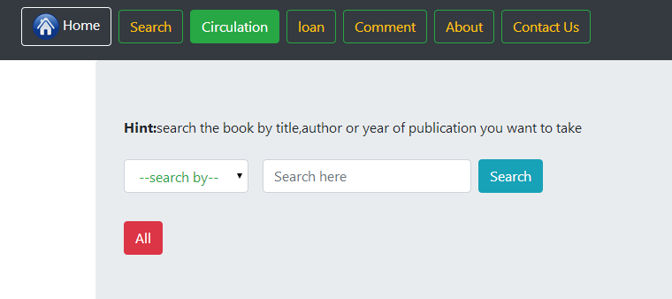

1. Fill the user id filed

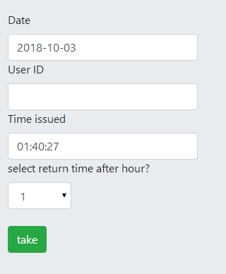

1. Loan page(choose from circulation or other place)

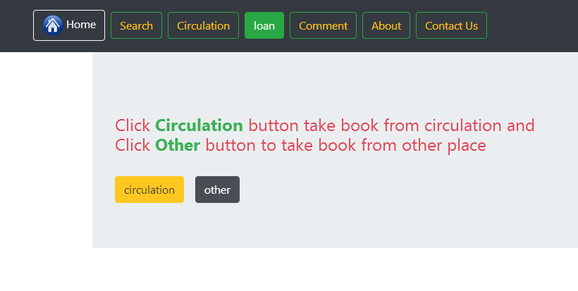

1. Loan form

* Fill all filed to borrow the selected book

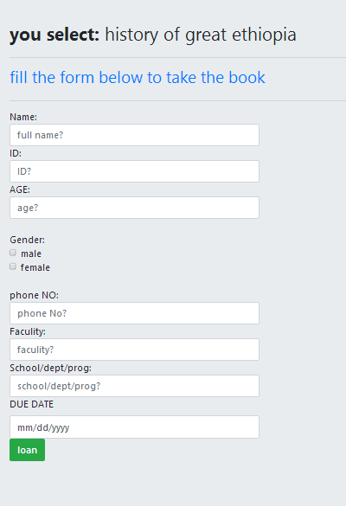

1. user give comment page

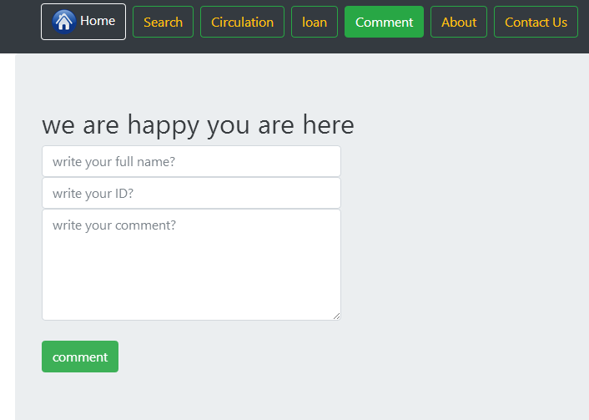

1. Comment for admin

* Admin see the comment and can delete it.

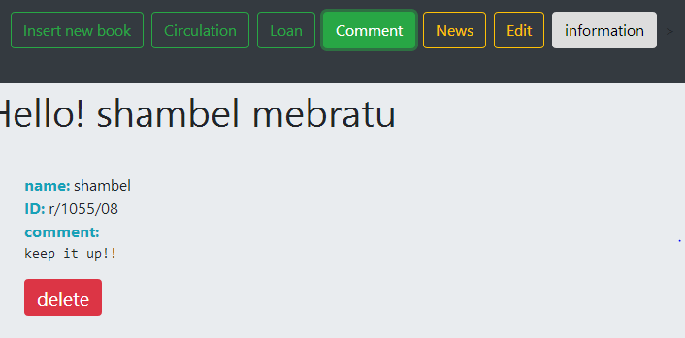

1. login page(admin only)

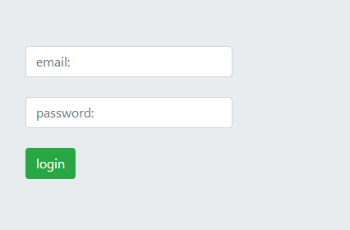

1. insert new book page(admin)

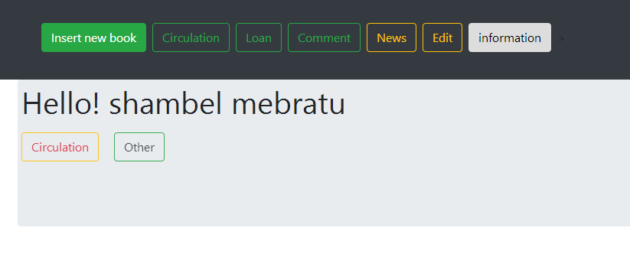

1. return and view status of circulation book

* If you want to return book search the user by id and return.
* If admin want to see who took the book and status search book by its title.

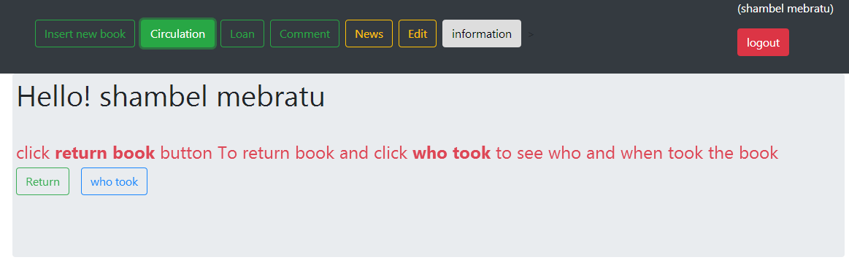

1. return and view status of borrowed book

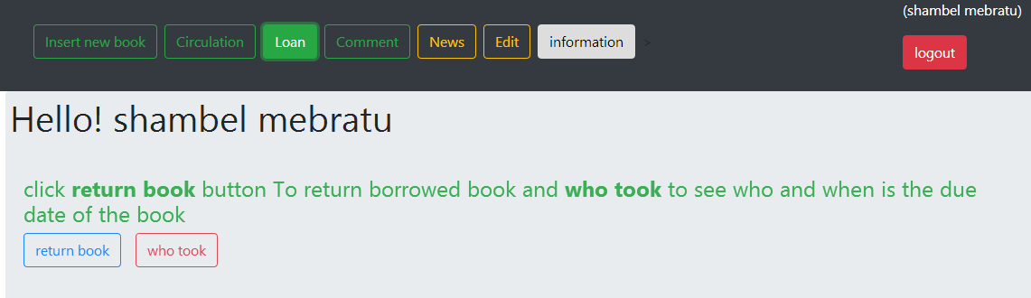

1. update news(add new news and delete old post)

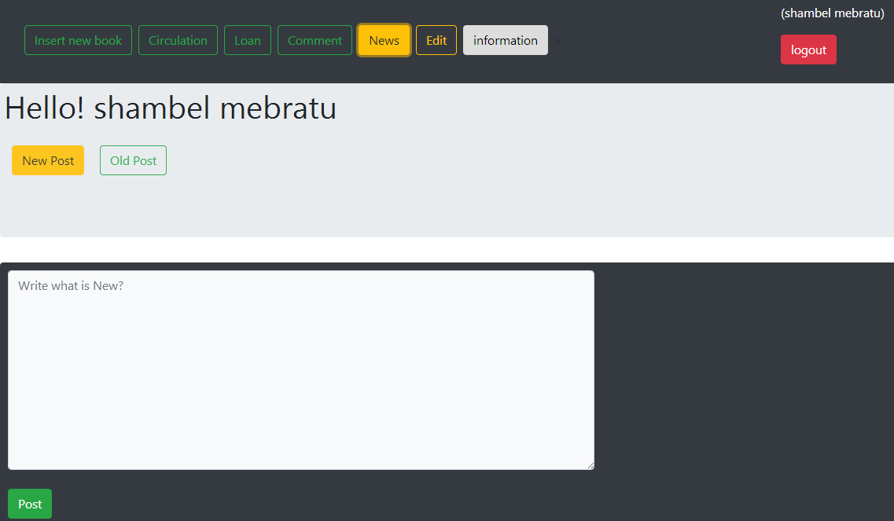

1. display for admin(can delete the book and update the book information)

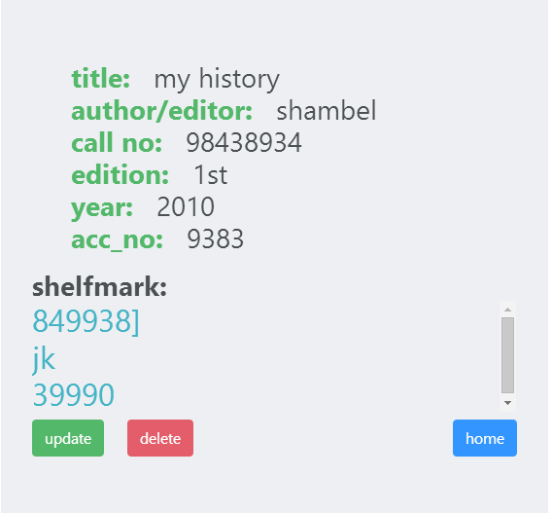

1. display information

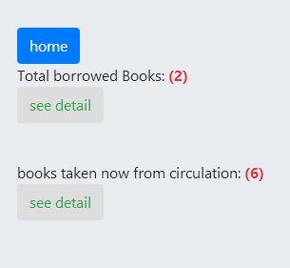

1. Database table

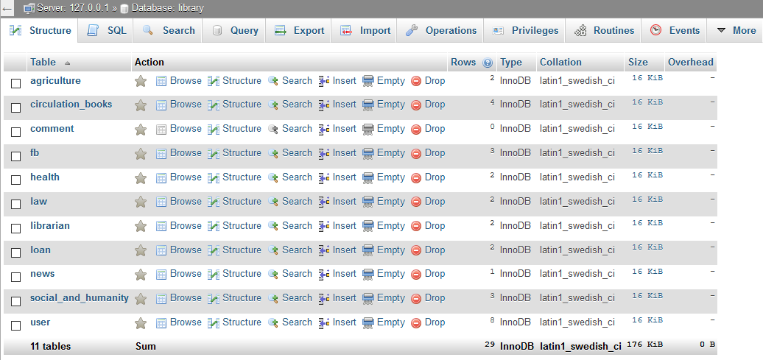

### **conclusion**

I get vast of knowledge from this internship, I spend my full summer time for reading and doing this project.

This Internship has a lot of value to me:

* Developed my programming skill.
* Developed my problem-solving technique, facing problem
* Face challenges.
* Spend time for good.

### Recommendation

Mizan tepi university don’t have many systems, for this case they give opportunity to student to develop system. So, I recommended you place student who want to develop system.