The Training Accuracy Percentage of the model after the 10th epoch was found to be “**89.960%**” & the Percentage Validation Accuracy of the model after the 10th epoch was found to be “**84.642%**”.

Individual Training and Validation accuracy after each epoch is shown below:

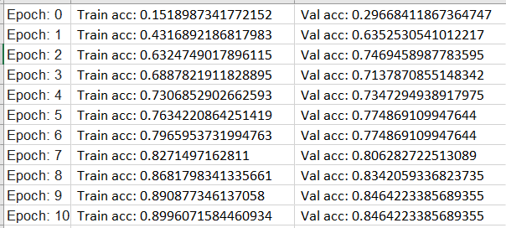

For detailed Training and Validation accuracy after each epoch is shown in the below graph:

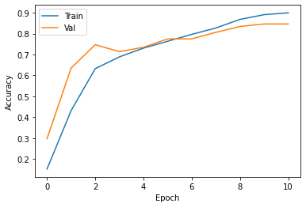

And the confusion matrix for the model is shown below:

