**MCQ**

1) Vanishing Gradient is a problem in model training, how will you manage this problem?

a. By using activation function, which has good gradient values. Not that small, Not that big.

b. By using gating function, not activation function and train the combination of all the gates.

c. Both a and b

d. Adding more hidden layers and dropout.

2) In the following line of code that implements an RNN sequential model for an NLP problem, what does the “decay” parameter signify?

Opt = tf.keras.optimizers.Adam(lr = 1e-3, decay=1e-5)

a. The decay rate of the loss function

b. The decay rate of the RNN model

c. The decay rate of the learning rate for each consecutive epoch

d. The decay rate of the optimizer function

3) When using an RNN to predict the next digit given a sequence of digits, which of the following will take place if the normalization operation is not performed? (Select all that apply.)

a. It makes it very difficult for the model to learn.

b. It makes the gradient very high.

c. It makes the gradient very low.

d. It increases the model’s learning rate.

4) The input image has been converted into a matrix of size 28 X 28 and a kernel/filter of size 7 X 7, with a stride of 1. What will be the size of the convoluted matrix?

A) 22 X 22

B) 21 X 21

C) 28 X 28

D) 7 X 7

5) In a simple MLP model with 8 neurons in the input layer, 5 neurons in the hidden

layer and 1 neuron in the output layer. What is the size of the weight matrices

between hidden output layer and input hidden layer?

A) [1 X 5] , [5 X 8]

B) [8 X 5] , [ 1 X 5]

C) [8 X 5] , [5 X 1]

D) [5 x 1] , [8 X 5]

6) **I am working with the fully connected architecture having one hidden layer with 3 neurons and one output neuron to solve a binary classification challenge. Below is the structure of input and output:**

**Input dataset: [ [1,0,1,0] , [1,0,1,1] , [0,1,0,1] ]**

**Output: [ [1] , [1] , [0] ]**

**To train the model, I have initialized all weights for hidden and output layer with 1.**

What do you say model will able to learn the pattern in the data?

1. Yes
2. B) No

7)

What value would be in place of question mark?

[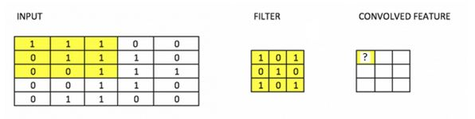](https://s3-ap-south-1.amazonaws.com/av-blog-media/wp-content/uploads/2017/06/19171440/Image33.jpg)

Here we see a convolutional function being applied to input.

A) 3  
B) 4  
C) 5  
D) 6

8)Is the data linearly separable?

[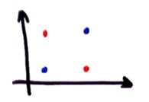](https://s3-ap-south-1.amazonaws.com/av-blog-media/wp-content/uploads/2017/06/19172951/Image36.jpg)

A) Yes  
B) No