Objective
The objective of Day 10 is to develop a practical Contact Book application using Python dictionaries. The application demonstrates how key-value data can be stored and managed efficiently. Users can add new contacts, search for existing contacts, update contact information, and delete contacts. The project provides practical experience with dictionaries, functions, conditional statements, validation, and CRUD operations.
Key Features
- Add new contacts.
- View all saved contacts.
- Search contacts using a phone number.
- Update existing contact information.
- Delete contacts.
- Use the phone number as the dictionary key.
- Store contact name and email as values.
- Prevent duplicate phone numbers.
- Validate phone-number input.
- Interactive Streamlit interface.
- Maintain contacts using Streamlit session state.
Technologies Used
The project uses Python and Streamlit. A Python dictionary is used as the main data structure, where the phone number acts as the key and the contact details such as name and email are stored as values. Python functions are used to perform the different contact-management operations, while conditional statements provide validation and error handling. Streamlit is used to create the interactive localhost interface Working Principle
The application stores contact information in a Python dictionary. Each phone number is used as a unique key, while the corresponding contact name and email are stored as values. When a user adds a contact, the program first checks whether the phone number already exists. During a search, the phone number is used to retrieve the corresponding dictionary value. Existing contact information can be updated, while unwanted contacts can be removed using the delete operation.
Learning Outcomes
This project helps develop a practical understanding of Python dictionaries, key-value pairs, dictionary methods, functions, CRUD operations, input validation, and Streamlit application development. It also demonstrates why dictionaries are useful when information needs to be retrieved using a unique key.
C:\Users\shamb\OneDrive\Desktop\VEDA internship\DAY10>
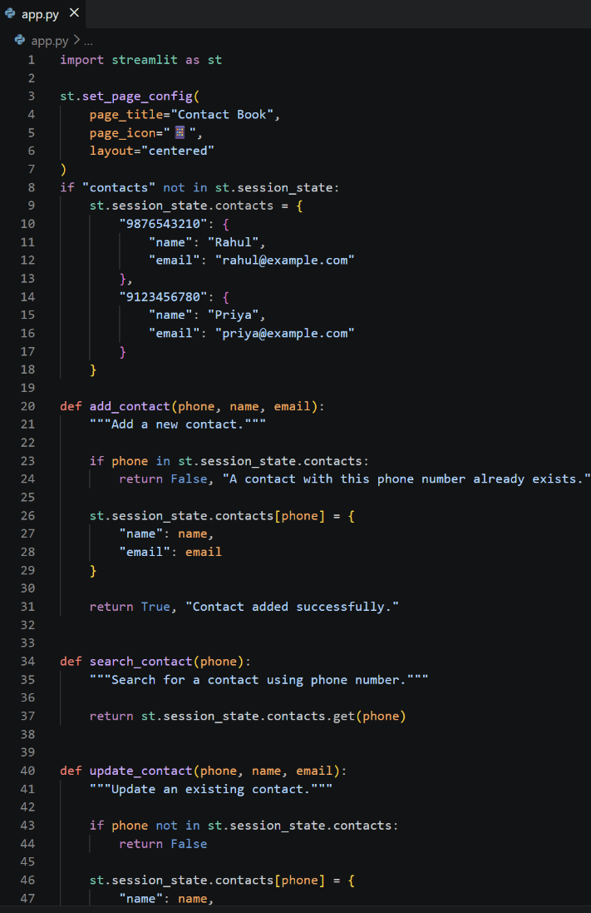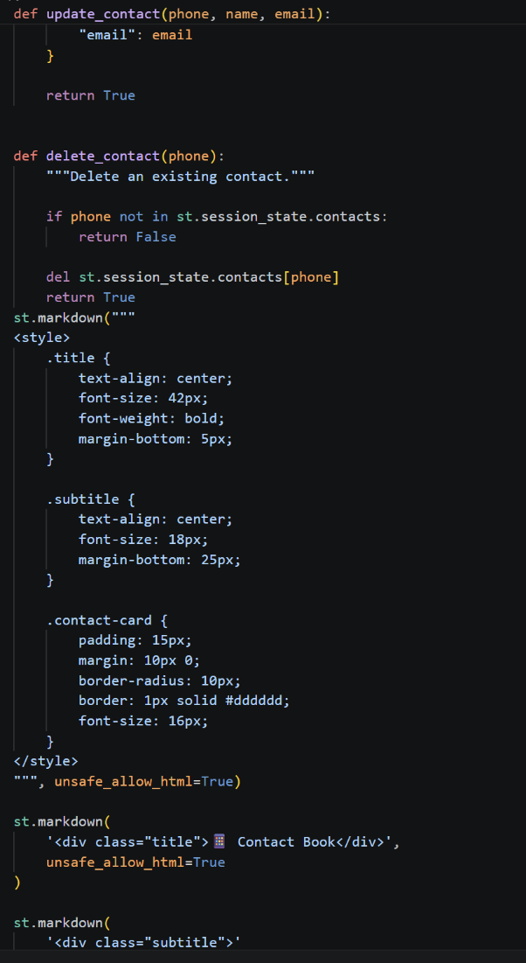

OUTPUT: http://localhost:8501
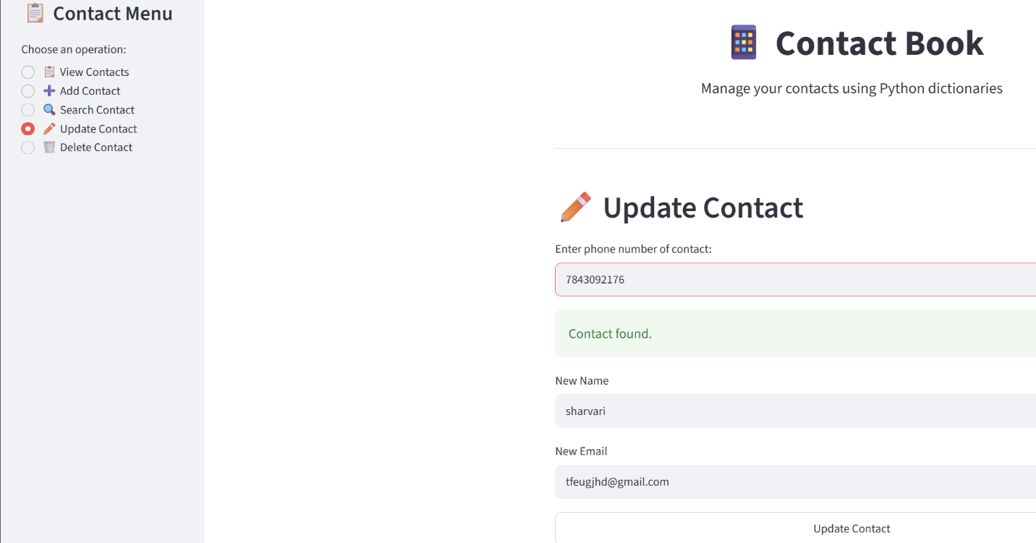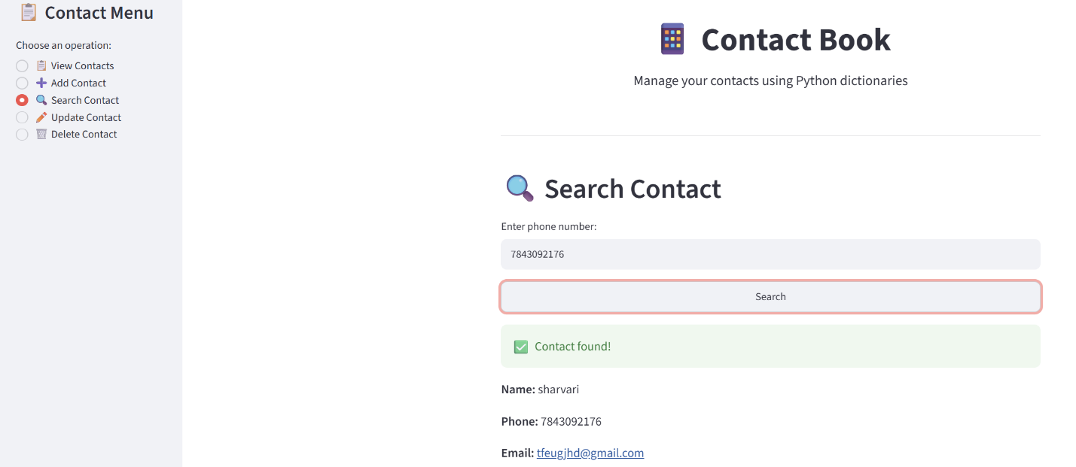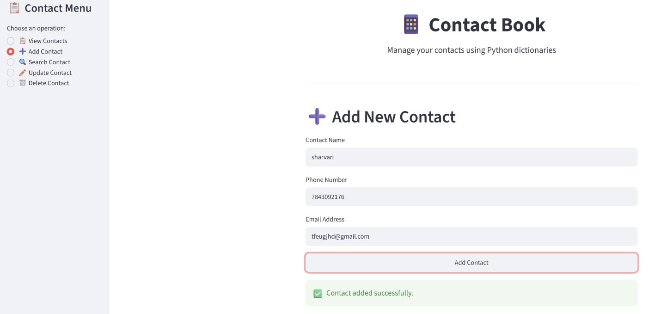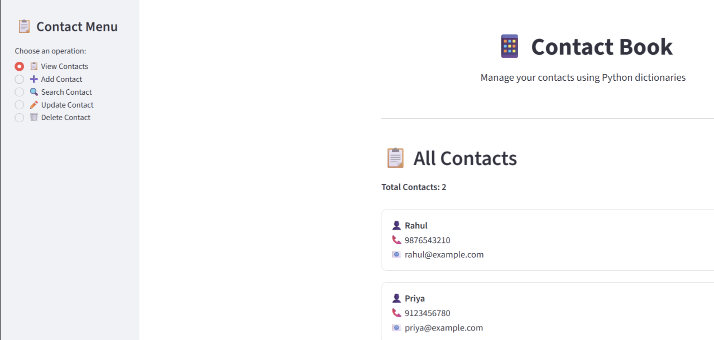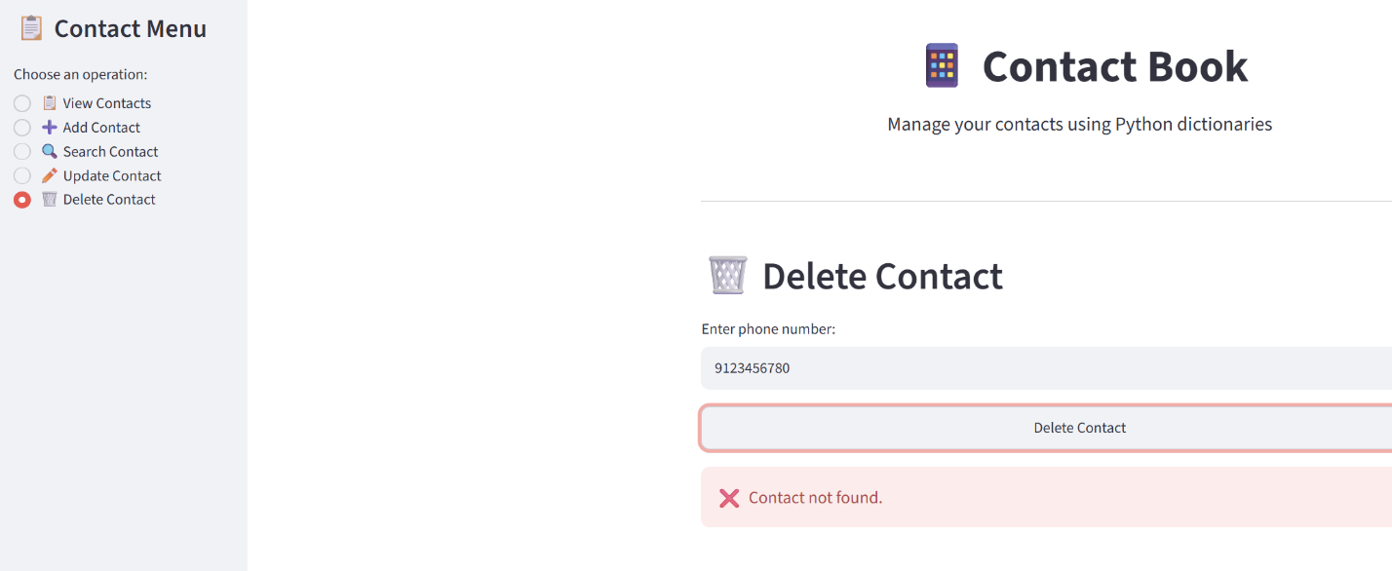
Github:https://github.com/shambhavi0804/VEDA-internship/commit/5da89da6b468b40d94a666ad5edfdd5410c60bbf
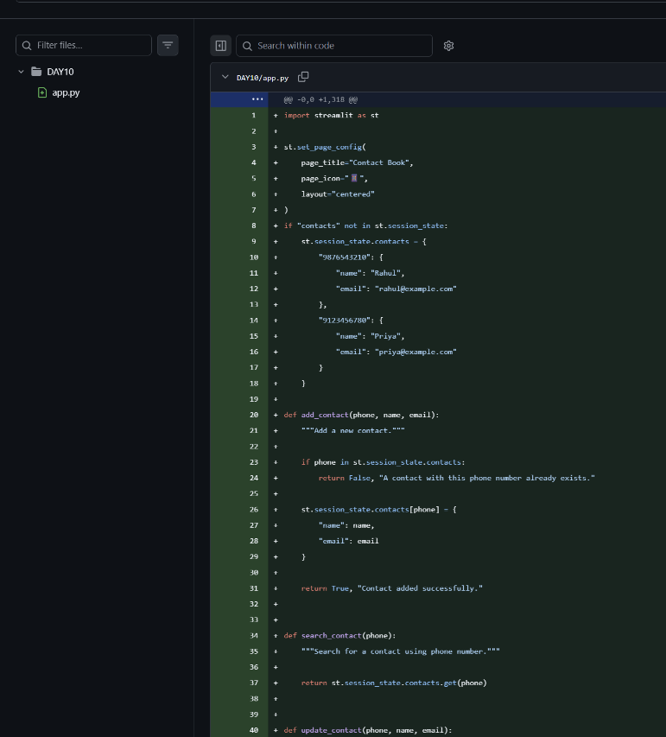

Linkedin:https://lnkd.in/p/d7J3cYim
