Objective
The objective of Day 11 is to develop a Word and Character Counter using Python and Streamlit. The application accepts a paragraph from the user and performs basic text analysis by calculating the number of characters, words, sentences, and spaces. This task helps strengthen understanding of Python strings, string manipulation, the split() method, len(), count(), regular expressions, and basic text processing.
Key Features
- Accepts paragraphs from the user.
- Counts total characters.
- Counts characters excluding spaces.
- Counts total words.
- Counts sentences.
- Counts spaces.
- Handles empty input.
- Displays statistics using Streamlit metrics.
- Displays the entered paragraph.
- Uses punctuation to identify sentences.
- Runs locally through Streamlit.
Technologies Used
The project uses Python as the programming language and Streamlit for the interactive user interface. Python string operations such as len(), split(), and count() are used for text analysis. The Python re module is used to identify sentence-ending punctuation such as periods, question marks, and exclamation marks.
Learning Outcomes
Through this project, you learn how to work with Python strings and perform basic text processing. You also gain practical experience with string methods, regular expressions, conditional statements, user input handling, and displaying calculated results through a Streamlit interface.

C:\Users\shamb\OneDrive\Desktop\VEDA internship\DAY11>
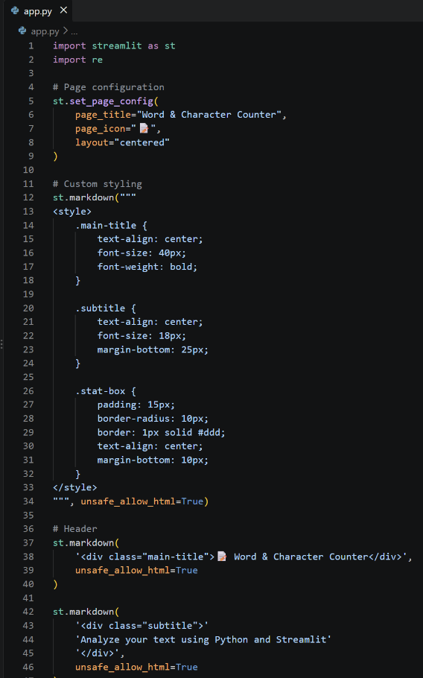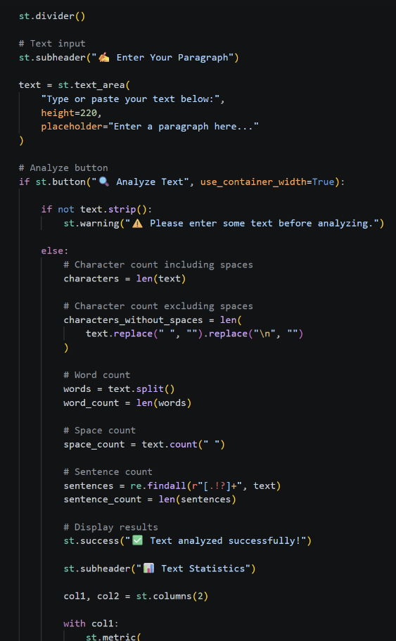
OUTPUT: http://localhost:8501
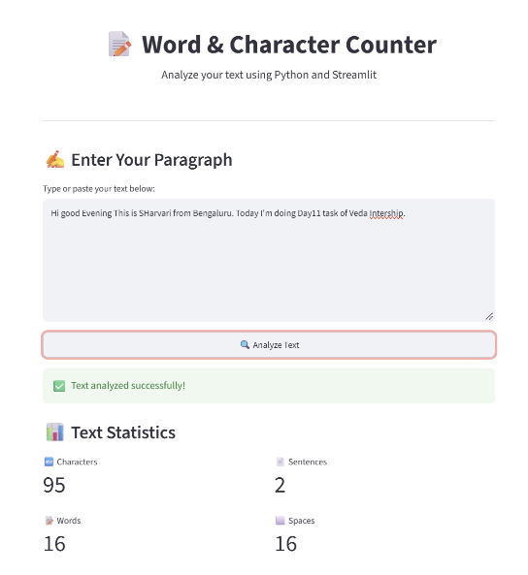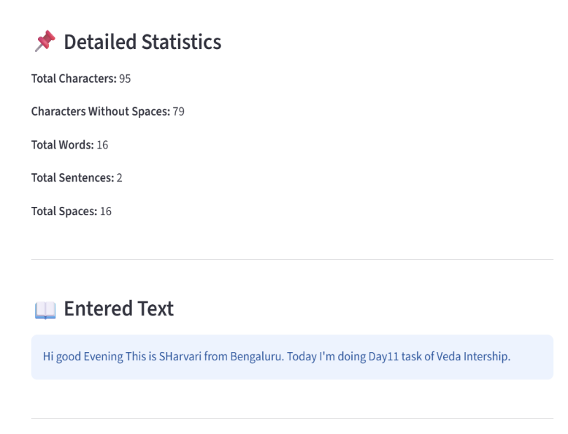

GITHUB: https://github.com/shambhavi0804/VEDA-internship/commit/a023f5977c2829f248c0f592fa091315c4c4f1b1
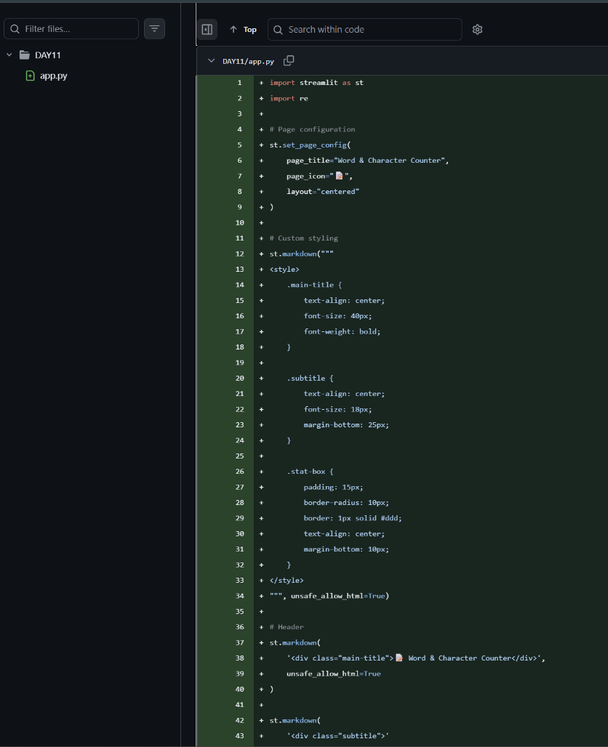
LINKEDIN: https://lnkd.in/p/dEVVex6w
