Objective
The objective of this task is to develop a Palindrome Checker using Python and Streamlit. The application accepts a word or sentence from the user and determines whether it remains the same when read forward and backward. The task helps develop practical knowledge of string manipulation, string slicing, comparison logic, input validation, and text normalization.
Key Features
- Accepts a word or complete sentence.
- Converts input to lowercase.
- Ignores unnecessary spaces.
- Reverses the normalized string using Python slicing.
- Compares the original normalized text with its reversed version.
- Displays whether the input is a palindrome.
- Handles empty input.
- Displays the normalized and reversed text.
- Provides example palindrome and non-palindrome values.
- Uses an interactive Streamlit interface.
Technologies Used
The project is developed using Python and Streamlit. Python string methods such as lower() and split() are used for normalization, while string slicing [::-1] is used to reverse the input. Conditional statements are used to compare the normalized and reversed strings and produce the appropriate result.
Learning Outcomes
This task provides practical experience with Python strings, string slicing, comparison operations, conditional statements, user input handling, and basic text normalization. It also improves understanding of how simple Python logic can be integrated into an interactive Streamlit application.

C:\Users\shamb\OneDrive\Desktop\VEDA internship\DAY12>
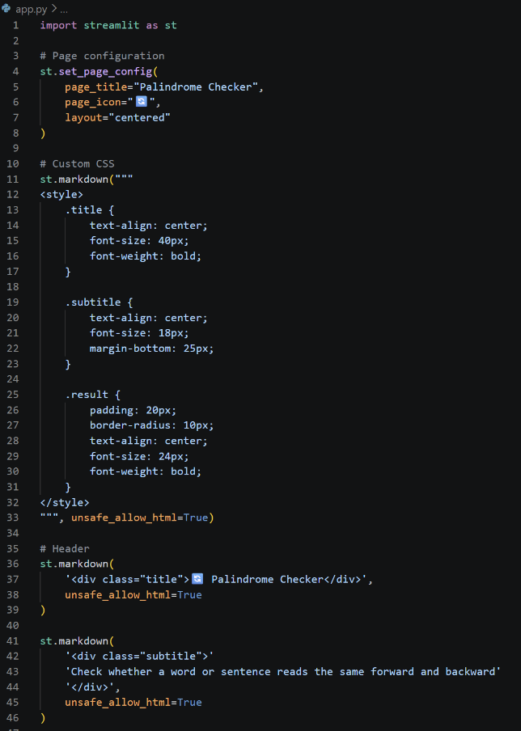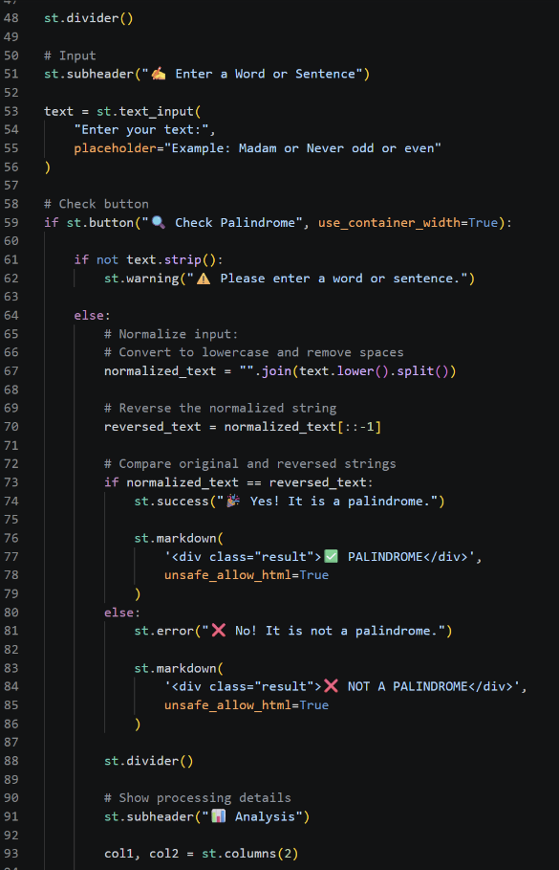
http://localhost:8501
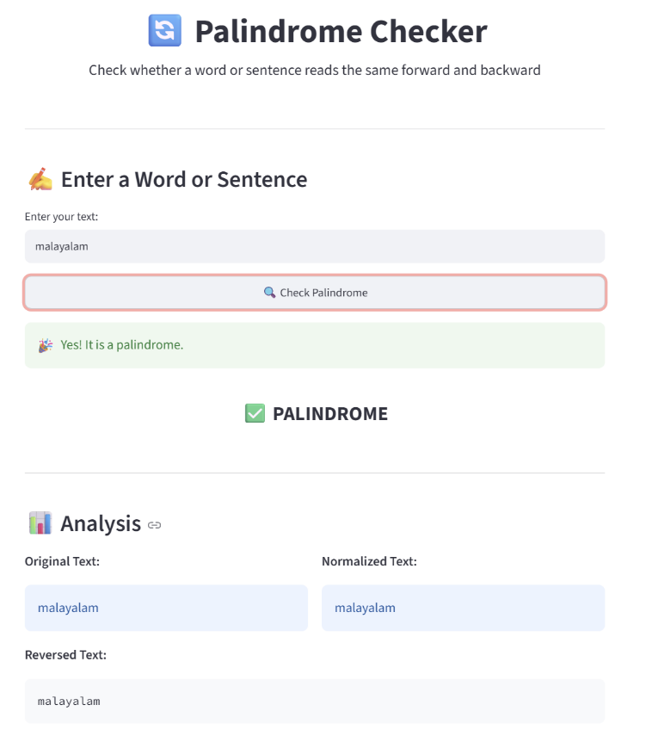
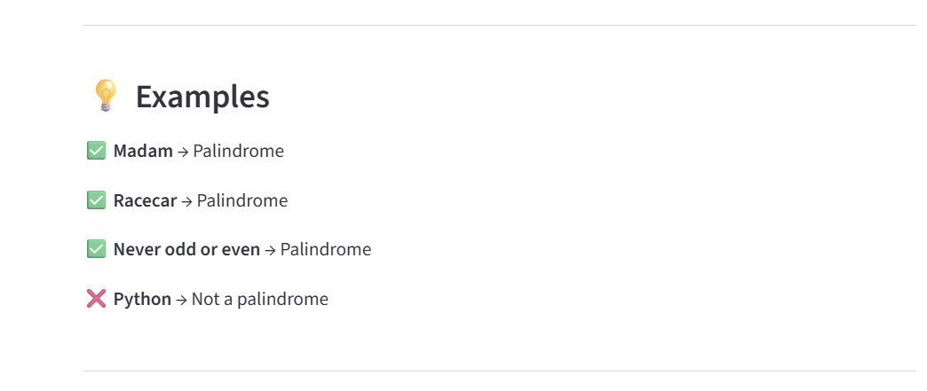
https://github.com/shambhavi0804/VEDA-internship/commit/a98d26e9d551c57f48d5a8d8c579e82565c6b487
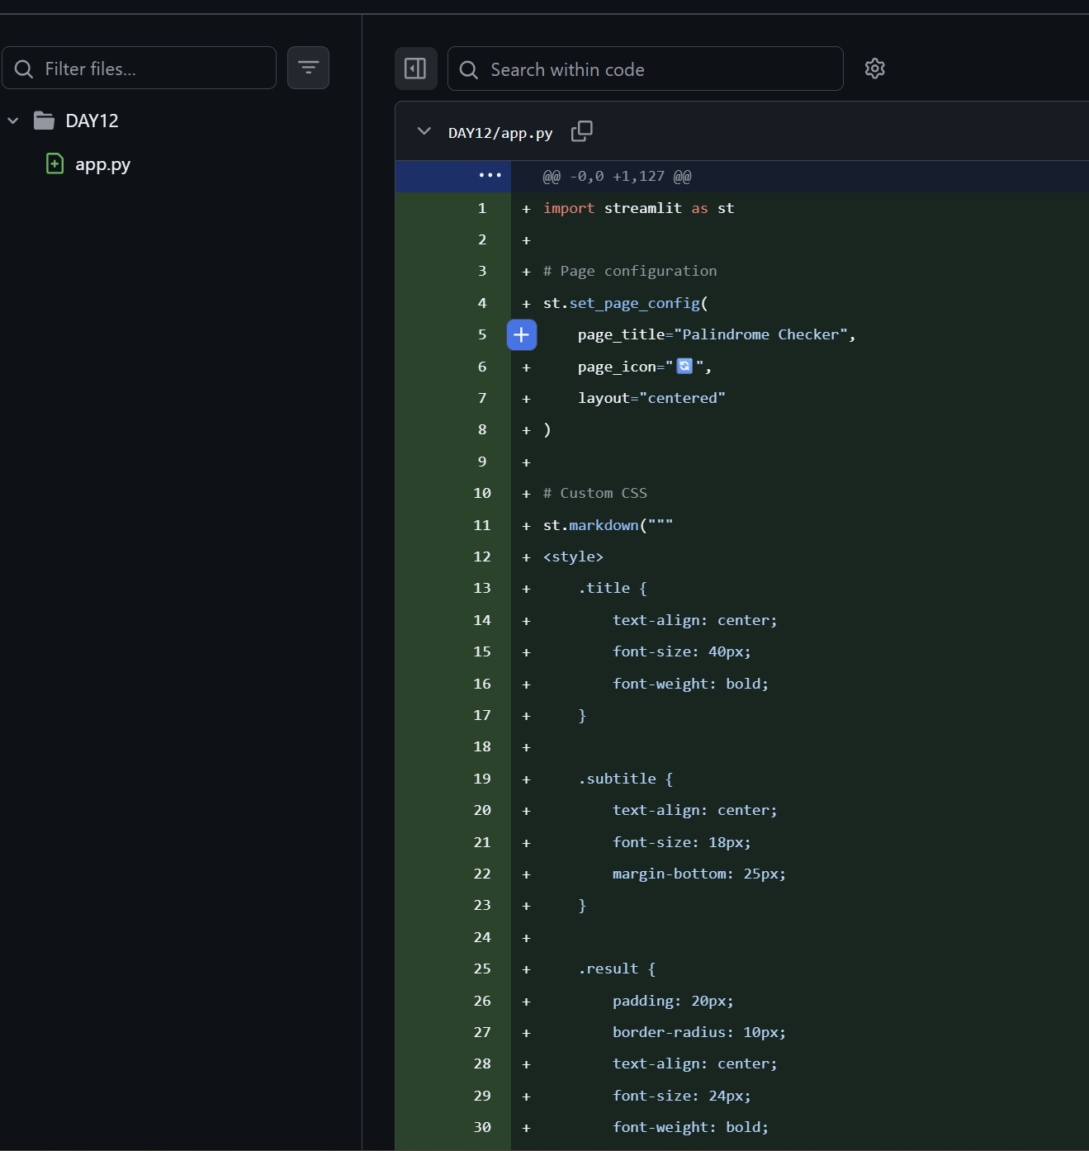
https://lnkd.in/p/dTE25Acm
