Objective
The objective of the Day 5 project is to develop an interactive Number Guessing Game using Python. The project focuses on understanding random number generation, loops, conditional statements, user input, and repeated interaction. The program generates a random number within a specified range and allows the user to continue entering guesses until the correct number is identified. The project also helps improve problem-solving skills and provides practical experience in developing an interactive Python application.
Key Features
The Number Guessing Game provides an interactive interface where the computer generates a random number between 1 and 100 and the user attempts to identify it by entering different guesses. After every guess, the application provides a clear hint indicating whether the entered number is too high or too low. An attempt counter keeps track of the number of guesses made by the user, and the game automatically stops when the correct number is found. A congratulatory message displays the successful result along with the number of attempts taken. The application also provides a Start New Game option that generates a new random number and resets the attempt counter.
Technologies Used
The project is developed using Python as the primary programming language. Python's built-in random module is used to generate the secret number using random.randint(). Streamlit is used to create a clear and interactive graphical interface for the game. Conditional statements such as if, elif, and else are used to compare the user's guess with the generated number and provide appropriate hints. Python variables and session state are used to maintain the generated number, attempt count, and game status during user interaction.
Learning Outcome
This project provides practical understanding of random number generation, conditional logic, user interaction, state management, and repeated program execution. It also demonstrates how basic Python programming concepts can be combined to create an interactive application. Through this project, the concepts of the random module, comparison operators, conditional statements, input handling, and attempt counting are applied in a real-world programming scenario.

C:\Users\shamb\OneDrive\Desktop\VEDA internship\DAY5>
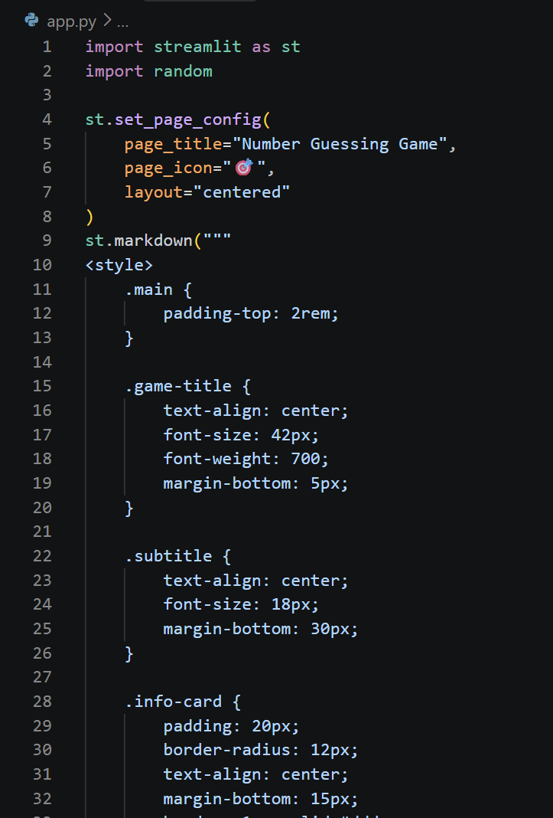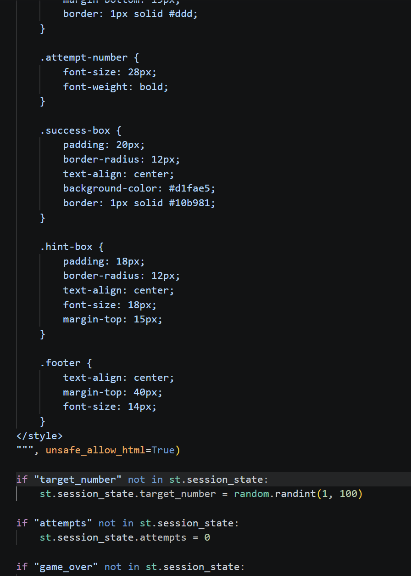
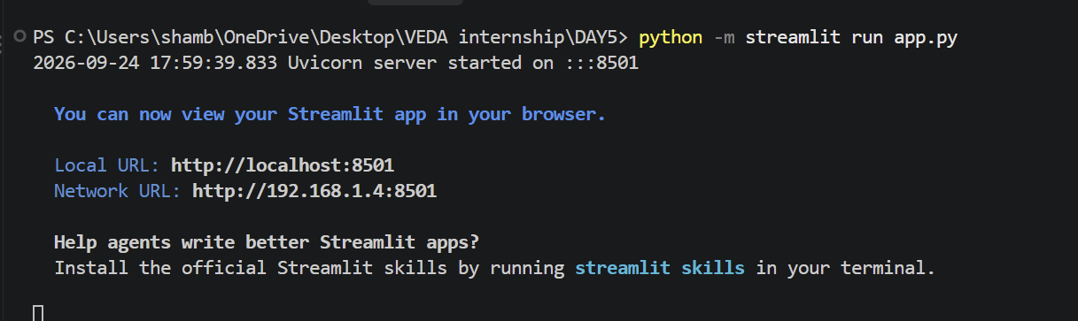
http://localhost:8501
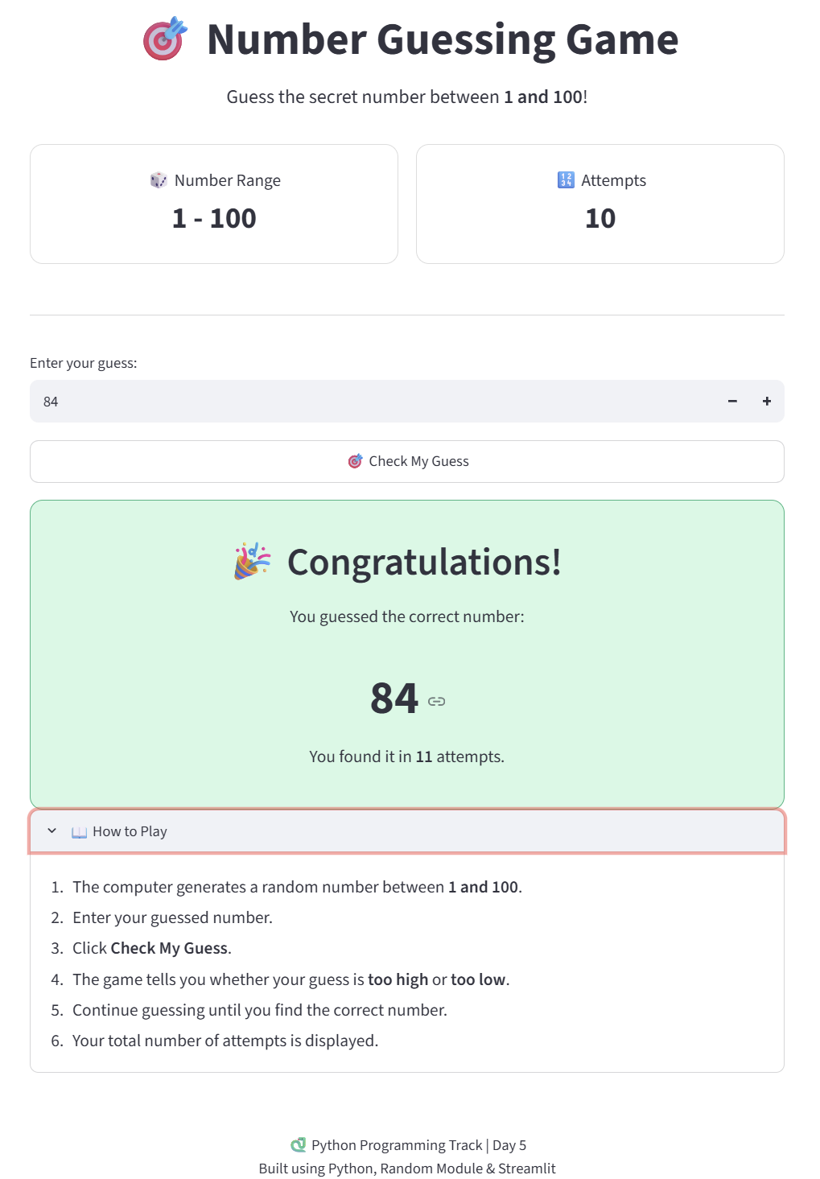

Github: https://github.com/shambhavi0804/VEDA-internship/commit/ce5e767c52bc94eb6828e70695c7cb60187ab25d
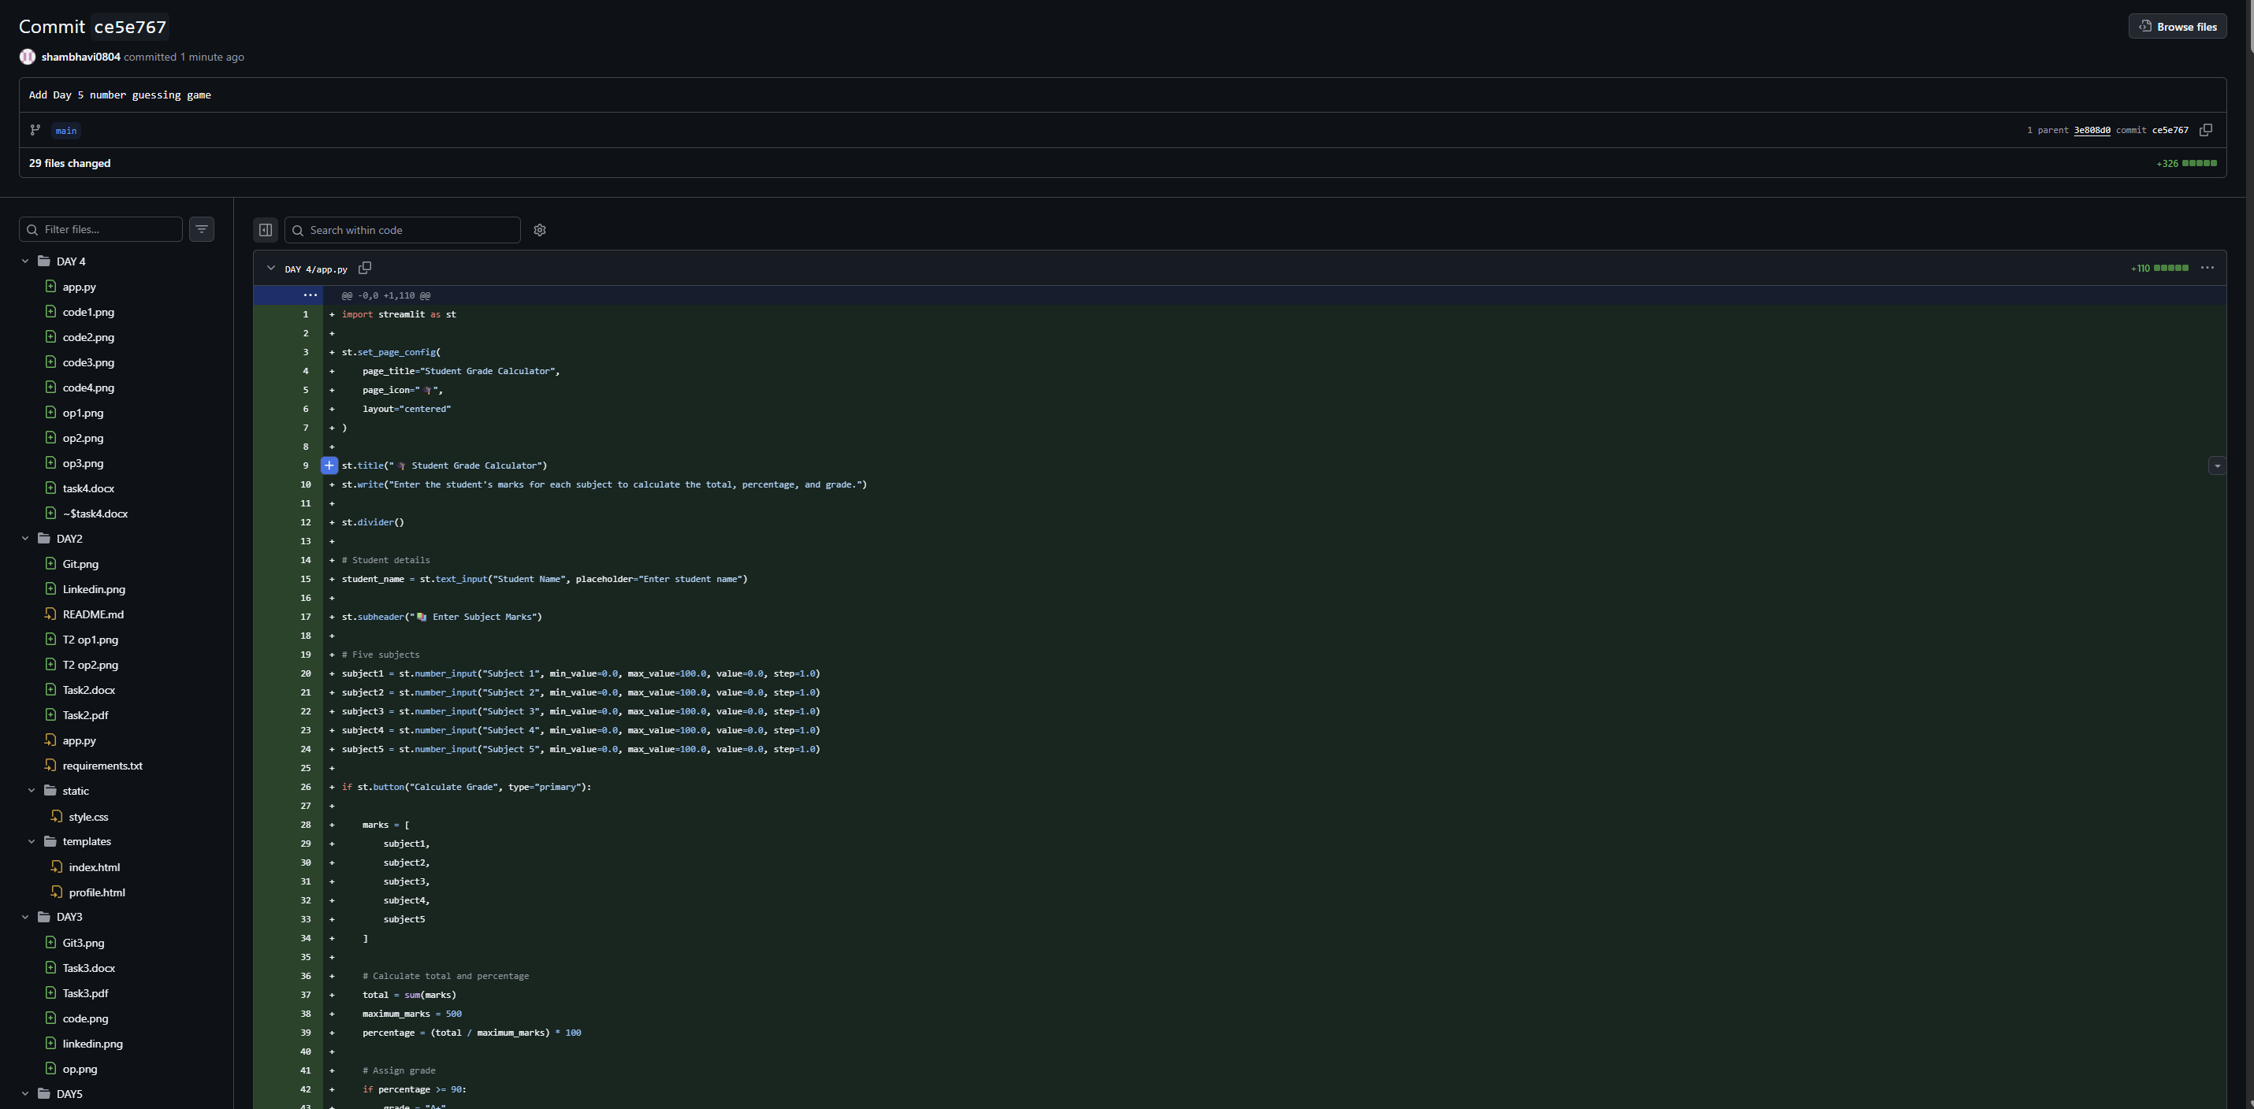
LinkedIn: https://lnkd.in/p/drAFgB4N
