Objective
The objective of the Day 6 project is to develop a simple Multiplication Table Generator using Python. The program accepts a number from the user and generates its multiplication table up to a specified limit. This task helps in understanding the use of for loops, the range() function, arithmetic operations, user input, and formatted output.
Key Features
- Accepts a number from the user.
- Allows the user to specify the multiplication limit.
- Generates the multiplication table using a for loop.
- Uses the range() function to control the table range.
- Performs multiplication automatically for each value.
- Displays the output in a clear and readable format.
- Allows tables of different lengths based on the user's specified limit.
- Displays a completion message after generating the table.
Technologies Used
The project is implemented using Python and uses basic Python programming concepts. The input() function is used to accept the number and limit from the user, while the for loop and range() function are used to generate the table. Arithmetic multiplication is used to calculate each result, and Python f-strings are used to format the output clearly.
Working Principle
The program first asks the user to enter the number for which the multiplication table needs to be generated. It then asks the user to enter the required multiplication limit. A for loop starts from 1 and continues until the specified limit. During every iteration, the entered number is multiplied by the current loop value, and the calculated result is displayed in the format Number × Multiplier = Result. Once the loop reaches the specified limit, the complete multiplication table is displayed.
Learning Outcomes
This project provides practical experience with fundamental Python programming concepts. It helps in understanding how loops can be used to perform repetitive calculations efficiently and how range() controls the number of iterations. The project also improves understanding of user input, arithmetic operations, variables, and formatted output.
Deliverables
- A working Python multiplication table program.
- User-defined multiplication number.
- User-defined multiplication limit.
- Properly formatted multiplication table.
- Output examples for at least three different numbers.
- Python source file named app.py
C:\Users\shamb\OneDrive\Desktop\VEDA internship\DAY6>
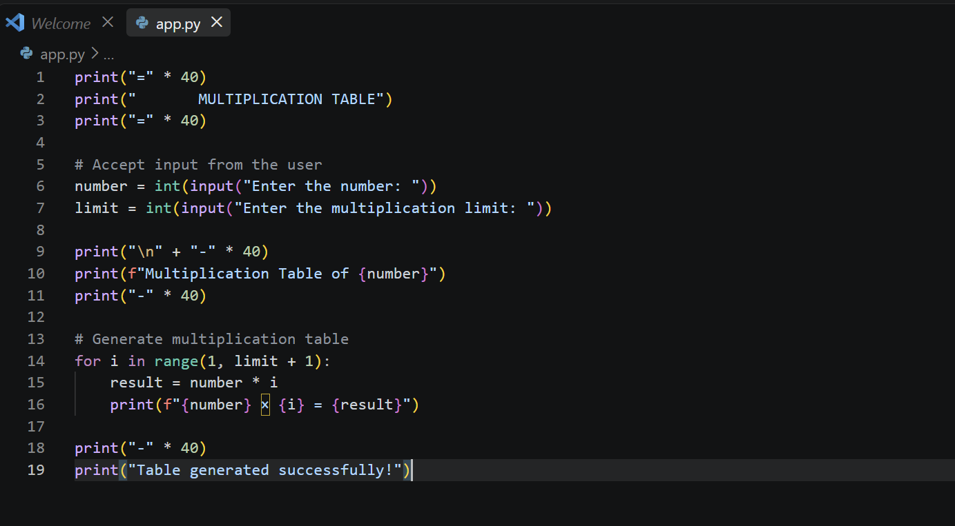
OUTPUT
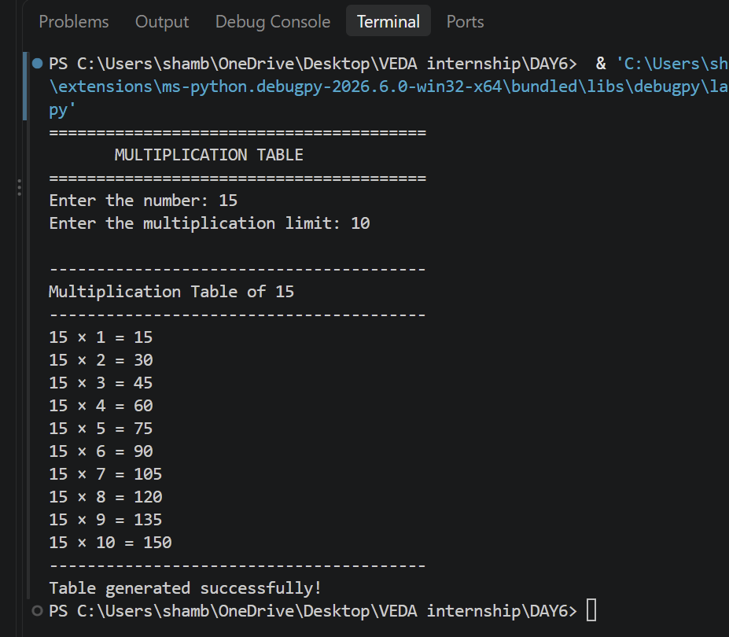
Github:https://github.com/shambhavi0804/VEDAinternship/commit/387483436a0b9da362b31e5c675cf37dc40c322c
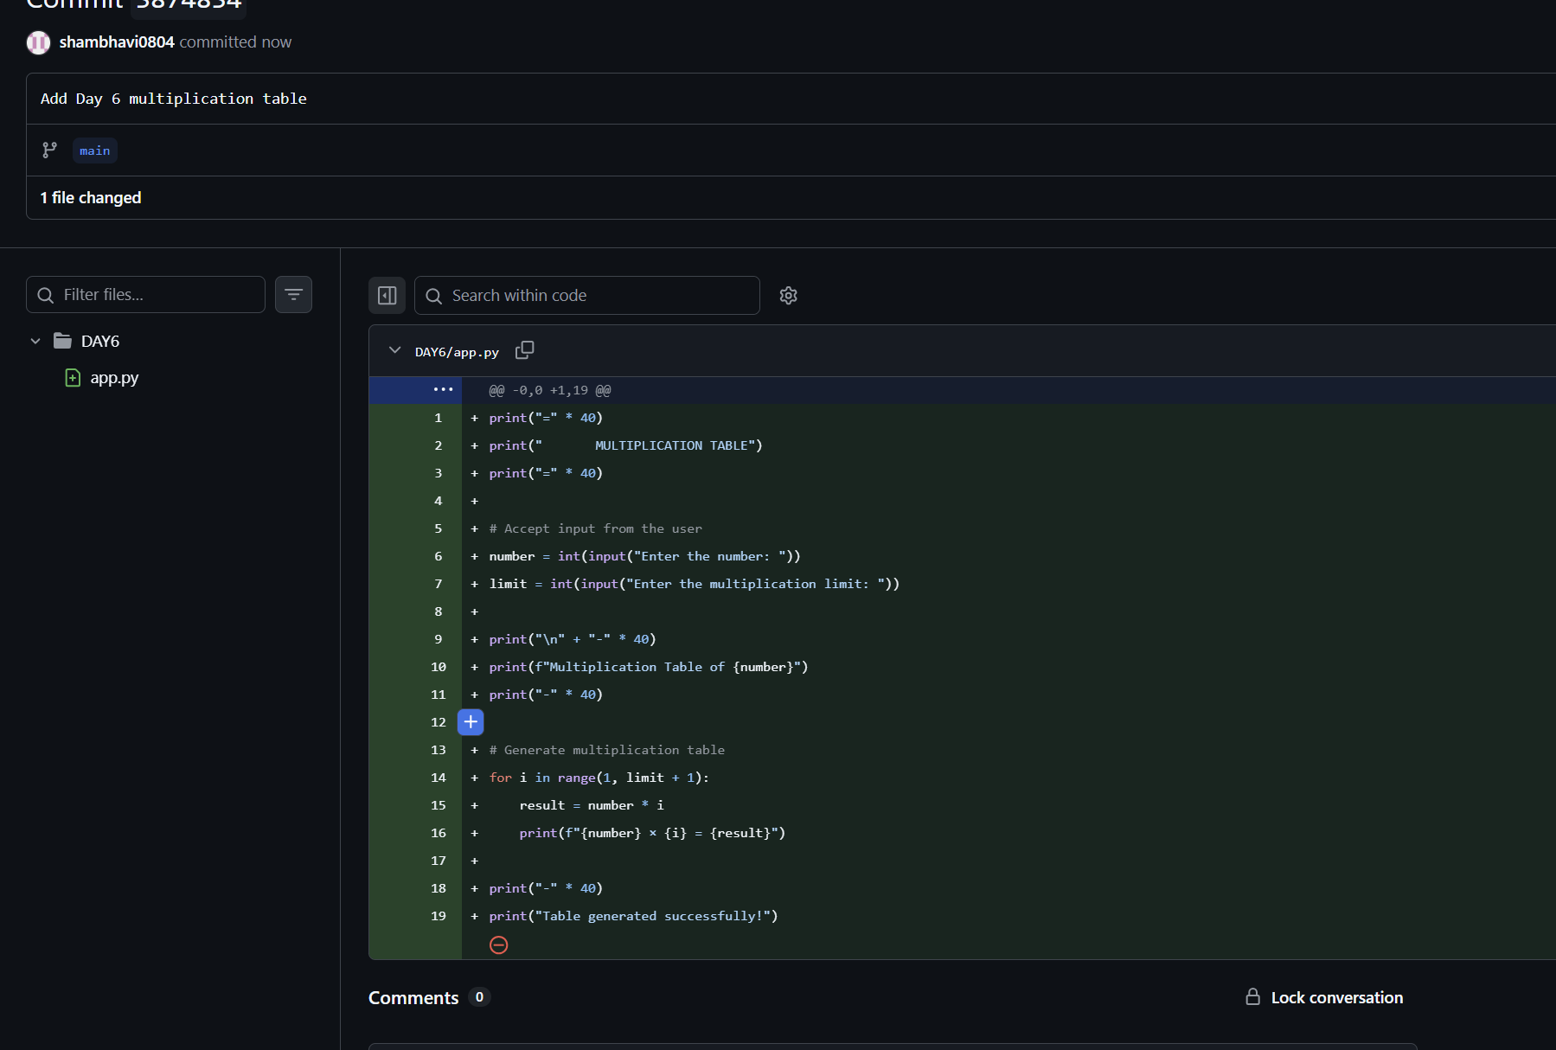
LinkedIn: https://lnkd.in/p/dWWbZjbV
