Objective
The objective of Day 7 is to develop a Simple Password Validator using Python and Streamlit. The application checks whether a password satisfies basic security requirements such as minimum length, uppercase and lowercase characters, a number, and a special character. This task helps strengthen the understanding of strings, conditions, loops, character checking, and basic input validation while creating an interactive web application.
Key Features
- Secure password input using a hidden password field.
- Checks whether the password contains at least 8 characters.
- Checks for at least one uppercase letter.
- Checks for at least one lowercase letter.
- Checks for at least one number.
- Checks for at least one special character.
- Displays individual validation results.
- Clearly identifies requirements that are missing.
- Displays how many validation requirements are satisfied.
- Shows a success message when all requirements are fulfilled.
- Provides a clean and interactive Streamlit interface.
Technologies Used
The project is developed using Python and Streamlit. Python string methods such as isupper(), islower(), and isdigit() are used to check individual characters. The string module is used to identify special characters, while conditional statements and loops are used to perform the validation. Streamlit provides the interactive user interface and allows the password to be entered using a hidden password field.
Working Principle
The application accepts a password from the user through a secure password input field. After the user clicks the validation button, the program checks the password against five predefined requirements. It verifies the length, uppercase character, lowercase character, digit, and special character. Each requirement is evaluated independently, and the application displays a clear success or error message for each condition. If all five requirements are satisfied, the password is marked as valid; otherwise, the application identifies the requirements that need improvement.
Learning Outcomes
This project provides practical experience in working with Python strings, character validation, conditional statements, loops, the string module, and Streamlit components. It also demonstrates how basic programming concepts can be used to create a practical input-validation application.
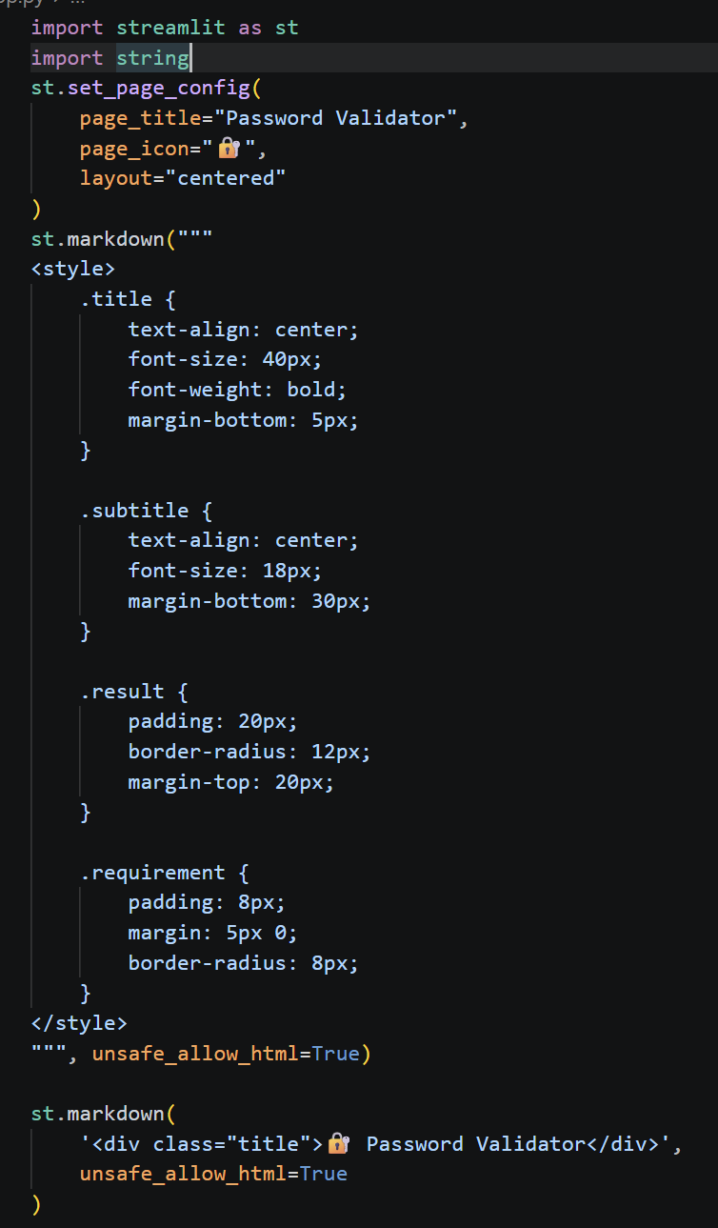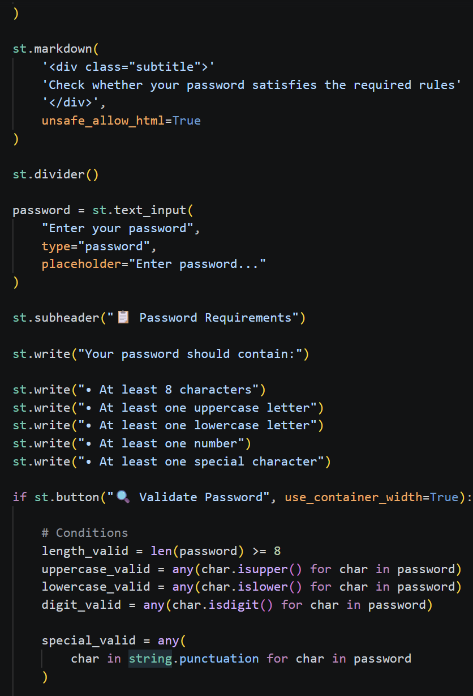

OUTPUT:http://localhost:8501
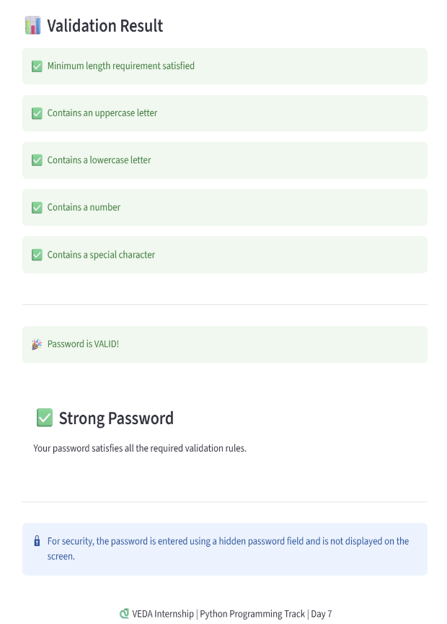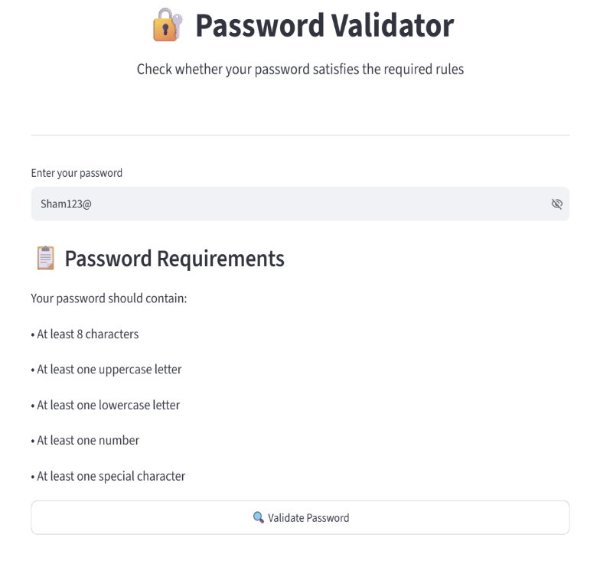

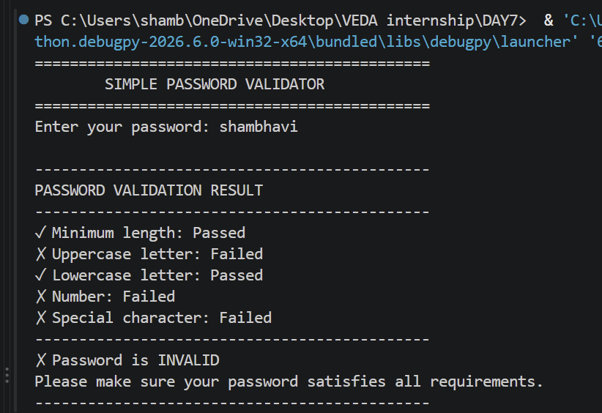

LINKEDIN: https://lnkd.in/p/dKajpJrt
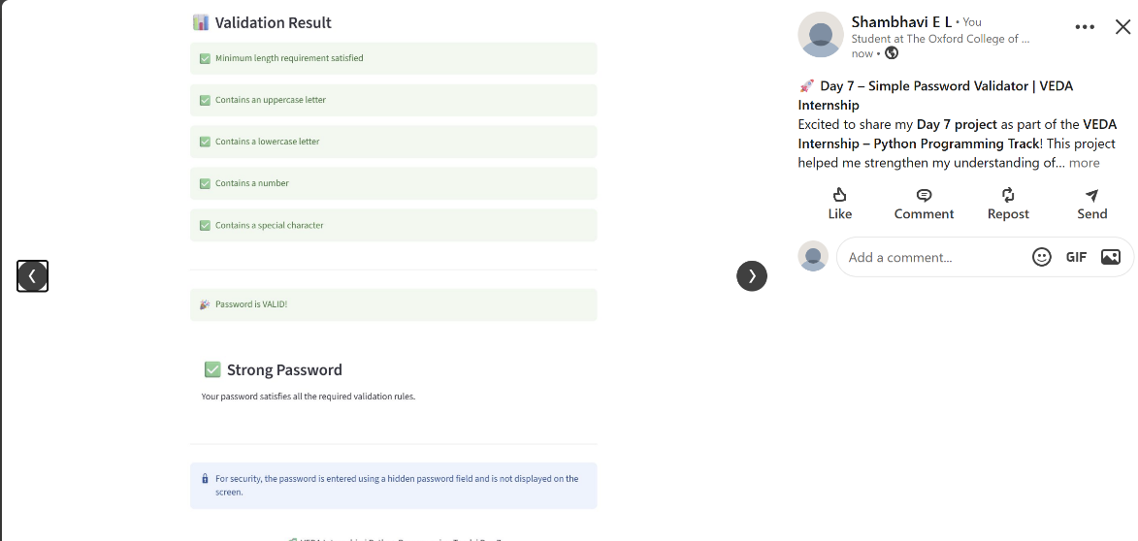

Github:https://github.com/shambhavi0804/VEDAinternship/commit/57a785a638ee5b875a5cef8f084bd3db1d30a07e
