Objective
The objective of the Day 8 project is to develop a Simple To-Do List application using Python and Streamlit that allows users to manage their daily tasks efficiently. The application demonstrates the practical use of Python lists, loops, conditional statements, functions, and menu-driven programming. It implements basic CRUD operations, allowing users to add, view, update, and remove tasks through an interactive local web interface.
Technologies Used
The application is developed using Python and Streamlit. Python lists are used to store tasks, while functions are created for different operations such as adding, updating, and removing tasks. Loops are used to display multiple tasks, and conditional statements are used for decision-making and input validation. Streamlit provides the interactive web interface and st.session_state is used to maintain the task list during user interaction.
Working Principle
The application starts with an empty task list. The user can select an operation from the menu, such as adding, viewing, updating, or removing a task. When a new task is added, it is stored in the Python list. The view operation displays all stored tasks with their corresponding numbers. For updating a task, the user selects its number and enters the new task description, which replaces the existing task. The remove operation deletes the selected task from the list. The application also checks for invalid or empty inputs and displays appropriate messages to the user.
Learning Outcomes
This project provides practical experience in developing a menu-driven application and understanding how CRUD operations work. It improves knowledge of Python lists, functions, loops, conditional statements, indexing, input validation, and Streamlit session state. The project also demonstrates how basic Python programming concepts can be combined to create a useful task-management application.

C:\Users\shamb\OneDrive\Desktop\VEDA internship\DAY8>
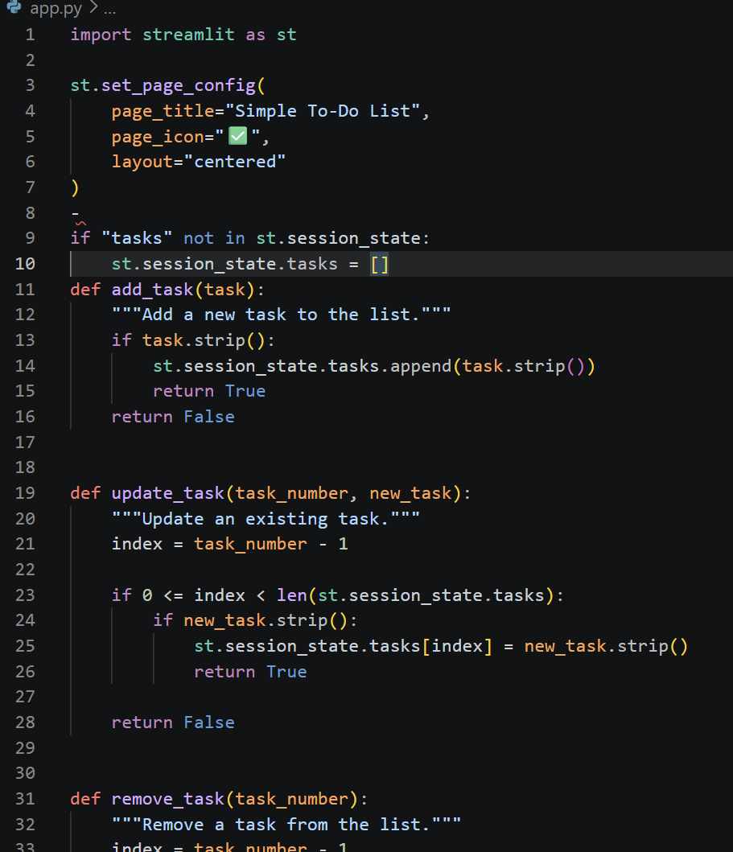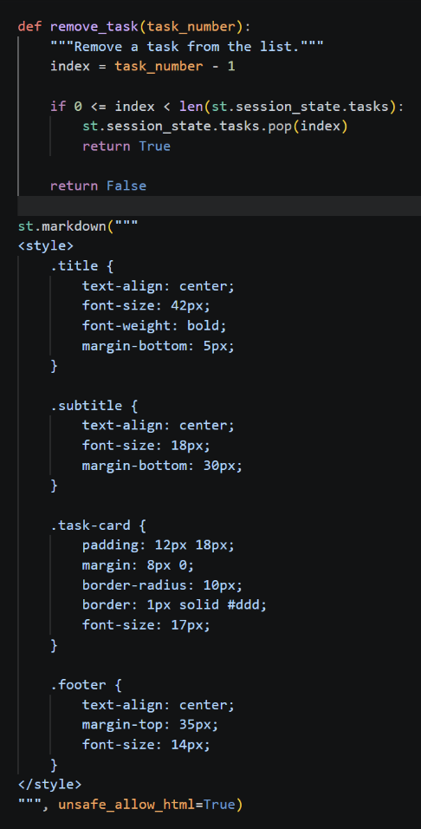
http://localhost:8501
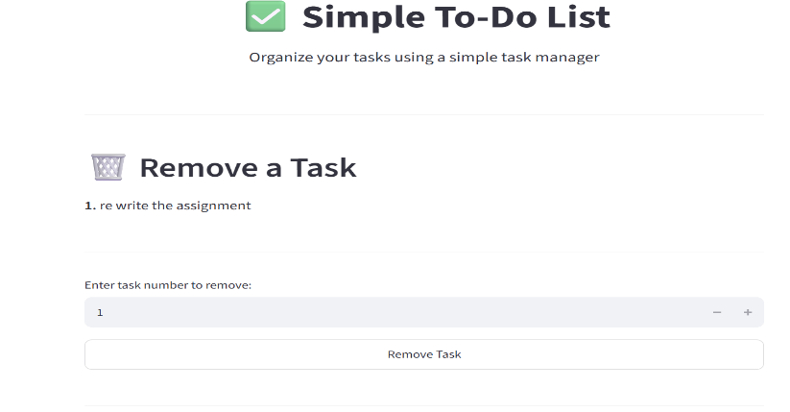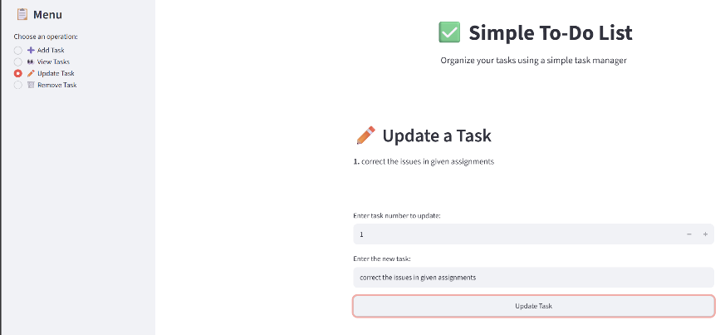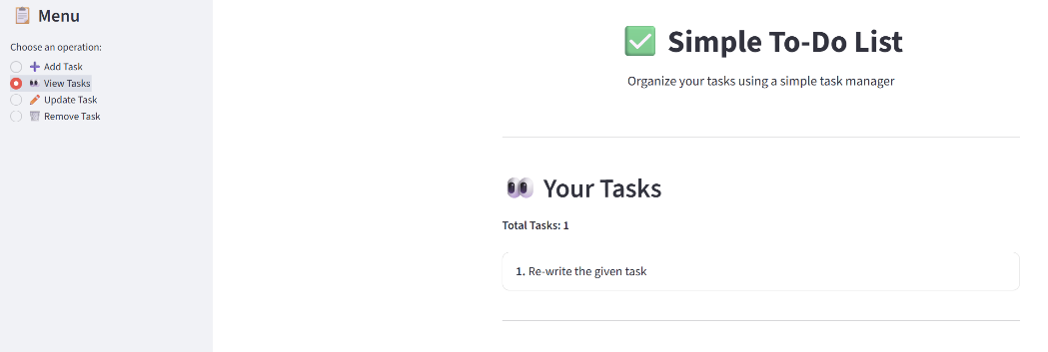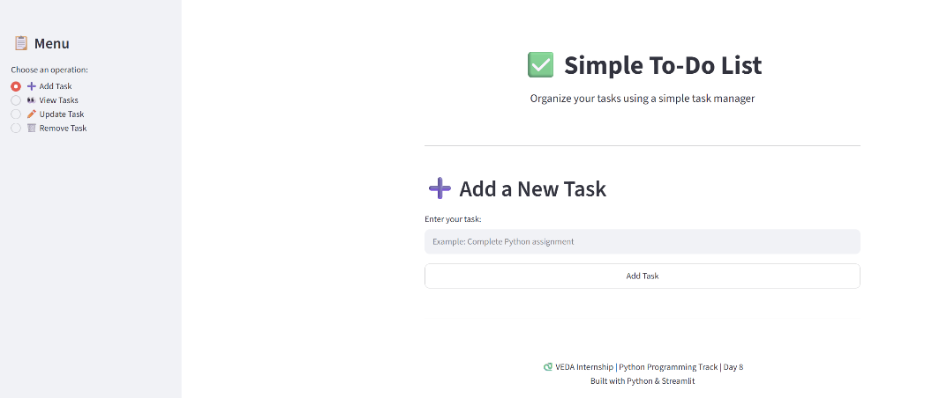
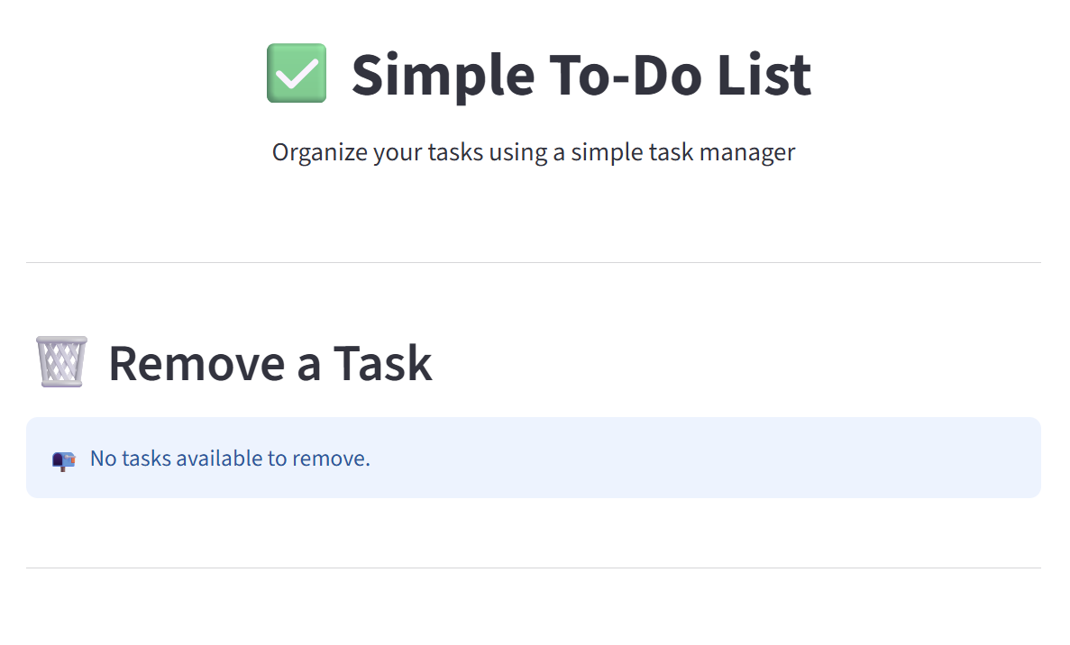

https://github.com/shambhavi0804/VEDA -internship/commit/61eaecfbdd5f5738c4bcd0a3b8ddb870750b3cb3
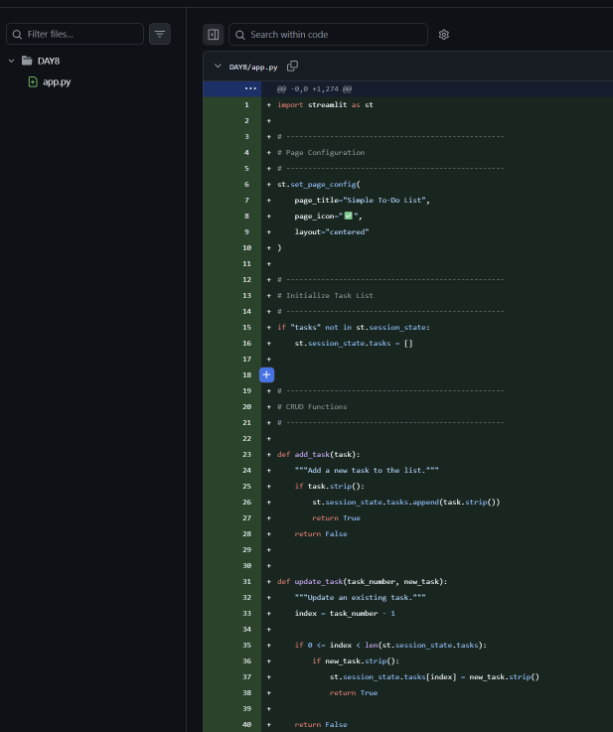
https://lnkd.in/p/dzxsXDXu
