Objective
The objective of Day 9 is to develop a practical Student Records application using Python lists. The application stores student names and their marks in separate lists and performs different list-processing operations such as searching for a student, sorting student records according to marks, and finding the highest and lowest scores. The project helps develop a practical understanding of Python lists, indexing, loops, built-in functions, and basic data processing.
Key Features
- Stores student names and marks using Python lists.
- Allows new student records to be added.
- Displays all student records.
- Provides student name searching functionality.
- Sorts students according to their marks.
- Identifies the student with the highest score.
- Identifies the student with the lowest score.
- Validates student names and marks.
- Restricts marks to the range of 0–100.
- Provides an interactive Streamlit interface.
- Uses Streamlit session state to maintain records during the session.
Technologies Used
The project is developed using Python and Streamlit. Python lists are used to store student names and marks, while loops and indexing are used to access corresponding student records. Built-in functions such as max() and min() are used to identify the highest and lowest scores. The sort() method is used to arrange student records based on marks, while string operations are used for student searching. Streamlit provides the interactive local web interface.
Working Principle
The application maintains two synchronized lists, one containing student names and the other containing their corresponding marks. When a student record is added, the name and mark are stored at matching indexes. The application can display all records, search for a particular student, sort records from highest to lowest marks, and calculate the highest and lowest scores. The use of matching indexes ensures that each student's name remains associated with the correct marks.
Learning Outcomes
This project provides practical experience with Python lists, indexing, loops, searching, sorting, built-in functions, and data processing. It also demonstrates why related data must be carefully synchronized when using multiple lists. Through the Streamlit interface, basic Python list operations are transformed into an interactive student-record application.
C:\Users\shamb\OneDrive\Desktop\VEDA internship\DAY9>
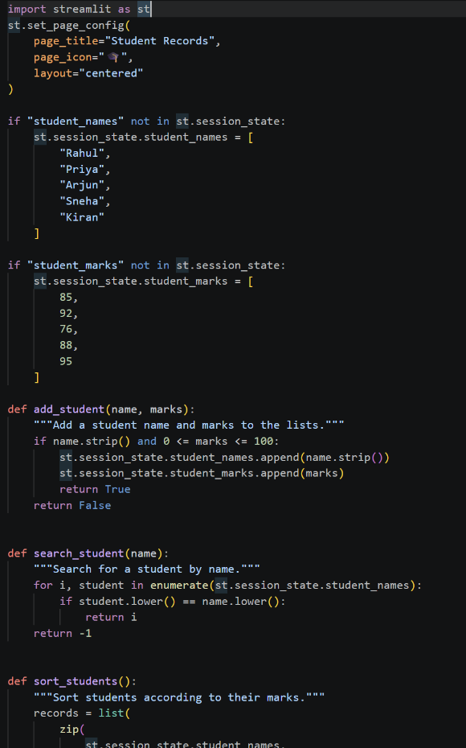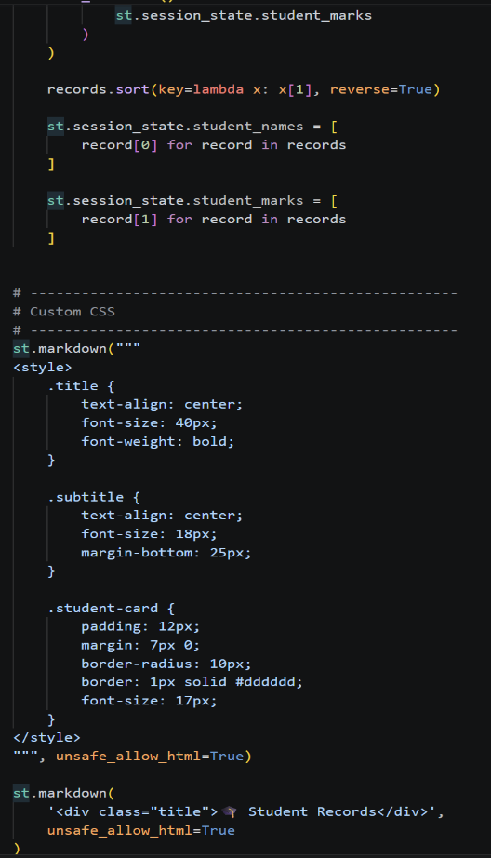

OUTPUT: http://localhost:8501

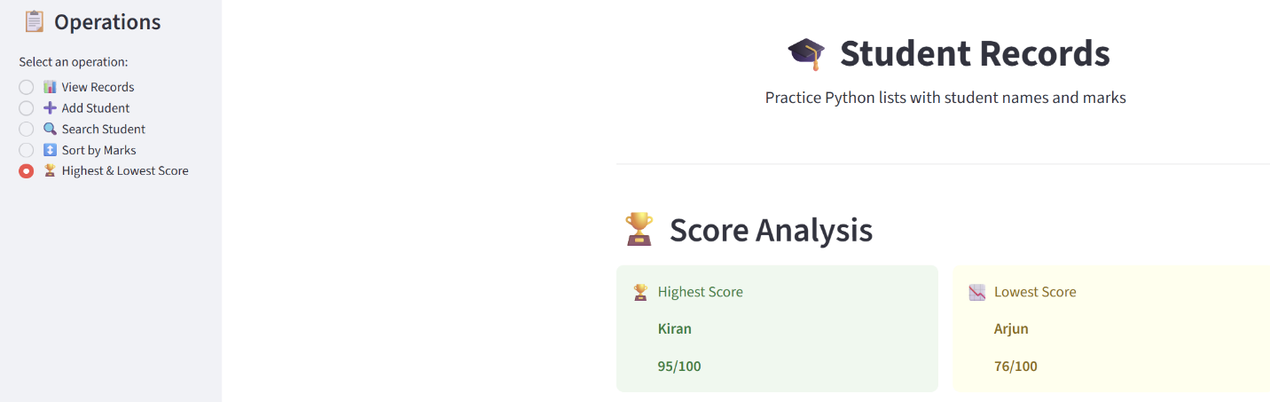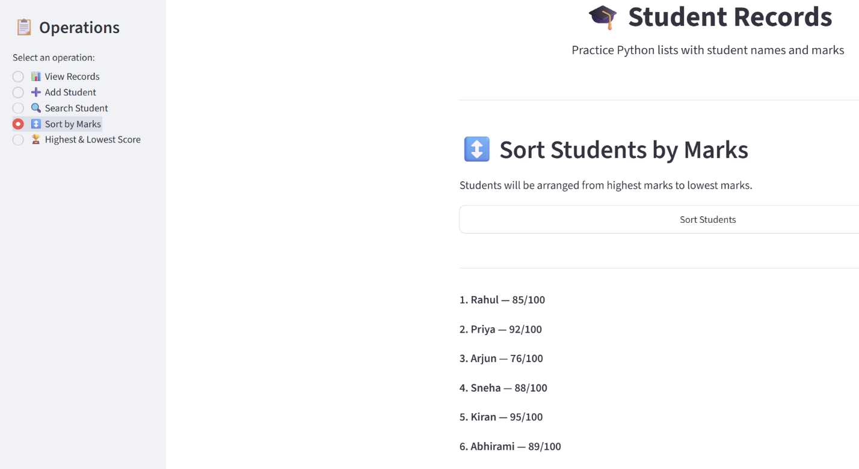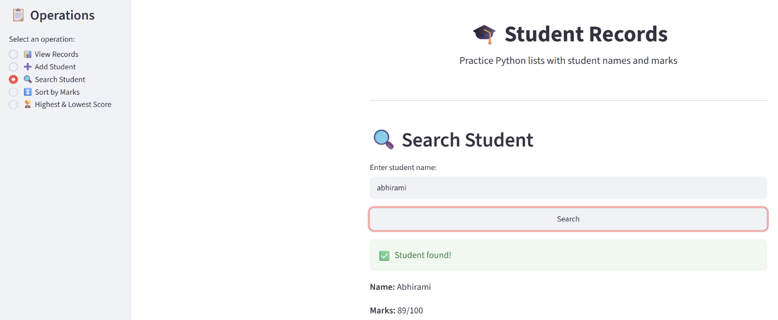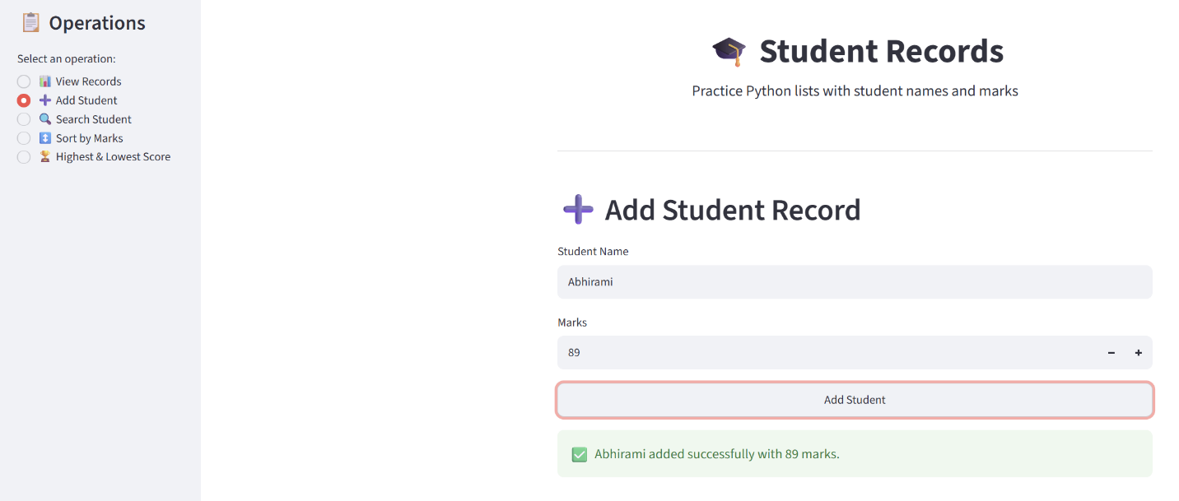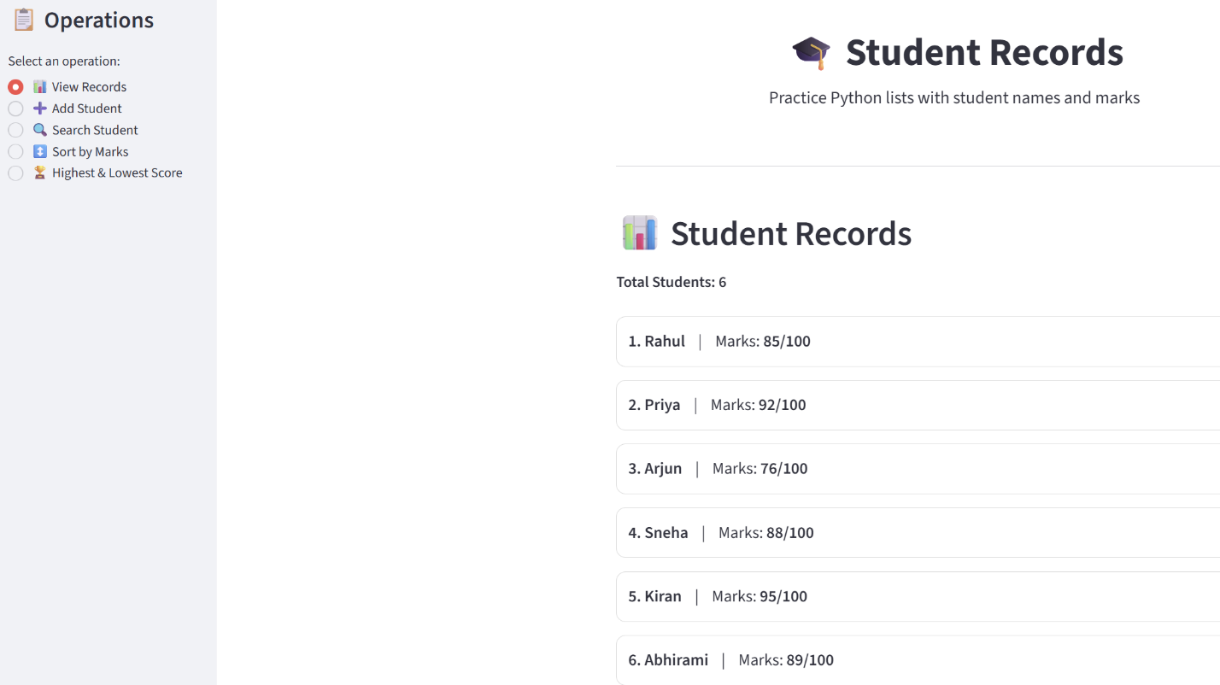

Linkedin:-https://lnkd.in/p/d888y3bF

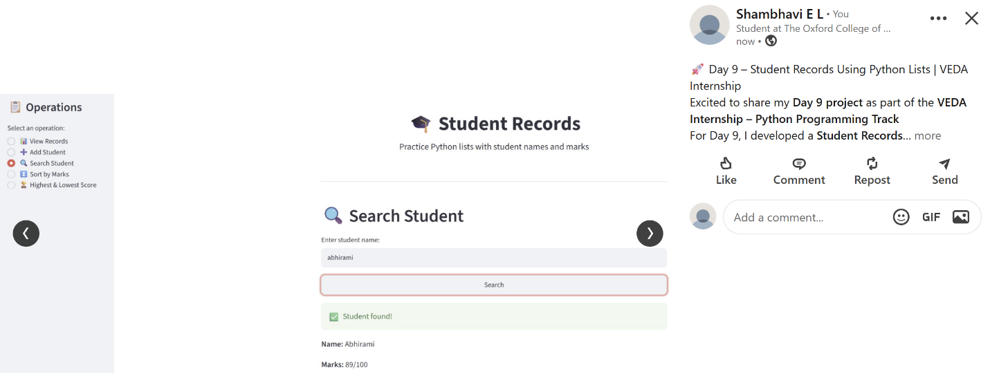

Github:-
