Objectives
The objective of this task is to develop a Python-based temperature conversion application that converts temperatures between Celsius, Fahrenheit, and Kelvin. The project helps practice Python functions, arithmetic operations, conditional statements, input validation, and formatted output while providing a simple interactive interface using Streamlit.
Key Features
- Converts Celsius to Fahrenheit and Kelvin.
- Converts Fahrenheit to Celsius and Kelvin.
- Converts Kelvin to Celsius and Fahrenheit.
- Allows the user to select the source and destination units.
- Accepts decimal temperature values.
- Uses separate functions for each conversion.
- Validates physically meaningful temperature values.
- Displays the converted temperature with two decimal places.
- Displays the formula used for the conversion.
- Provides a clean and user-friendly Streamlit interface.
- Runs locally through the Streamlit development server.
Technologies Used
- Python
- Streamlit
- Python functions
- Conditional statements
- Arithmetic operators
- Input validation
- HTML/CSS styling through Streamlit
Deliverables
The completed task includes a working temperature conversion program, conversion formulas, input validation, sample conversion results, and a Streamlit-based user interface.
C:\Users\shamb\OneDrive\Desktop\VEDA internship\DAY14>
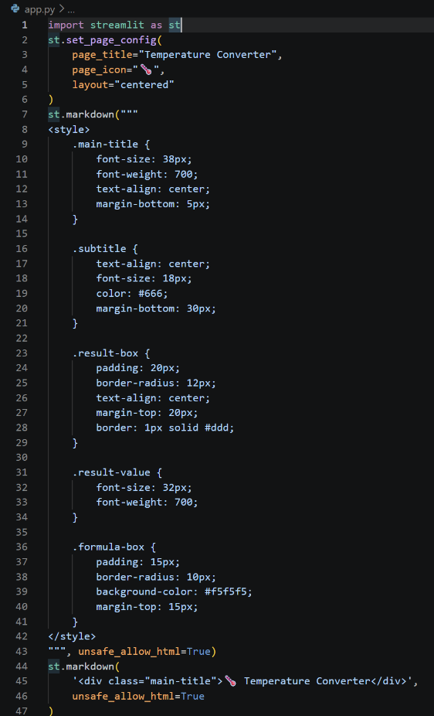 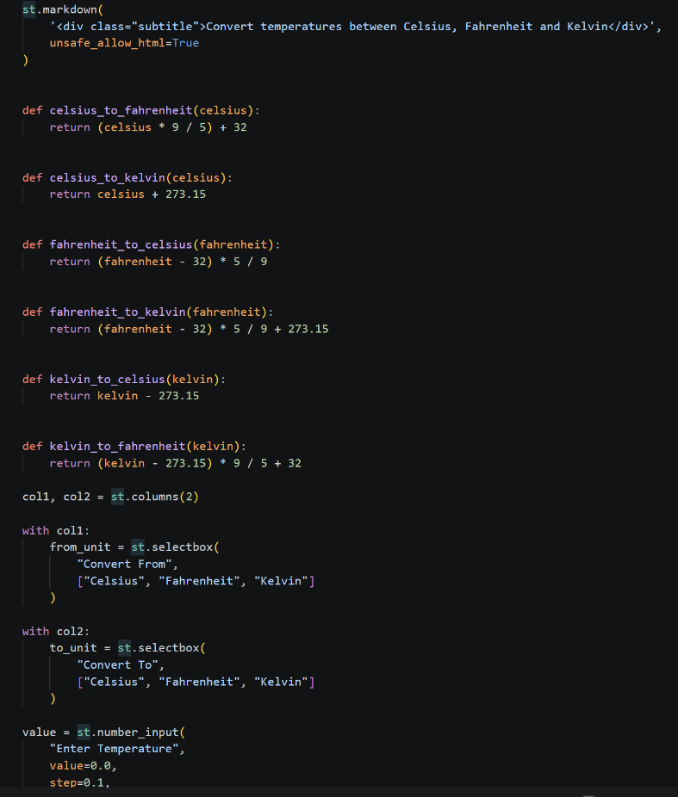OUTPUT:_http://localhost:8501
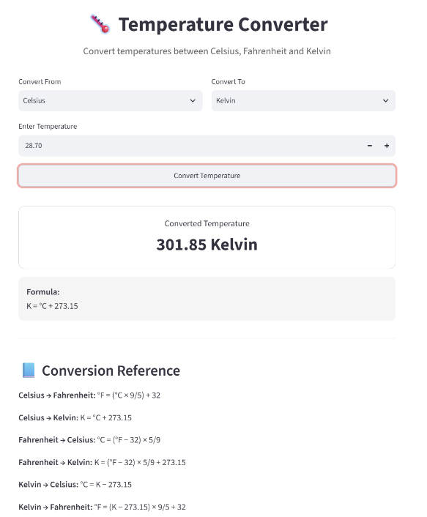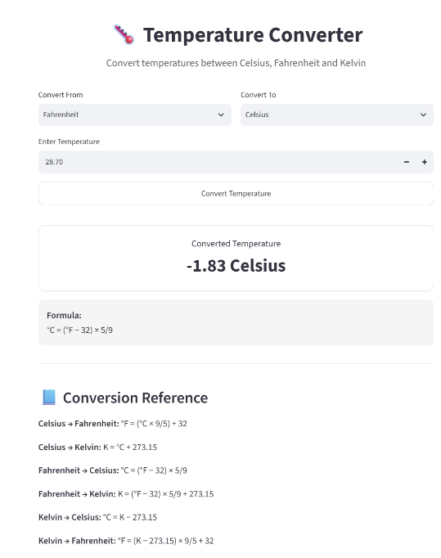
Github:- https://github.com/shambhavi0804/VEDA-internship/commit/5ccf680e8b7c060a9a219ec93c1dfa1a74d81293
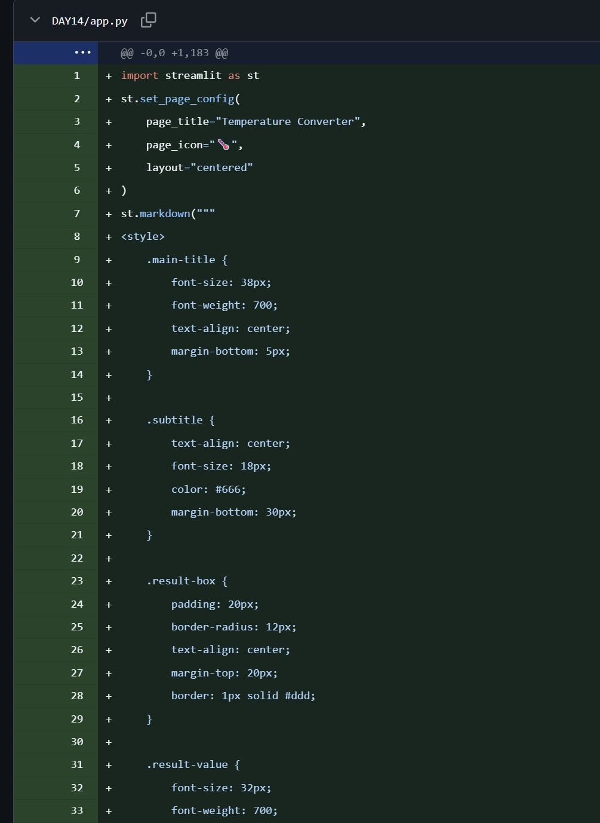
Linkedin:- https://lnkd.in/p/dGadw_q2
