2. Objectives
The objective of this task is to develop a practical Shopping Bill Generator using Python and Streamlit. The application allows users to enter product names, quantities, and prices and automatically calculates the subtotal, discount, tax, and final payable amount. This task helps strengthen knowledge of Python lists, dictionaries, loops, functions, arithmetic operations, input validation, and formatted output while applying them to a real-world billing scenario.
3. Key Features
The application provides a simple interface for entering multiple products and their corresponding quantities and prices. It calculates the total price for each product and combines them to determine the subtotal. Users can also specify a discount percentage and tax/GST percentage, after which the application calculates the discount amount, taxable amount, tax amount, and final bill amount.
Main Features
- Multiple product entries.
- Product name input.
- Quantity input.
- Price input.
- Automatic item-wise total calculation.
- Formatted shopping bill.
- Discount calculation.
- Tax/GST calculation.
- Final payable amount.
- Basic input validation.
- Streamlit local-host interface.
4. Technologies Used
Python is used as the main programming language for implementing the billing logic and calculations. Streamlit is used to create the interactive web interface and display the generated bill. Python lists and dictionaries are used to store product information, while loops and arithmetic operations are used to process the billing data.
Technologies
- Python
- Streamlit
- Lists
- Dictionaries
- Loops
- Functions
- Conditional statements
- Arithmetic operations
- Input validation
5. Deliverables
- Shopping bill generator program.
- Itemized product bill.
- Subtotal calculation.
- Discount calculation.
- Tax/GST calculation.
- Final amount calculation.
- Streamlit-based user interface.
- Sample bill output.

C:\Users\shamb\OneDrive\Desktop\VEDA internship\DAY15>
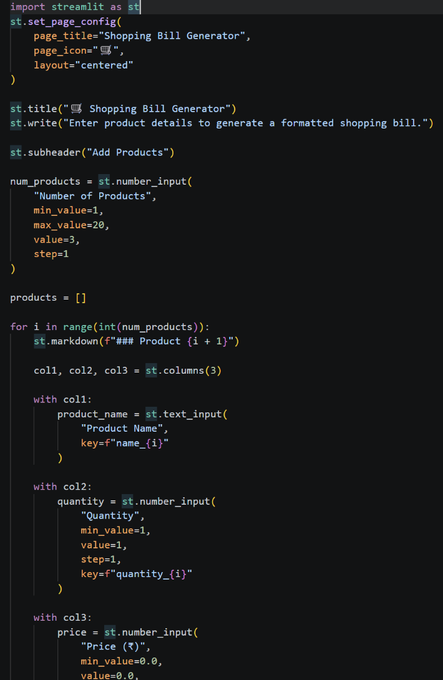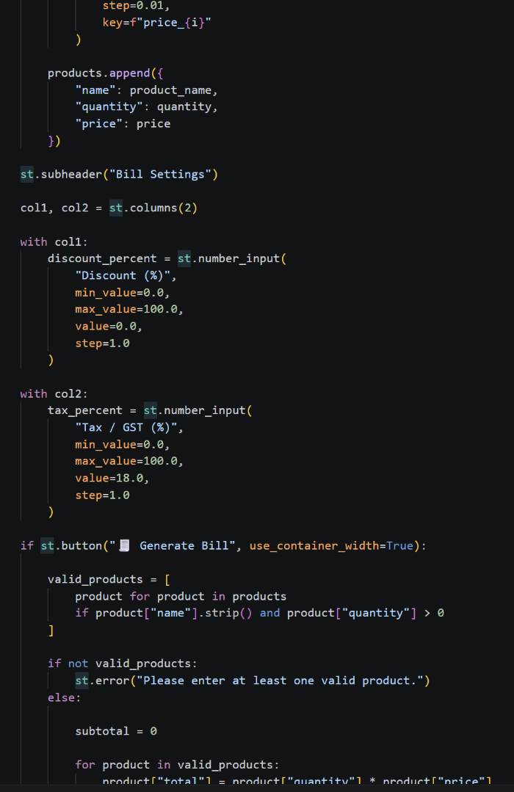

OUTPUT:_http://localhost:8501
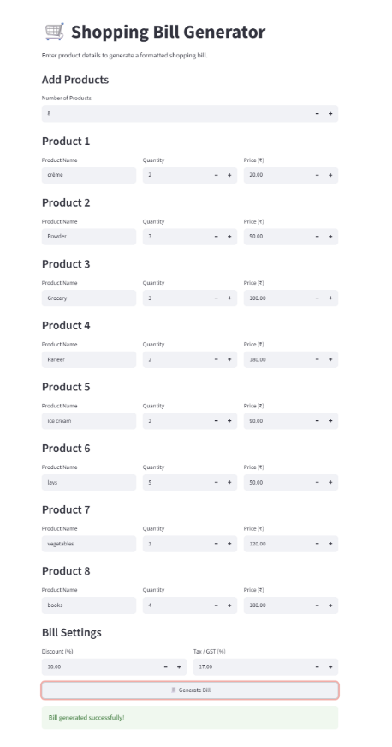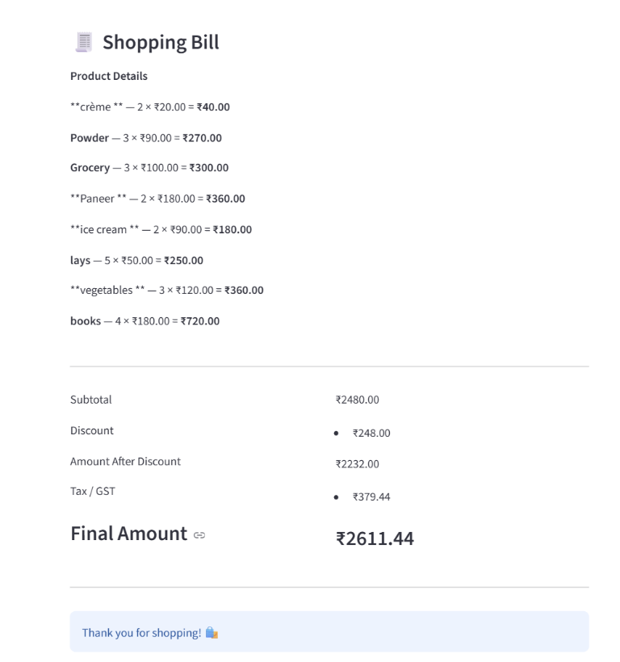
Github:- https://github.com/shambhavi0804/VEDA-internship/commit/f0022ee4df17ed5896a35799d3c40a5d1fa8f5a3
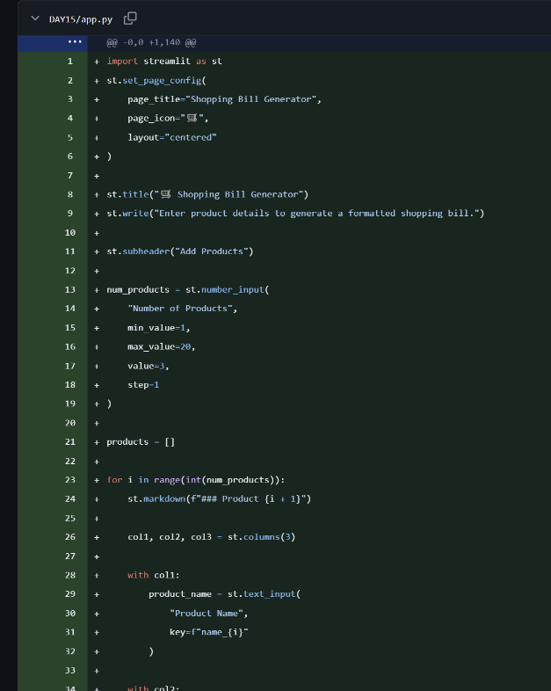
Linkedin:- https://lnkd.in/p/dVNDASqt
