Objectives
- To develop a simple calculator using Python.
- To practice arithmetic operators such as +, -, *, /, and %.
- To understand functions and conditional statements.
- To handle user input effectively.
- To prevent errors such as division by zero.
- To display calculation results clearly.
Key Features
- Addition — Adds two numbers.
- Subtraction — Subtracts the second number from the first.
- Multiplication — Multiplies two numbers.
- Division — Divides the first number by the second.
- Modulus — Returns the remainder after division.
- Division-by-zero protection — Prevents runtime errors.
- Invalid input handling — Displays an error when non-numeric input is entered.
- Continuous operation — The calculator can perform multiple calculations until the user selects Exit.
- Clean console interface — Uses headings, separators, and clearly numbered options.
- Separate functions — Each arithmetic operation is implemented independently.

Technologies Used
Python 3

Conditional Statements

Input/Output

Exception Handling

C:\Users\shamb\OneDrive\Desktop\VEDA internship\DAY2>
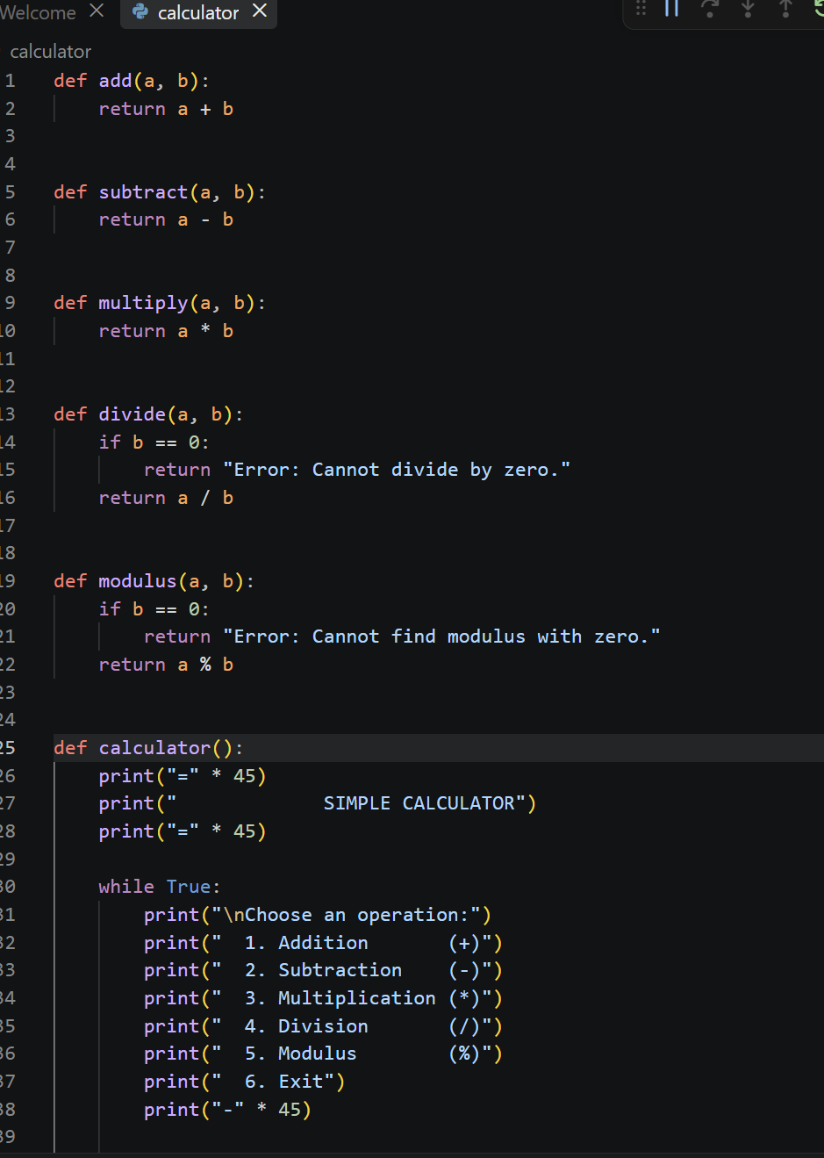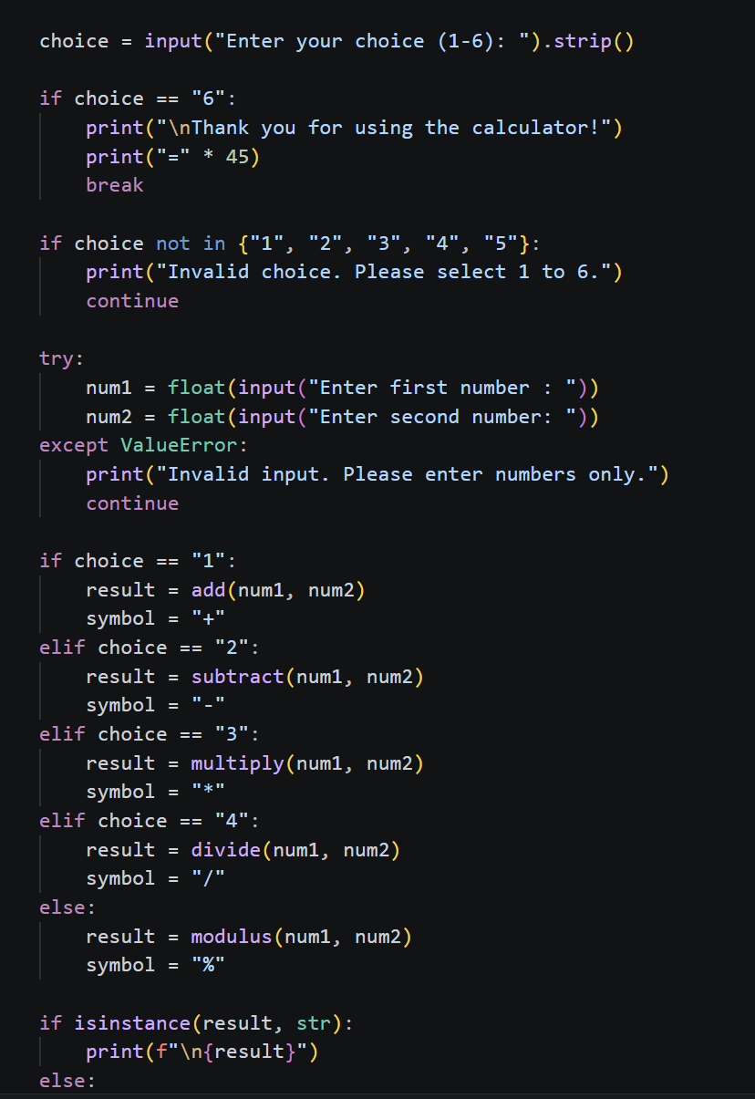
OUTPUT: Snapshot
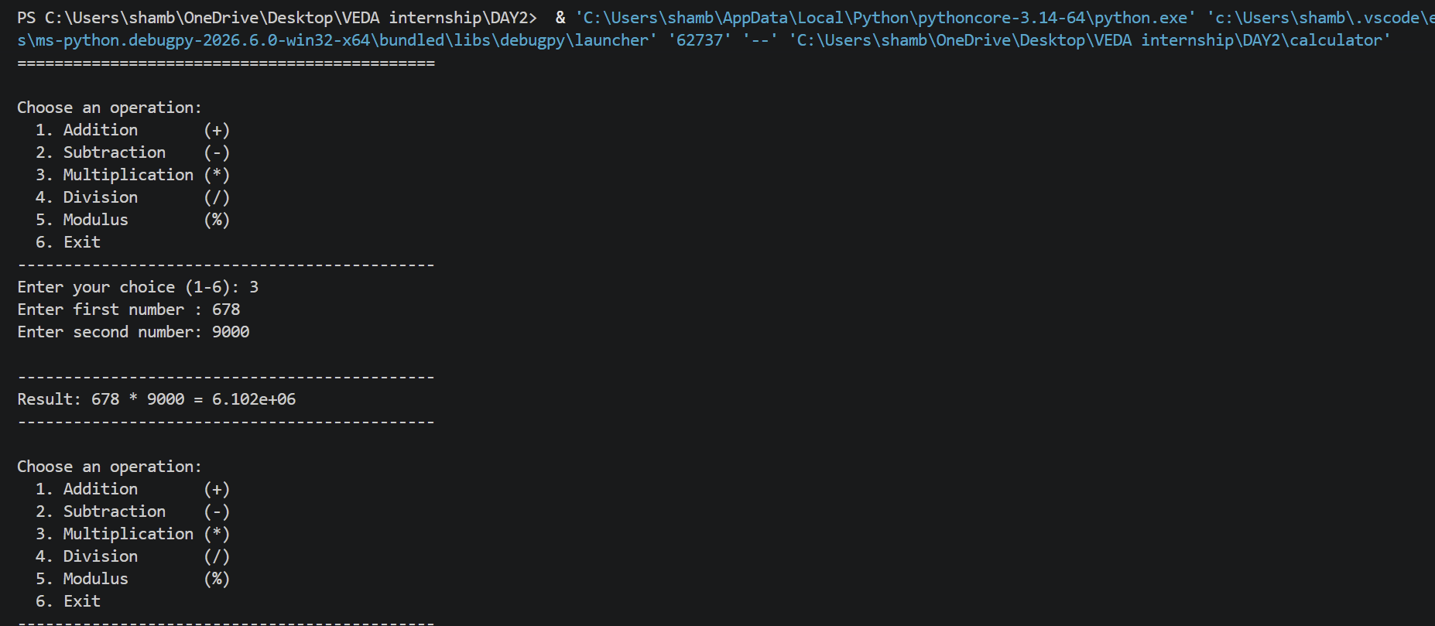
Github: https://github.com/shambhavi0804/VEDA-internship/commit/52ba4c78e406bbd62997612fe3c5685ccf095bb3
