Objective
The objective of this project is to develop a simple Python-based application that determines whether a given number is even or odd. The application uses the modulus (%) operator to check the remainder when a number is divided by 2. A Streamlit-based interface is used to provide an interactive local web application where users can enter numbers and view the result instantly.
Key Features
- Checks whether the entered number is even or odd.
- Uses the modulus (%) operator for number classification.
- Supports positive, negative, and zero values.
- Provides an interactive Streamlit web interface.
- Displays clear messages for both Even Number and Odd Number results.
- Provides example inputs to demonstrate both even and odd outputs.
- Runs locally through a localhost web application.
- Uses conditional statements to determine the result.
Technologies Used
- Python – Used as the primary programming language.
- Streamlit – Used to create the interactive web interface.
- Modulus Operator (%) – Used to determine whether a number is divisible by 2.
- Conditional Statements (if-else) – Used to classify the input as even or odd.
- Git & GitHub – Used for source-code version control and project submission.
- Localhost – Used to run and test the Streamlit application locally.

C:\Users\shamb\OneDrive\Desktop\VEDA internship\DAY3>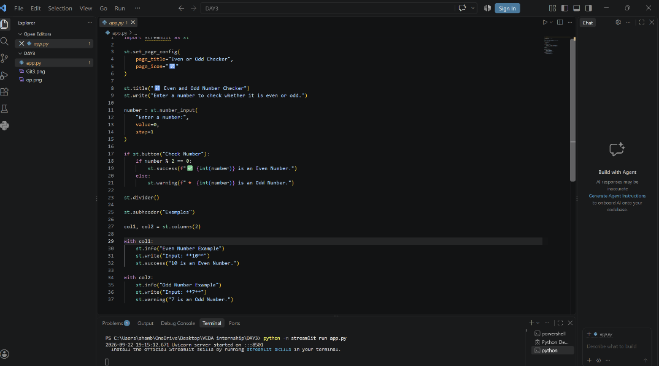
OUTPUT
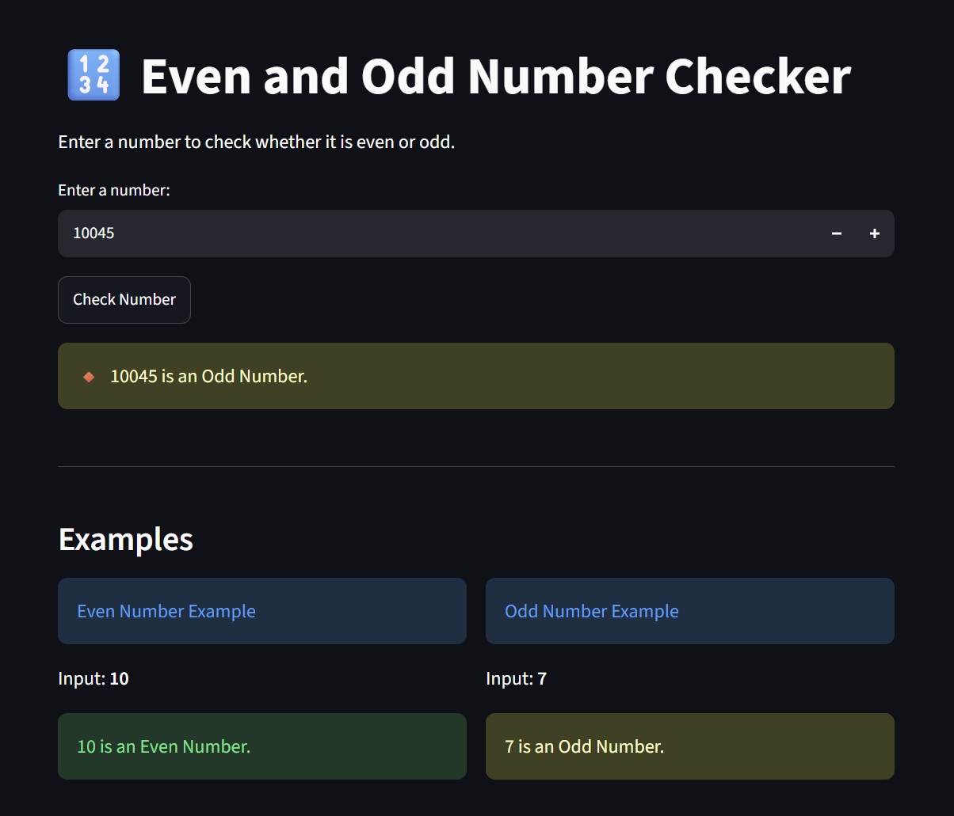

Github: https://github.com/shambhavi0804/VEDA-internship/commit/d10490c726b53baa9c86efed6bf1c7c2026db76chttps://lnkd.in/p/d8c6xVrH
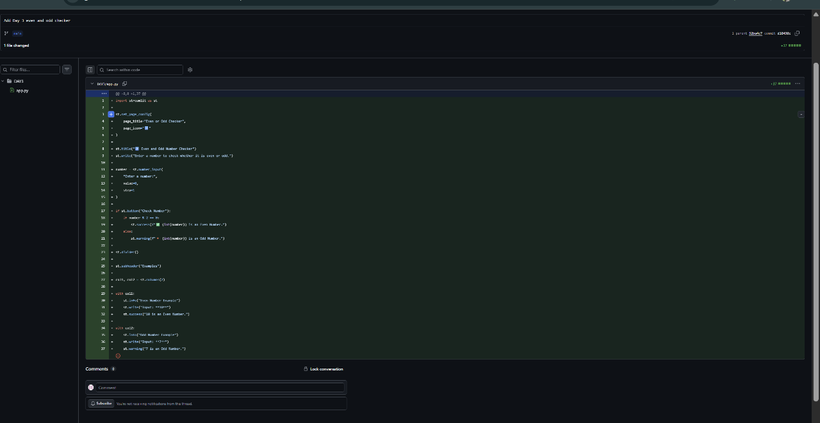

LinkedIn: https://lnkd.in/p/dCaAcDHi
