Objective
The main objective of this task is to develop an Employee Salary Calculator that calculates an employee's gross salary, deductions, and final net salary based on predefined and configurable salary rules. This task helps in practicing Python dictionaries, functions, conditional validation, arithmetic operations, and implementing business rules in a practical application. The Streamlit interface makes the calculator interactive and easy to use.
Key Objectives
- Calculate employee gross salary.
- Calculate different salary allowances.
- Calculate deductions such as PF and tax.
- Calculate final net salary.
- Practice Python functions and dictionaries.
- Implement configurable salary rules.
- Perform input validation.
- Build an interactive Streamlit application.
3. Key Features
The application allows the user to enter an employee name and basic salary and then automatically calculates the complete salary breakdown. It calculates HRA, travel allowance, gross salary, PF deduction, tax deduction, total deductions, and final net salary. The application also validates the employee name and salary input to prevent invalid calculations. Salary rules are maintained separately in the program, making them easy to modify when requirements change.
Main Features
- Employee name input
- Basic salary input
- HRA calculation
- Travel allowance calculation
- Gross salary calculation
- PF deduction
- Tax deduction
- Total deductions
- Net salary calculation
- Input validation
- Salary breakdown
- Configurable salary rules
- Streamlit local web interface

C:\Users\shamb\OneDrive\Desktop\VEDA internship\DAY16>
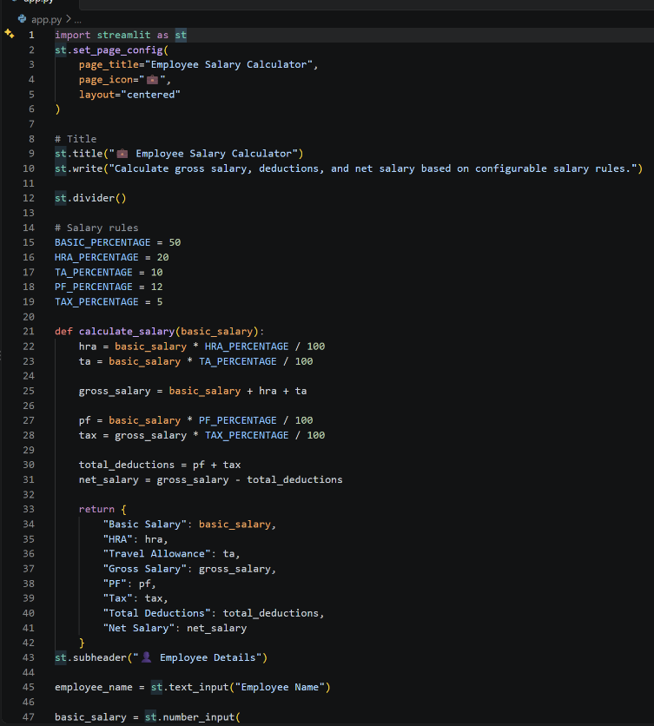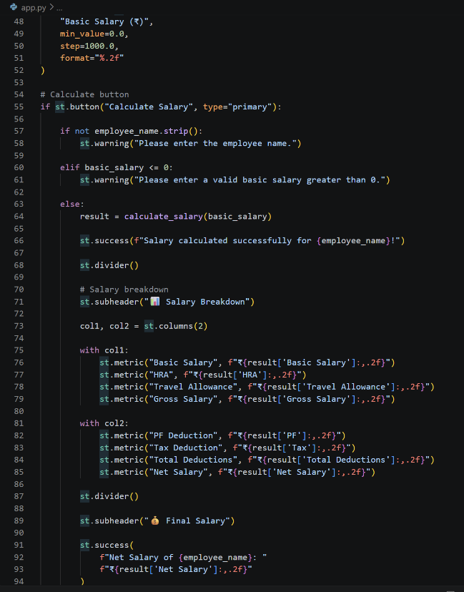

OUTPUT:_http://localhost:8501/
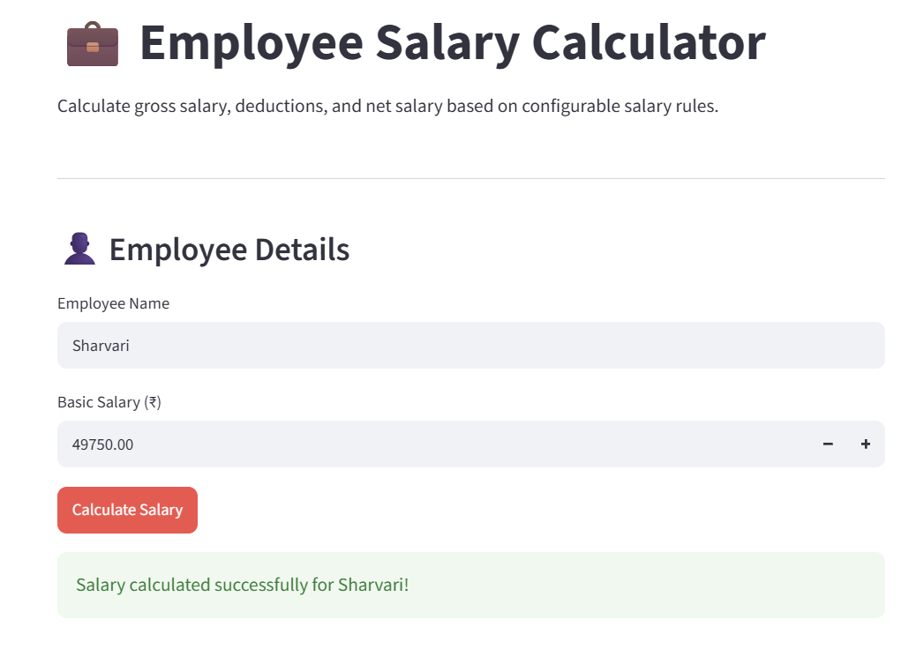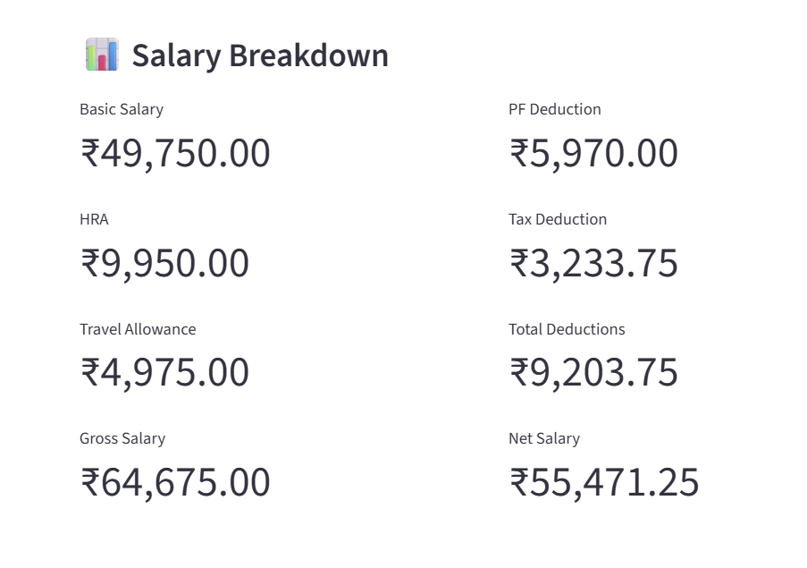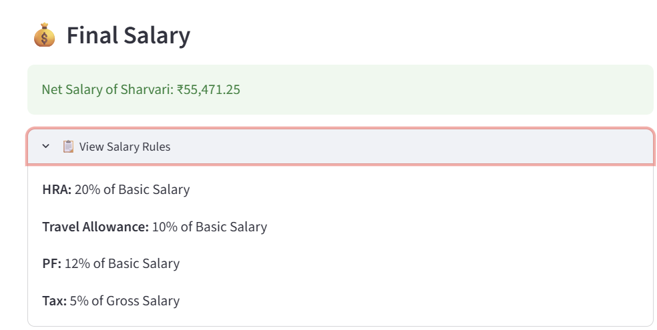
Linkedin:-https://lnkd.in/p/dnWH-3TN
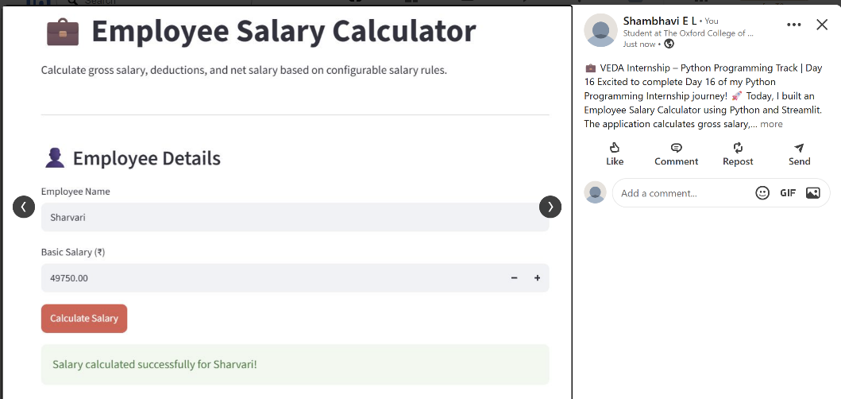

Github:-https://github.com/shambhavi0804/VEDA-internship/commit/0b1a8068ff8b3246e129c03b7bd9418346410dba
