Objective
The objective of this task is to develop a simple Menu-Driven Bank Account Simulator that allows users to perform common banking operations such as checking their balance, depositing money, withdrawing money, and viewing transaction history. The project helps practice Python functions, loops, validation, data structures, and state management while applying these concepts to a practical banking scenario. In the Streamlit version, session state is used to maintain the account balance and transaction history while the application is running.
Objectives
- Practice Python functions.
- Understand application state management.
- Implement deposit and withdrawal operations.
- Perform balance calculations.
- Maintain transaction history.
- Practice input validation.
- Prevent invalid withdrawals.
- Build an interactive Streamlit application.
3. Key Features
The application provides a simple banking interface where users can select different operations from the sidebar. Users can check their current balance, deposit money, withdraw money, and view their complete transaction history. The application validates transaction amounts and prevents withdrawals when the requested amount is greater than the available balance.
4.Technologies Used
The project uses Python for implementing the banking logic and Streamlit for creating the interactive user interface. Python functions are used to separate banking operations, while dictionaries and lists are used to store transaction information. Streamlit's session state maintains the account balance and transaction history while the application is running.

5. Deliverables
The completed project provides a working bank account simulator with the core banking operations described in the task.
Deliverables
- Bank account simulator
- Balance inquiry
- Deposit functionality
- Withdrawal functionality
- Transaction history
- Balance calculation
- Input validation
- Insufficient-balance protection
- Streamlit user interface
C:\Users\shamb\OneDrive\Desktop\VEDA internship\DAY17>
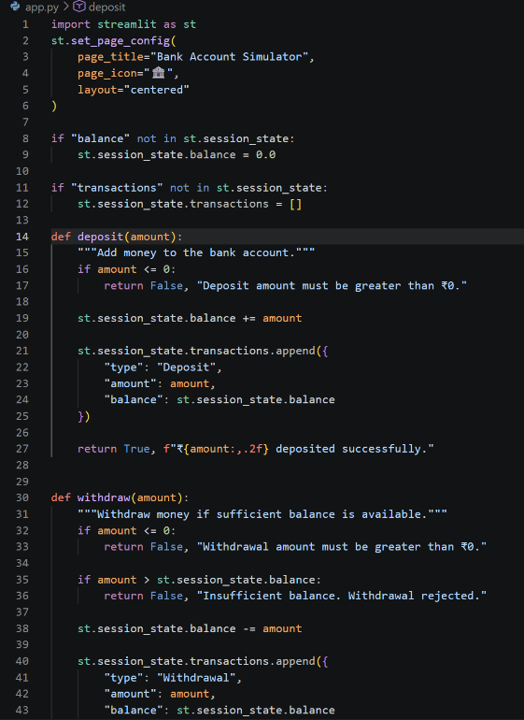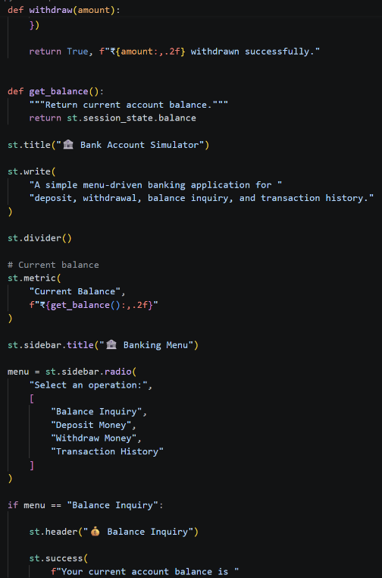

OUTPUT:_-http://localhost:8501
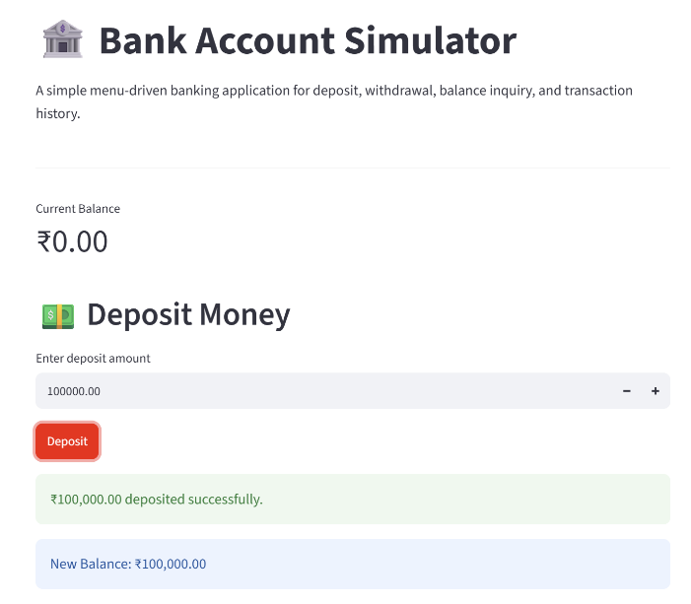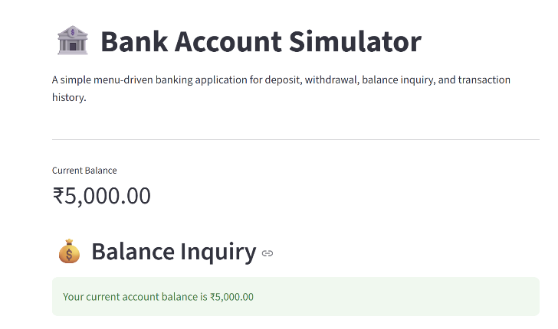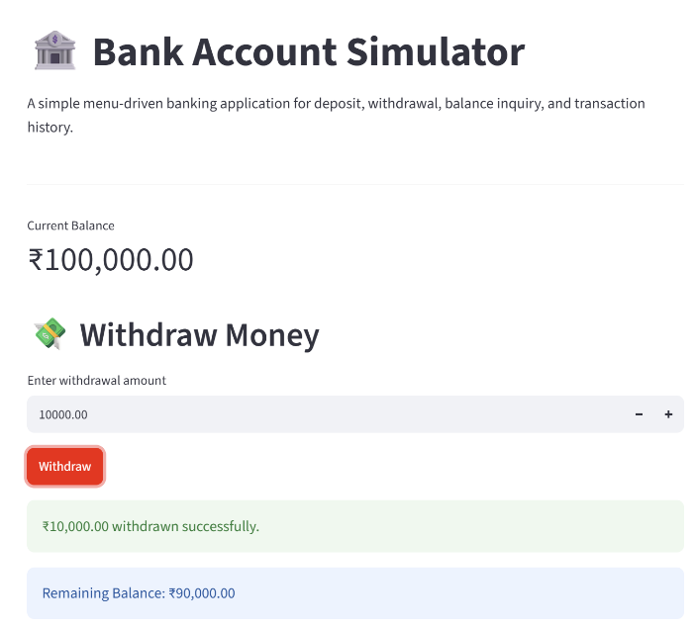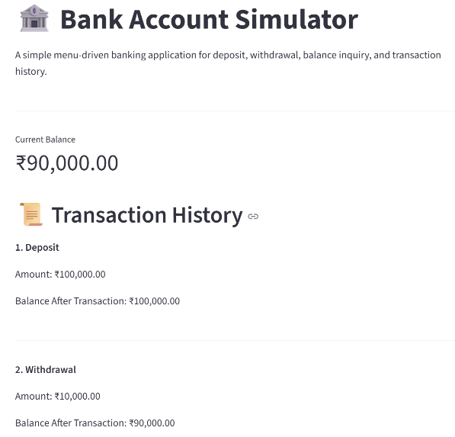
LinkedIn:- https://lnkd.in/p/dsTyfU5U
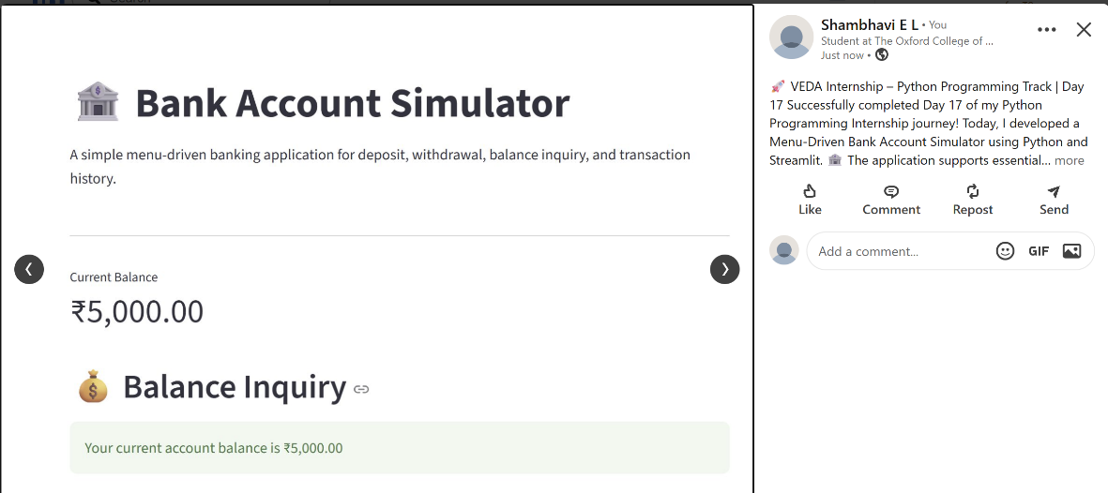
Github:-https://github.com/shambhavi0804/VEDA-internship/commit/b411edf8fbb09f7cc9a2b248d563804e971b0b78

