Objectives
Paragraph
The objective of Day 18 is to understand and implement exception handling in Python. The project focuses on using try, except, else, and finally blocks to safely handle expected runtime problems such as invalid input, division by zero, invalid list indexes, and missing dictionary keys. The Streamlit interface makes it possible to test different error conditions interactively.
Bullet Points
- Understand Python exception handling.
- Practice try, except, else, and finally.
- Handle invalid numeric input.
- Handle division by zero.
- Handle invalid list indexes.
- Handle missing dictionary keys.
- Display meaningful error messages.
- Prevent the application from crashing.
Technologies Used
Tools
- Python
- Streamlit
- VS Code / Python IDE
- Git
- GitHub
Deliverables
- Exception-handling demonstration program
- At least five handled error cases
- Interactive Streamlit application
- Meaningful error messages
- Examples of successful and failed operations
- Explanation of common Python exceptions
C:\Users\shamb\OneDrive\Desktop\VEDA internship\DAY18>
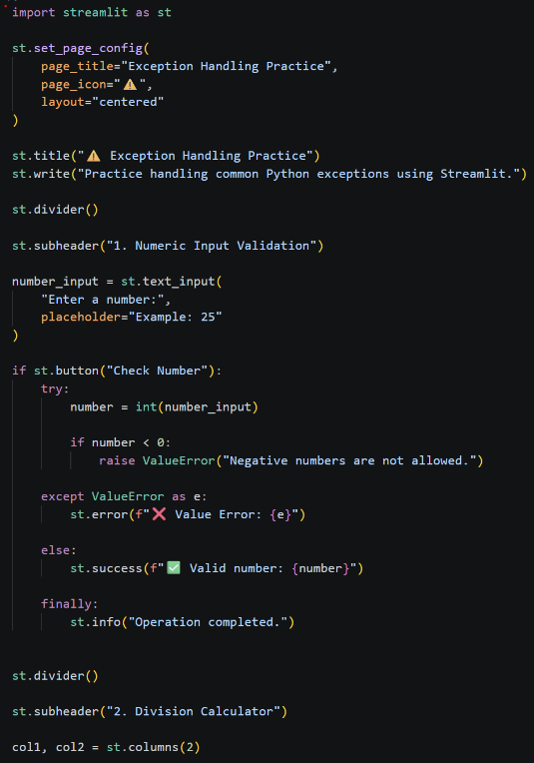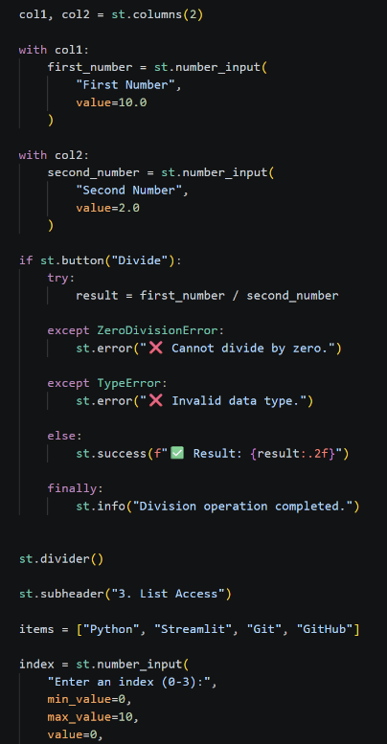
Output:- http://localhost:8501
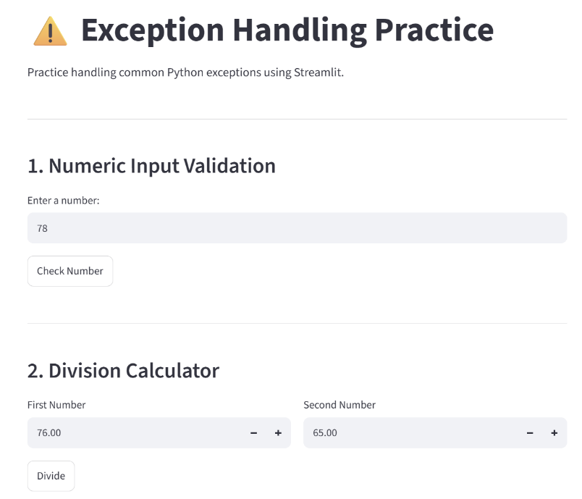
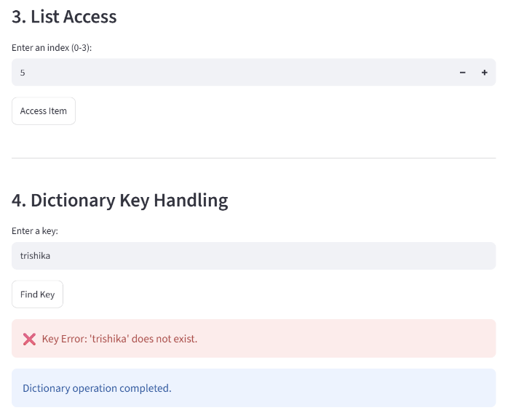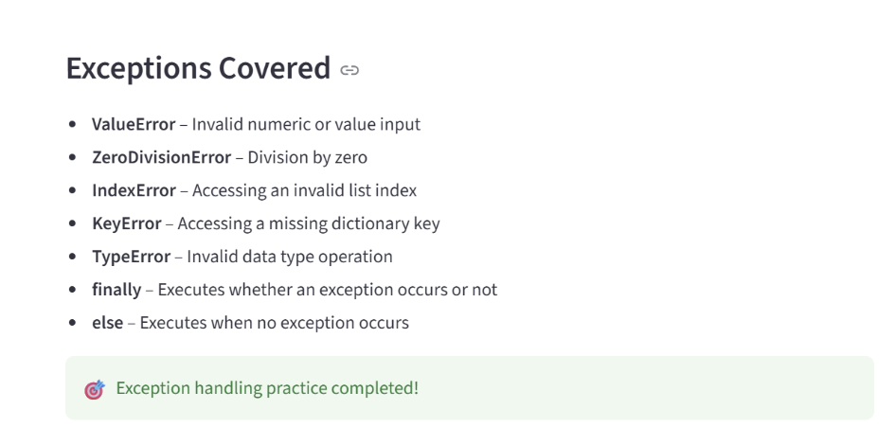
Github:https://github.com/shambhavi0804/VEDA-internship/commit/55829e6c920f225e0cda106483fae7cdbf1e2298
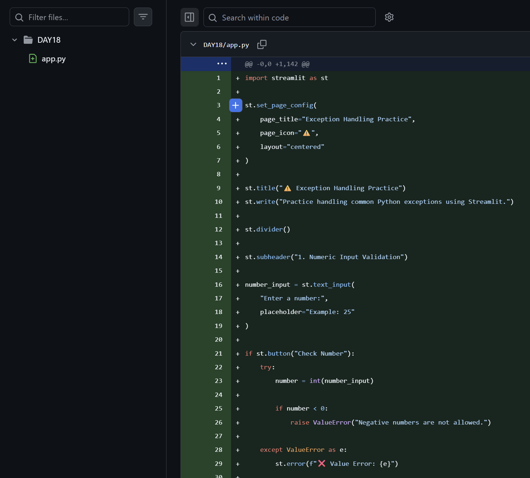
Linkedin:-https://lnkd.in/p/ddM8Nq52
