Objective
To build a Python-based CSV Data Processor that can read CSV files, analyze numerical data, calculate useful statistics, and handle missing or invalid values.
Learning Objectives
- Understand CSV file processing in Python.
- Learn to use Python's built-in csv module.
- Practice reading structured data.
- Perform calculations on numerical data.
- Handle missing values.
- Handle invalid numerical values.
- Practice loops and conditional statements.
- Build an interactive interface using Streamlit.
- Generate a simple summary report.
3. Key Features
CSV File Upload
Users can upload .csv files directly through the Streamlit interface.
Dataset Preview
The uploaded records and columns are displayed in the application.
Numeric Column Detection
The application automatically identifies columns containing numerical values.
Statistical Analysis
For the selected column, the application calculates:
- Total number of records
- Valid values
- Total
- Average
- Highest value
- Lowest value
- Missing values
- Invalid values
Error Handling
The application handles:
- Empty CSV files
- Missing values
- Invalid numeric values
- Invalid file encoding
- CSV files without columns
Summary Report
A readable summary report is generated containing the calculated statistics.
Download
Users can download the generated summary report as a .txt file.
Technologies Used
Technology | Purpose
Python | Core programming
Streamlit | Web interface
CSV module | Reading and processing CSV files
Python Lists | Storing records and numeric values
Loops | Processing CSV records
Exception Handling | Handling invalid input/errors

C:\Users\shamb\OneDrive\Desktop\VEDA internship\DAY20>
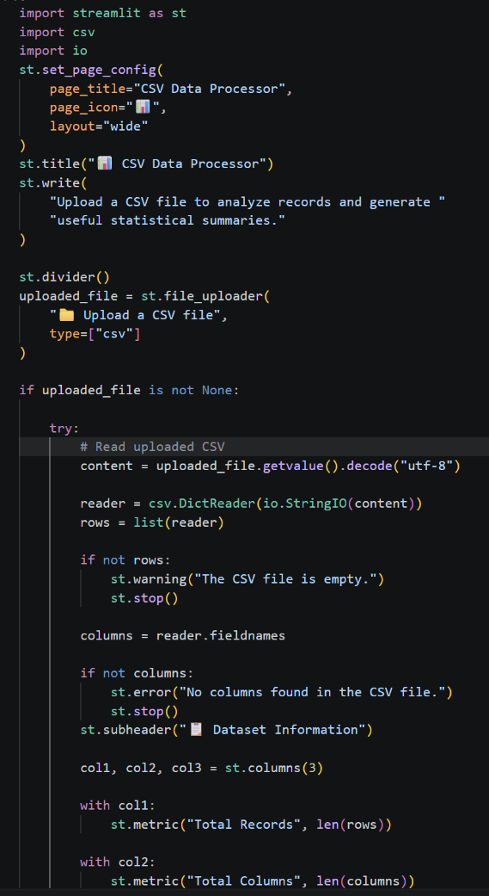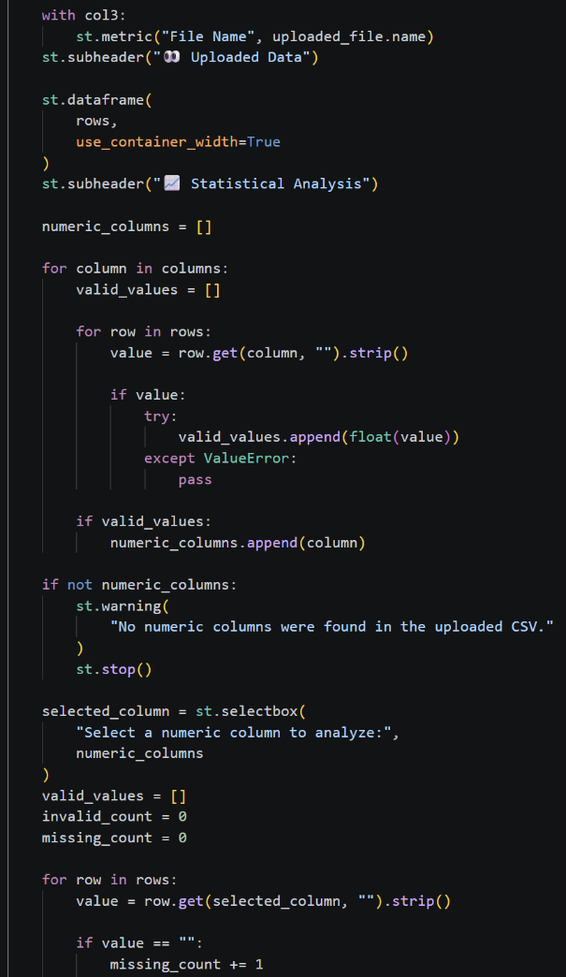
Output: http://localhost:8501
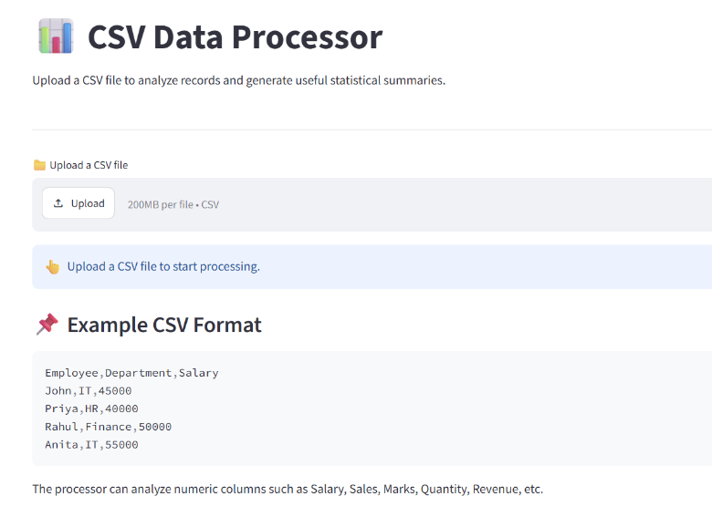
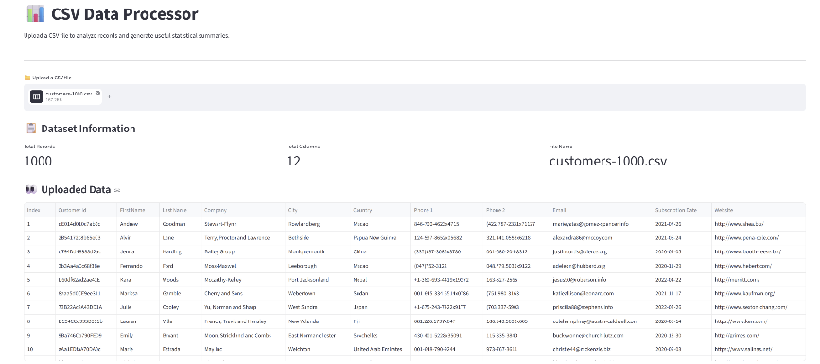
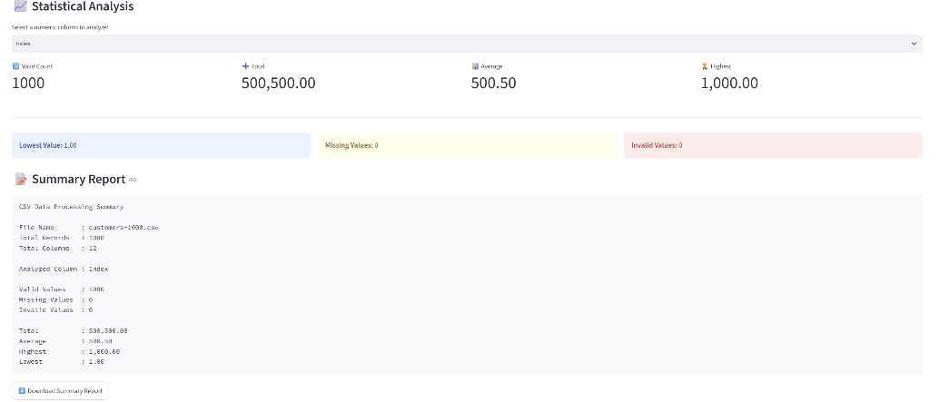
Github:-https://github.com/shambhavi0804/VEDA-internship/commit/4aa1fe927fa64bca078f64cc67997a3d3591836c
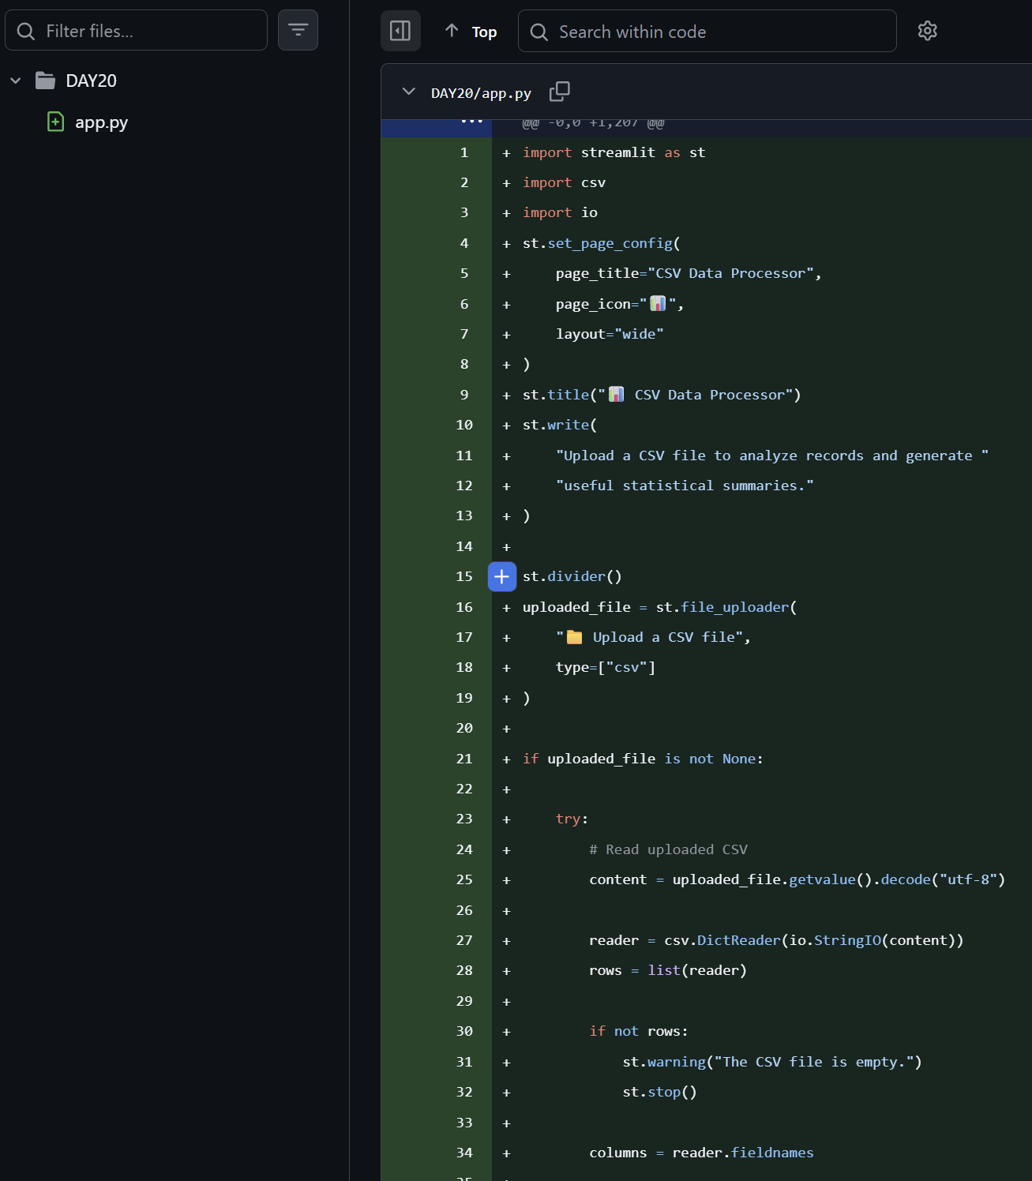

Linkedin:- https://lnkd.in/p/dcuqG7Df
