Objective
Main Objective
To develop a Python-based JSON Data Processor that reads structured JSON data and performs searching, filtering, and summary operations.
Key Features
JSON File Upload
Upload .json files directly through the Streamlit application.
Data Preview
Display JSON records in a table.
Technologies Used
Technology | Purpose
Python | Application logic
Streamlit | Interactive web interface
JSON module | JSON file processing
Pandas | Data analysis and tabular display
Lists | Record management
Dictionaries | Structured JSON data
Exception Handling | Error management

C:\Users\shamb\OneDrive\Desktop\VEDA internship\DAY21>
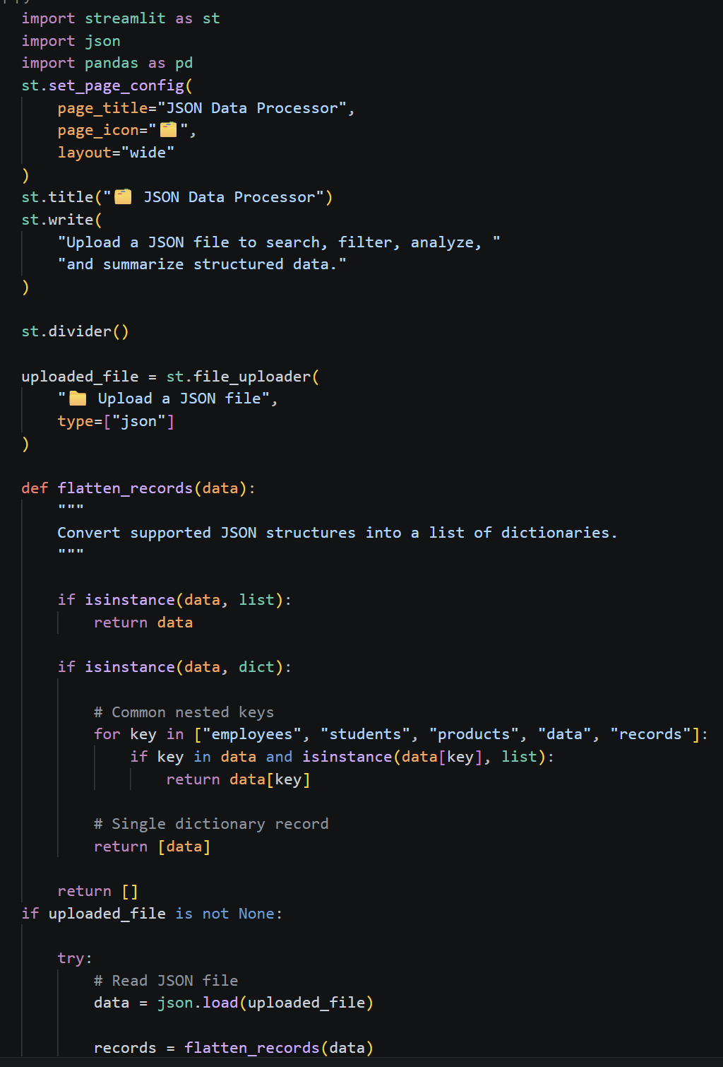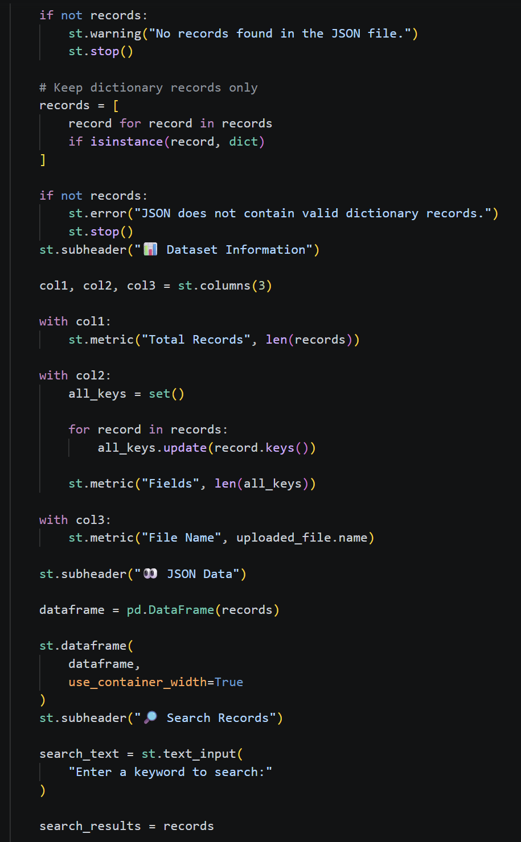
Output: http://localhost:8501
