Objective
The objective of this task is to develop a Prime Number Analyzer using Python and Streamlit. The application checks whether a given number is prime and generates all prime numbers within a user-specified range. The task helps strengthen understanding of loops, conditional statements, functions, mathematical logic, and basic algorithm optimization.
Key Features
- Checks whether a number is prime.
- Generates prime numbers within a specified range.
- Uses a reusable is_prime() function.
- Checks divisibility only up to the square root of the number.
- Handles 0 and 1 correctly as non-prime numbers.
- Handles the special case of 2.
- Displays all generated prime numbers.
- Validates the starting and ending range.
- Includes an explanation of the prime-checking algorithm.
- Provides an interactive Streamlit interface.
Technologies Used
The project uses Python as the programming language and Streamlit for the graphical web interface. Python functions, loops, conditional statements, the math.isqrt() function, and the modulo operator % are used to implement the prime-number checking logic.
Learning Outcomes
This task helps develop practical knowledge of Python functions, loops, conditional logic, mathematical operations, and algorithmic thinking. It also introduces a more efficient prime-checking approach by limiting divisibility checks to values up to the square root of the number.

C:\Users\shamb\OneDrive\Desktop\VEDA internship\DAY13>
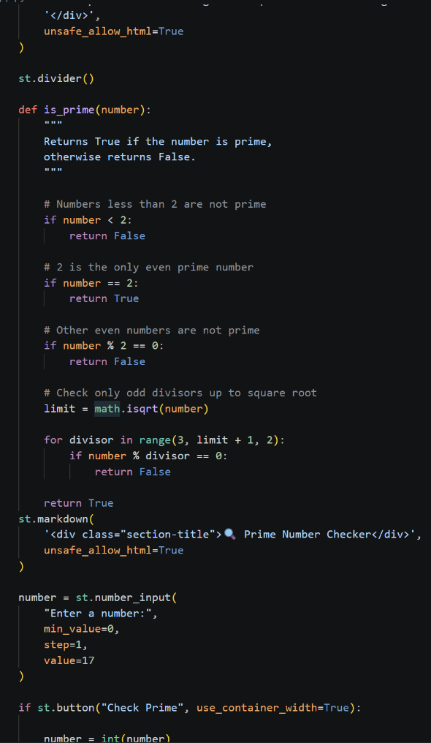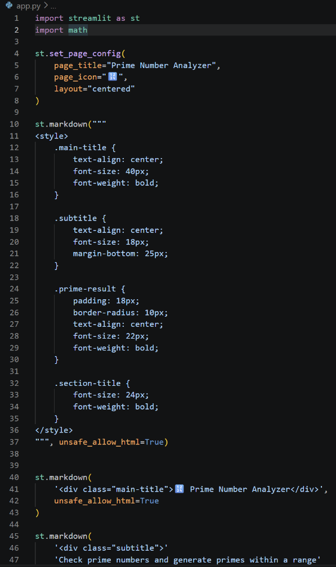
OUTPUT:http://localhost:8501
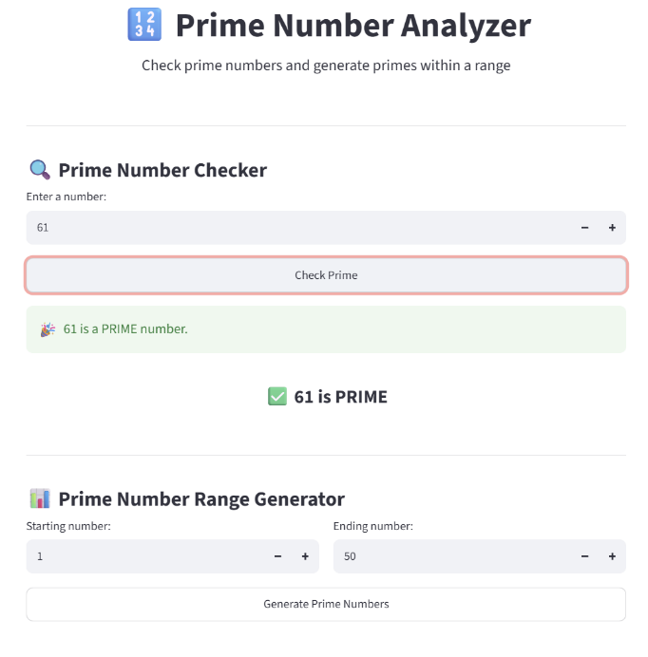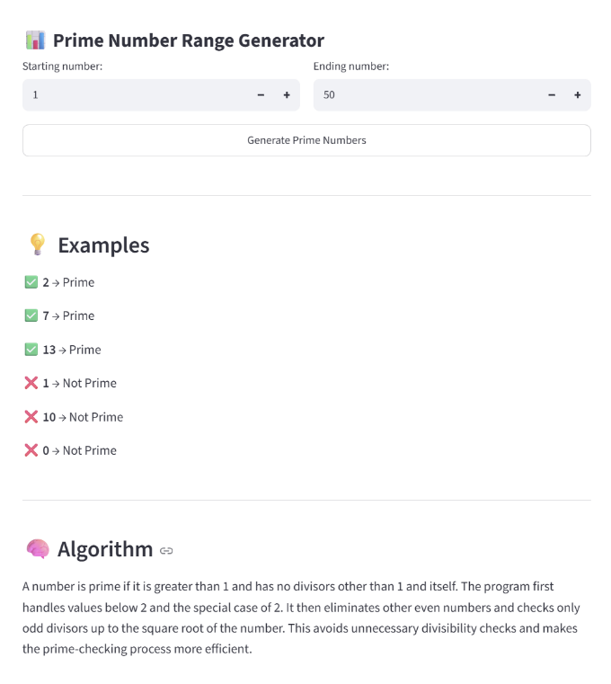
Github: https://github.com/shambhavi0804/VEDA-internship/commit/b899bce6642e94513ef47c6d
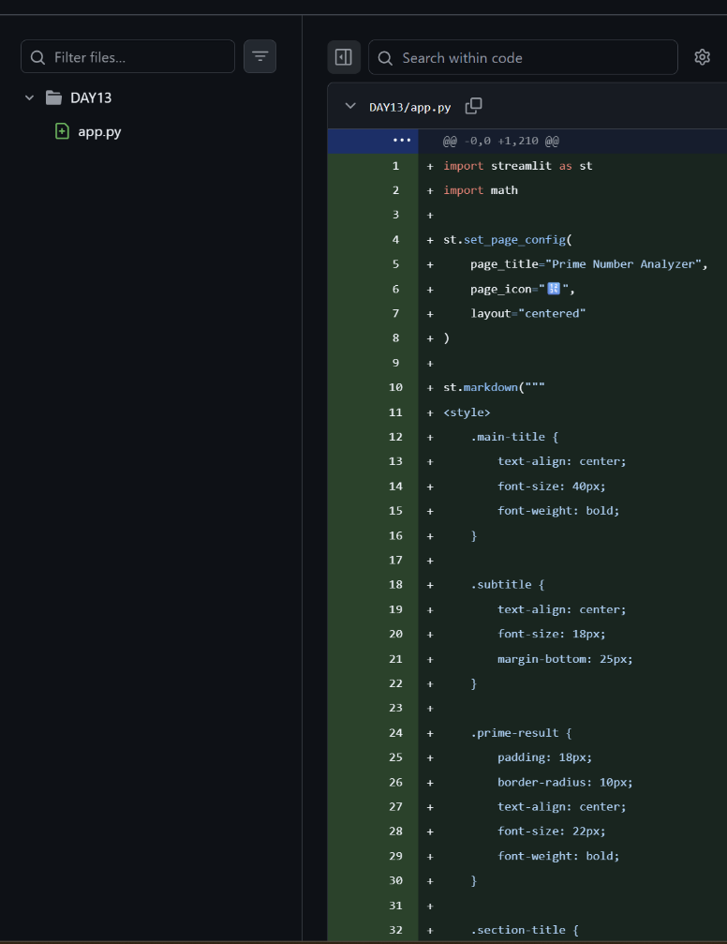
Linkedin: https://lnkd.in/p/dsWycU4U
