Course Number: 420-DW4-AS
Course Title: Web Server Applications Development II
Session: Autumn 2024
Group: 7278

FINAL PROJECT REPORT
DUE DATE:
December 4th, 2024

SUBMITTED TO:
Teacher: QUANG HOANG CAO

BY:
Student ID: 2231473
Student Name: HUYNH TU ANH CHAU

Contents
Project description 6
Project development 6
Phase I – Analysis 6
The Requirements 6
Functional Requirements Document 6
Phase II – Design 8
Tables 8
Relationship Diagram 11
System Architecture 11
Phase III – Implementation 11
Home Page (after running this program): 11
Owner Dashboard (after logging-in as an owner): 11
Manager Dashboard (after logging-in as a manager): 12
Tenant Dashboard (after logging-in as a tenant): 12
Phase IV – Testing 12
Screenshots 14
Home page when first running the app 14
Owner Login Screen 15
Manager Login Screen 16
Tenant Login Screen 17
Owner Registration Screen 18
Owner Registration Validation Screens 19
Tenant Registration Screen 21
Tenant Registration Validation Screens 22
Owner Dashboard After Logging-In Successfully 23
Owners Edit Their Profile Screen 23
Owner’s Details Screen 24
Owner Delete Validation Screen 24
Owner Views All Buildings and Having Details Button Only Screens 25
Owner Searches for Buildings Result Screens 25
Owner Views One Building’s Details Screen 26
Owner Views All Apartment and Having Details Button Only 27
Owner Searches for Apartments Result Screens 27
Owner Views One Apartment’s Details Screen 28
Owner Views All Tenants with CRUD Actions Screen 29
Owner Searches for A Tenant by Email Result Screens 29
Owner Edit One Tenant’s Details with Validation Screens 30
Owner Views One Tenant's Details Screen 31
Owner Deletes One Tenant with Confirmation Screen 32
Owner Views All Managers Screen 32
Owner Searches for A Manager Result Screen 33
Owner Creates a Manager Account with Validation Screen 33
Owner Views All Created Messages to a Manager with CRUD actions Screen 34
Owner Sends a Message to a Manager (fetching from database) with Validation Screen 34
Owner Edits a Message Screen 35
Owner Views One Message’s Details Screen 35
Owner Deletes a Message with Confirmation Screen 36
Owner Views Assigned Events Screen 36
Owner Edits Status of Assigned Events Screen 37
Owner Views One Event’s Details Screen 38
Manager Dashboard After Logging-In Screen 38
Managers Edit Their Profile with Validation Screen 39
Managers Delete Their Accounts with Confirmation Screen 40
Manager Views Assigned Buildings with CRUD actions Screen 40
Manager Edits One Building with Validation Screen 41
Manager Views One Building’s Details 42
Manager Deletes One Building with Confirmation Screen 43
Manager Searches for A Building Result Screens 43
Manager Creates a New Building with Validation Screen 44
Manager Views All Apartments related to Assigned Buildings with CRUD actions Screen 45
Manager Edits an Apartment’s Details with Validation Screen 45
Manager Views an Apartment's Details Screen 46
Manager Deletes an Apartment with Confirmation and Informative Message Screens 46
Manager Views Assigned Message Sent by Owners Screen 47
Manager Responses to A Message Screen 48
Manager Views One Message’s Details Screen 48
Manager Deletes a Message with Confirmation Screen 49
Manager Views Assigned Messages Sent by Tenants Screen 49
Manager Responses to a Message Screen 50
Manager Views a Message’s Details Screen 50
Manager Deletes a Message with Confirmation Screen 51
Manager Views All Created Appointments with CRUD actions Screen 51
Manager Edits an Appointment with validation Screens 52
Manager Deletes an Appointment with confirmation Screen 53
Manager Creates an Appointment with Tenants (fetching from database) with Validation Screens 54
Manager Views All Created Events with CRUD actions Screen 55
Managers Views and Edits Description of an Event Screen 55
Manager Views Details of an Event Screen 56
Manager Deletes an Event with Confirmation Screen 56
Manager Creates an Event with Validation Screen 57
Tenant Dashboard After Logging-In Screen 57
Tenants Edit Their Profile with Validation Screen 58
Tenants View Their Profiles’ Details 58
Tenants Delete Their Profile with Confirmation Screen 59
Tenant Views Only Available and Assigned Apartments with Details Button Screens 59
Tenant Searches for an Apartment Result Screens 60
Tenant Views All Created Messages with CRUD actions Screen 61
Tenant Edits a Message with Validation Screen 62
Tenant Views a Message’s Details Screen 62
Tenant Deletes a Message with Confirmation Screens 63
Tenant Creates a New Message to Managers (fetching from database) with Validation Screen 64
Tenant Creates a New Appointment with Validation Screen 64
Tenant Views All Created Appointments with CRUD actions Screen 65
Tenant Edits an Appointment with Validation Screen 65
Tenant Deletes an Appointment with Confirmation Screen 66
Conclusion 66
Sample Data for User Login 66
Login as an Owner 66
Login as a Manager 66
Login as a Tenant 67
Bibliography 67

Project description
The project is a Property Rental Management System designed for Property Owners, Managers, and Tenants to interact with the system and perform their respective operations seamlessly. The system is developed using the ASP.NET MVC Framework and Entity Framework (Database First approach) for efficient database management. Development was carried out in Visual Studio 2022, while the database was designed and managed using SQL Server Management Studio (SSMS) 19.
This project utilizes session-based tracking to ensure that each user type (Owner, Manager, Tenant) has access only to functionalities specific to their session. The interface is designed with a focus on user-friendliness and responsiveness, allowing each user type to perform CRUD (Create, Read, Update, Delete) operations easily and securely.
Currently, the system supports one Owner only for interaction and management purposes. Notice: While this limitation is in place for further testing, the application currently allows new owners to be registered through the web interface.
Testing Note: During testing, it has been observed that if a record is deleted without fully handling dependencies (e.g., other records relying on that data), errors may occur. This behavior has been identified and is under further updates and testing to ensure proper dependency checks and handling in the code.

Project development

Phase I – Analysis

The Requirements
include providing roles for Property Owners, Managers, and Tenants to interact with the system and perform specific CRUD operations.

Functional Requirements Document

Owners can:
        - Manage managers account (CRUD operations).
        - Search for any managers by email.
        - Edit, view details, and delete any tenant accounts.
        - Search for any tenants by email.
        - View all buildings and apartments (optional)
        - Search for buildings by address, city, province, etc. (optional)
        - Search for apartments by address, city, postal code, etc. (optional)
        - Send messages to a manager.
        - Edit message’s content, view details of message, delete sent messages which sent to a manager. (optional)
        - View, update, and view details assigned events which are created by managers.
        - Edit or view details or delete their own accounts. (optional)

Managers can:
        - Manage buildings, apartments (CRUD operations).
        - Search for assigned buildings by address, city, province, etc. (optional)
        - Search for assigned apartments by address, city, postal code, etc. (optional)
        - Manage appointments with tenants (CRUD operations).
        - Response(Edit) to owners’ messages.
        - View details or delete owners’ messages.
        - Response(Edit) to tenants’ messages.
        - View details or delete tenants' messages.
        - Manage events with owners (CRUD operations).
        - Edit or view details or delete their own accounts. (optional)

Tenants can:
        - Register to Property Rental Management Web Site.
        - View all apartments.
        - Search for apartments by address, city, province, etc. (optional)
        - View Details for each apartment. (optional)
        - Send messages to a manager.
        - Edit message’s content, view details of message, delete sent messages which sent to a manager. (optional)
        - Book appointments with a manager.
        - Edit or view details or delete their own accounts. (optional)

Phase II – Design

Tables
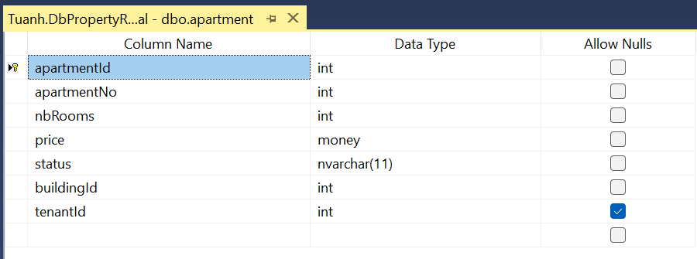
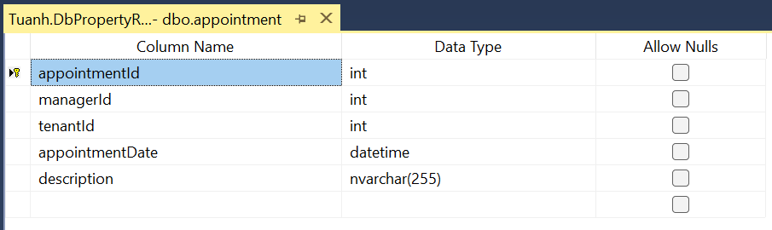
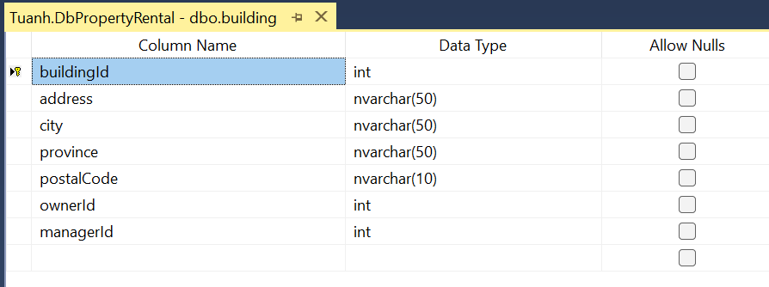
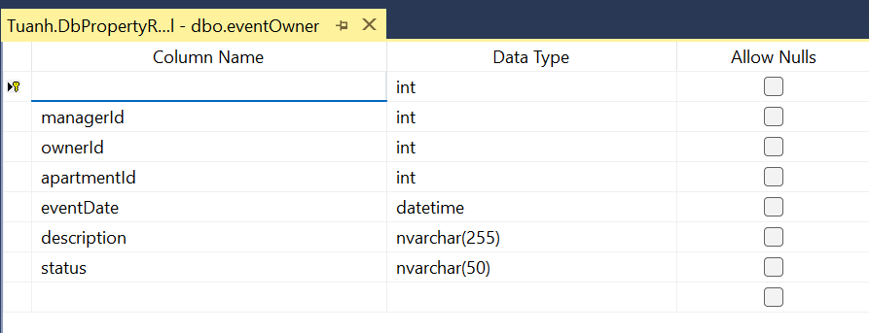
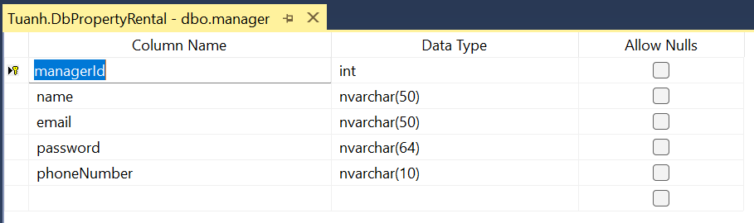
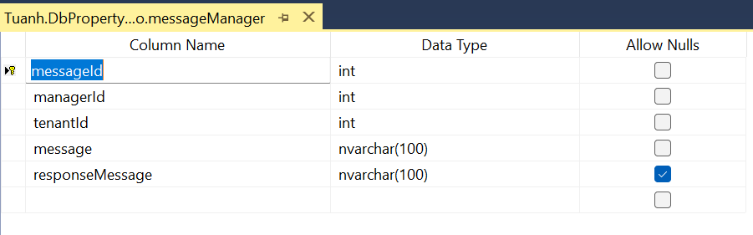
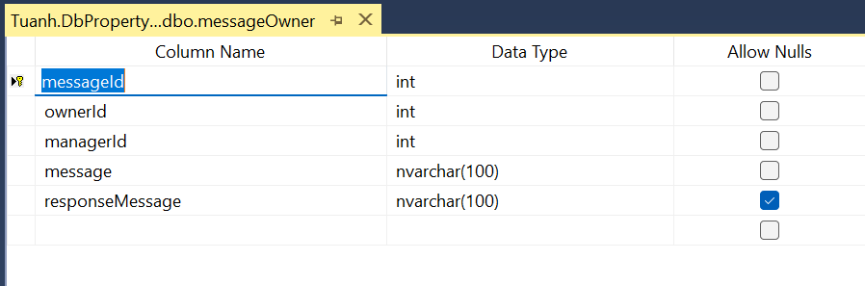
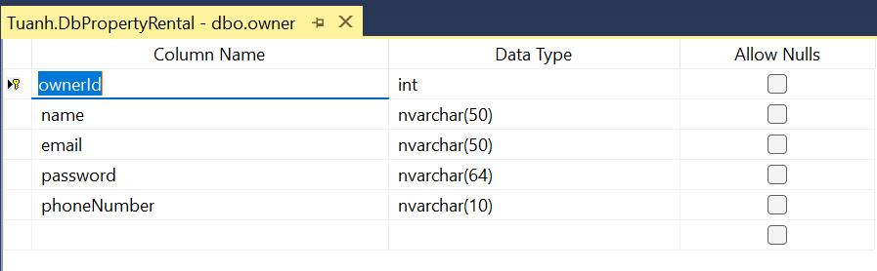
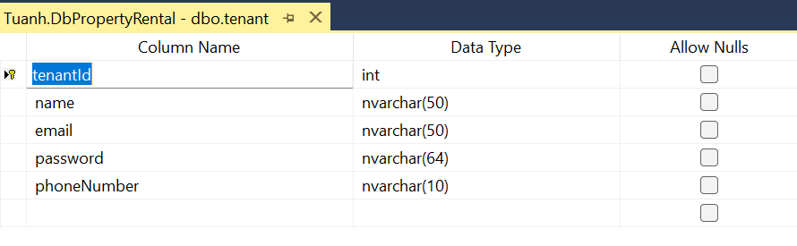

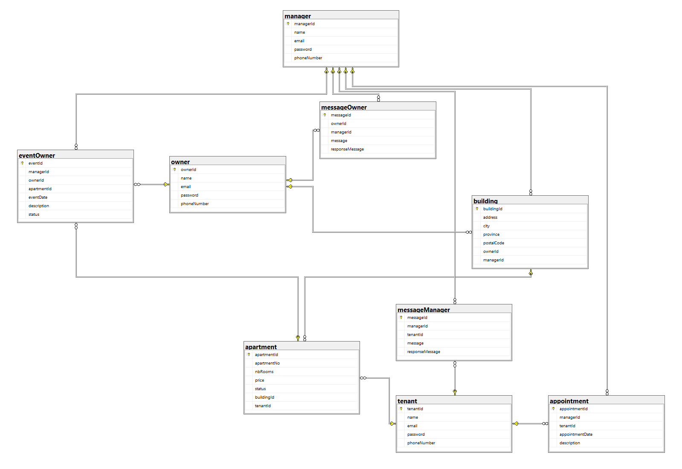
Relationship Diagram

System Architecture
      - MVC (Model-View-Controller) pattern.
      - Session-based access control.

Phase III – Implementation

Home Page (after running this program):
      - Displays system information and lists available apartments.
      - Includes a search bar for filtering apartments by apartment ID.
      - Includes tabs to login as owner/manager/tenant.
      - Include tabs to register as owners or tenants.

Owner Dashboard (after logging-in as an owner):
      - Edit or view details or delete their own accounts.
      - Access to manage Managers (CRUD operations and search functionality).
      - Access to manage Tenants (CRUD operations and search functionality).
      - View details of all Buildings and Apartments with search functionality.
      - Manage messages to a manager (CRUD operations)
      - View assigned events and update its status or view its details.

Manager Dashboard (after logging-in as a manager):
      - Edit or view details or delete their own accounts.
      - Access to manage Buildings (CRUD operations and search functionality).
      - Access to manage Apartments (CRUD operations and search functionality).
      - Access to manage messages which are created by owners. Manager can response, view details, and delete messages.
      - Access to manage messages which are created by tenants. Manager can response, view details, and delete messages.
      - Access to manage appointments with tenants (CRUD operations).
      - Access to manage events with owners (CRUD operations).

Tenant Dashboard (after logging-in as a tenant):
      - Edit or view details or delete their own accounts.
      - View all Apartments with search functionality.
      - Access to manage messages to managers (CRUD operations).
      - Access to manage appointments to managers (CRUD operations).

Phase IV – Testing
User Role | Functional Requirements | Result
Owner | Create/Update/Delete/Search/List any property manager account | Passed
Owner | Not allowing to edit/create manager’s email that already existing. | Passed
Owner | View details of all Buildings and Apartments with search functionality. | Passed
Owner | Update/Delete/Search/List any potential tenant account. | Passed
Owner | - Not allowing to edit tenant ‘s email that already existing.  - Allow bypassing Tenant model validation if leaving password field empty if owner does not want to edit existing password of the chosen tenant account. | Passed
Owner | Perform CRUD operations related to messages which will be sent to managers. | Passed
Owner | - Not allowing to edit manager ‘s email that already existing.  - Allow bypassing Manager model validation if leaving password field empty if owner does not want to edit existing password of the chosen manager account. | Passed
Owner | Update assigned event’s status (Pending/Resolved) or view its details which are sent by managers. | Passed
Manager | Perform CRUD operations related to buildings, including search functionality. | Passed
Manager | Perform CRUD operations related to apartments, including search functionality. | Passed
Manager | Keep track of apartments status | Passed
Manager | Schedule potential tenants ‘appointments (CRUD operations). | Passed
Manager | Respond to potential tenants ‘messages (Edit, View Details, Delete operations). | Passed
Manager | Access to manager messages to owners (CRUD operations). | Passed
Manager | Report any events to the property  owner when necessary (CRUD operations). | Passed
Tenants | Create an on-line account through Property Rental Management Web Site | Passed
Tenants | View any available and already assigned apartments suitable for their needs | Passed
Tenants | Make an appointment with the property manager | Passed
Tenants | Send necessary messages to the property manager (CRUD operations). | Passed

Screenshots

Home page when first running the app
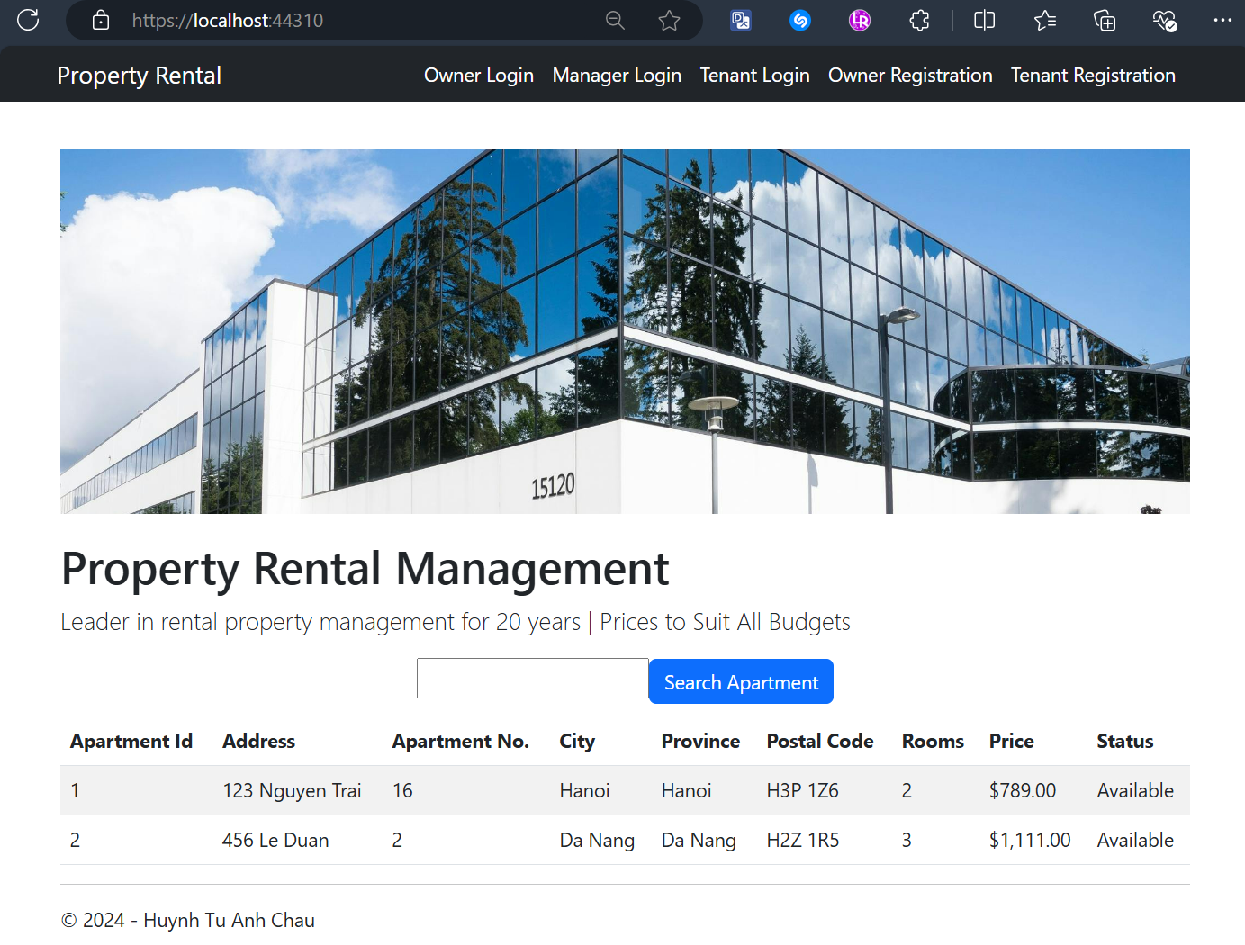

Owner Login Screen
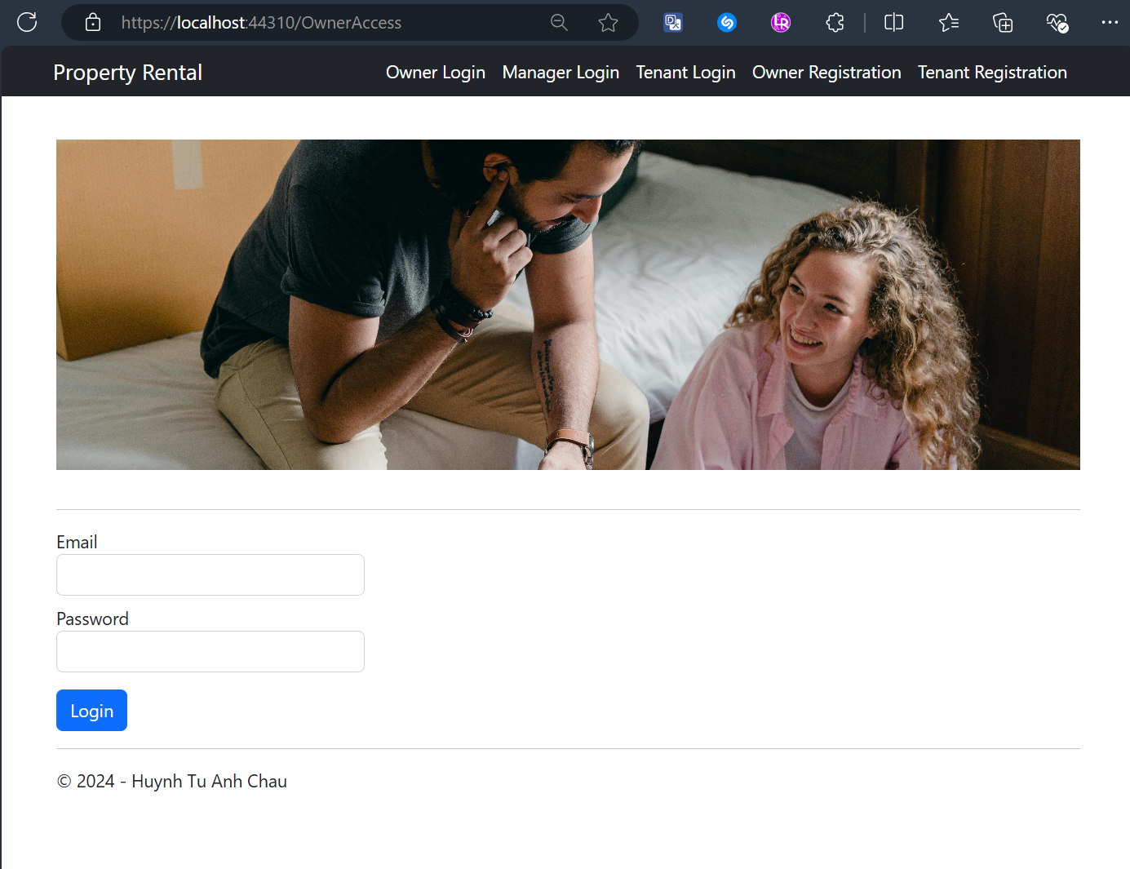

Manager Login Screen
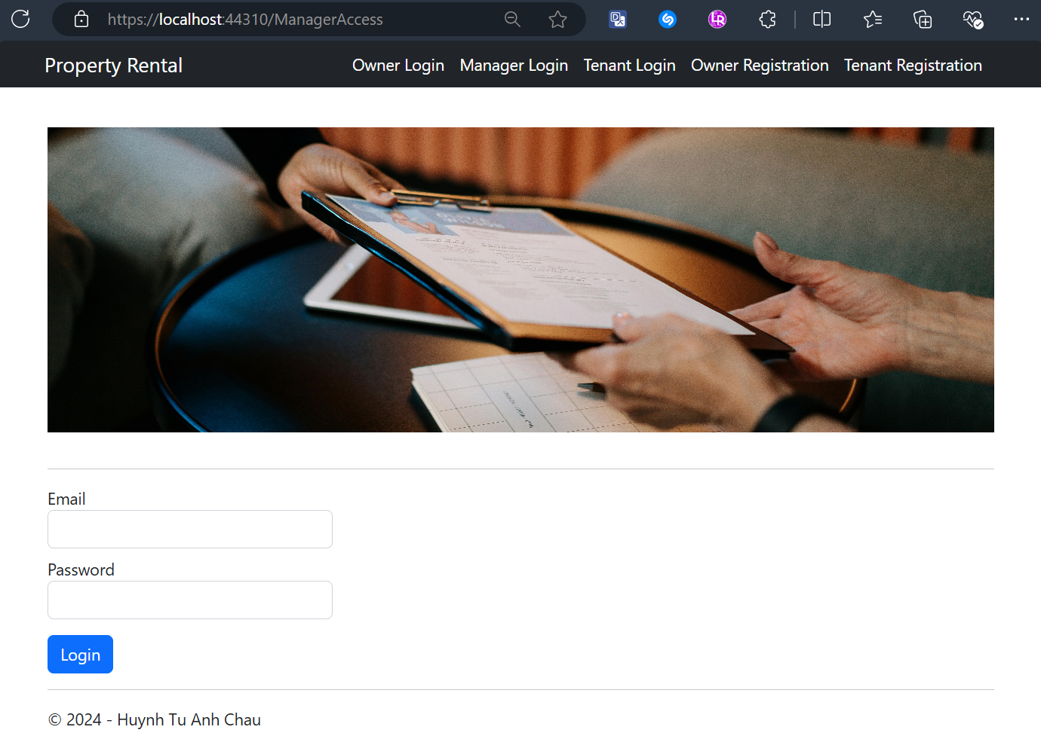

Tenant Login Screen
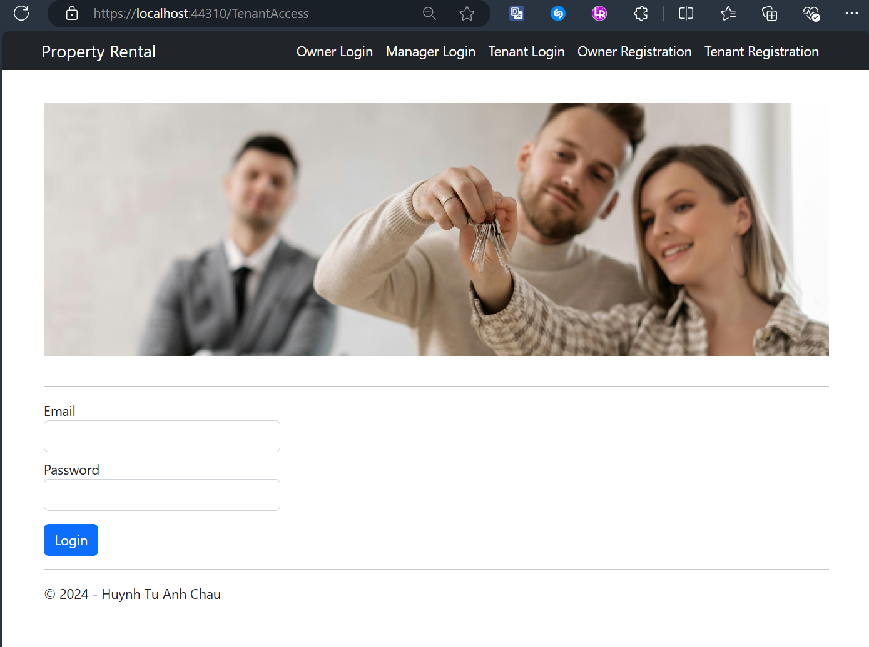

Owner Registration Screen
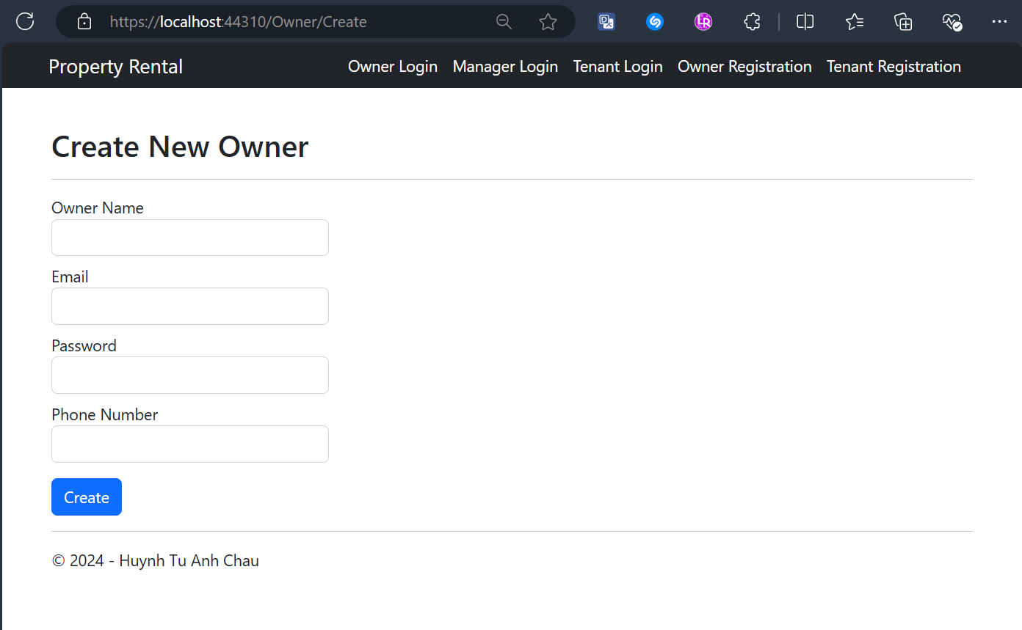

Owner Registration Validation Screens
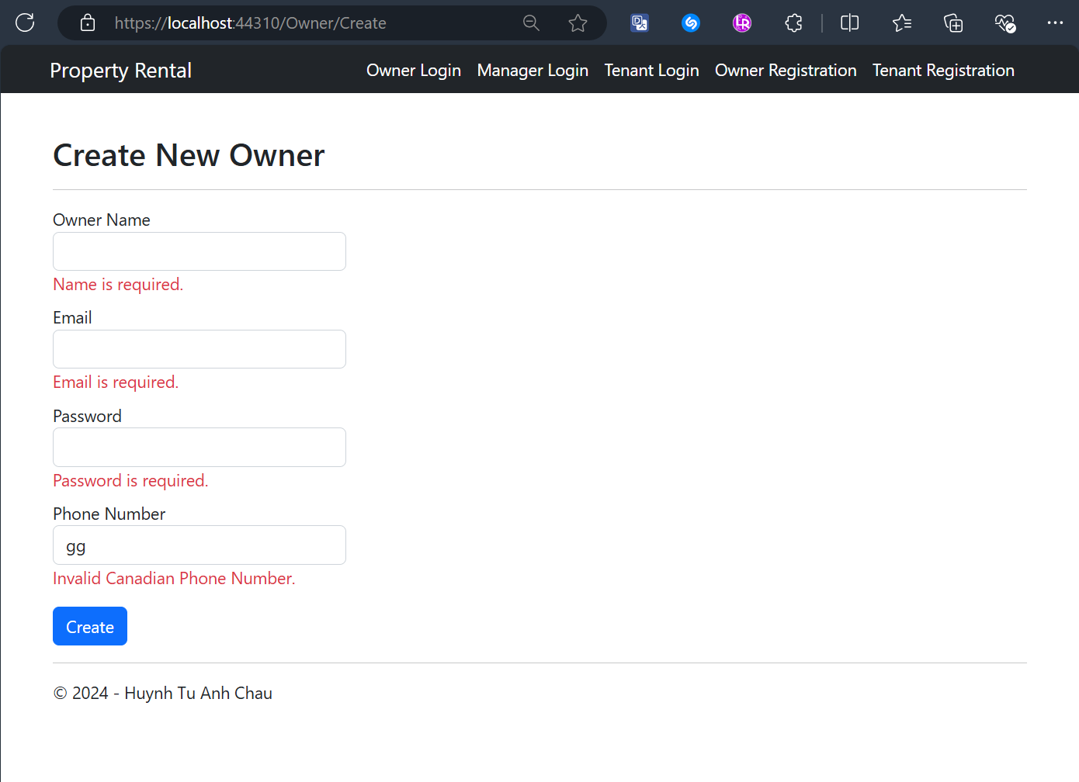
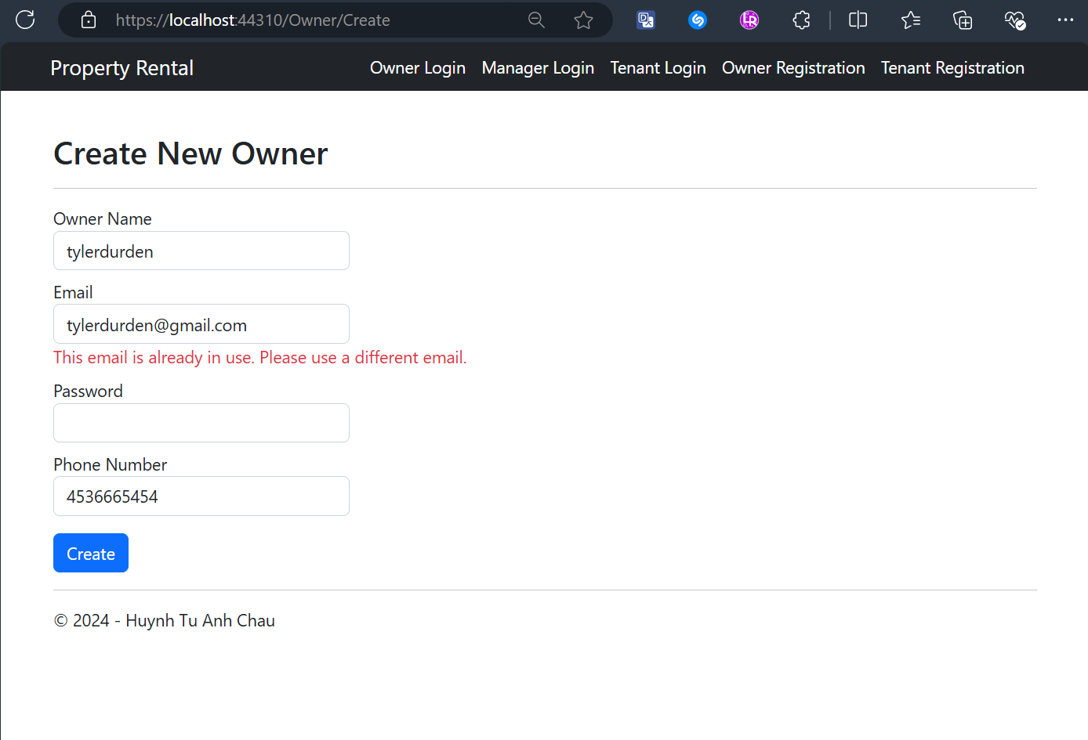

Tenant Registration Screen
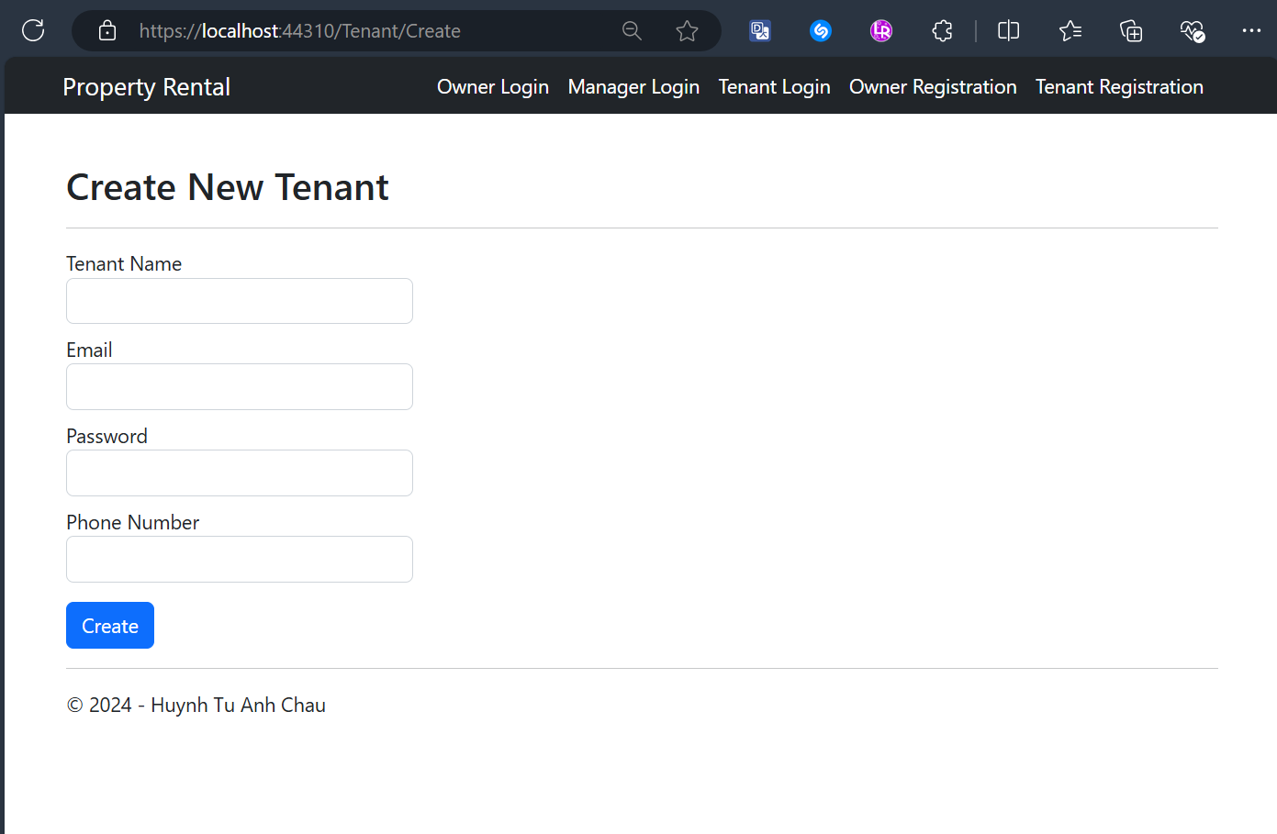

Tenant Registration Validation Screens
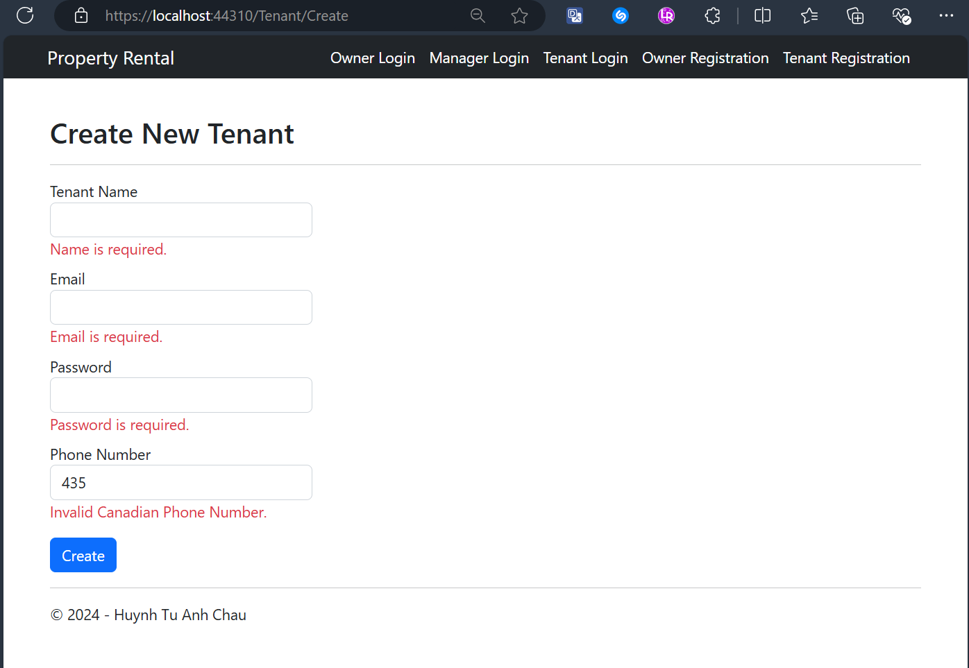
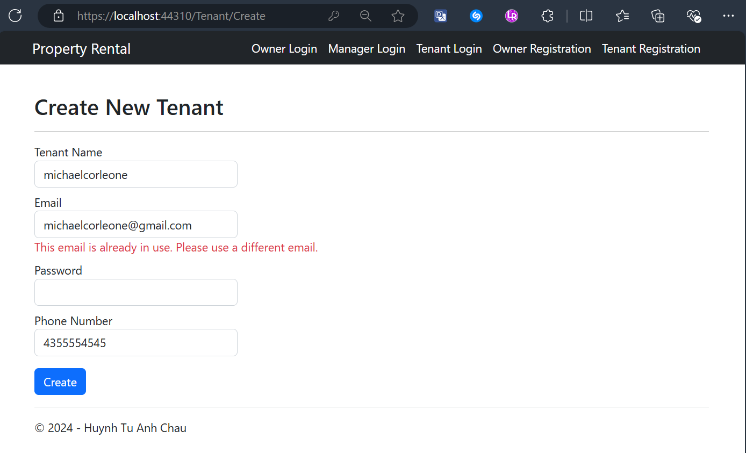

Owner Dashboard After Logging-In Successfully
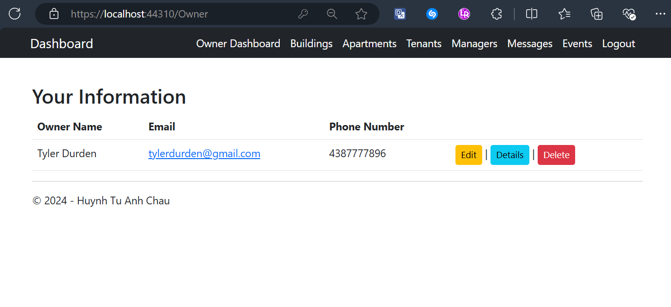

Owners Edit Their Profile Screen
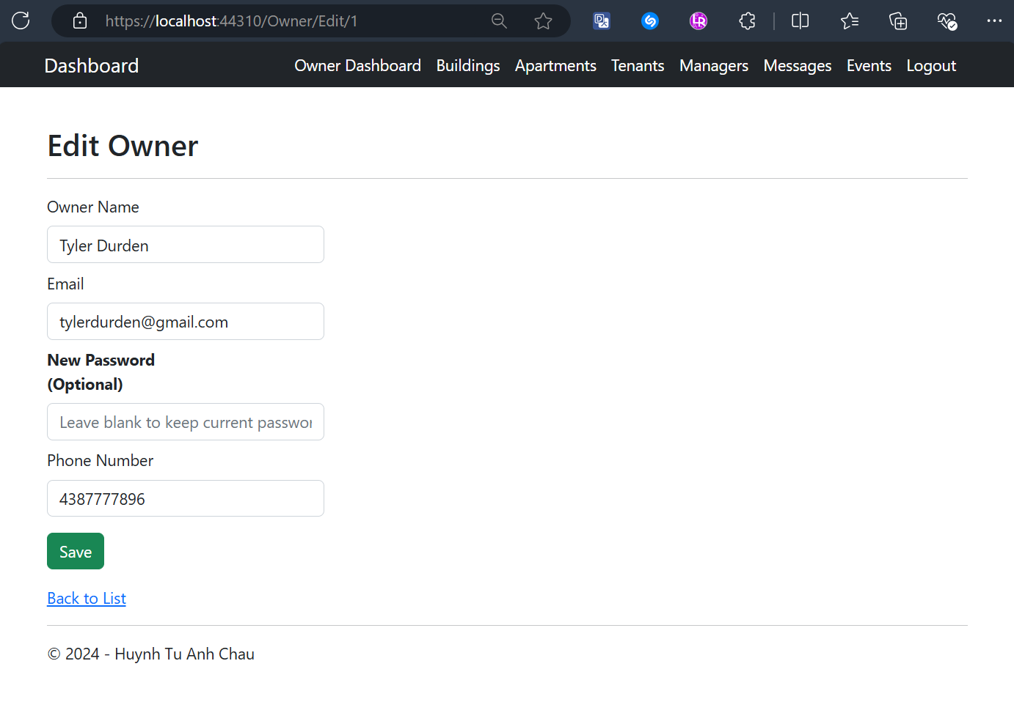

Owner’s Details Screen
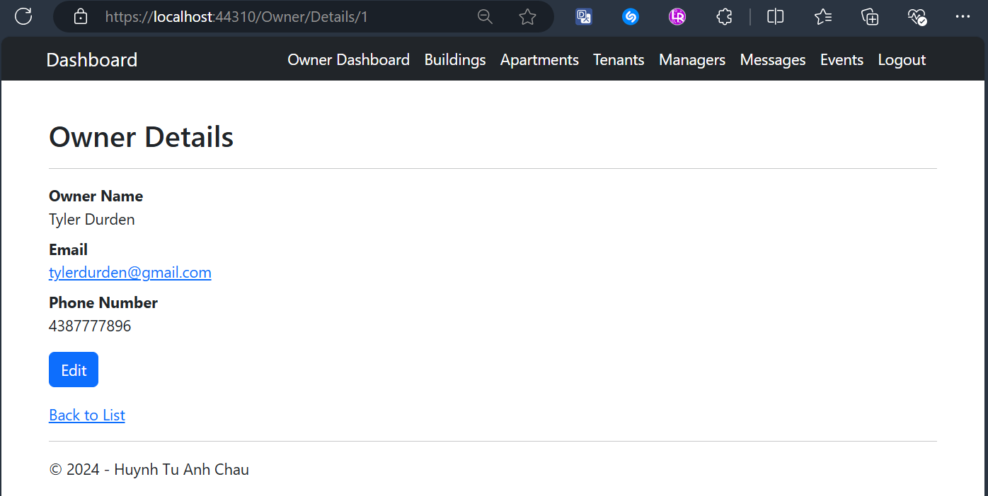

Owner Delete Validation Screen
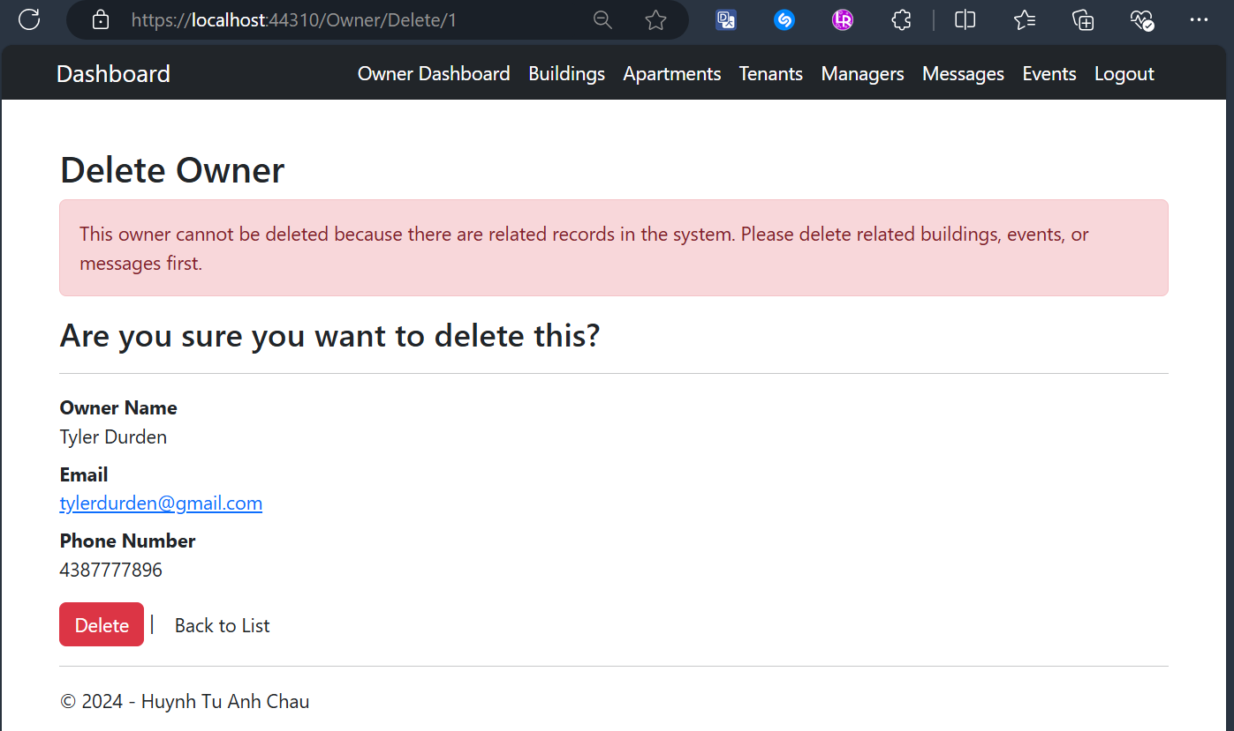

Owner Views All Buildings and Having Details Button Only Screens
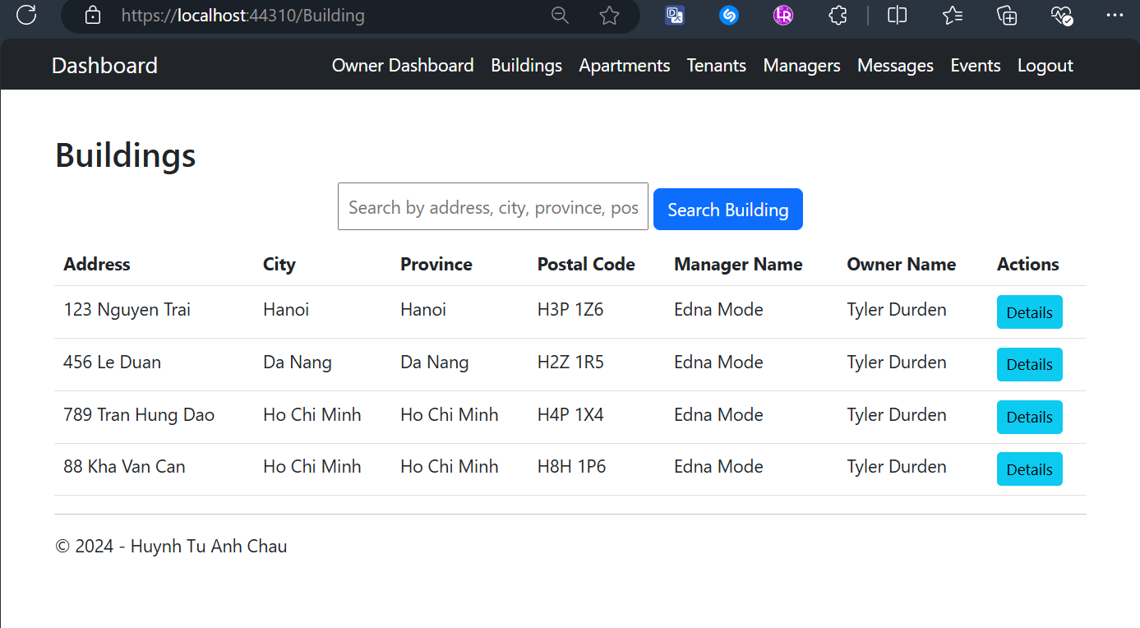

Owner Searches for Buildings Result Screens
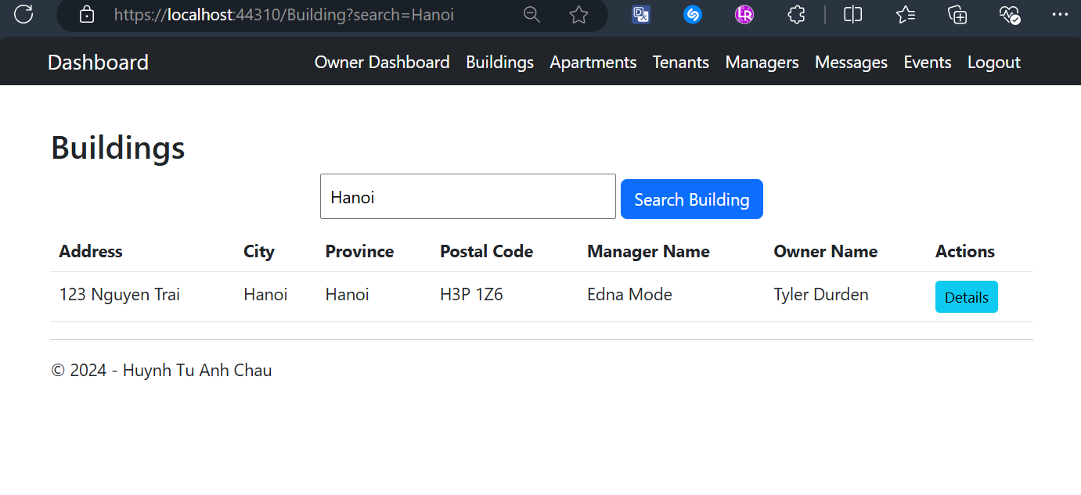
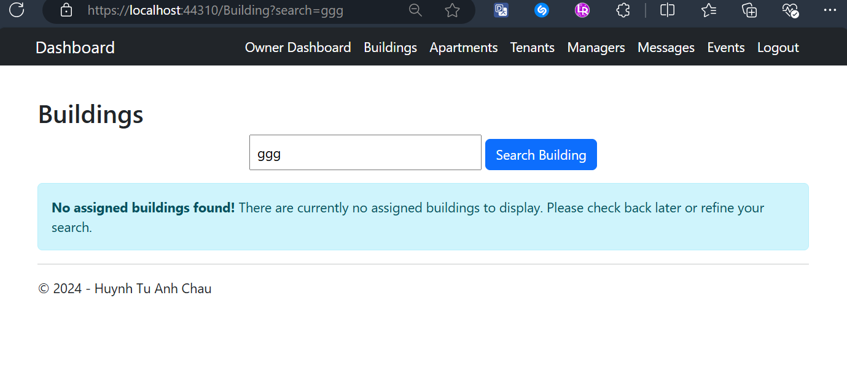

Owner Views One Building’s Details Screen
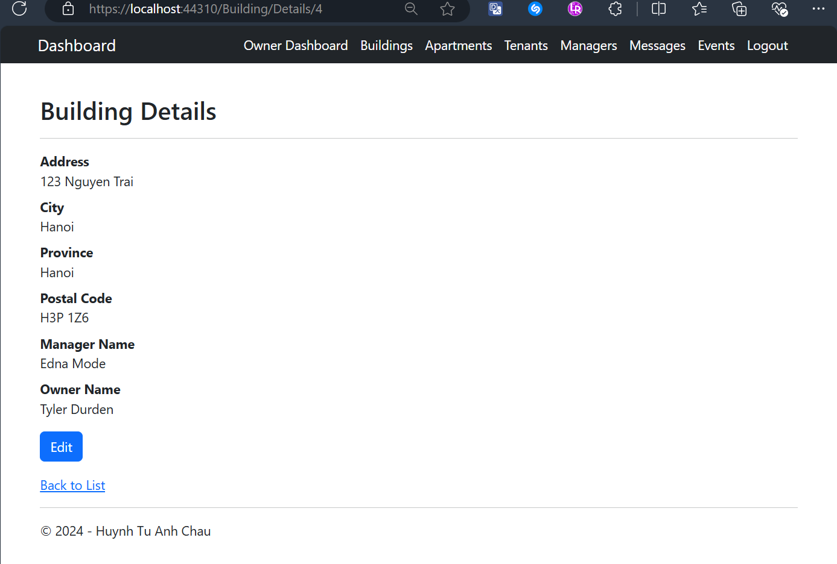

Owner Views All Apartment and Having Details Button Only
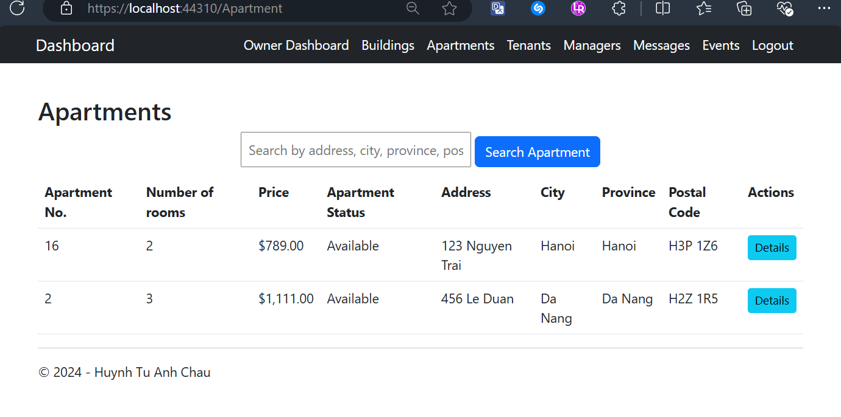

Owner Searches for Apartments Result Screens
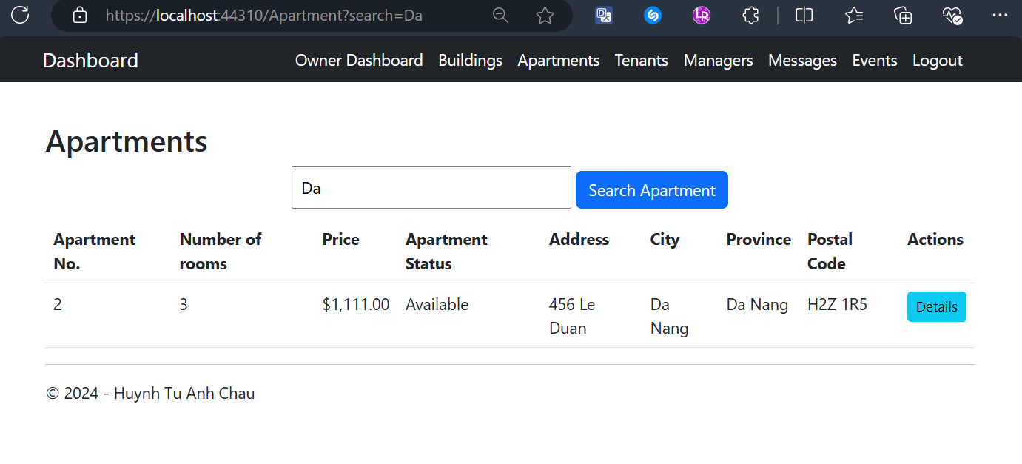
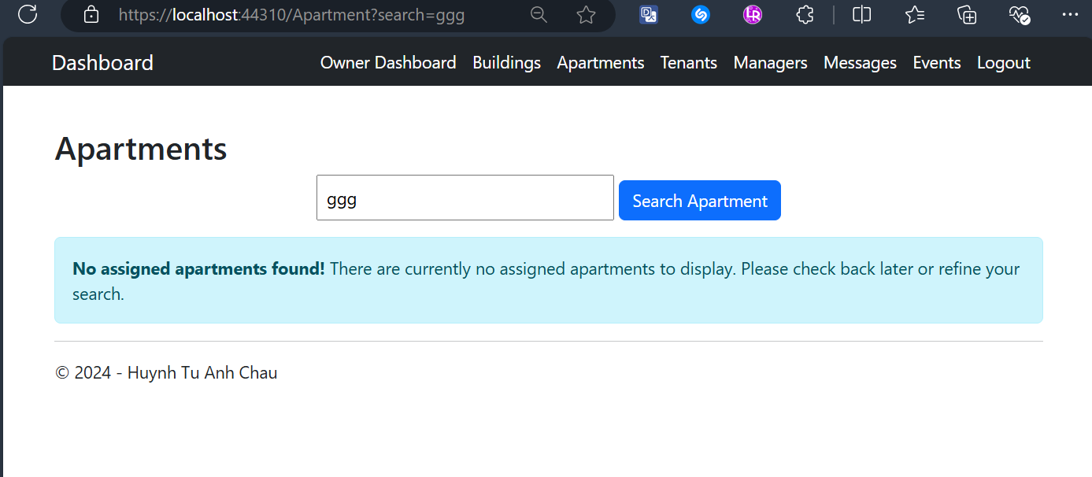

Owner Views One Apartment’s Details Screen
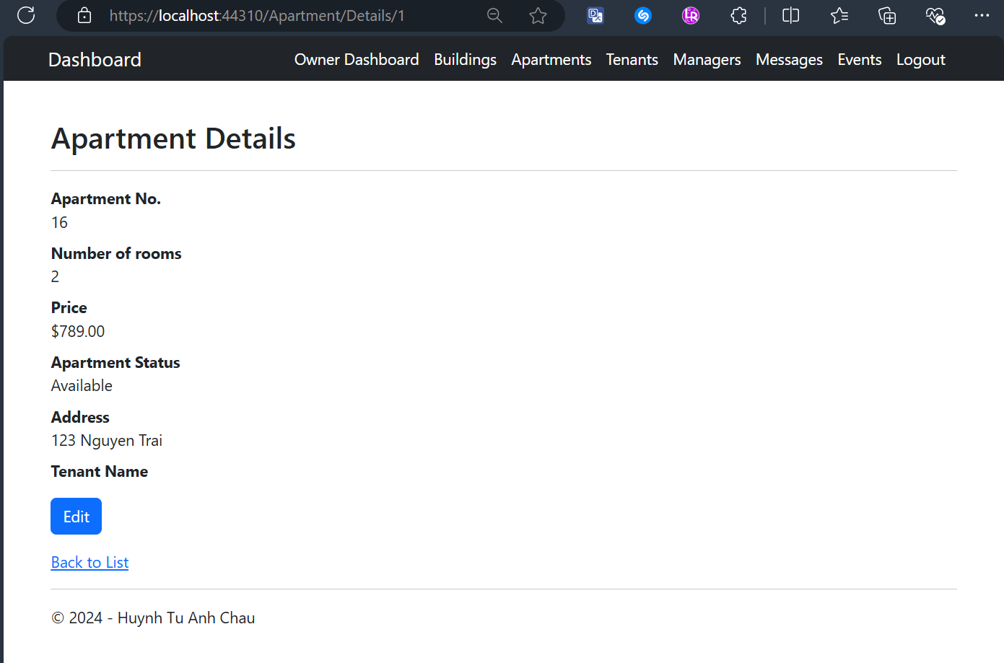

Owner Views All Tenants with CRUD Actions Screen
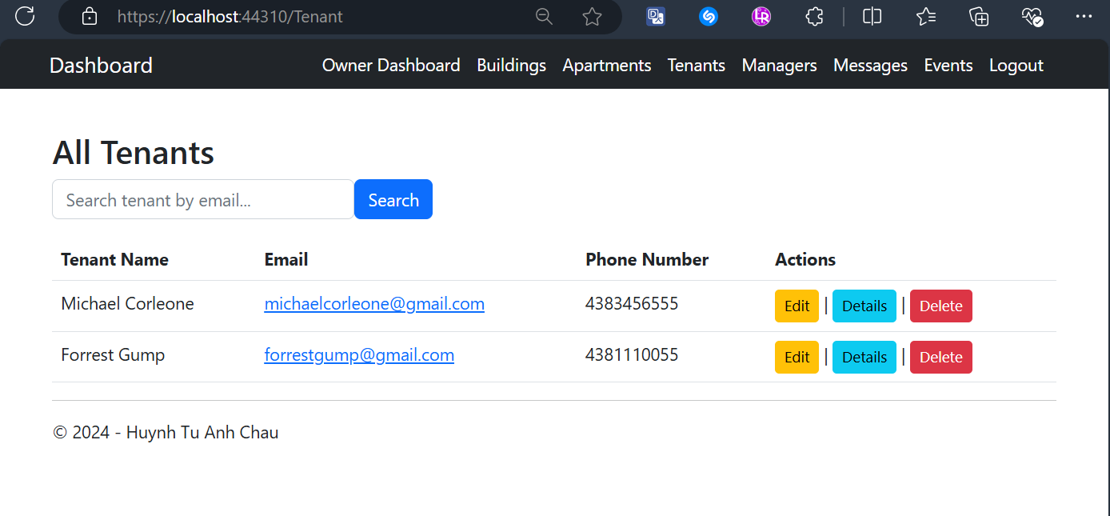

Owner Searches for A Tenant by Email Result Screens
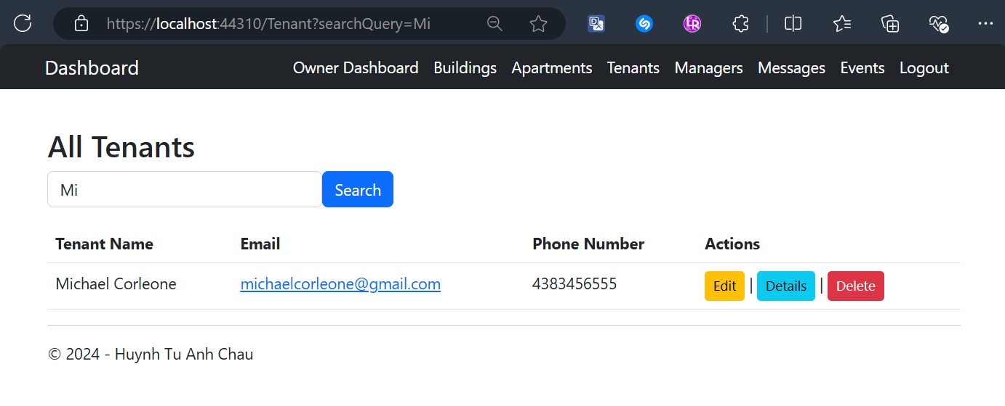
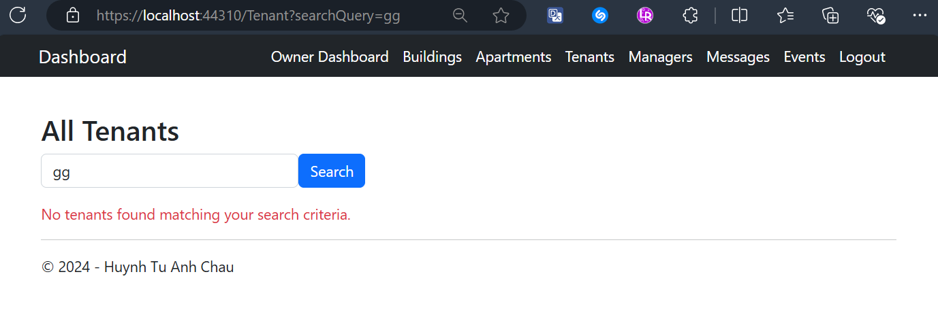

Owner Edit One Tenant’s Details with Validation Screens
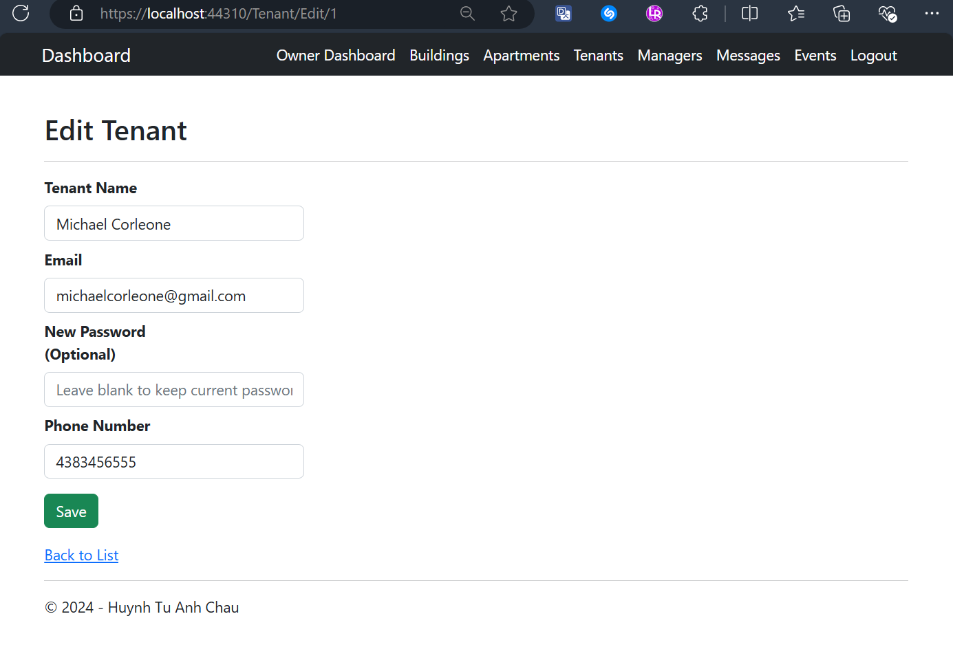
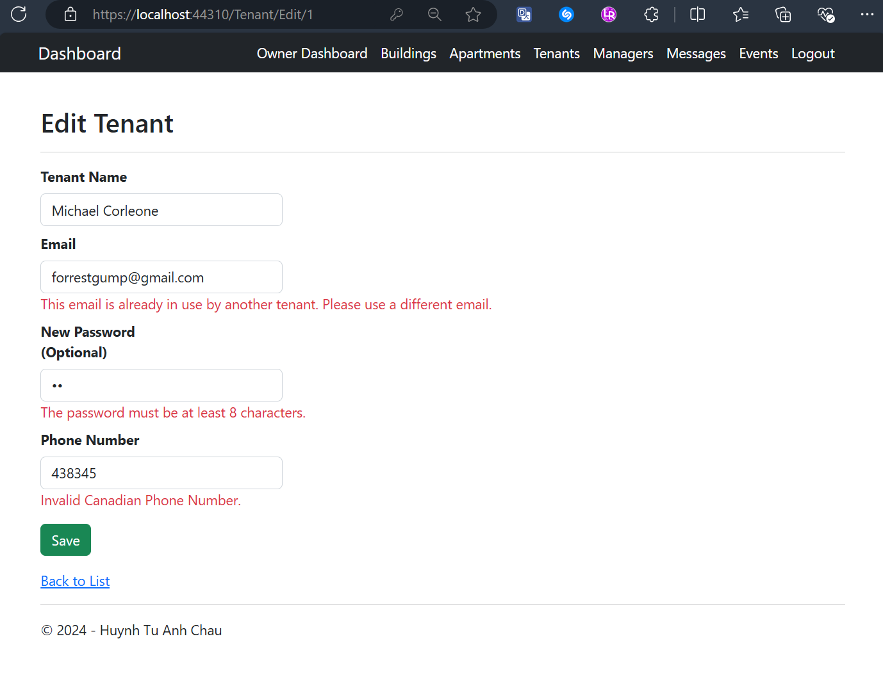

Owner Views One Tenant's Details Screen
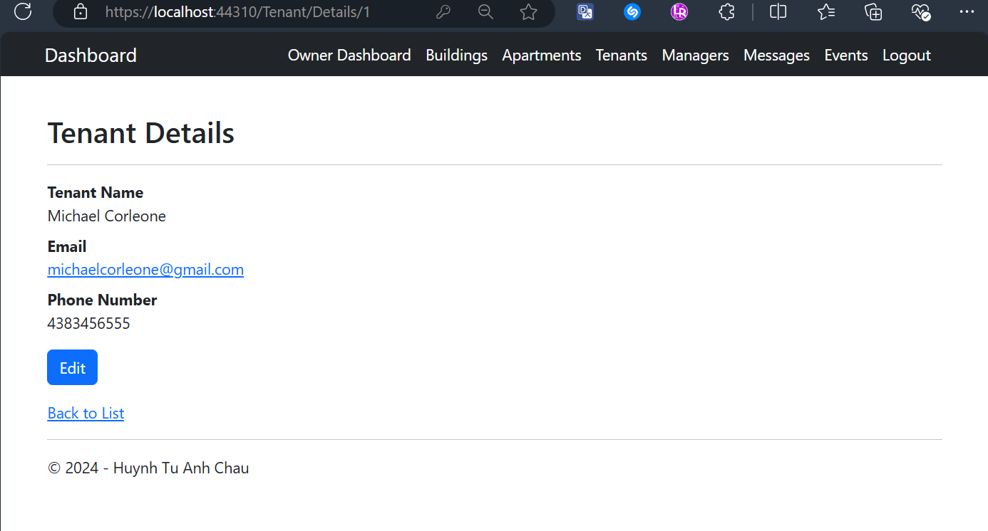

Owner Deletes One Tenant with Confirmation Screen
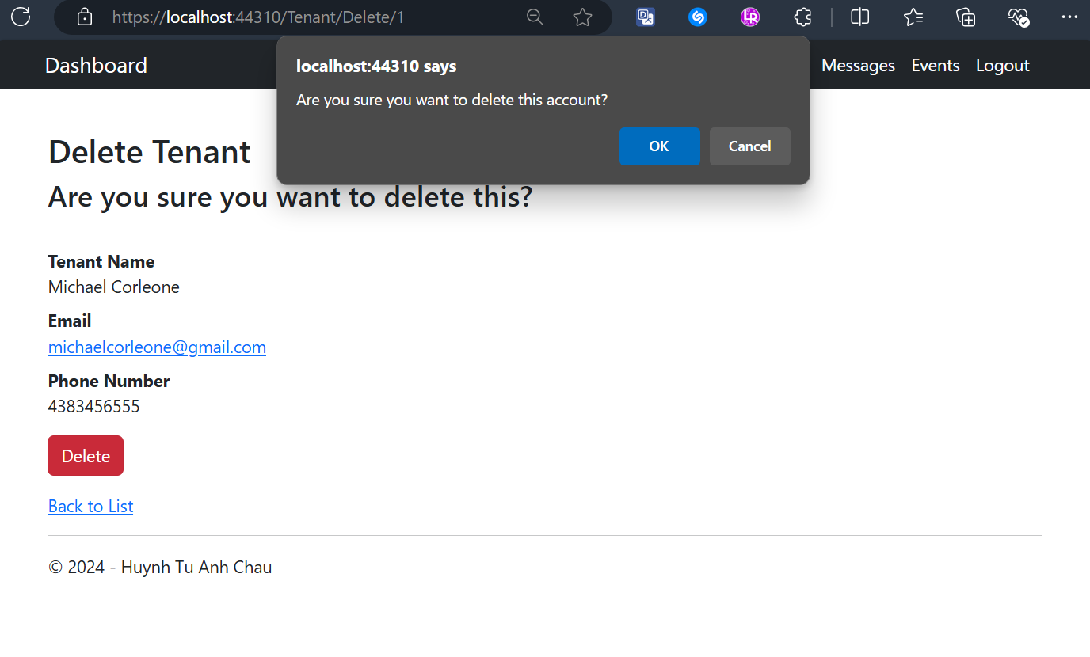

Owner Views All Managers Screen
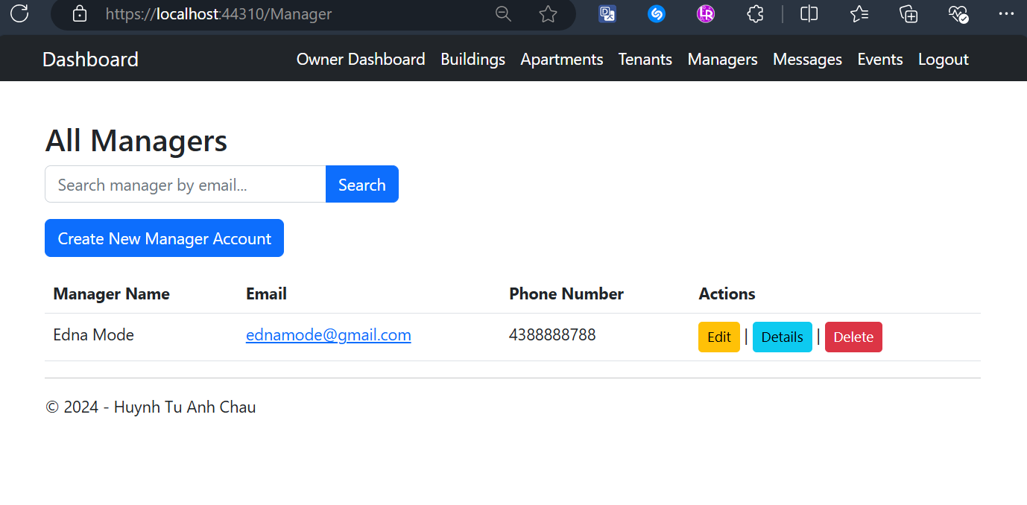

Owner Searches for A Manager Result Screen
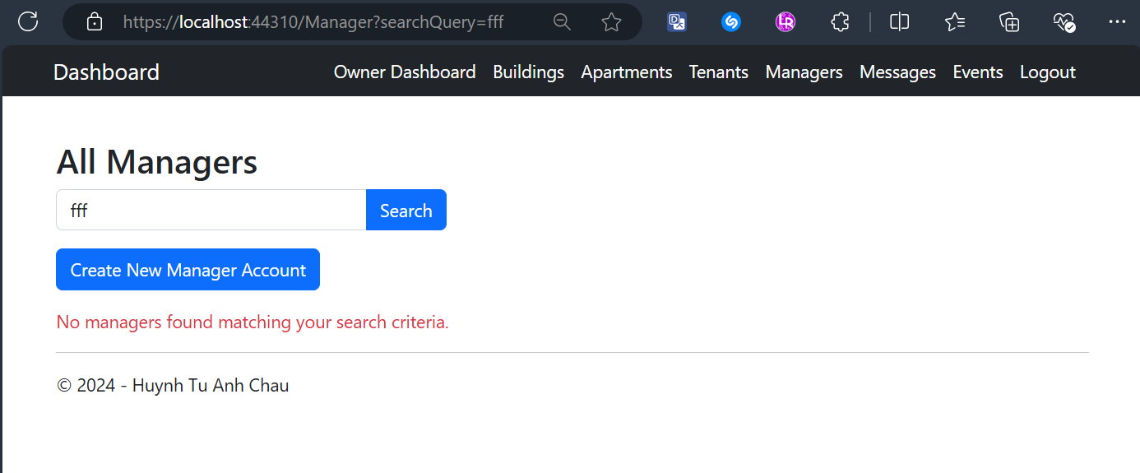

Owner Creates a Manager Account with Validation Screen
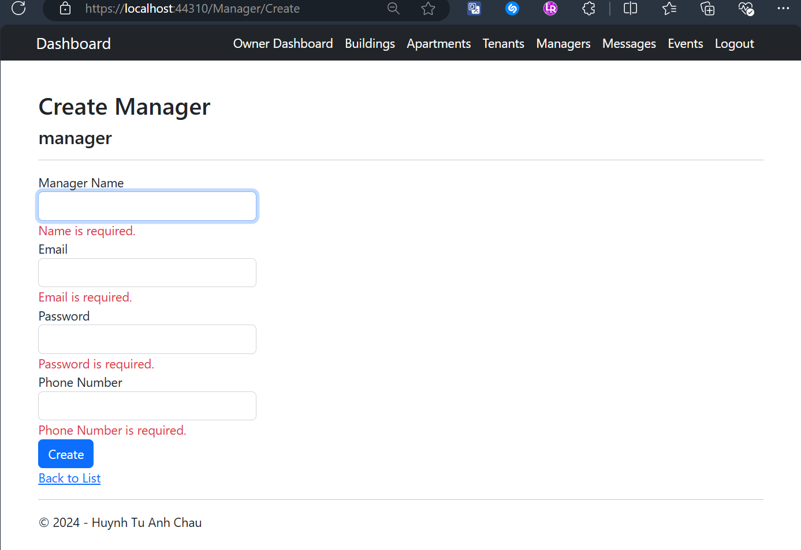

Owner Views All Created Messages to a Manager with CRUD actions Screen
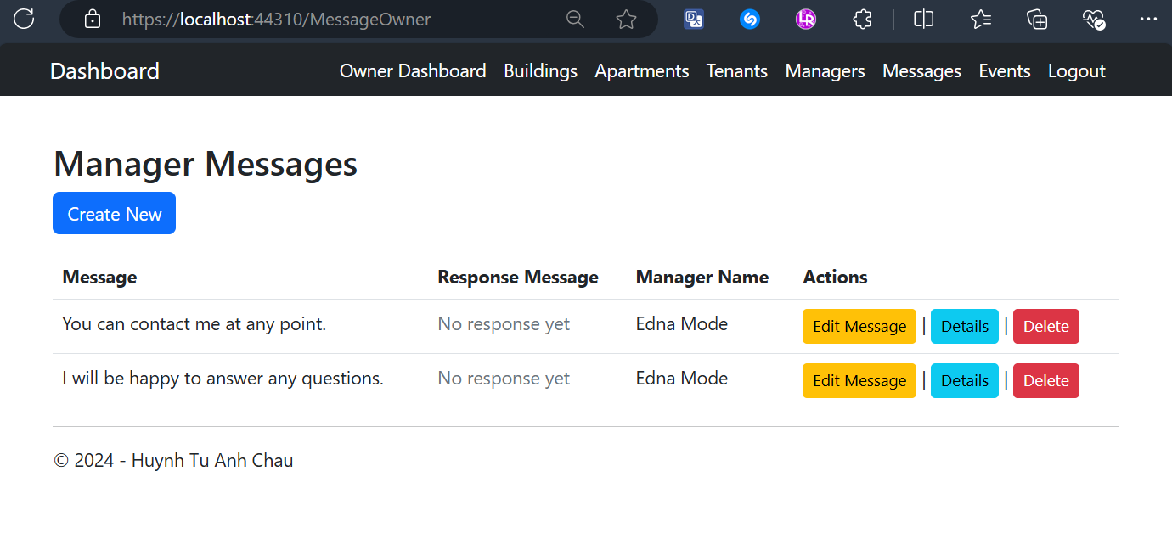

Owner Sends a Message to a Manager (fetching from database) with Validation Screen
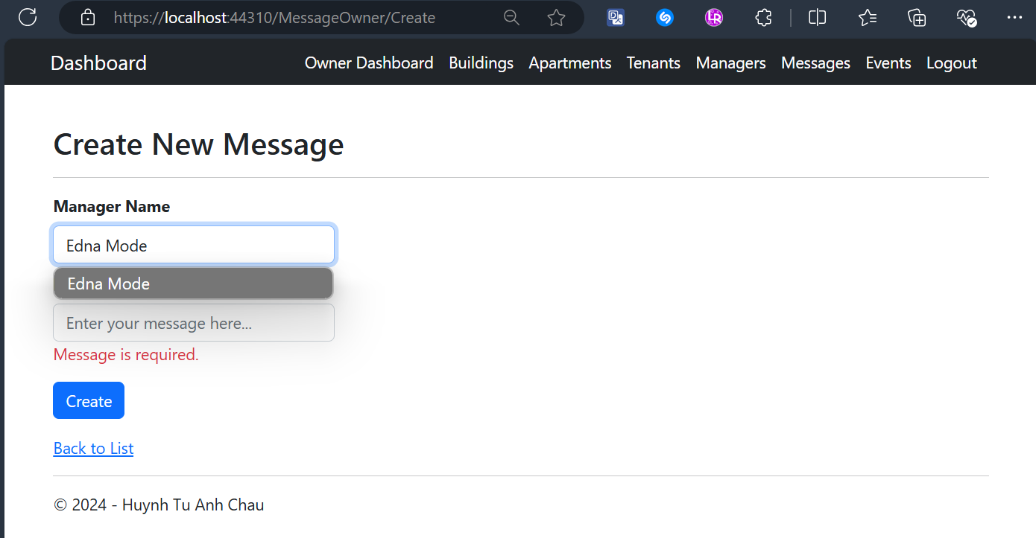

Owner Edits a Message Screen
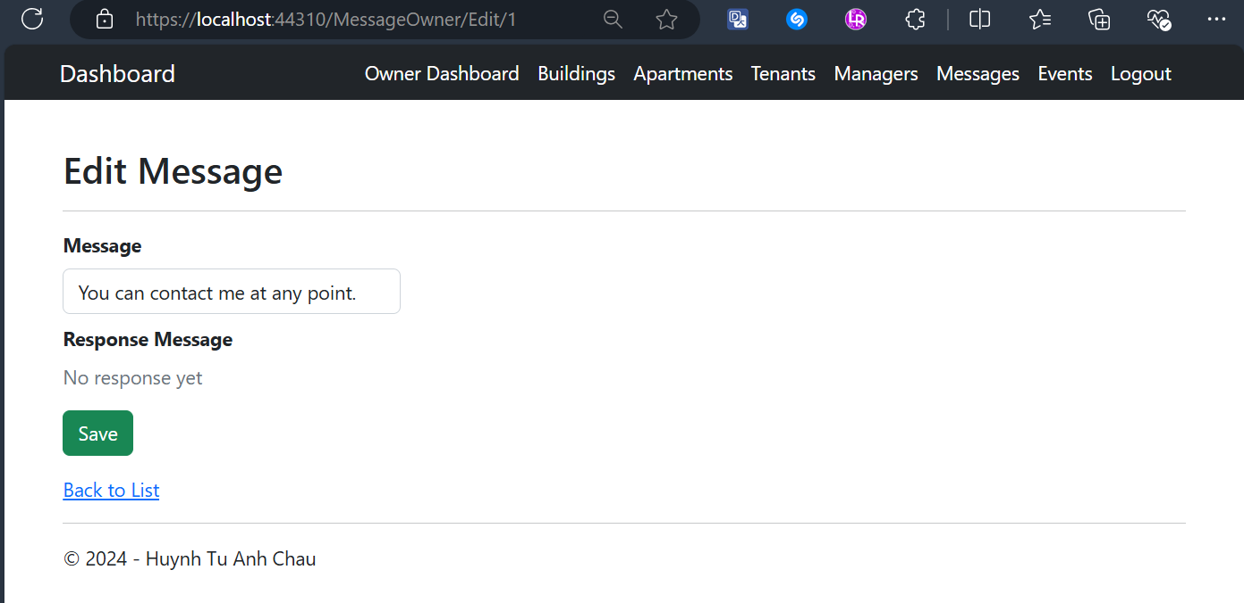

Owner Views One Message’s Details Screen
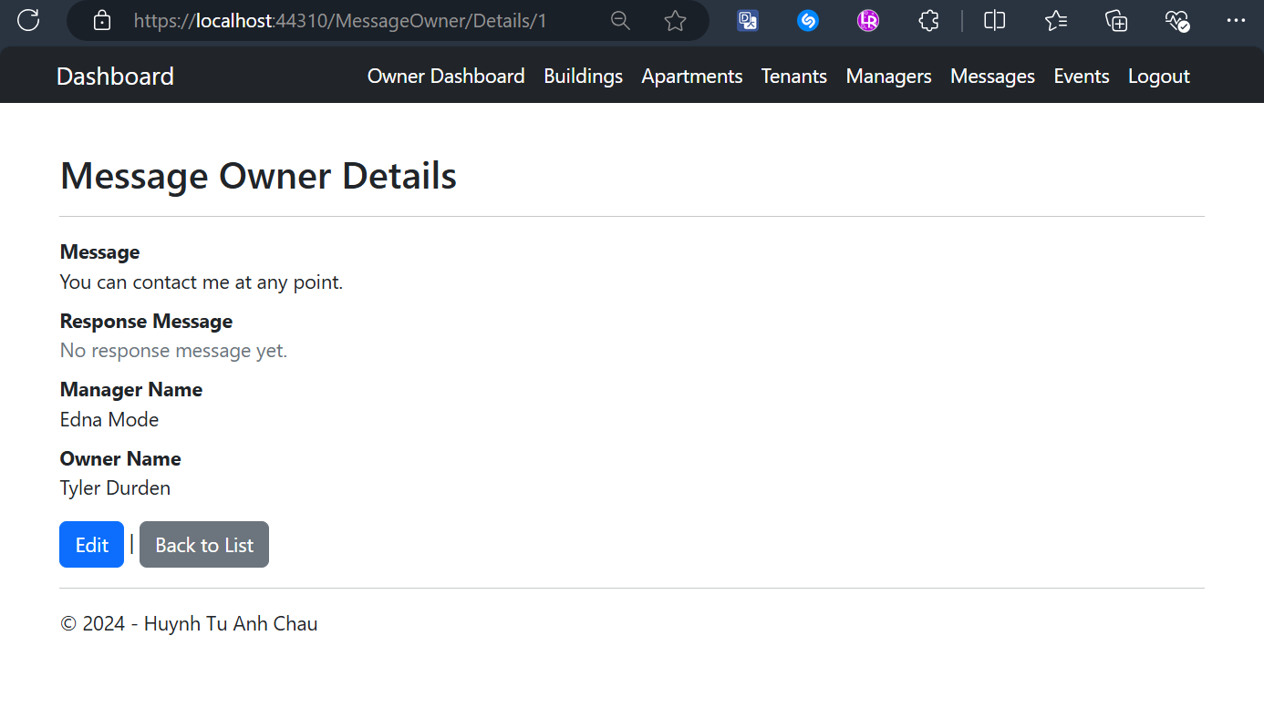

Owner Deletes a Message with Confirmation Screen
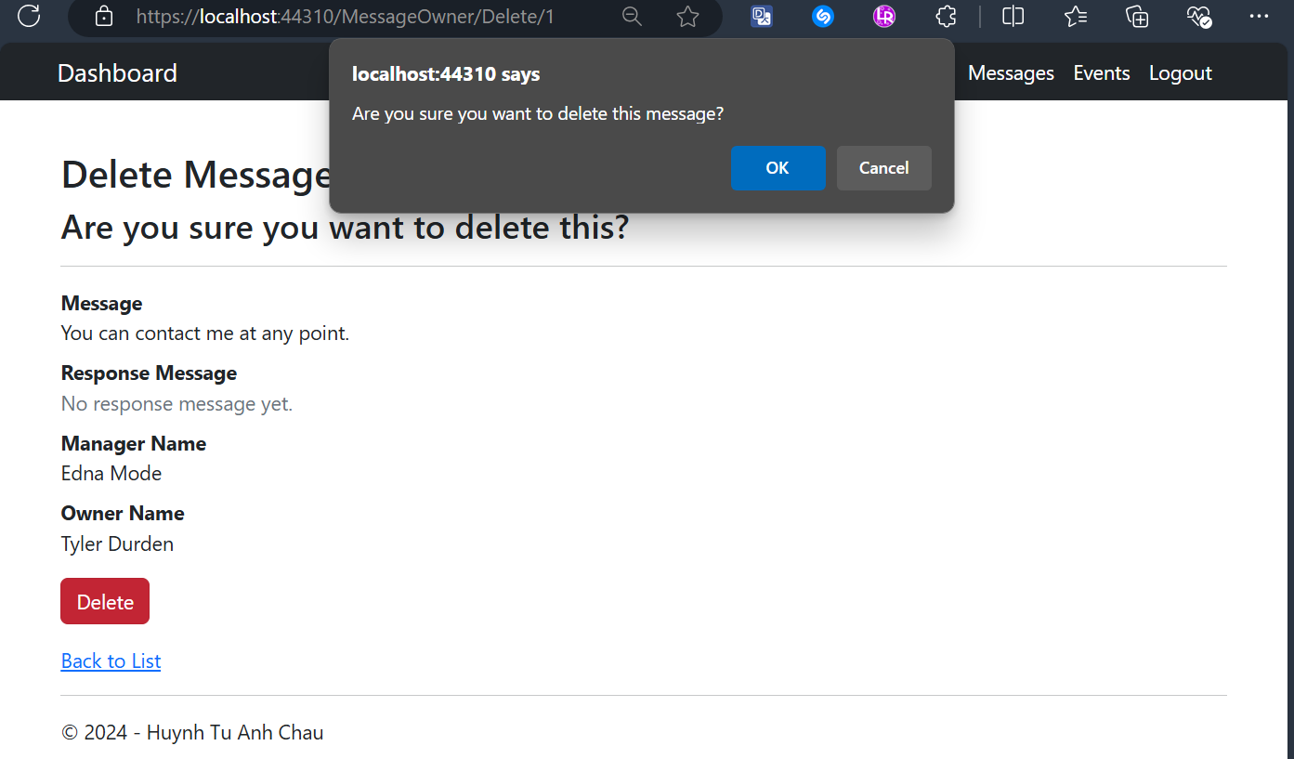

Owner Views Assigned Events Screen
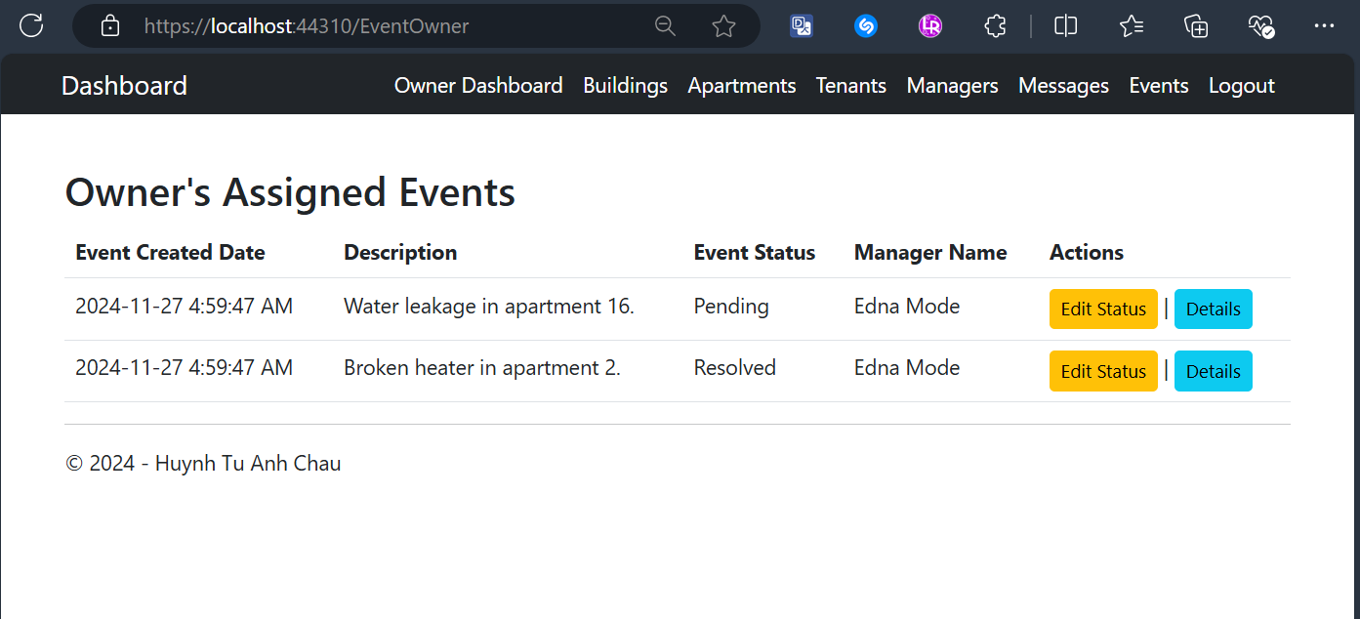

Owner Edits Status of Assigned Events Screen
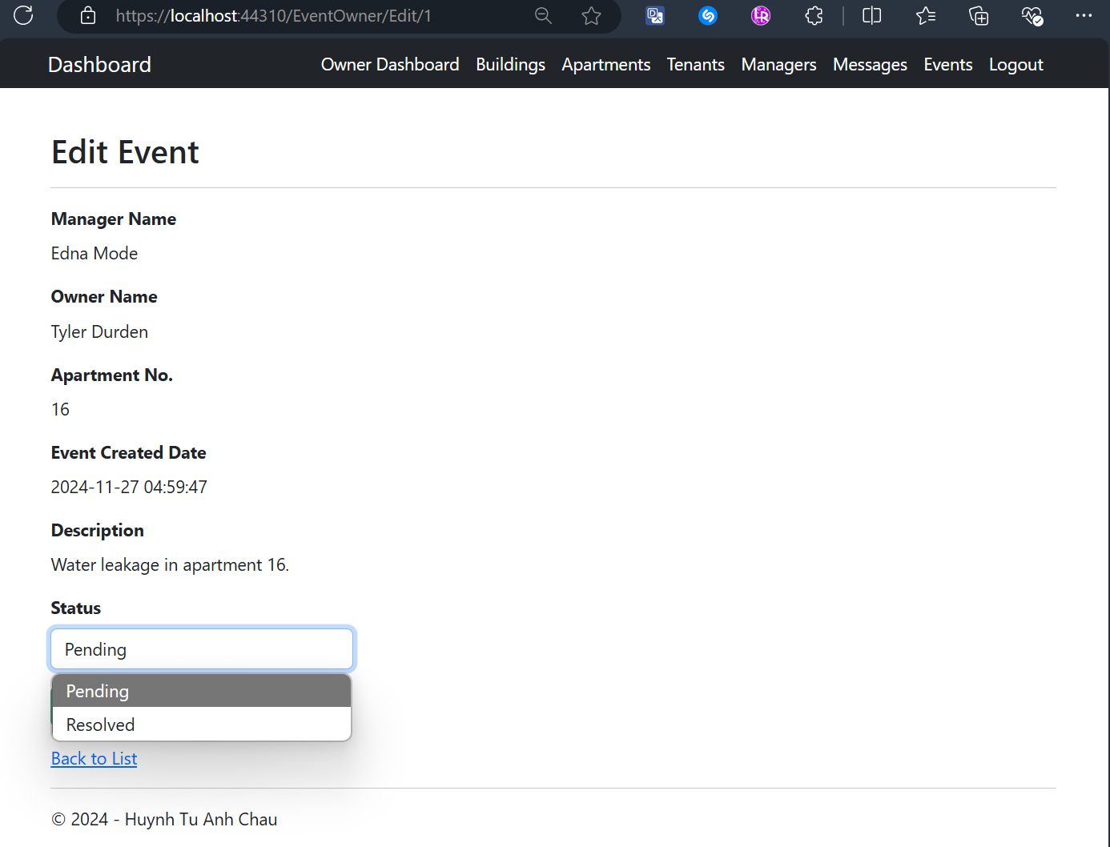

Owner Views One Event’s Details Screen
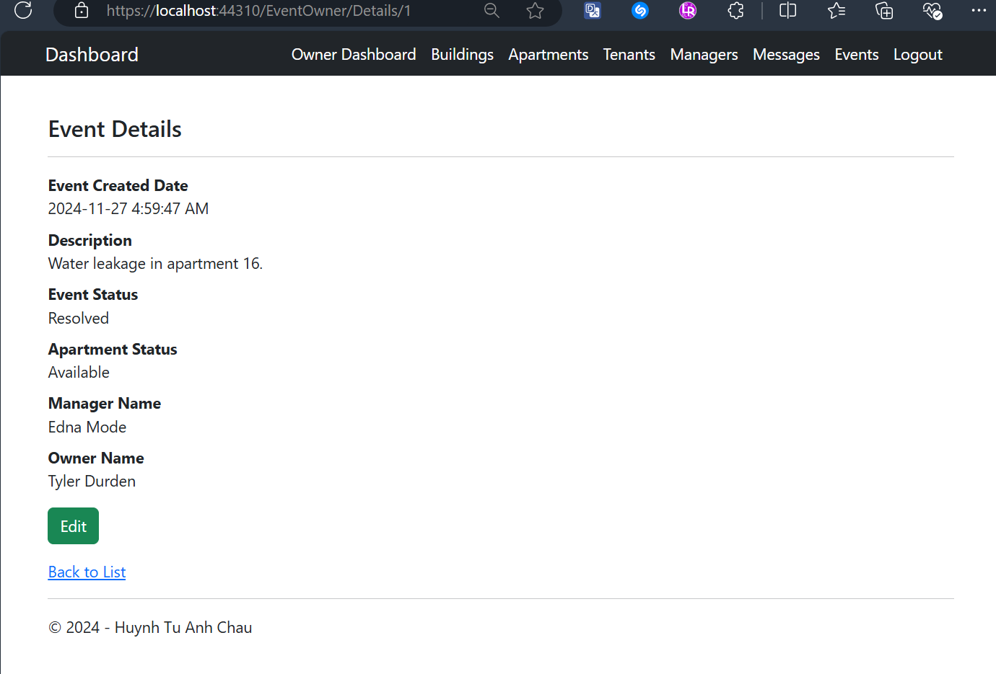

Manager Dashboard After Logging-In Screen
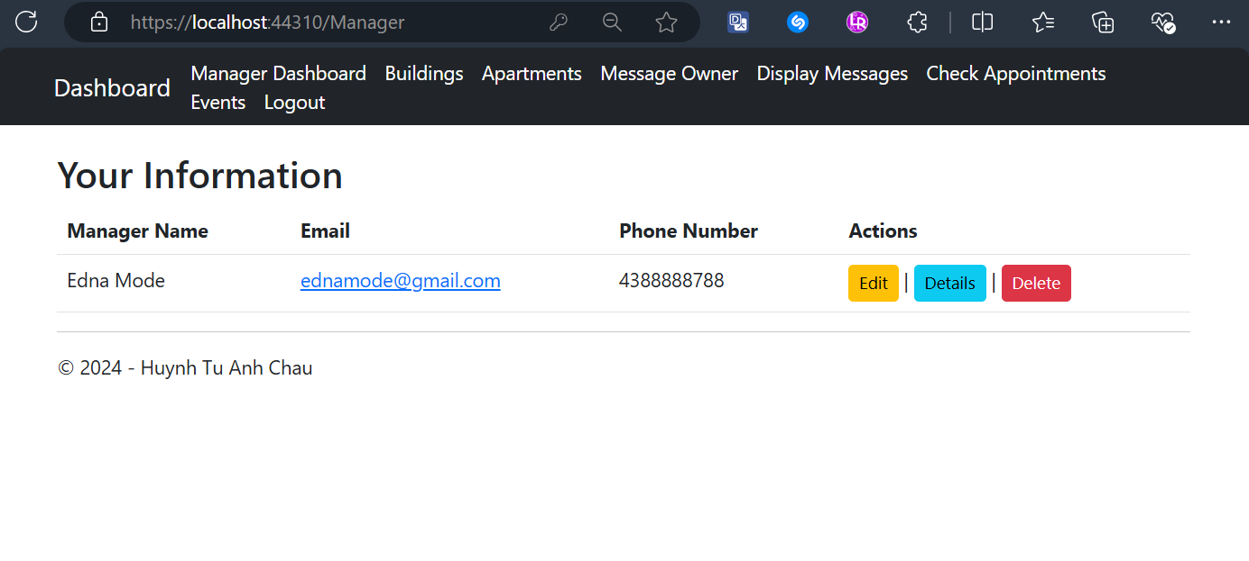

Managers Edit Their Profile with Validation Screen
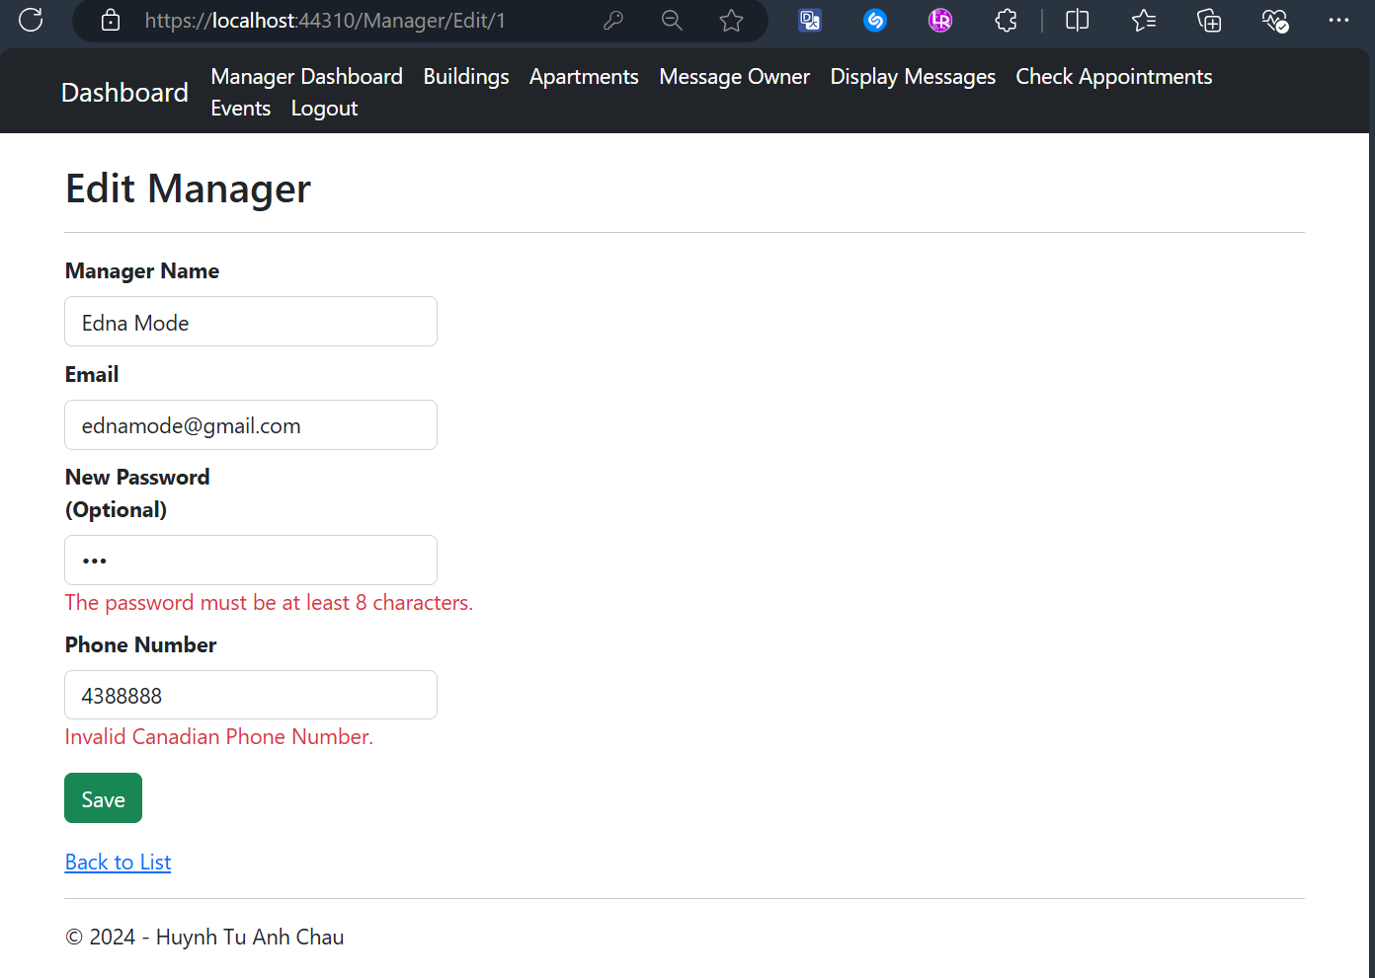

Managers Delete Their Accounts with Confirmation Screen
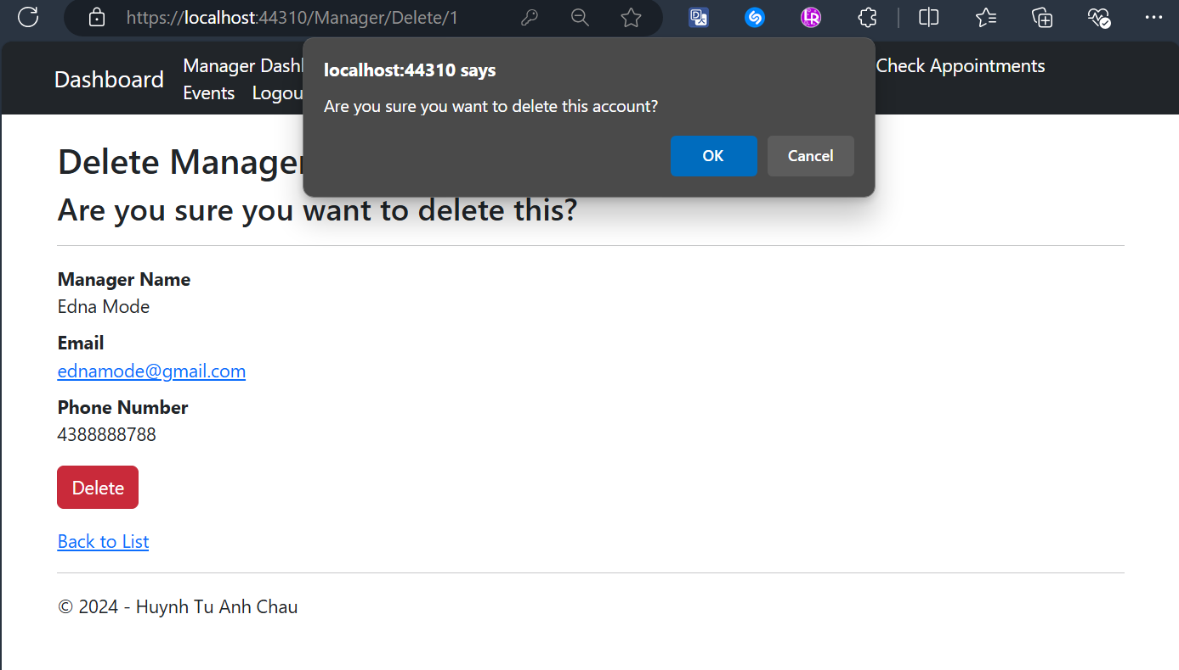

Manager Views Assigned Buildings with CRUD actions Screen
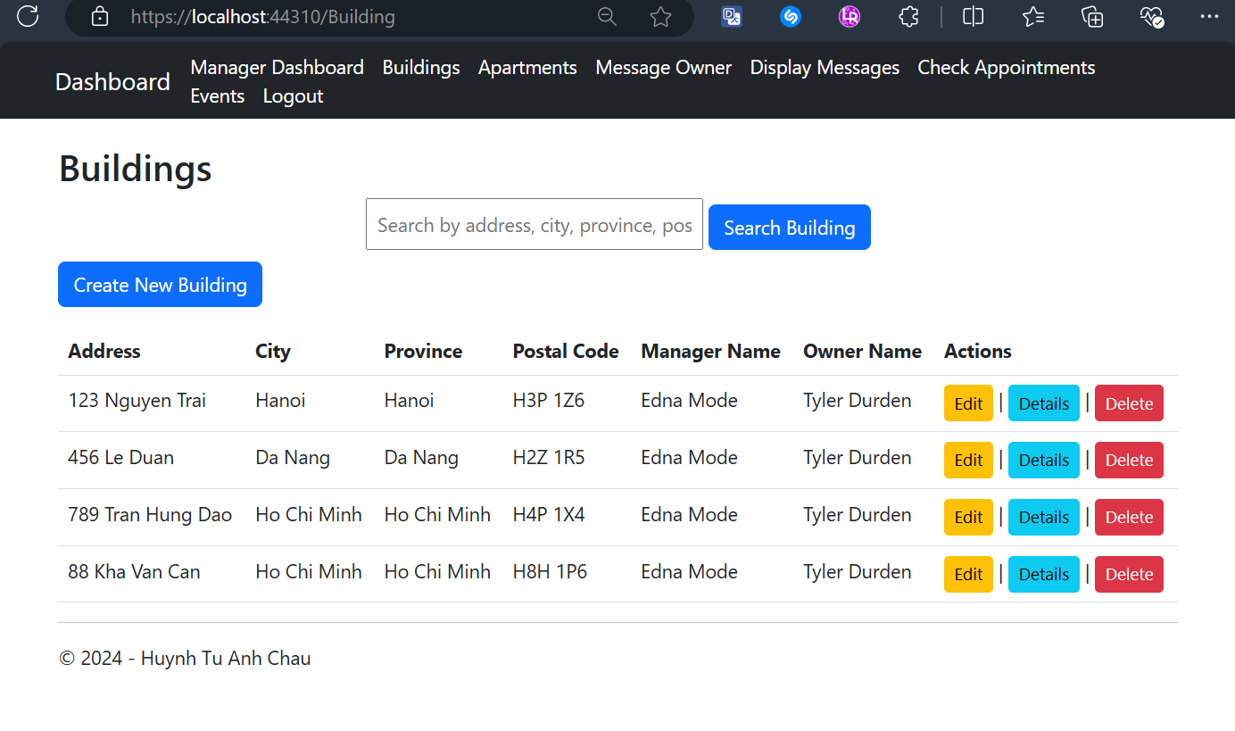

Manager Edits One Building with Validation Screen
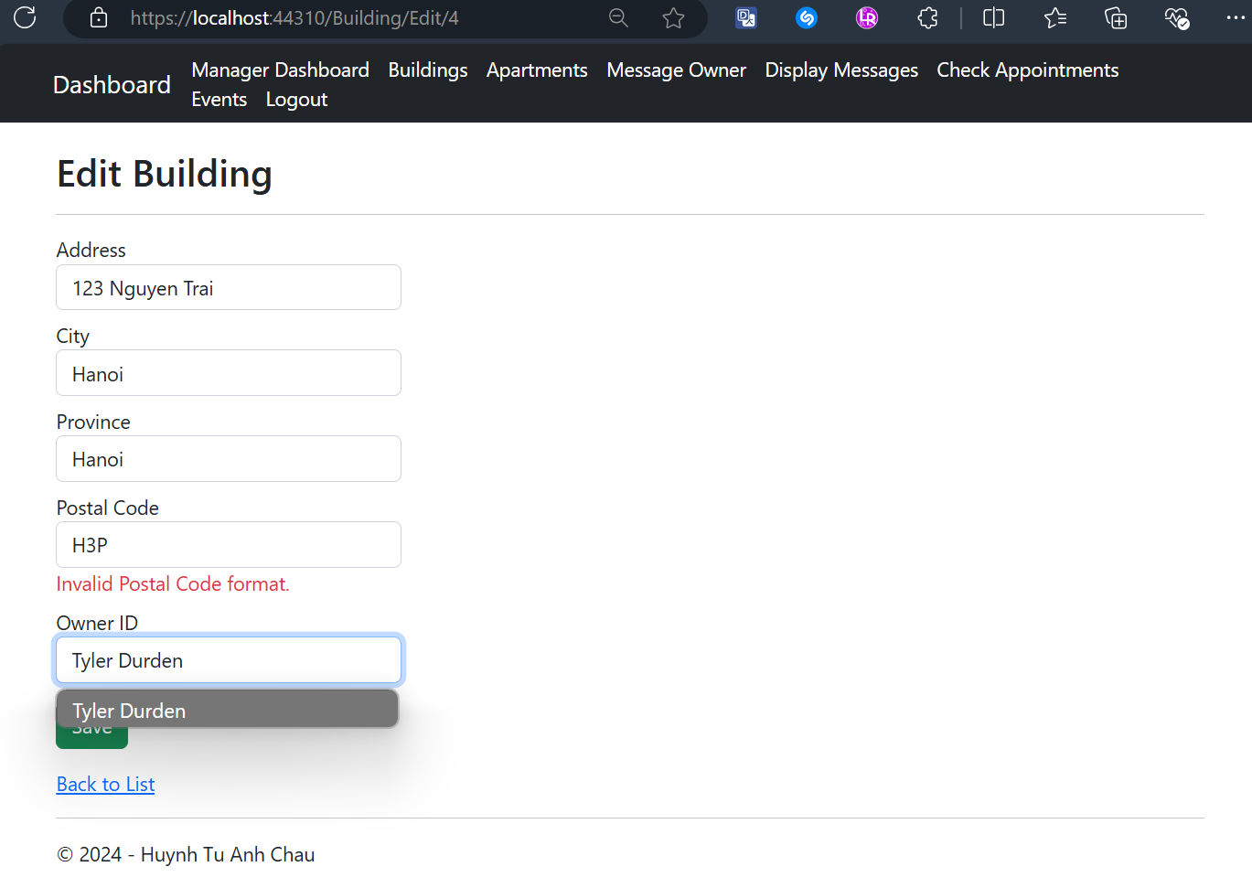

Manager Views One Building’s Details
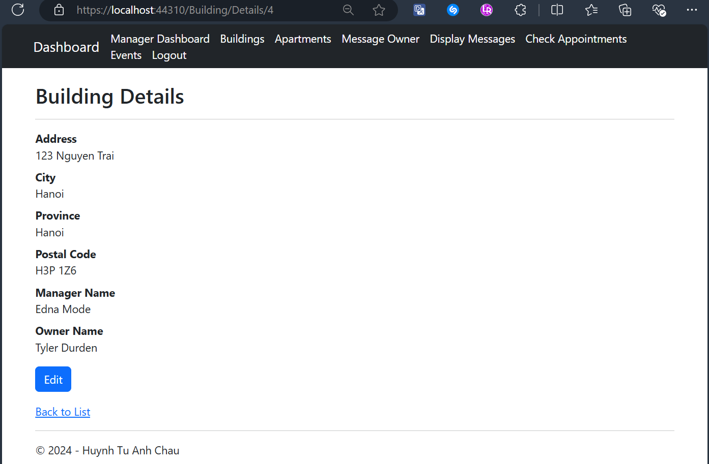

Manager Deletes One Building with Confirmation Screen
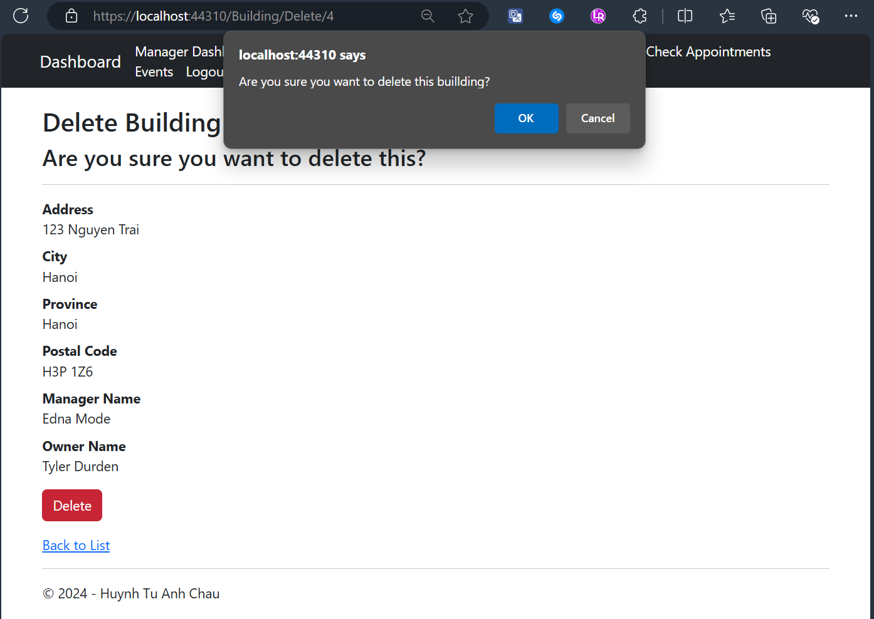

Manager Searches for A Building Result Screens
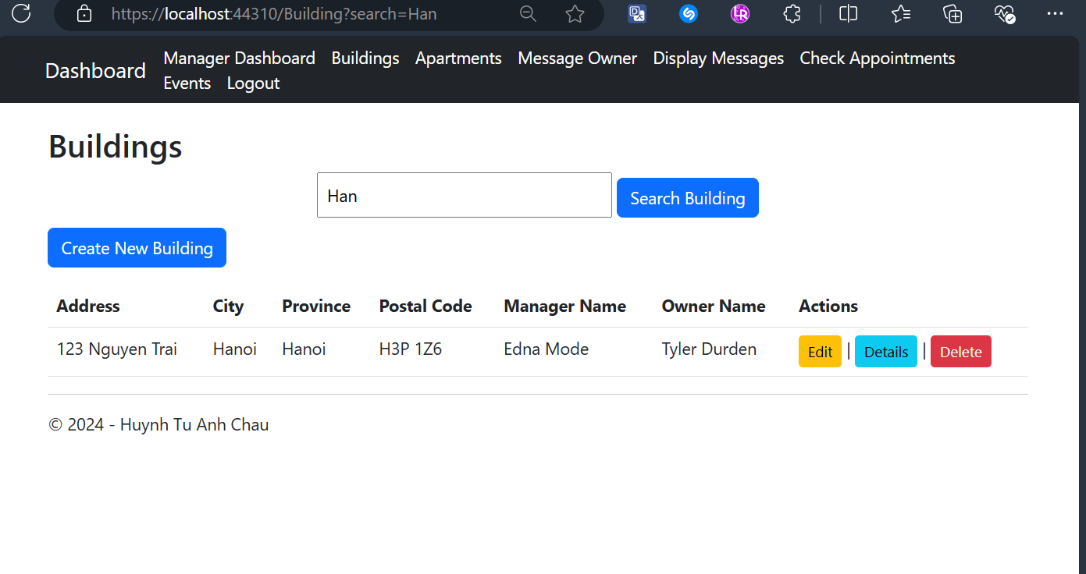
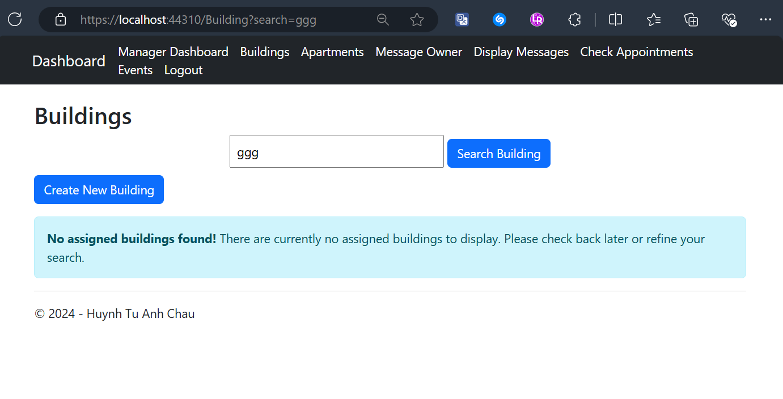

Manager Creates a New Building with Validation Screen
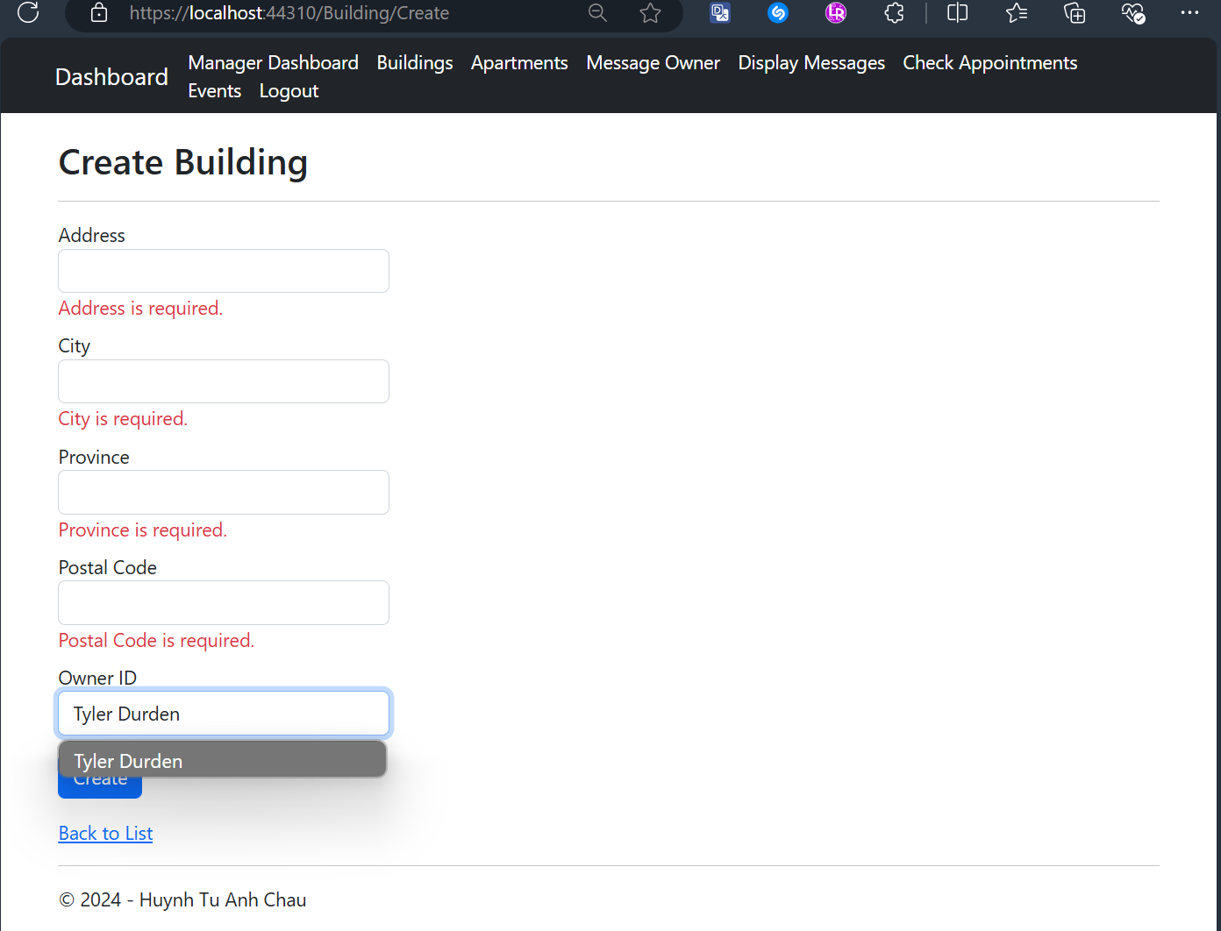

Manager Views All Apartments related to Assigned Buildings with CRUD actions Screen

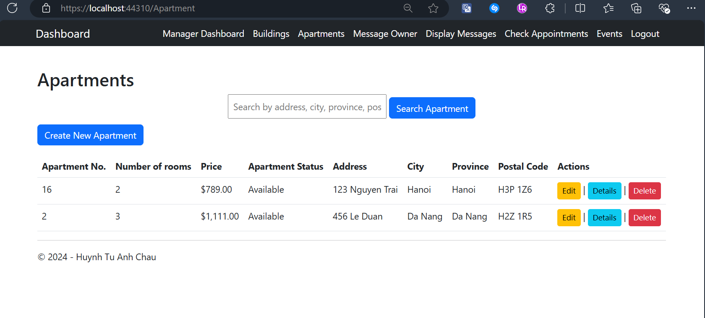Manager Edits an Apartment’s Details with Validation Screen
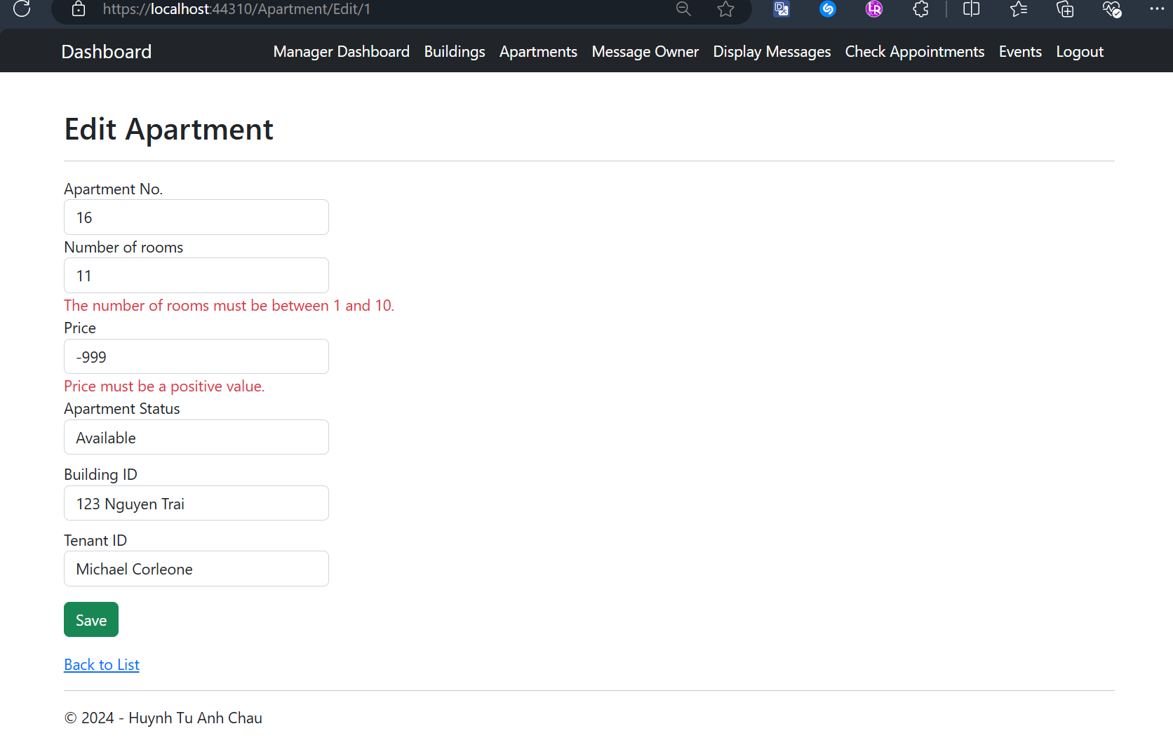

Manager Views an Apartment's Details Screen
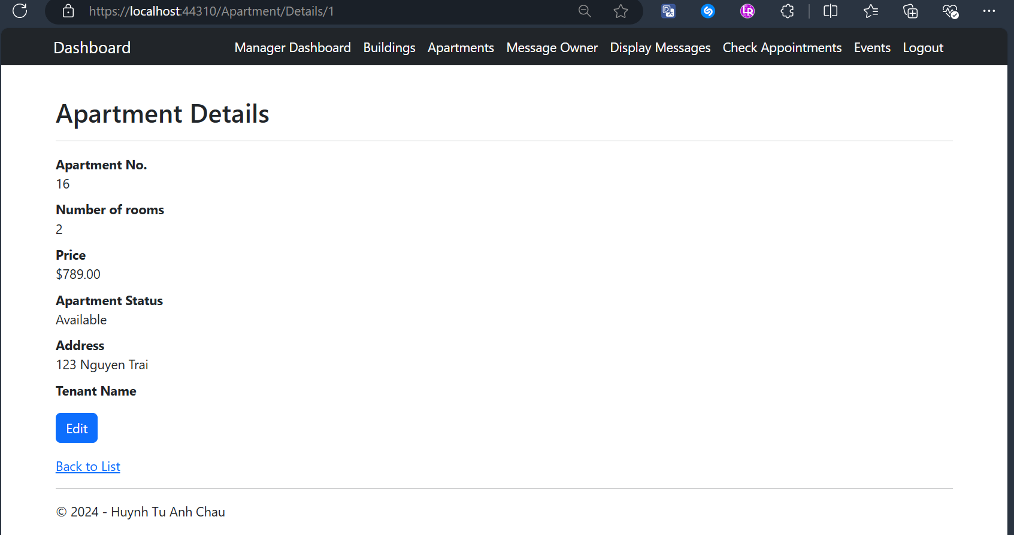

Manager Deletes an Apartment with Confirmation and Informative Message Screens
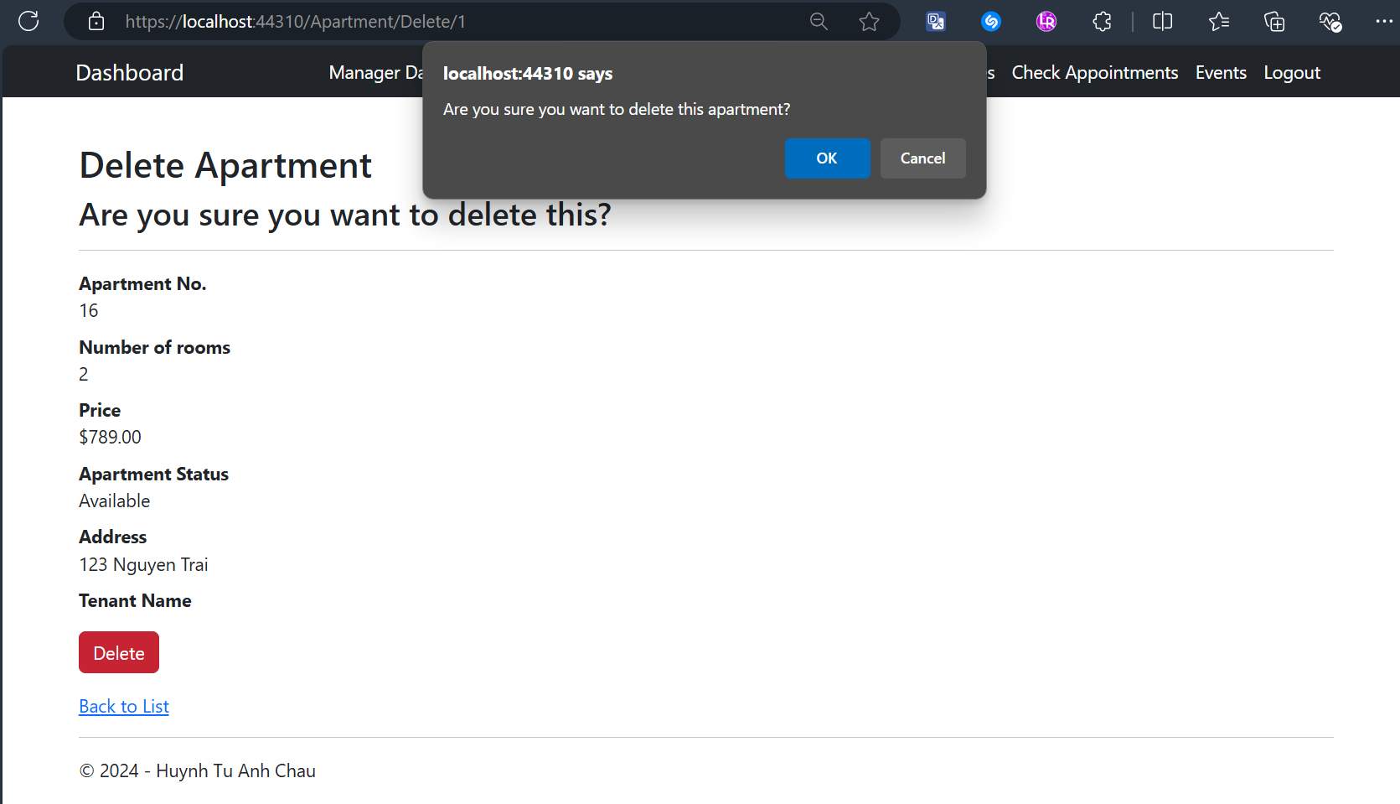
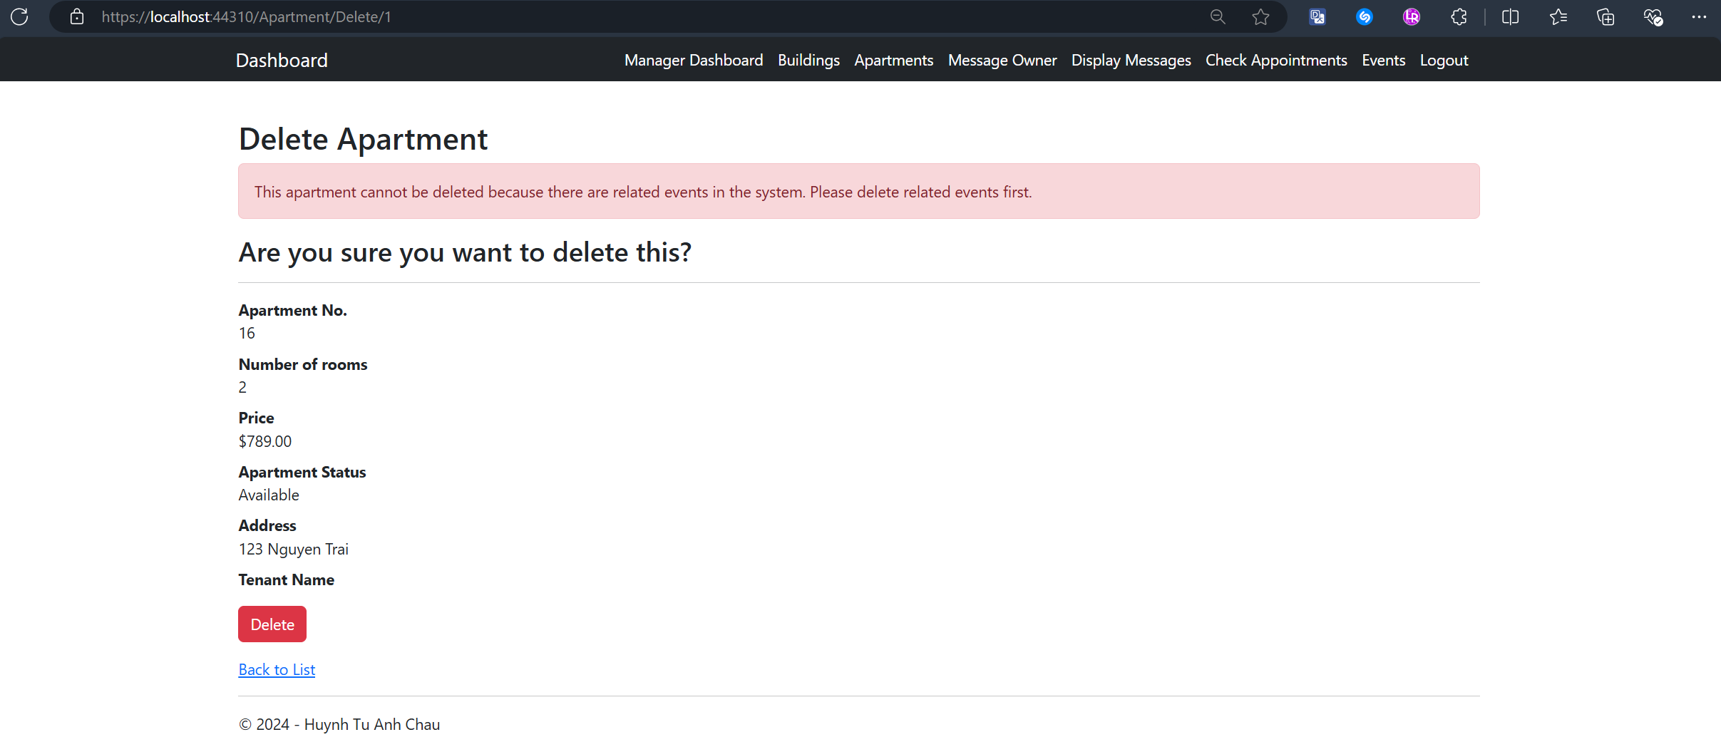

Manager Views Assigned Message Sent by Owners Screen
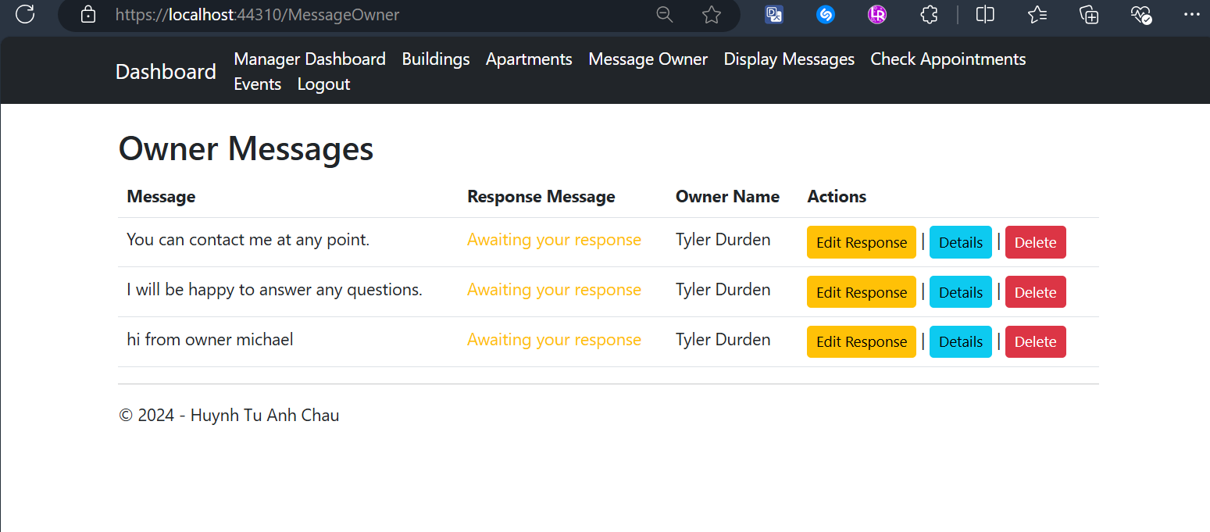

Manager Responses to A Message Screen
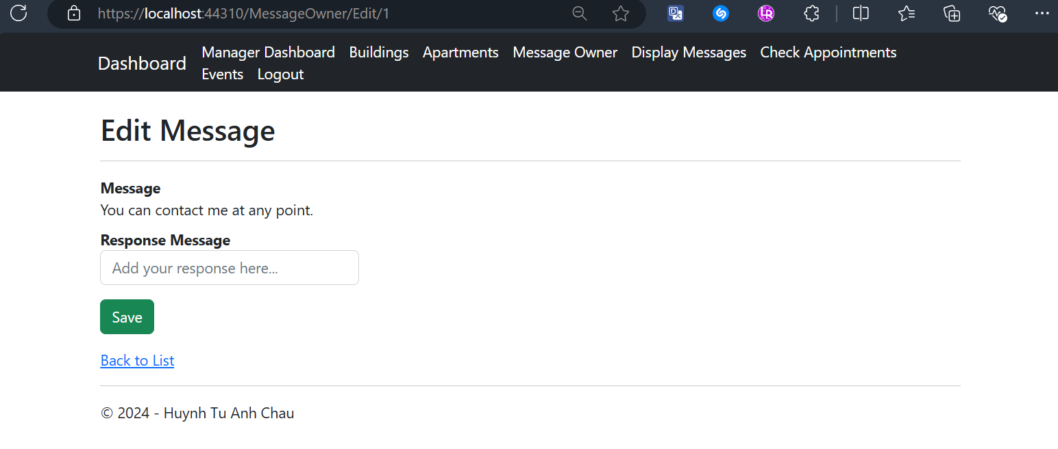

Manager Views One Message’s Details Screen
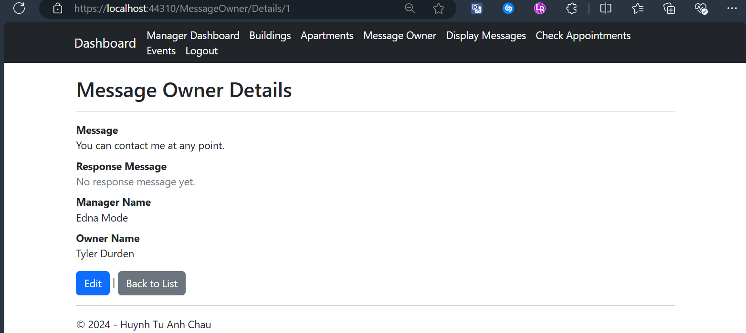

Manager Deletes a Message with Confirmation Screen
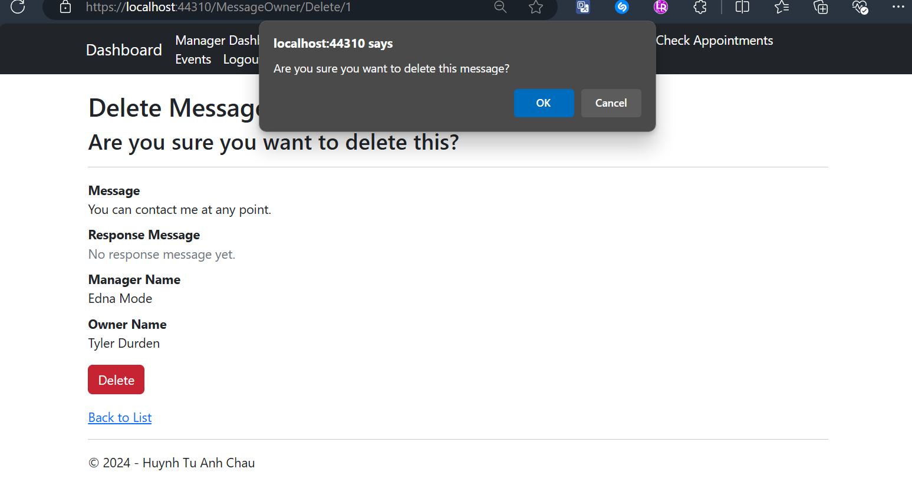

Manager Views Assigned Messages Sent by Tenants Screen
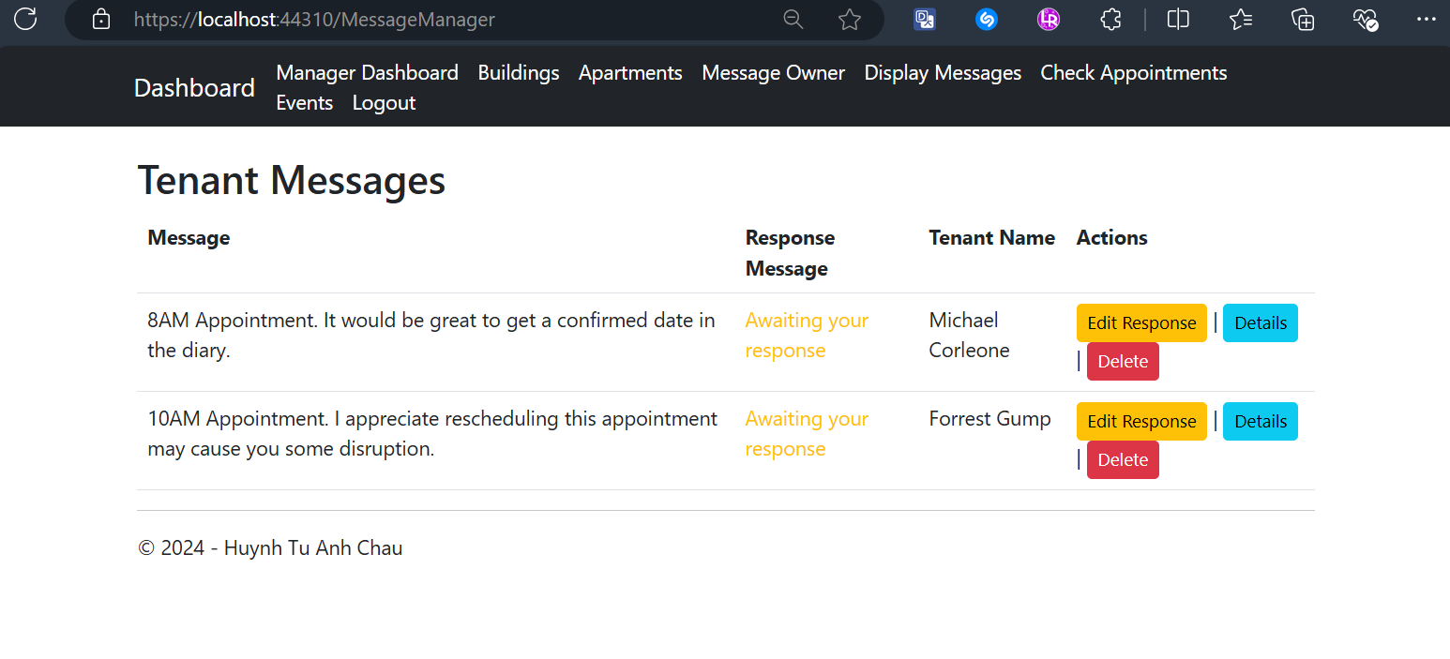

Manager Responses to a Message Screen
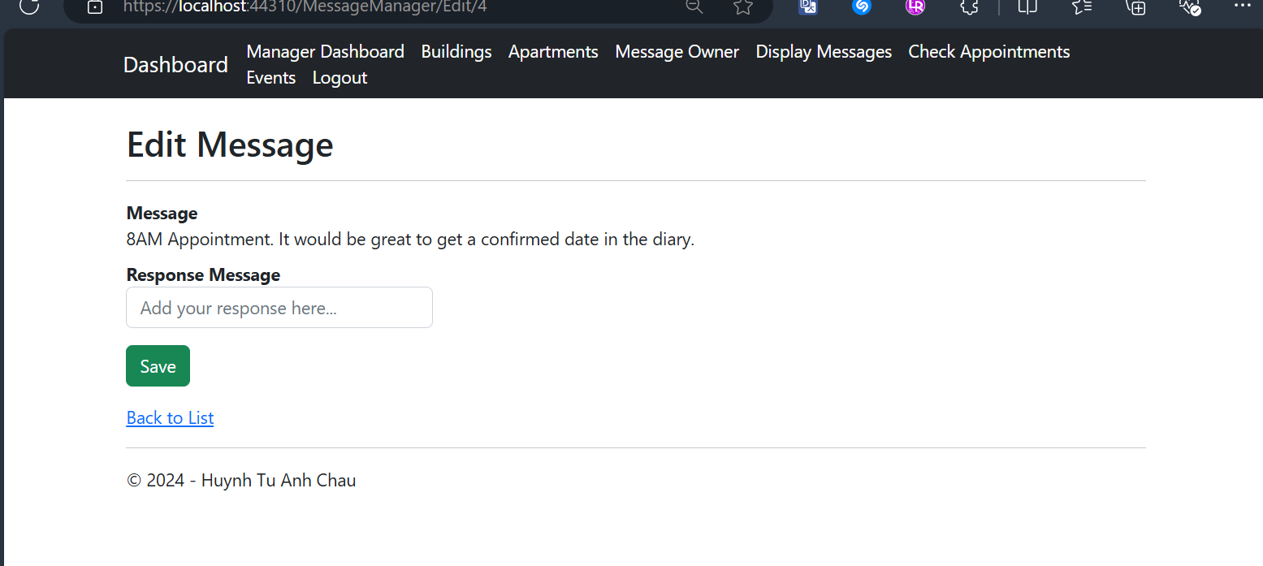

Manager Views a Message’s Details Screen
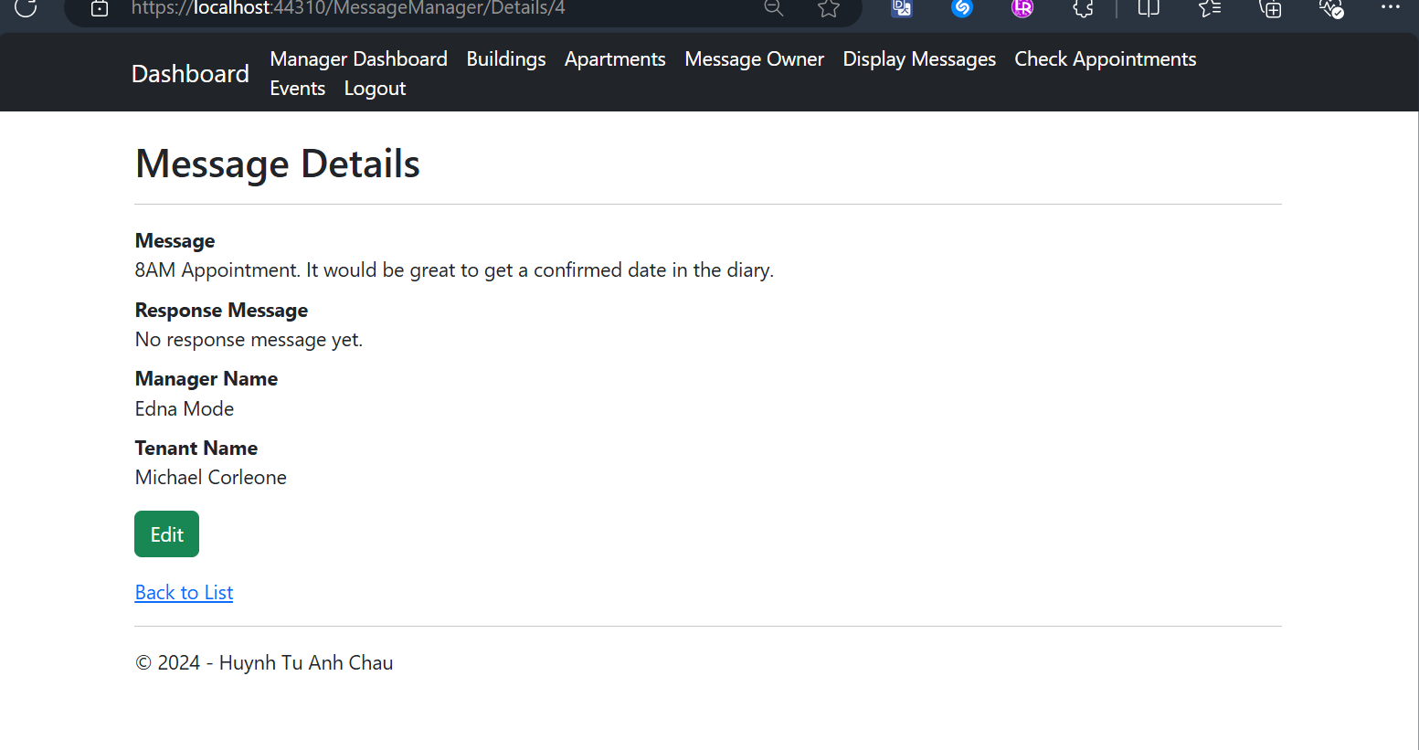

Manager Deletes a Message with Confirmation Screen
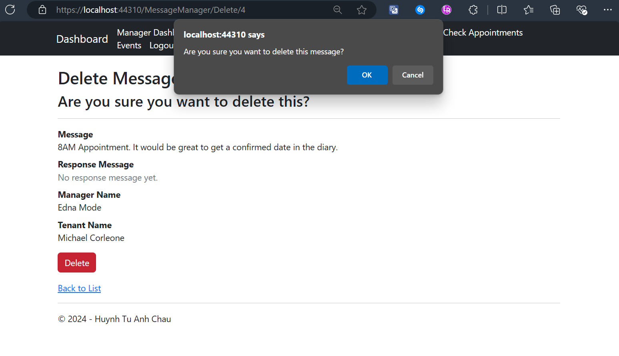

Manager Views All Created Appointments with CRUD actions Screen
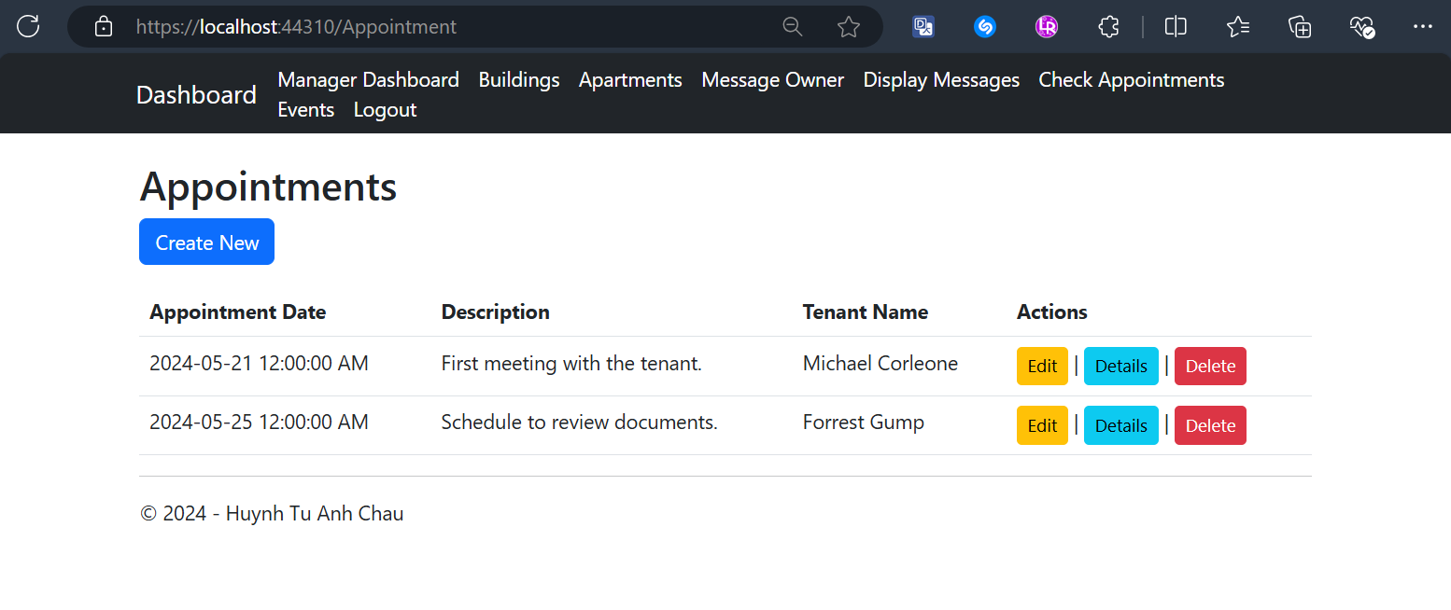

Manager Edits an Appointment with validation Screens
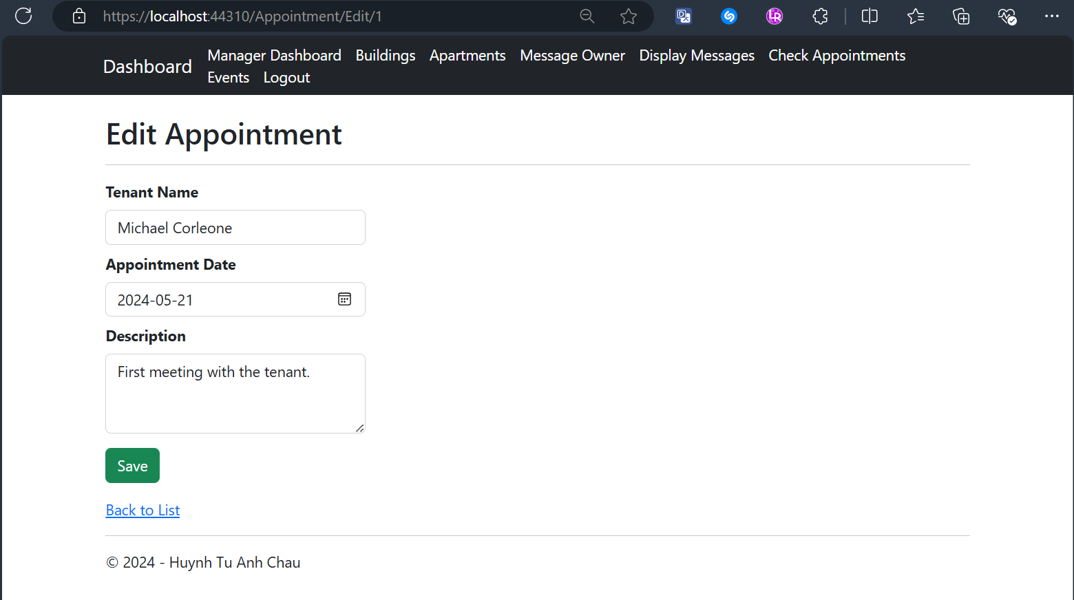
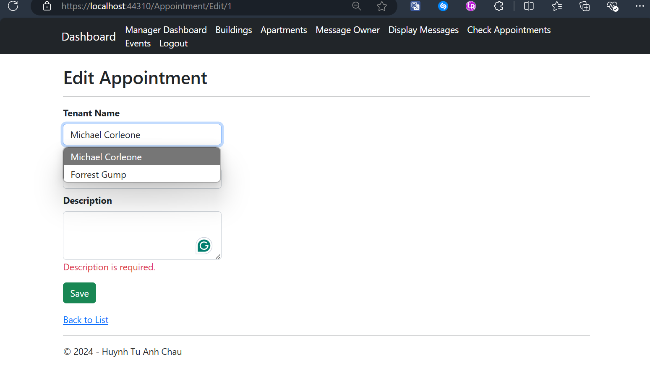
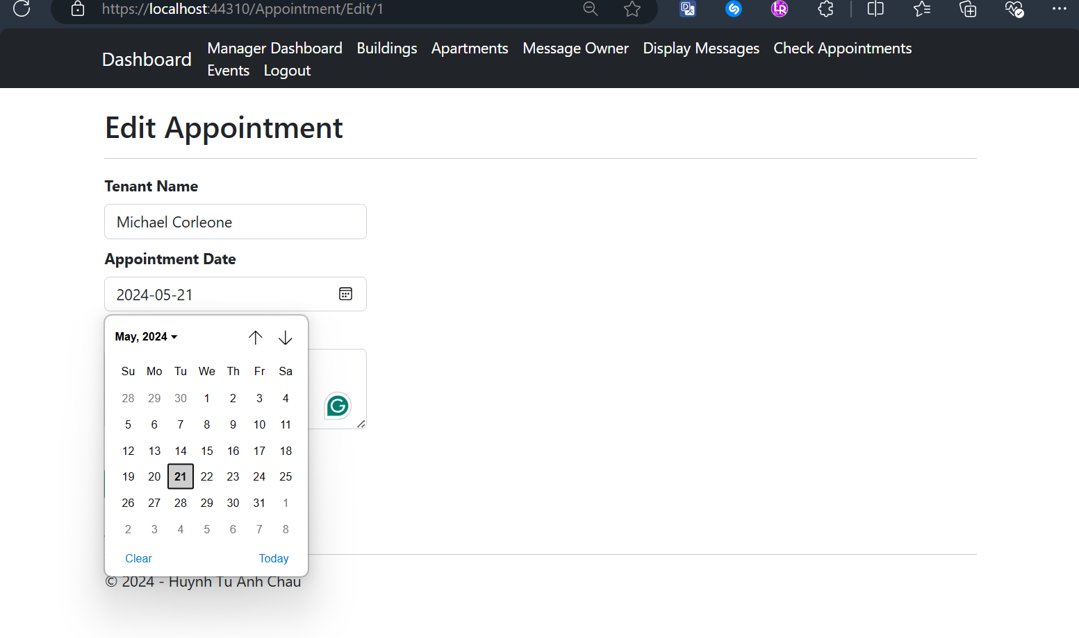

Manager Deletes an Appointment with confirmation Screen
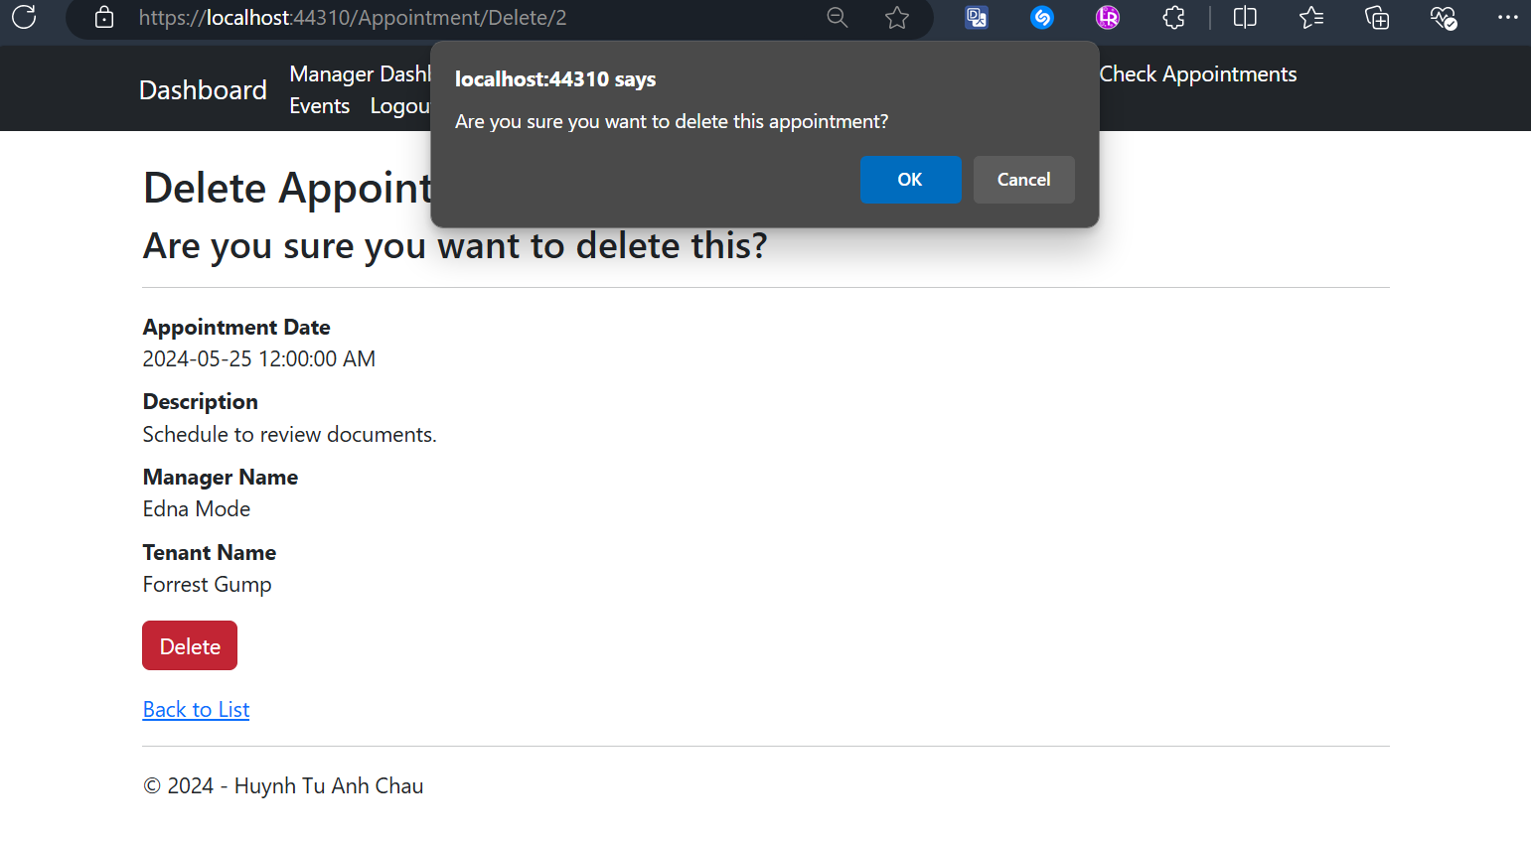

Manager Creates an Appointment with Tenants (fetching from database) with Validation Screens
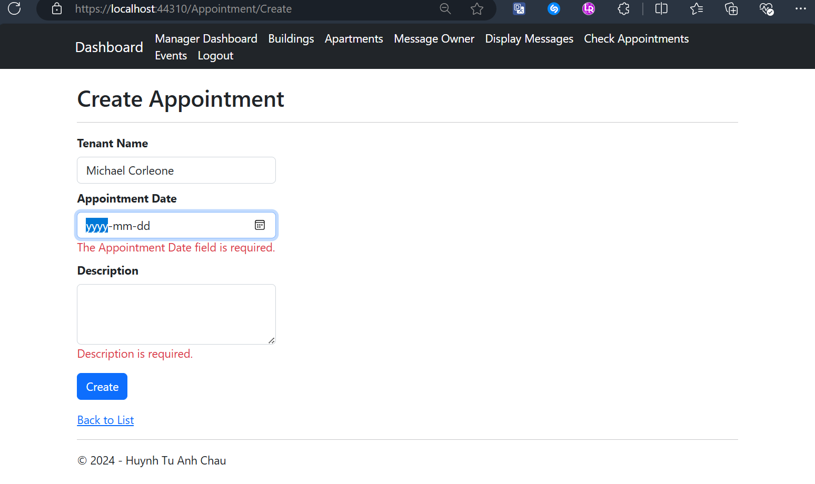
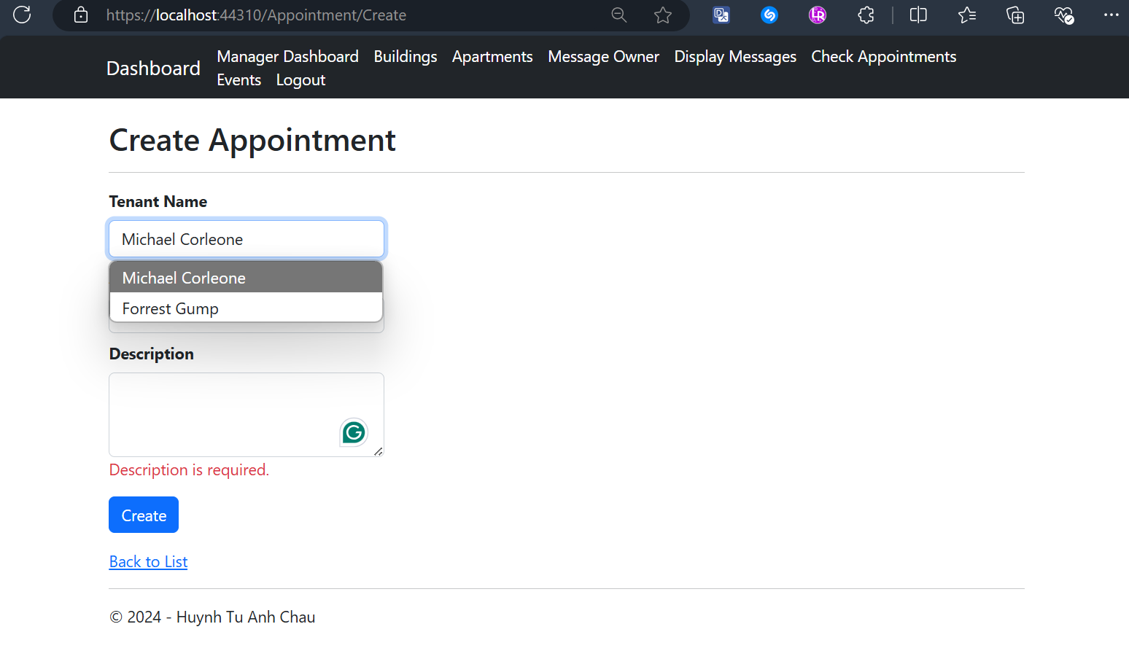

Manager Views All Created Events with CRUD actions Screen
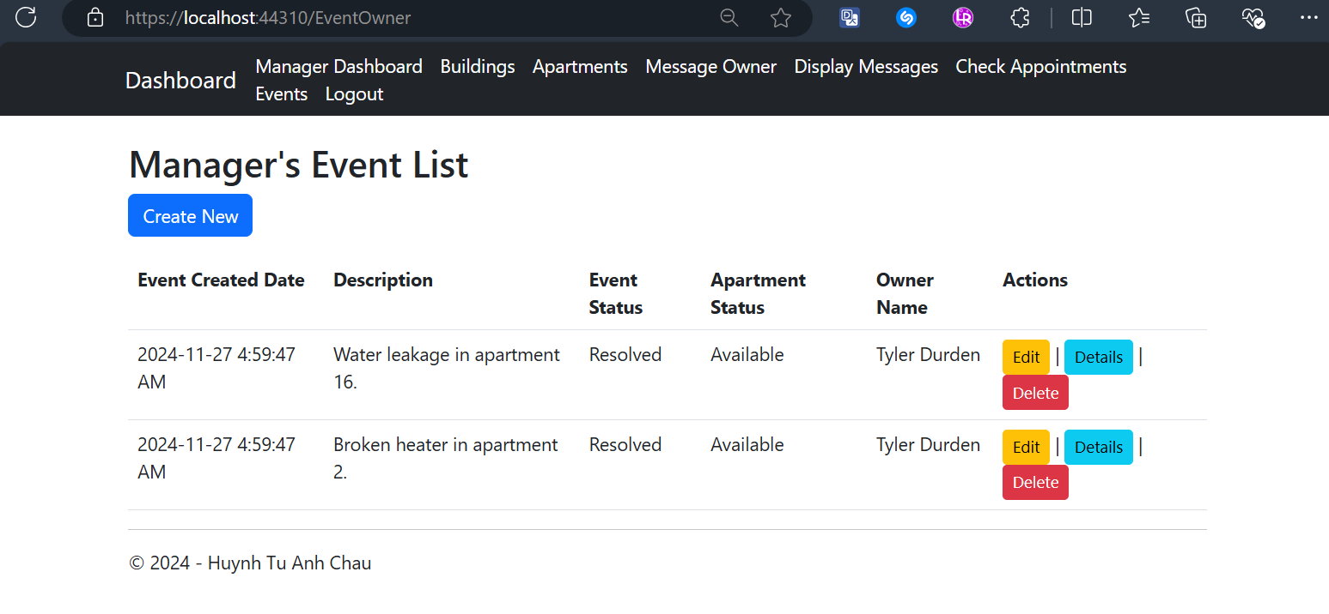

Managers Views and Edits Description of an Event Screen
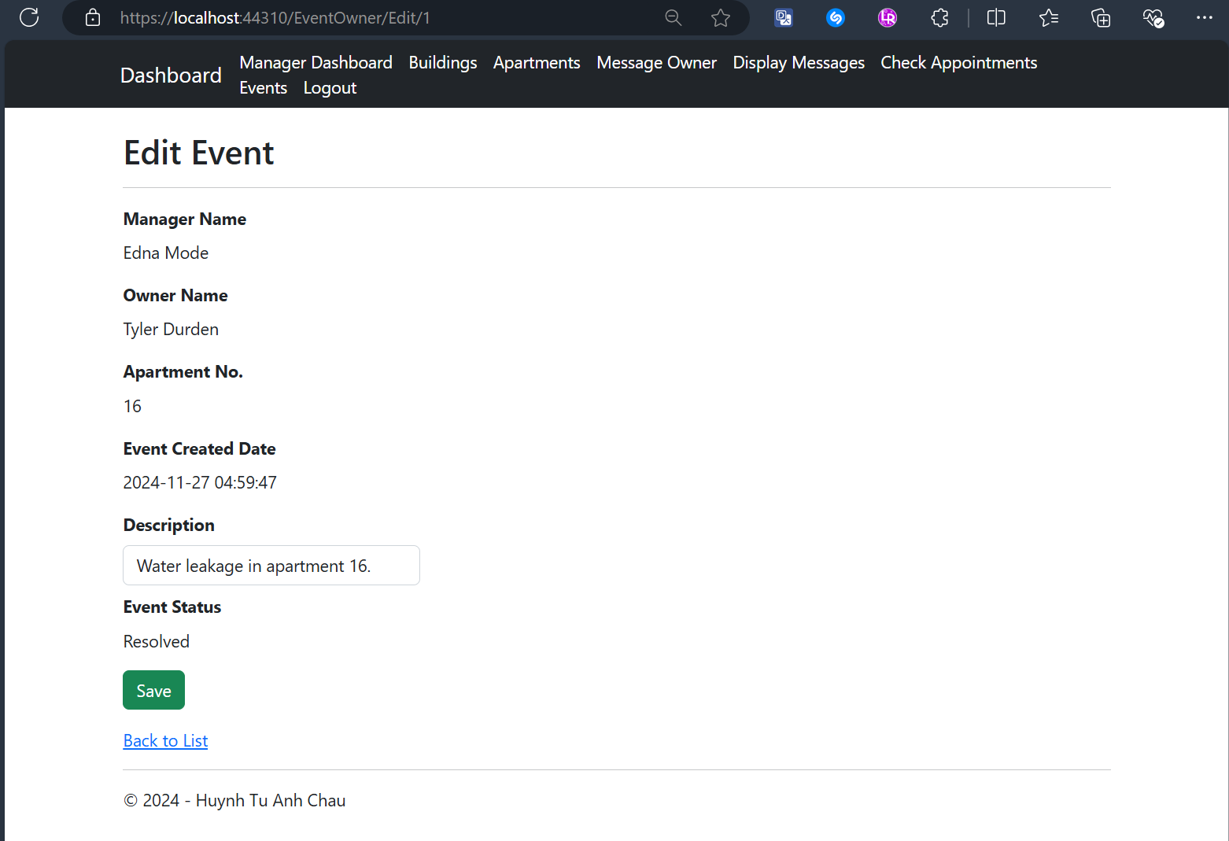

Manager Views Details of an Event Screen
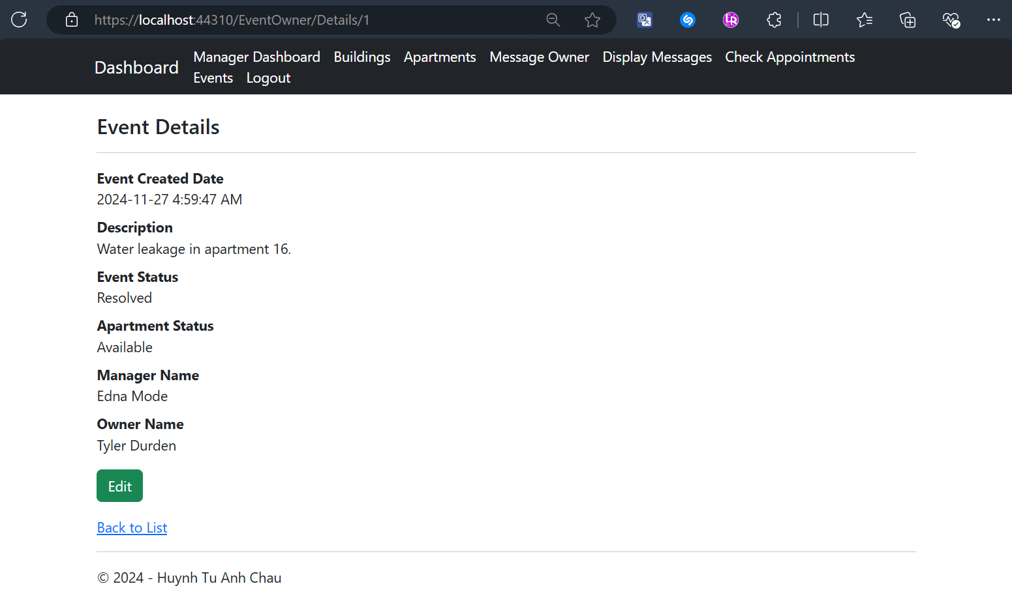

Manager Deletes an Event with Confirmation Screen
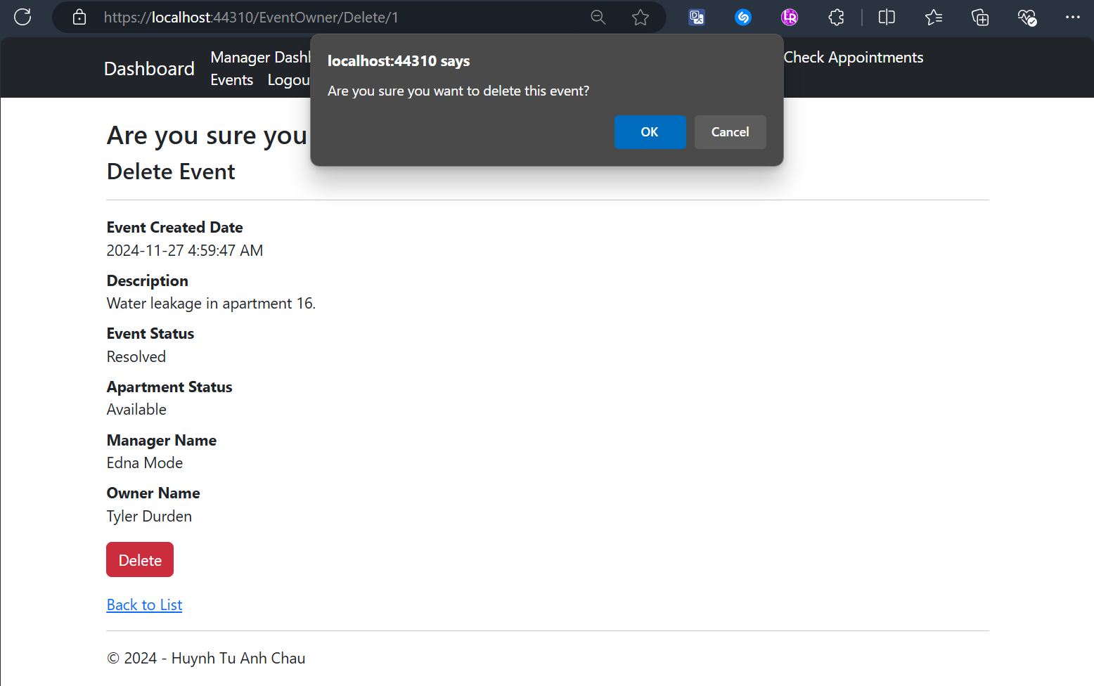

Manager Creates an Event with Validation Screen
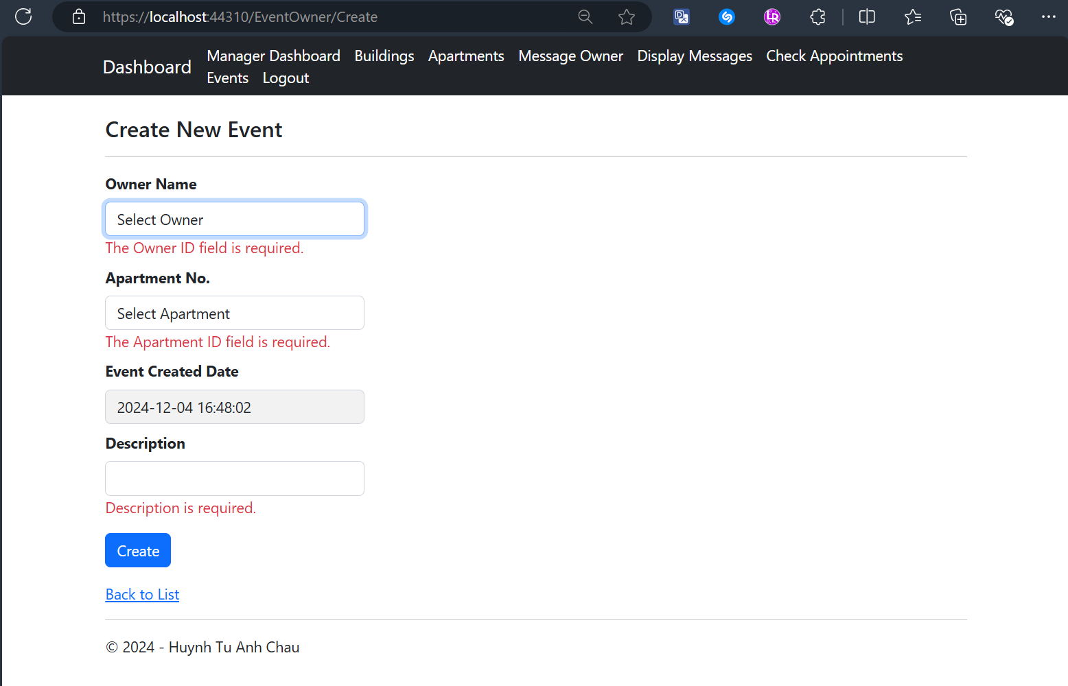

Tenant Dashboard After Logging-In Screen
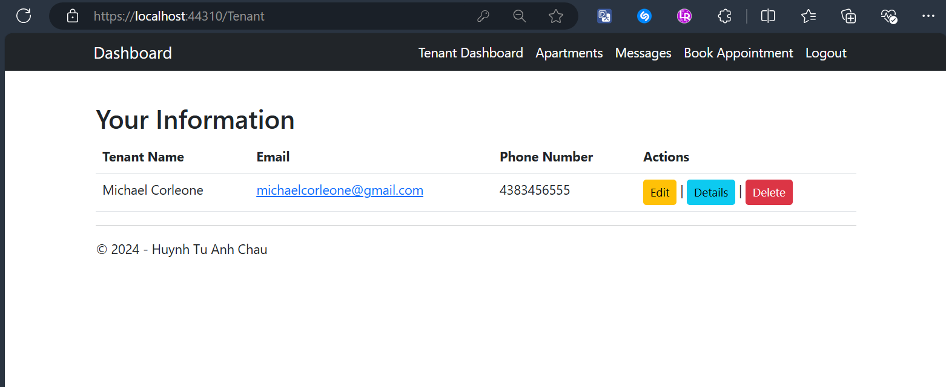

Tenants Edit Their Profile with Validation Screen
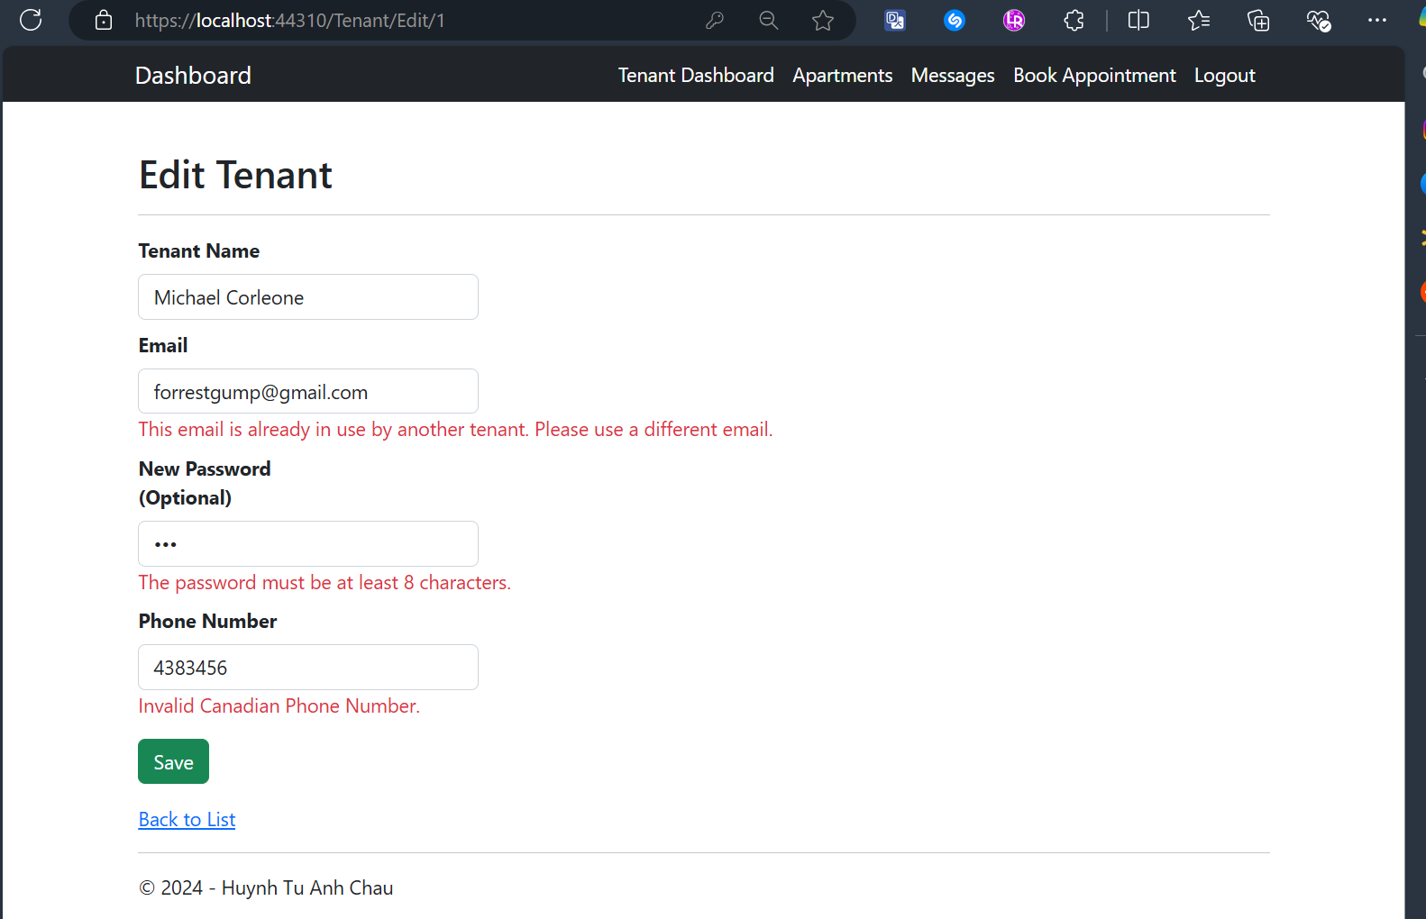

Tenants View Their Profiles’ Details
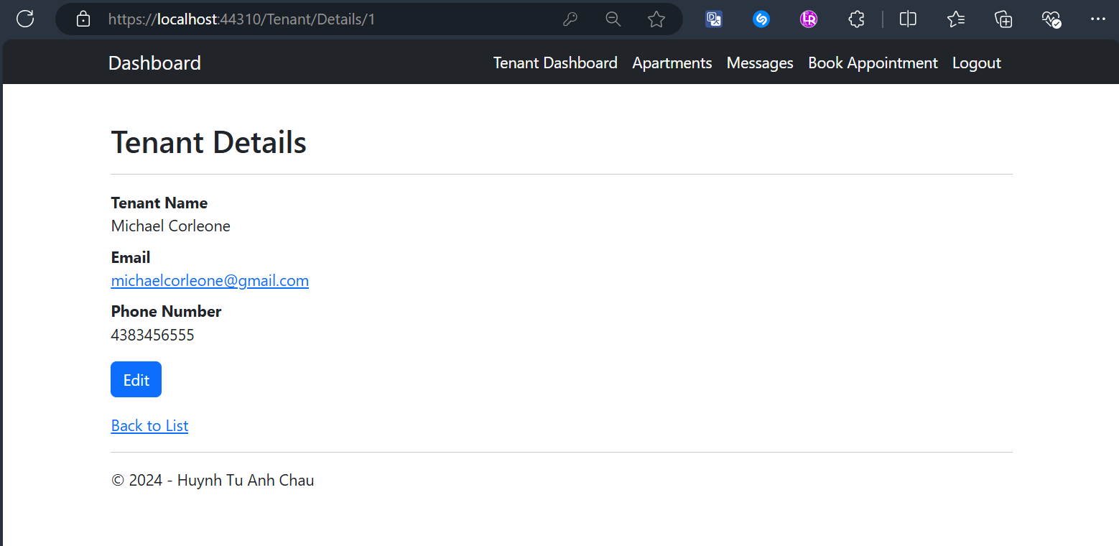

Tenants Delete Their Profile with Confirmation Screen
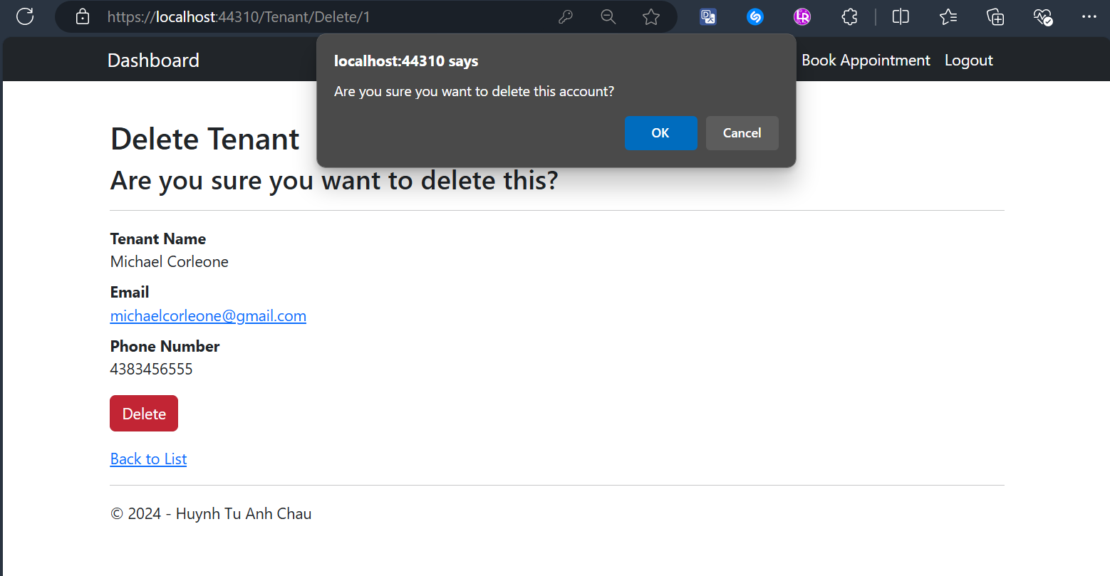

Tenant Views Only Available and Assigned Apartments with Details Button Screens
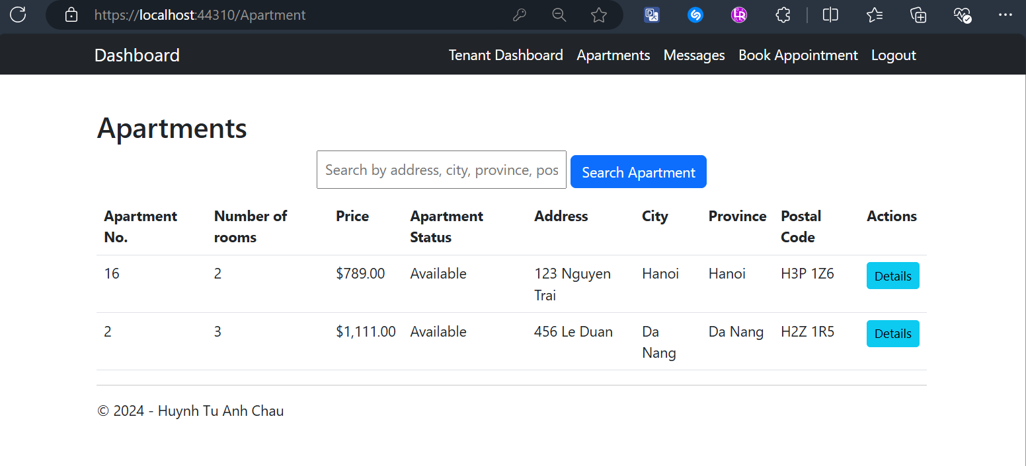
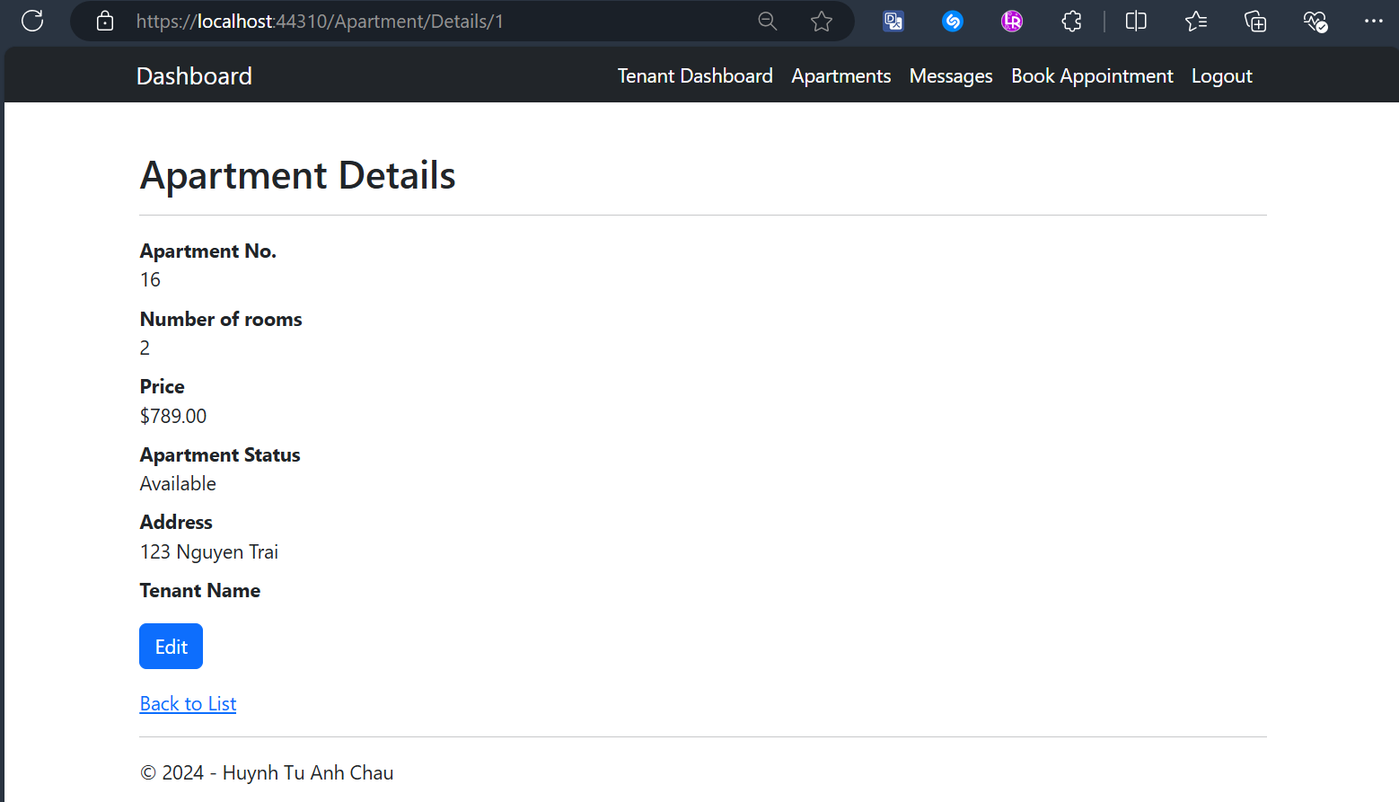

Tenant Searches for an Apartment Result Screens
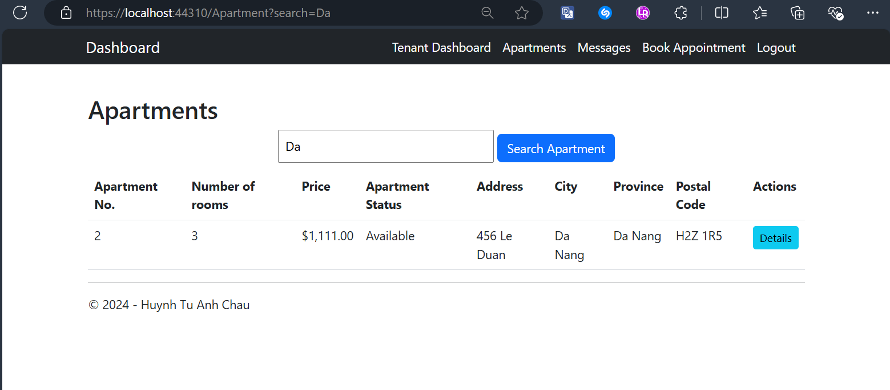
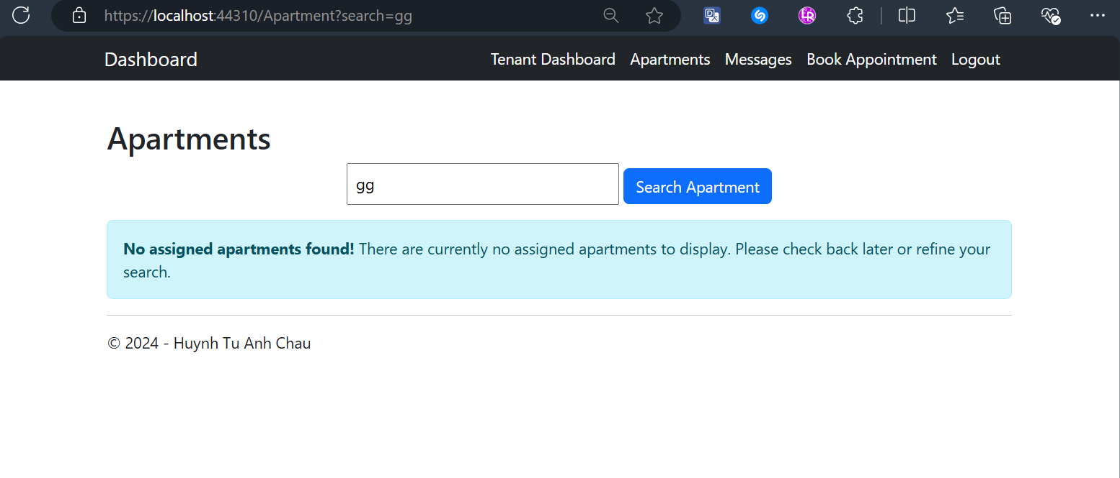

Tenant Views All Created Messages with CRUD actions Screen
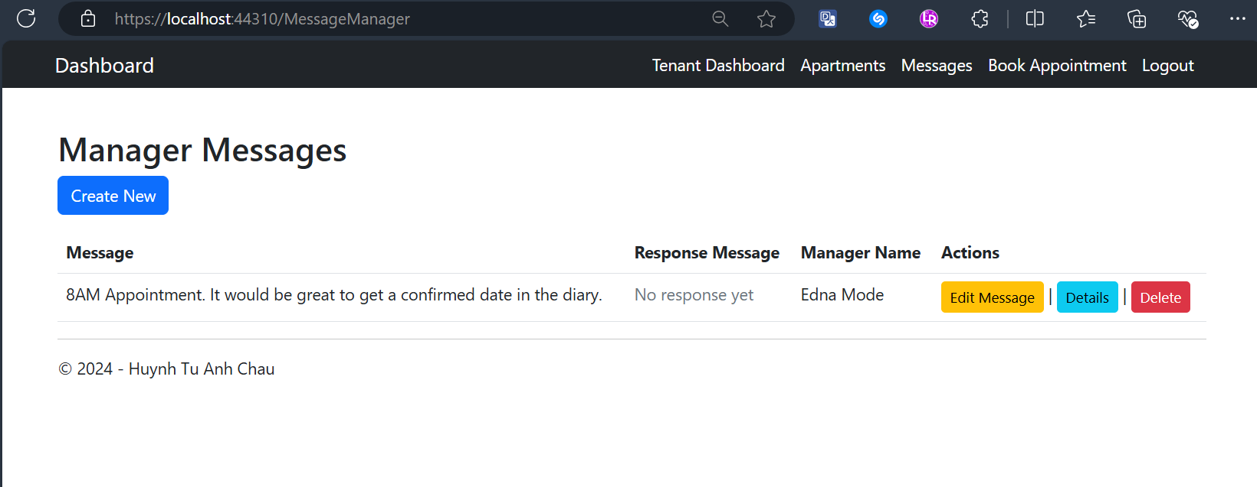

Tenant Edits a Message with Validation Screen
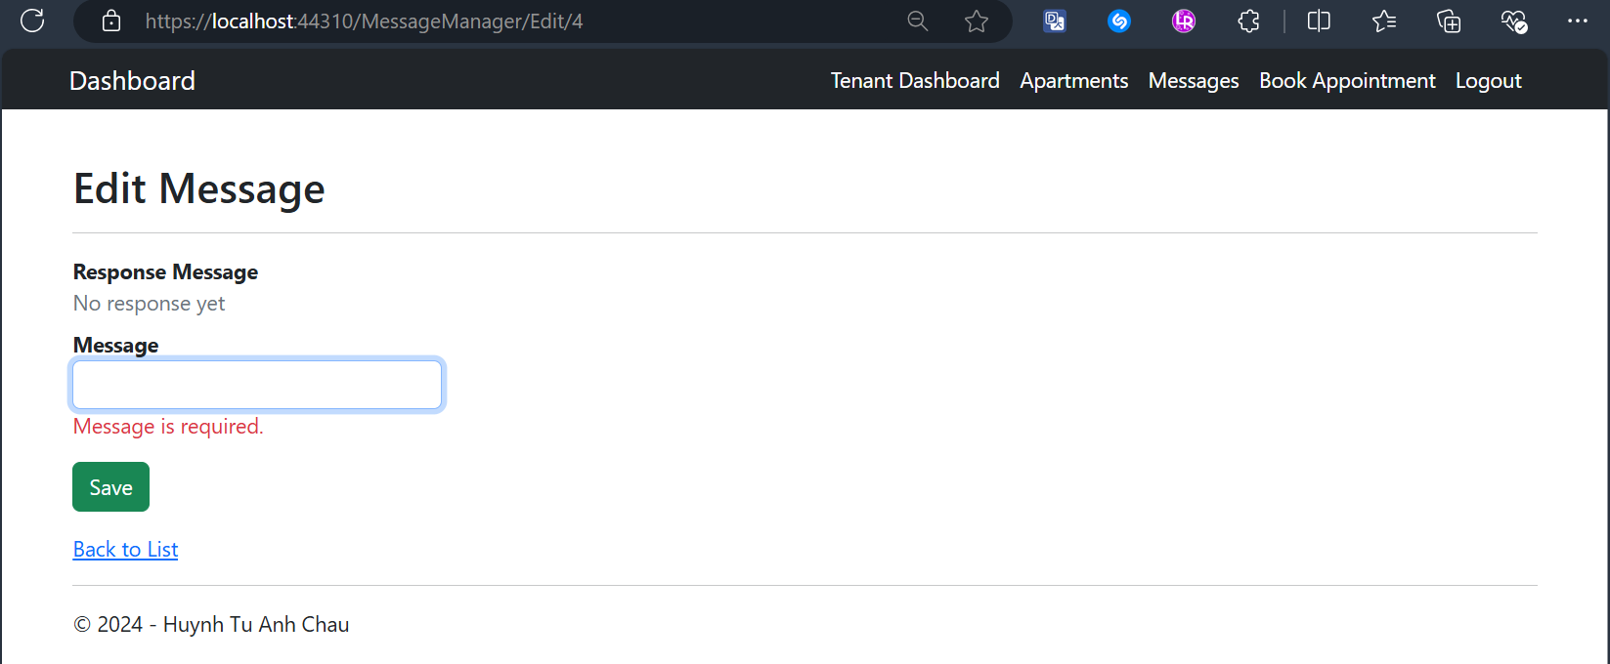

Tenant Views a Message’s Details Screen
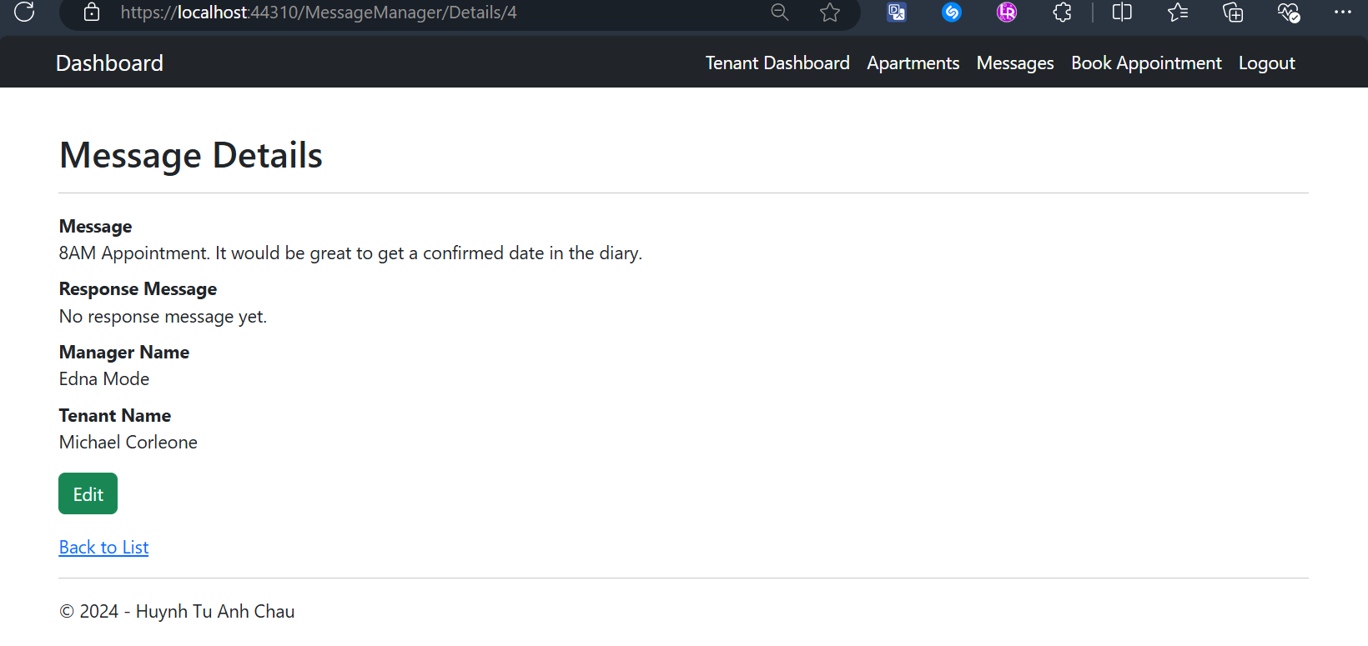

Tenant Deletes a Message with Confirmation Screens
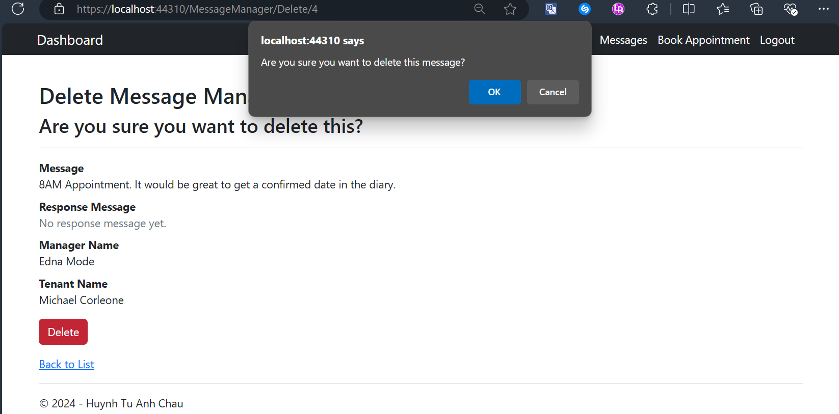
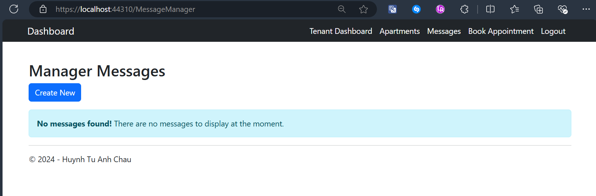

Tenant Creates a New Message to Managers (fetching from database) with Validation Screen
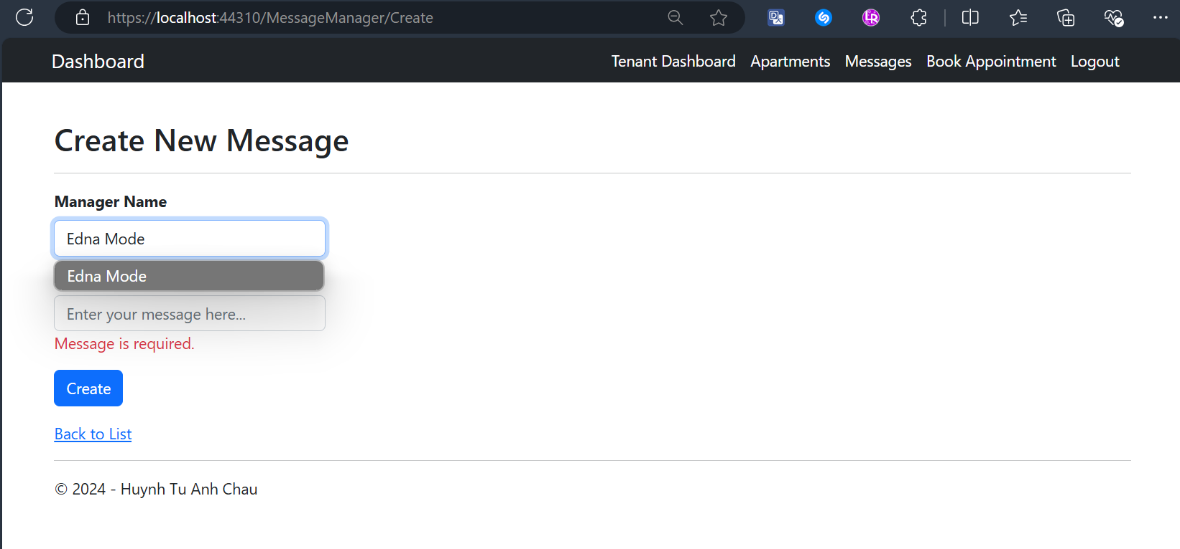

Tenant Creates a New Appointment with Validation Screen
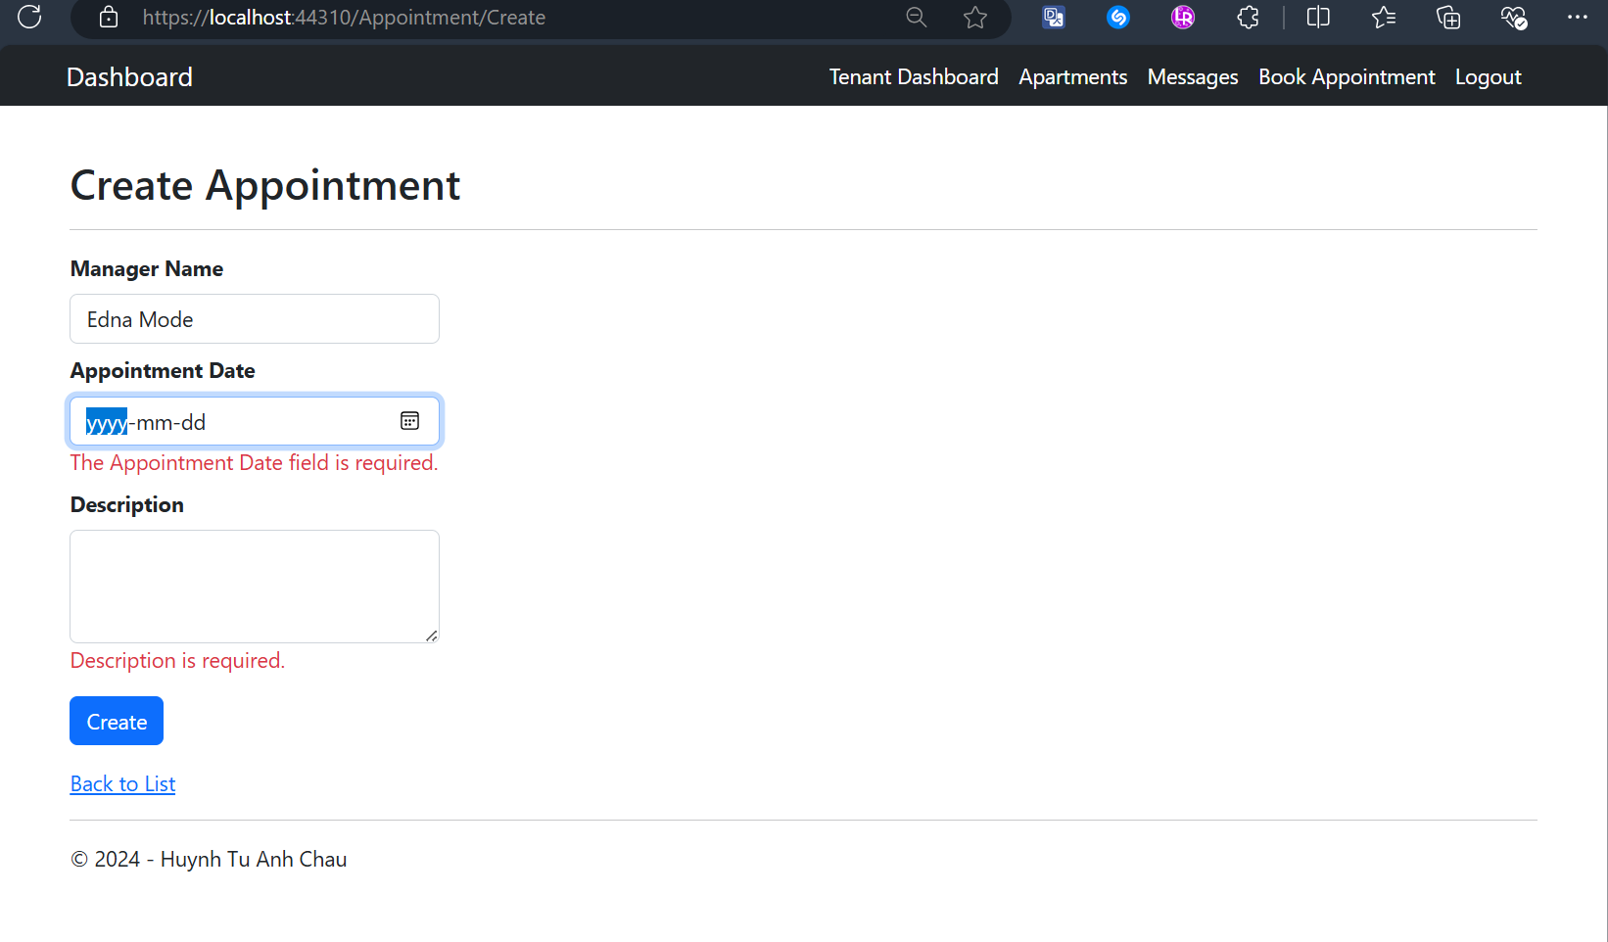

Tenant Views All Created Appointments with CRUD actions Screen
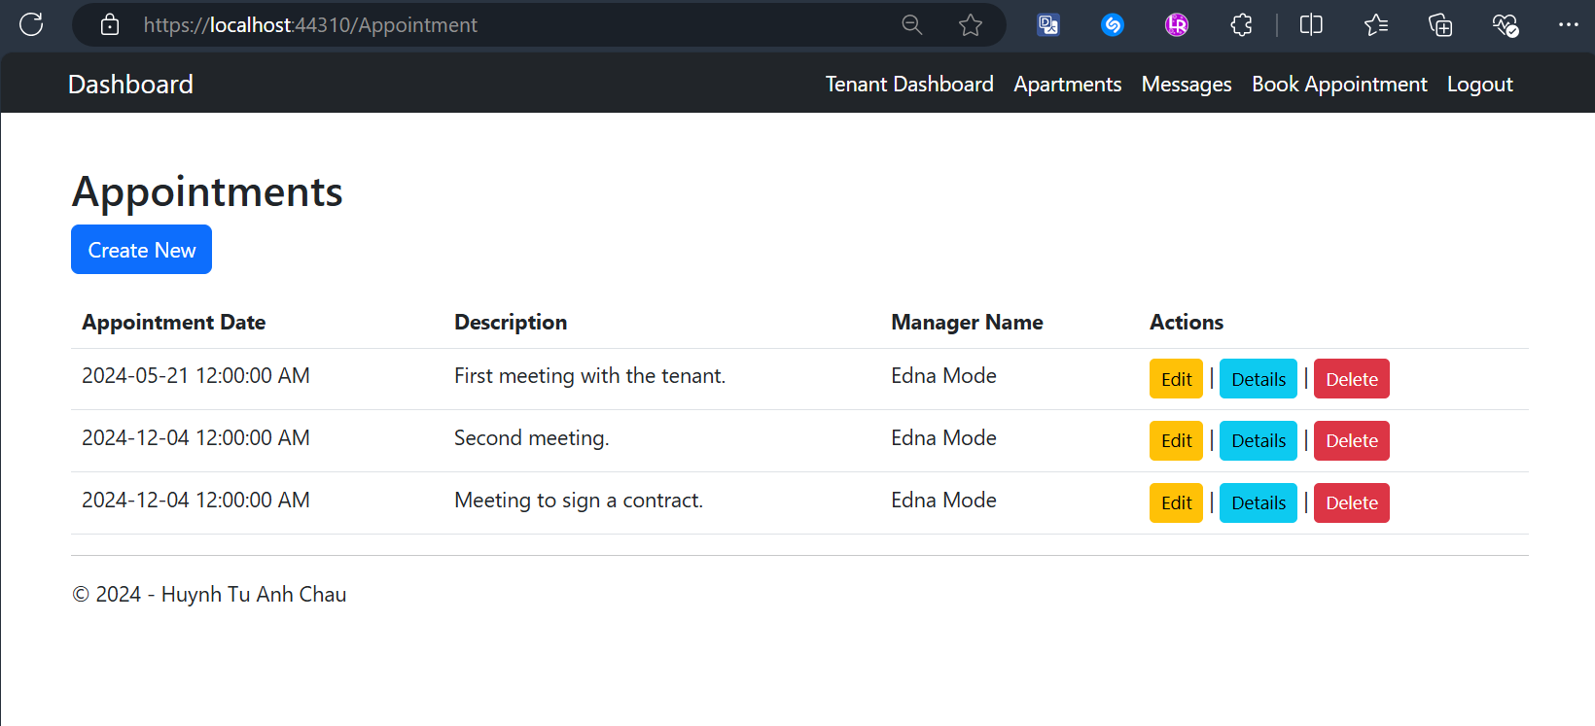

Tenant Edits an Appointment with Validation Screen
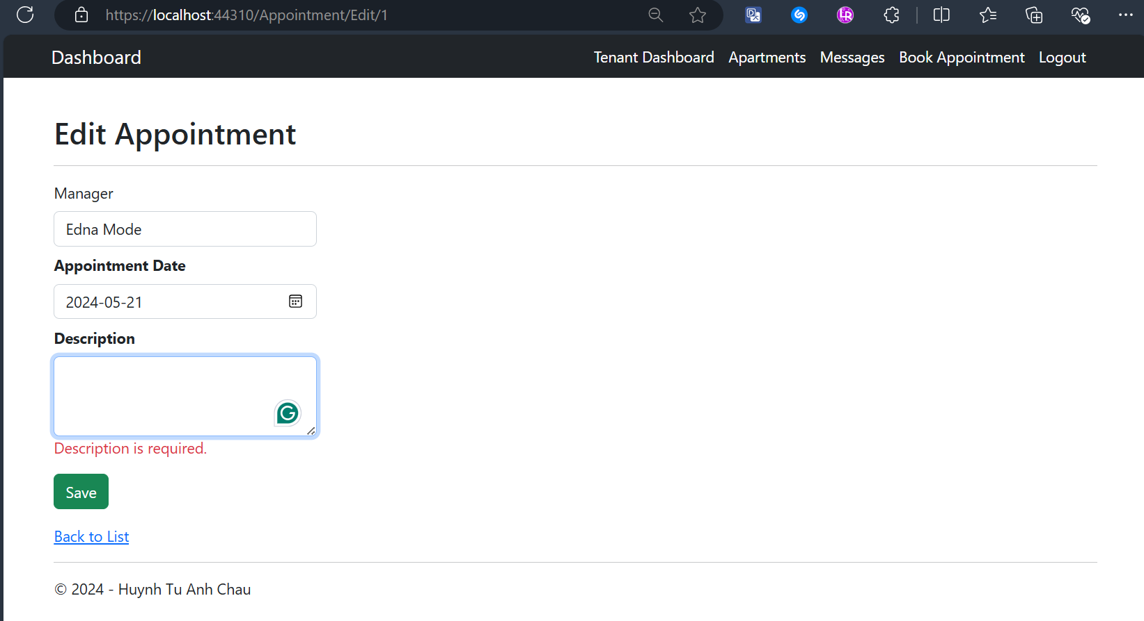

Tenant Deletes an Appointment with Confirmation Screen
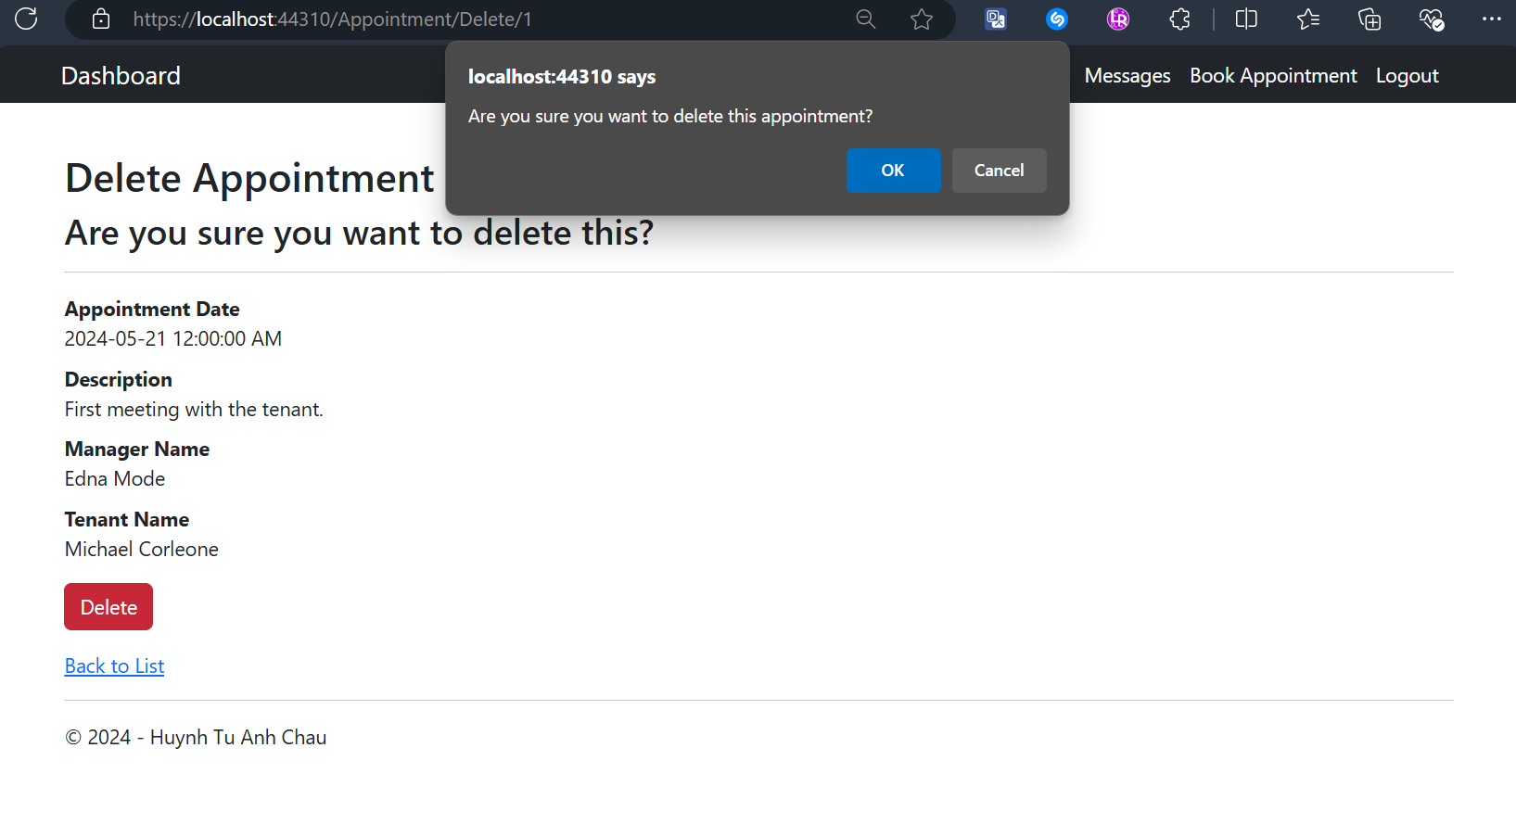

Conclusion
This project provided hands-on experience with ASP.NET MVC and Entity Framework. The implementation emphasized:
- Leveraging Entity Framework for efficient database operations.
- Applying session-based access control to enhance security.
- Developing user-friendly and responsive web interfaces.
The project also reinforced the importance of planning, testing, and adhering to best practices in web development.

Sample Data for User Login

Login as an Owner
  - Email: tylerdurden@gmail.com
  - Password: password123

Login as a Manager
  - Email: ednamode@gmail.com
  - Password: password123

Login as a Tenant
  - Email: michaelcorleone@gmail.com
  - Password: password123

Bibliography
• Microsoft ASP.NET Documentation: https://learn.microsoft.com/aspnet
• Entity Framework Documentation: https://learn.microsoft.com/ef
• Bootstrap Framework: https://getbootstrap.com

