User Can Create/Login using Contact Number.

User can view items, add/remove items to card and place the order.

Only written the api using spring boot to support above functionalities.

1. Create User - <http://localhost:8081/login>  
   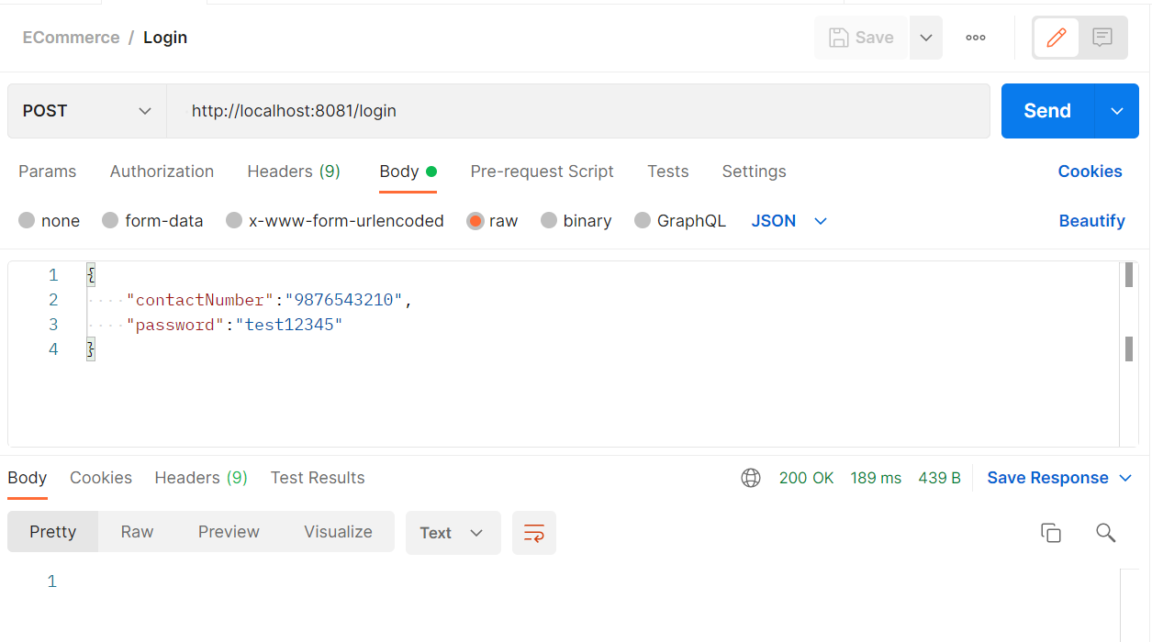
2. Login User - <http://localhost:8081/login> - Fetch JWT Token From Header  
   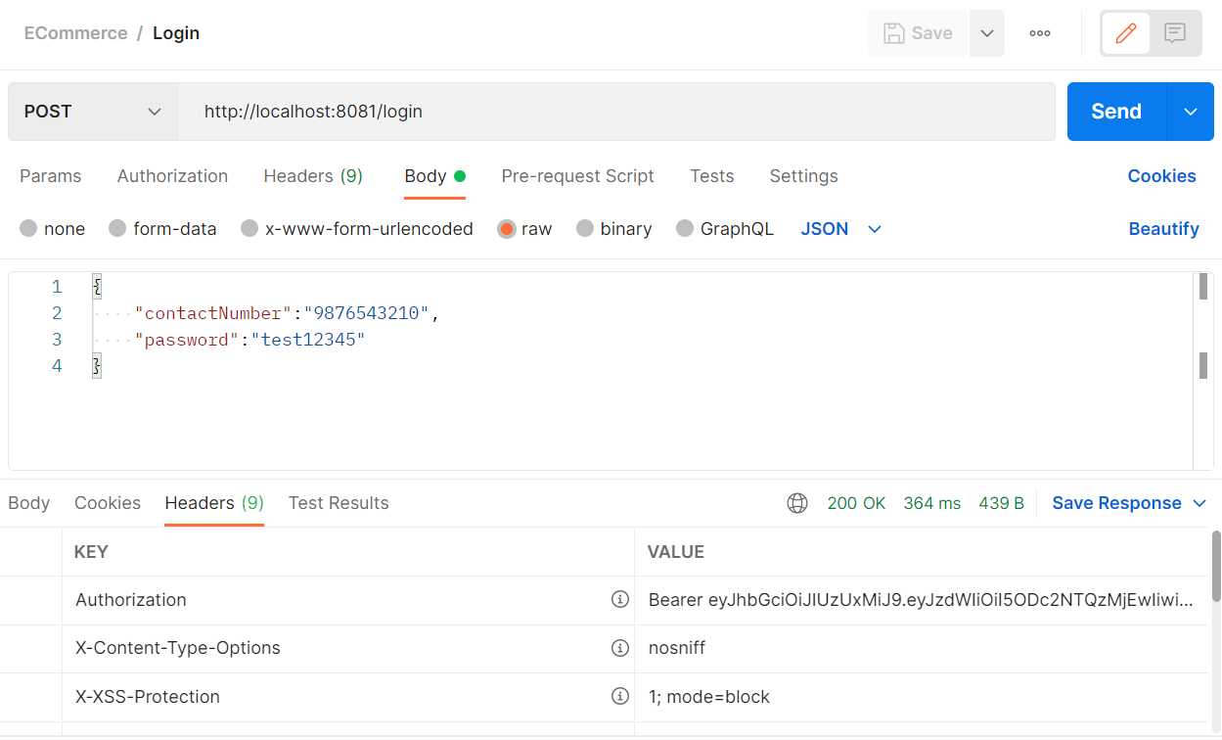
3. Get All Available Items - http://localhost:8081/api/item/  
   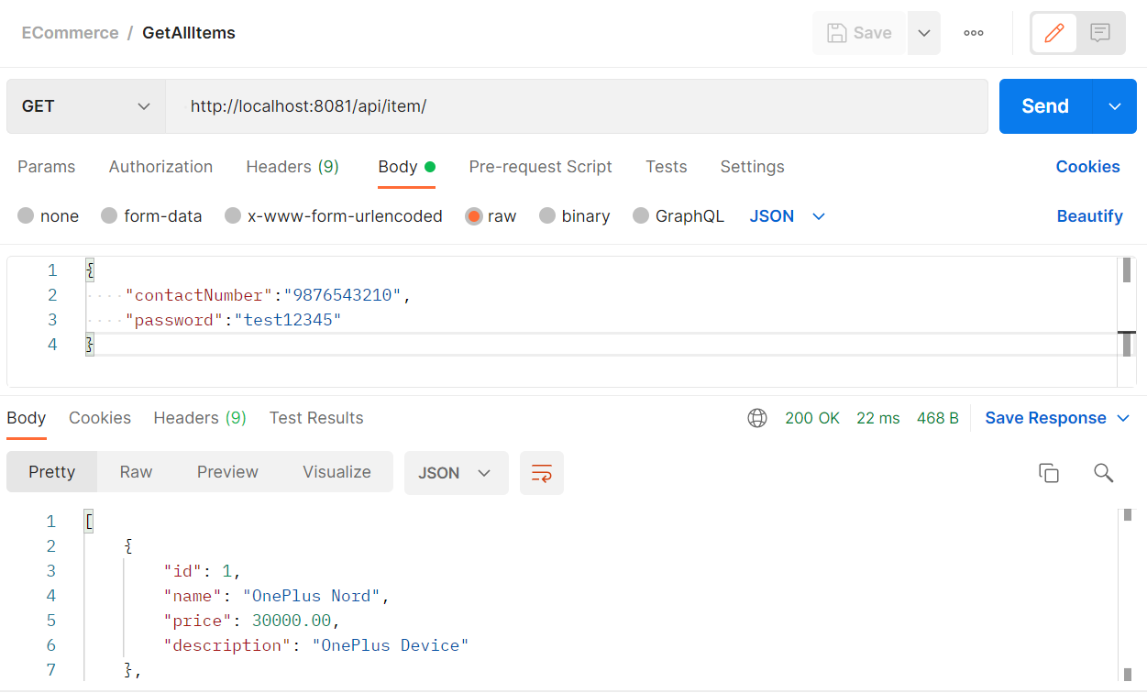
4. GetItemById- <http://localhost:8081/api/item/1>  
   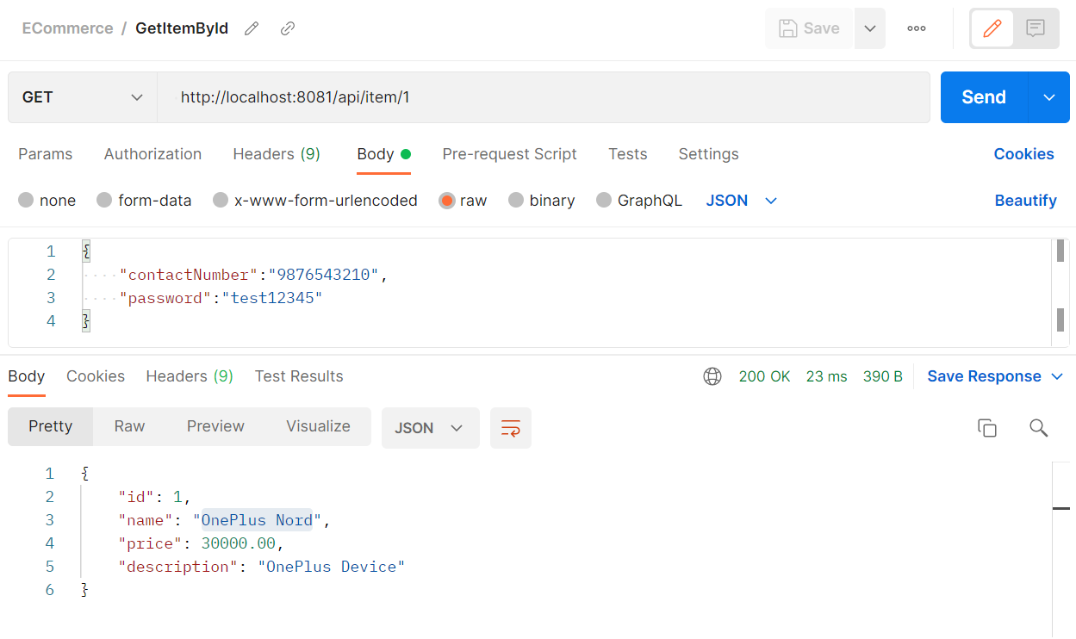
5. AddItemsToCart - <http://localhost:8081/api/cart/addToCart>  
   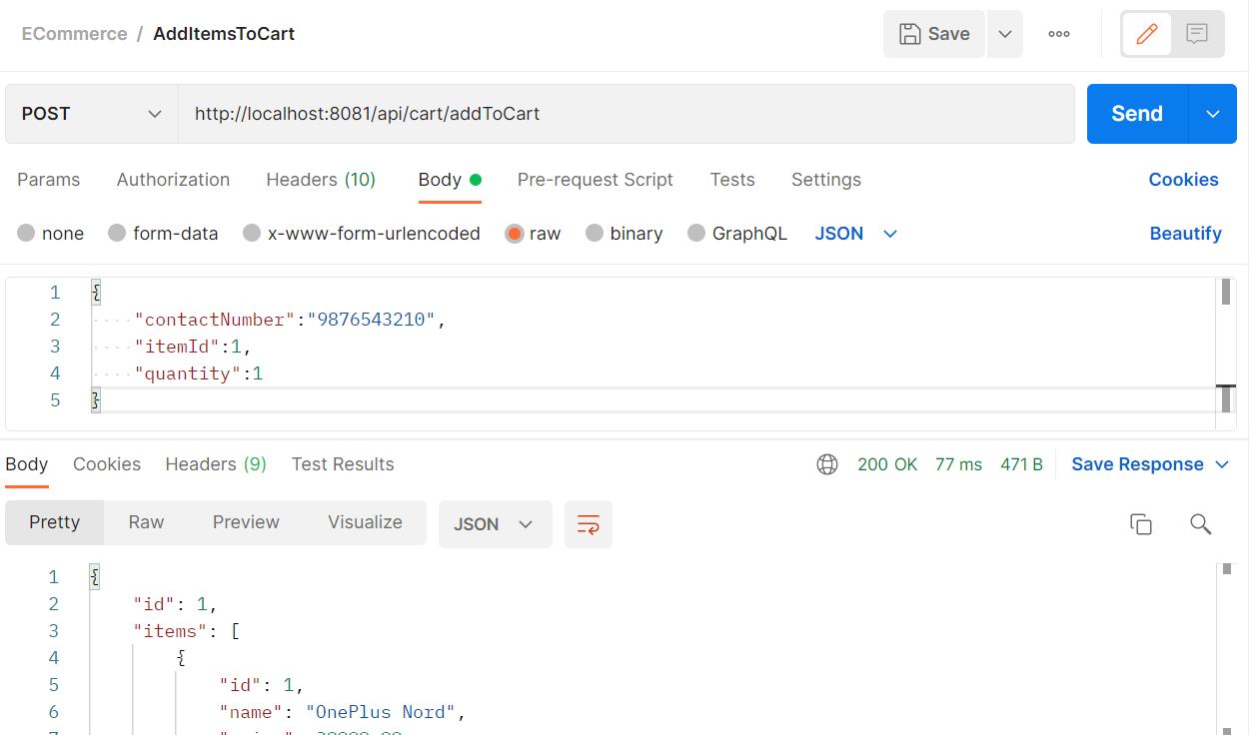
6. PlaceOrderFromCart - http://localhost:8081/api/order/submit/9876543210

