%%writefile cudabasic.cu

#include <stdlib.h>

#include <stdio.h>

#include <string.h>

double time_h = 0;

double time_d = 0;

int numOfRounds = 1;

void meanFilter_h (unsigned char* raw_image, unsigned char* filtered_image, int img_width, int img_height, int window_size)

{

int half_window = (window_size - 1) / 2;

for (int i=0; i < img_height; i++)

{

for(int j=0; j < img_width; j++)

{

int left_limit, right_limit, top_limit, bottom_limit;

if(j - half_window >= 0){

left_limit = j-half_window;

}else{

left_limit = 0;

}

if(j + half_window <= img_width-1){

right_limit = j + half_window;

}else{

right_limit = img_width-1;

}

if(i - half_window >= 0){

top_limit = i - half_window;

}else{

top_limit = 0;

}

if(i + half_window <= img_height-1){

bottom_limit = i + half_window;

}else{

bottom_limit = img_height-1;

}

double sum_r = 0, sum_g = 0, sum_b = 0;

for(int k = top_limit; k <= bottom_limit; k++)

{

for(int m = left_limit; m <= right_limit; m++)

{

int index = (k * img_width + m) * 3;

// Accumulate the values of each color channel separately

sum_r += raw_image[index];

sum_g += raw_image[index + 1];

sum_b += raw_image[index + 2];

}

}

int current_window_size = (bottom_limit - top_limit + 1) * (right_limit - left_limit + 1);

// Calculate the mean value for each color channel

filtered_image[(i * img_width + j) * 3] = sum_r / current_window_size;

filtered_image[(i * img_width + j) * 3 + 1] = sum_g / current_window_size;

filtered_image[(i * img_width + j) * 3 + 2] = sum_b / current_window_size;

}

}

}

__global__ void meanFilter_d (unsigned char* raw_image, unsigned char* filtered_image, int img_width, int img_height, int window_size)

{

int j = blockIdx.x * blockDim.x + threadIdx.x;

int i = blockIdx.y * blockDim.y + threadIdx.y;

int half_window = (window_size - 1) / 2;

if (i < img_height && j < img_width)

{

int left_limit, right_limit, top_limit, bottom_limit;

if(j - half_window >= 0){

left_limit = j-half_window;

}else{

left_limit = 0;

}

if(j + half_window <= img_width-1){

right_limit = j + half_window;

}else{

right_limit = img_width-1;

}

if(i - half_window >= 0){

top_limit = i - half_window;

}else{

top_limit = 0;

}

if(i + half_window <= img_height-1){

bottom_limit = i + half_window;

}else{

bottom_limit = img_height-1;

}

double sumR = 0, sumG = 0, sumB = 0;

int current_window_size = 0;

for(int k = top_limit; k <= bottom_limit; k++)

{

for(int m = left_limit; m <= right_limit; m++)

{

// Calculate the indices for Red, Green, and Blue components

int index = 3 * (k * img_width + m);

sumR += raw_image[index]; // Red component

sumG += raw_image[index + 1]; // Green component

sumB += raw_image[index + 2]; // Blue component

current_window_size++;

}

}

// Calculate the average values for Red, Green, and Blue components

unsigned char avgR = sumR / current_window_size;

unsigned char avgG = sumG / current_window_size;

unsigned char avgB = sumB / current_window_size;

// Write the average values to the filtered image

int output_index = 3 * (i * img_width + j);

filtered_image[output_index] = avgR; // Red component

filtered_image[output_index + 1] = avgG; // Green component

filtered_image[output_index + 2] = avgB; // Blue component

}

}

void saveBitmap(const char* filename, int width, int height, unsigned char* imageData,unsigned char *info) {

FILE* file = fopen(filename, "wb");

if (file == NULL) {

fprintf(stderr, "Error: Unable to open file %s for writing.\n", filename);

exit(1);

}

printf("File %s opened successfully for writing.\n", filename);

// Calculate padding bytes

int padding = (4 - (width * 3) % 4) % 4;

unsigned char fileHeader[138];

memcpy(fileHeader, info, 138);

// Write the file header

fwrite(fileHeader, sizeof(unsigned char), 138, file);

// Allocate memory for a single row including padding

unsigned char* paddedRow = (unsigned char*)malloc(sizeof(unsigned char) * (width * 3 + padding));

if (paddedRow == NULL) {

fprintf(stderr, "Error: Unable to allocate memory for padded row.\n");

fclose(file);

exit(1);

}

fwrite(imageData, sizeof(unsigned char), width * height * 3, file);

// Write padding bytes

//unsigned char paddingData[4] = {0, 0, 0, 0};

//for (int i = 0; i < padding; i++) {

// fwrite(paddingData, sizeof(unsigned char), 1, file);

// }

if (ferror(file)) {

fprintf(stderr, "Error writing to file.\n");

fclose(file);

free(paddedRow);

exit(1);

}

// Free allocated memory

// Close the file

fclose(file);

}

int main(int argc,char **argv)

{

printf("Begin......\n");

//get bitmap to a char array

FILE* file = fopen("/content/drive/MyDrive/img_640.bmp", "rb");

unsigned char info[138];

fread(info, sizeof(unsigned char), 138, file);

int width, height;

memcpy(&width, info + 18, sizeof(int));

memcpy(&height, info + 22, sizeof(int));

int window_size = 3;

int size = 3 * width * abs(height);

unsigned char *inputImage = (unsigned char*)malloc(size * sizeof(unsigned char));

unsigned char* result_image_data_d;

unsigned char *result_image_data_h=(unsigned char*)malloc(size * sizeof(unsigned char));

unsigned char *result_image_data_h1=(unsigned char*)malloc(size * sizeof(unsigned char));

unsigned char* image_data_d;

fread(inputImage, sizeof(unsigned char), size, file);

fclose(file);

int block_size = 32;

int grid_size = width/block_size;

dim3 dimBlock(block_size, block_size, 1);

dim3 dimGrid(grid_size, grid_size, 1);

for(int x = 0; x < numOfRounds; x += 1)

{

cudaMalloc((void **)&image_data_d,size*sizeof(unsigned char));

cudaMalloc((void **)&result_image_data_d,size*sizeof(unsigned char));

cudaMemcpy(image_data_d,inputImage,size*sizeof(unsigned char),cudaMemcpyHostToDevice);

clock_t start_d=clock();

//execution of GPU code

meanFilter_d <<< dimGrid, dimBlock >>> (image_data_d, result_image_data_d, width, height, window_size);

cudaDeviceSynchronize();

cudaError_t error = cudaGetLastError();

if(error!=cudaSuccess)

{

fprintf(stderr,"ERROR: %s\n", cudaGetErrorString(error) );

exit(-1);

}

clock_t end_d = clock();

cudaMemcpy(result_image_data_h, result_image_data_d, size * sizeof(unsigned char), cudaMemcpyDeviceToHost);

saveBitmap("image1.bmp", width, height, result_image_data_h,info);

clock_t start_h = clock();

//executing CPU code

meanFilter_h(inputImage, result_image_data_h1, width, height, window_size);

clock_t end_h = clock();

time_h += (double)(end_h-start_h)/CLOCKS_PER_SEC;

time_d += (double)(end_d-start_d)/CLOCKS_PER_SEC;

cudaFree(image_data_d);

cudaFree(result_image_data_d);

}

printf("Average GPU execution time: %f\n",(time_d/numOfRounds));

printf("Average CPU execution time: %f\n",(time_h/numOfRounds));

printf("CPU/GPU time: %f\n",(time_h/time_d));

return 0;

}

**Output**

Begin......

File image1.bmp opened successfully for writing.

Average GPU execution time: 0.001159

Average CPU execution time: 0.041736

CPU/GPU time: 36.010354

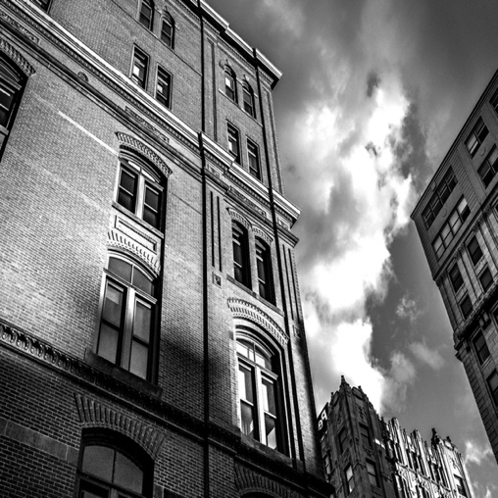

Original Image

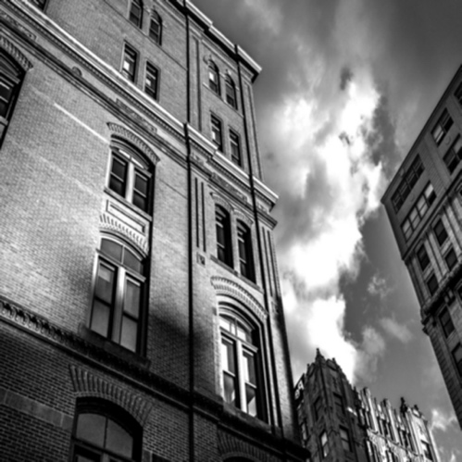

Blurred Image