MUSIC STORE DATABASE
Business Requirements Document (BRD)
Customer, Catalogue, Playlist, Order and Payment Data Platform
Version 1.0 | 4 August 2026
Source basis: Music_store_db.sql

Document Control
Field | Value
Document title | Music Store Database - Business Requirements Document
Version | 1.0
Status | Design baseline
Prepared for | Music Store Database Design Project
Source schema | Music_store_db.sql
Database platform | PostgreSQL
Schema coverage | 14 tables, 93 columns, 16 foreign keys, 9 enum types

Source-derived content reflects the uploaded SQL schema. Items identified as “proposed” or “assumed” are design recommendations that are not explicitly enforced by the current SQL file.

1. Executive Summary
The Music Store Database provides a normalized PostgreSQL foundation for managing registered customers, music metadata, artist and genre relationships, customer playlists, product purchases, order line items, and payment transactions. The design separates catalogue data from customer activity and commerce data while preserving referential integrity through primary keys, foreign keys, unique constraints, enumerated domains, and check constraints.
The database supports the purchase of either individual tracks or complete albums. It also supports many-to-many relationships between artists and albums, artists and tracks, and tracks and genres. Customer playlists retain track order and visibility settings. Orders preserve historical line prices, and payments are recorded separately so that multiple payment attempts can be associated with one order.

2. Business Context and Problem Statement
A digital music store needs a consistent data model that avoids duplicate catalogue records, correctly represents collaborations and classifications, supports customer-curated playlists, and records purchases and payment outcomes without mixing product, order, and payment concepts. The database must also maintain reliable relationships for reporting and future application development.

3. Business Objectives
- Maintain a trusted master catalogue of artists, albums, tracks, genres, and media formats.
- Support artist collaborations and role-based credits at album and track level.
- Allow customers to register, maintain status, and create ordered playlists.
- Support the purchase of individual tracks or complete albums.
- Separate order capture, order line items, and payment transactions.
- Enforce essential data-quality and integrity rules in PostgreSQL.
- Provide a foundation for sales, catalogue, playlist, and payment reporting.

4. Stakeholders
Stakeholder | Interest / Responsibility
Customer | Registers, browses the catalogue, creates playlists, and purchases music.
Catalogue administrator | Maintains artists, albums, tracks, genres, media types, prices, and release metadata.
Commerce administrator | Reviews orders, line items, totals, statuses, and payment outcomes.
Application developer | Builds APIs, user interfaces, and business workflows on the schema.
Database administrator | Deploys, secures, backs up, tunes, and monitors PostgreSQL.
Business analyst / reporting user | Uses the model for customer, catalogue, playlist, sales, and payment analysis.

5. Scope

5.1 In Scope
- Customer identity, location, registration date, and lifecycle status.
- Artist profiles and lifecycle status.
- Albums, album types, prices, release dates, and cover-image references.
- Track metadata, duration, pricing, explicit-content indicator, track/disc sequence, and media format.
- Album-artist, track-artist, and track-genre many-to-many associations.
- Customer playlists, visibility, descriptions, track positions, and added timestamps.
- Order header totals, statuses, currency, and audit timestamps.
- Order items for either tracks or albums.
- Payment amount, status, mode, date, and transaction reference.

5.2 Out of Scope
- Audio file storage, streaming, content delivery, and digital-rights management.
- Shopping cart, wish list, recommendations, reviews, ratings, and social following.
- Discount-code master data, taxation rules, invoicing, and refund allocation details.
- Royalty calculation, licensing, rights ownership, and artist settlement.
- Authentication credentials, passwords, multifactor authentication, and authorization roles.
- Physical inventory, shipping, and fulfilment.

6. High-Level Business Processes
Process | Description
Customer registration | Create a customer with a unique email, registration date, and active status.
Catalogue setup | Create media types, genres, artists, albums, album credits, tracks, track credits, and genre assignments.
Playlist management | Create a customer playlist, define visibility, add tracks, and maintain a unique position for each track.
Order capture | Create an order for a customer and calculate subtotal, tax, discount, and total.
Order item capture | Add one or more track or album line items while storing the price charged at purchase time.
Payment processing | Record one or more payment attempts or transactions against an order and maintain status and payment mode.
Reporting | Join customer, catalogue, order, item, and payment data for operational and analytical queries.

7. Functional Requirements
ID | Requirement
FR-01 | The system shall create and maintain customer records with unique email addresses.
FR-02 | The system shall maintain customer status as active, inactive, or blocked.
FR-03 | The system shall maintain artist profiles and artist status.
FR-04 | The system shall maintain albums classified as album, EP, single, or compilation.
FR-05 | The system shall associate multiple artists with an album and record the artist role.
FR-06 | The system shall maintain a unique controlled list of genres.
FR-07 | The system shall maintain a unique controlled list of media types.
FR-08 | The system shall maintain track metadata, price, duration, media format, explicit-content flag, disc number, and track number.
FR-09 | The system shall associate tracks with multiple artists and contribution roles.
FR-10 | The system shall associate tracks with multiple genres.
FR-11 | The system shall allow a customer to create multiple playlists.
FR-12 | The system shall maintain playlist visibility as private, public, or unlisted.
FR-13 | The system shall preserve the position and added timestamp of each track in a playlist.
FR-14 | The system shall create purchase orders for registered customers.
FR-15 | The system shall maintain order status as pending, confirmed, completed, cancelled, or refunded.
FR-16 | The system shall store subtotal, tax, discount, total, and currency for each order.
FR-17 | The system shall add track or album items to an order.
FR-18 | The system shall ensure that an order item references either a track or an album, not both.
FR-19 | The system shall store the unit price and quantity used for each order item.
FR-20 | The system shall record one or more payments against an order.
FR-21 | The system shall maintain payment status and payment mode using controlled values.
FR-22 | The system shall store a unique payment transaction reference when supplied.
FR-23 | The system shall provide creation and update timestamps for auditable master and transaction records.

8. Business Rules
ID | Rule
BR-01 | Customer email must be unique and not null.
BR-02 | Customer status is limited to active, inactive, or blocked.
BR-03 | Artist debut year, when supplied, must be at least 1800.
BR-04 | Album and track prices cannot be negative.
BR-05 | Every track must reference an album and a media type.
BR-06 | Track duration, track number, and disc number must be greater than zero.
BR-07 | The album, disc number, and track number combination must be unique.
BR-08 | Playlist name must be unique within a customer account.
BR-09 | Playlist track position must be positive and unique within a playlist.
BR-10 | Order subtotal, tax, discount, and total cannot be negative.
BR-11 | Order total must equal subtotal plus tax minus discount.
BR-12 | An order item must reference exactly one product type: track or album.
BR-13 | Order item quantity must be greater than zero.
BR-14 | Payment amount must be greater than zero.
BR-15 | Payment transaction reference must be unique when present.

9. Data Requirements and Entity Summary
Entity | Purpose | Primary Key
customer | Customer master | customer_id
artist | Artist master | artist_id
album | Album/release catalogue | album_id
album_artist | Album-to-artist association | album_id + artist_id
genre | Music genre master | genre_id
media_type | Audio/media format master | media_type_id
track | Track catalogue | track_id
track_genre | Track-to-genre association | track_id + genre_id
track_artist | Track-to-artist association | track_id + artist_id
playlist | Customer playlist header | playlist_id
playlist_track | Playlist track membership and sequence | playlist_id + track_id
orders | Customer purchase order | order_id
order_item | Purchased track or album line | order_item_id
payment | Order payment transaction | payment_id

10. Entity Relationship Design
The logical ERD below shows the major entities and the associative tables that resolve many-to-many relationships. The separately delivered physical ERD contains all columns and key indicators.
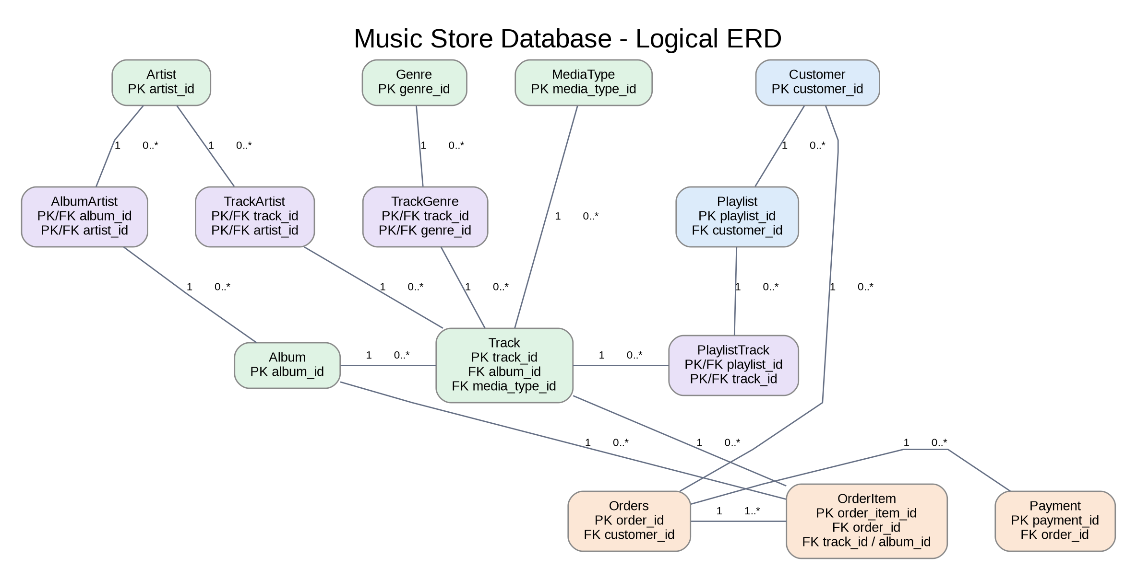
Figure 1. Music Store Database logical entity relationship diagram

11. Non-Functional Requirements
The following are proposed implementation requirements. They are not all explicitly enforced by the current SQL schema.
ID | Category | Requirement
NFR-01 | Integrity | PostgreSQL shall enforce primary keys, foreign keys, enums, unique constraints, and check constraints.
NFR-02 | Performance | Foreign-key and common search columns shall be indexed based on query workload.
NFR-03 | Security | Application connections shall use least-privilege database roles and encrypted transport.
NFR-04 | Privacy | Customer contact data shall be protected and access shall be limited to authorized users.
NFR-05 | Auditability | Created and updated timestamps shall be populated consistently; updated_at should be maintained through application logic or a database trigger.
NFR-06 | Reliability | Database backups and restore tests shall be scheduled and documented.
NFR-07 | Scalability | The design shall support increasing catalogue, playlist, order, and payment volumes without changing core relationships.
NFR-08 | Data quality | Email, enum, pricing, quantity, duration, and total validation failures shall be rejected.

12. Proposed Reports and Queries
- Customer registration and status summary by country and city.
- Artist, album, and track catalogue by release type and release date.
- Track catalogue by genre, media type, artist, and explicit-content flag.
- Playlist count and track count by customer and visibility.
- Order value, tax, discount, and status summary by day or customer.
- Top-selling tracks and albums using order-item quantity and unit price.
- Successful, failed, pending, and refunded payments by payment mode.
- Orders with no successful payment or with multiple payment attempts.

13. Acceptance Criteria
ID | Acceptance Criterion
AC-01 | All 14 schema tables deploy successfully in PostgreSQL.
AC-02 | All primary keys, composite keys, foreign keys, enums, and checks are created.
AC-03 | Duplicate customer emails and duplicate controlled names are rejected.
AC-04 | A track cannot be inserted without a valid album and media type.
AC-05 | Duplicate album/disc/track positions are rejected.
AC-06 | A customer can create a playlist and add tracks in unique positive positions.
AC-07 | An order item referencing both a track and an album is rejected.
AC-08 | An order with an incorrect total calculation is rejected.
AC-09 | A positive payment can be associated with a valid order.
AC-10 | Core catalogue, playlist, order, and payment joins return consistent results.

14. Assumptions, Limitations, and Design Observations
- The database represents a digital music store and does not store audio binary content.
- Every track belongs to an album record; standalone singles are represented as albums of type single.
- Order currency is stored as a three-character code, but the schema does not validate it against an ISO currency master.
- Tax and discount calculations occur before insert or update; the database only validates the resulting total formula.
- The schema supports multiple payments per order but does not allocate refunds to individual order items.
- The updated_at columns default on insert but require application logic or triggers for later updates.
- The explicit unique index uq_customer_email is redundant because customer.email already has a UNIQUE constraint; it can be removed to avoid duplicate indexing.
- The current composite keys allow one role per artist for each album or track. Multiple simultaneous roles would require artist_role in the primary key or a separate role-assignment table.

15. Requirement-to-Data Traceability
Capability | Tables | Requirements
Customer management | customer | FR-01, FR-02
Artist and album catalogue | artist, album, album_artist | FR-03 to FR-05
Track classification and credits | track, media_type, genre, track_genre, track_artist | FR-06 to FR-10
Playlist management | playlist, playlist_track | FR-11 to FR-13
Order processing | orders, order_item | FR-14 to FR-19
Payment processing | payment | FR-20 to FR-22
Audit timestamps | customer, artist, album, track, playlist, orders, payment | FR-23

Appendix A. Controlled Values
Enum | Allowed Values
customer_status | active, inactive, blocked
artist_status | active, inactive, retired
album_type | album, ep, single, compilation
album_artist_role | primary, featured, compilation
track_artist_role | primary, featured, composer, performer, producer
playlist_visibility | private, public, unlisted
order_status | pending, confirmed, completed, cancelled, refunded
payment_status | pending, successful, failed, refunded
payment_mode | card, upi, net_banking, wallet, paypal

