Dataset:

Data of Indian cities is scraped from the following URL:

<https://www.latlong.net/category/cities-102-15.html>

This contains 794 cities spread out across 8 HTML pages in the following format:

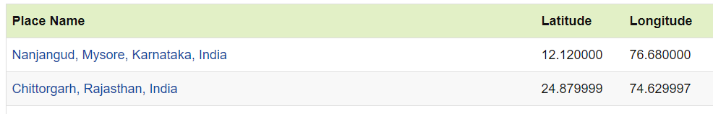

The field ‘Place Name’ represents the Name of cities, ‘Latitude’ field represents the Latitude and the ‘Longitude’ field represents the Longitude of the city.

This table is stored in a dataframe df. From df, cities in Maharashtra and Karnataka are filtered out (which is the requirement for our project) and stored in another dataframe df_mah.

Along with the above described table, locality based data is derived from Foursquares using the developer version.