ASG Airlines Data Engineering
NeoStats Data Engineering Assessment
End-to-End Data Engineering Case Study
Python | MySQL | Azure Database for MySQL | Power BI | Pytest
September 2026

Contents
1. Executive Summary | 2. Assessment Objective | 3. Source Dataset | 4. Technology Stack | 5. Overall Architecture | 6. Data Flow | 7. Data Model | 8. Ingestion Design | 9. Data Cleaning | 10. Duration Logic | 11. Governance | 12. Payment Logic | 13. PII and Security | 14. Gold Layer | 15. KPIs | 16. Power BI | 17. Azure | 18. Automation | 19. Error Handling | 20. Testing | 21. Scalability | 22. Assumptions | 23. Limitations | 24. Requirement Mapping | 25. Submission Checklist

1. Executive Summary
This project converts the supplied airline workbook into validated, auditable, PII-aware reporting data. It preserves RAW source values, applies conservative cleaning rules, records corrections in audit_log, quarantines unsafe records, builds aggregation-ready Gold tables, synchronizes validated data incrementally to Azure MySQL, and presents two Power BI pages. The validated assessment dataset contains 964 Gold flights and 1,000 rows in each passenger, booking-payment-summary, and booking-fact table. True operational delay is intentionally not fabricated because scheduled-versus-actual timestamps are absent.

2. Assessment Objective
The assessment asks for ingestion, quality checks, cleaning, transformation, aggregation, error handling, documentation, and a business-friendly Power BI dashboard. The repository addresses these through batch Python modules, layered MySQL tables, explicit audit/quarantine governance, Gold reporting tables, Azure synchronization, reproducible orchestration, tests, and dashboard artifacts.

3. Source Dataset
The source is data/raw/UseCase - Airlines.xlsx with flight, booking, passenger, and payment sheets. Important flight fields include flight_id, airline, source, destination, departure_time, arrival_time, and duration. Bookings connect passengers, flights, dates, status, and seat data; payments connect booking IDs to amounts and methods. Source issues include duplicates, missing values, malformed identifiers, invalid timestamps, formula duration values, payment placeholders, and conflicting references. Passenger PII exists in source but is not reproduced in this document.

4. Technology Stack
The implementation uses Python, Pandas, OpenPyXL, MySQL 8.x, SQLAlchemy, PyMySQL, python-dotenv, Pytest, Azure Database for MySQL Flexible Server, Power BI PBIP/PBIR/TMDL, Git/GitHub, and Windows Task Scheduler.

5. Overall Architecture
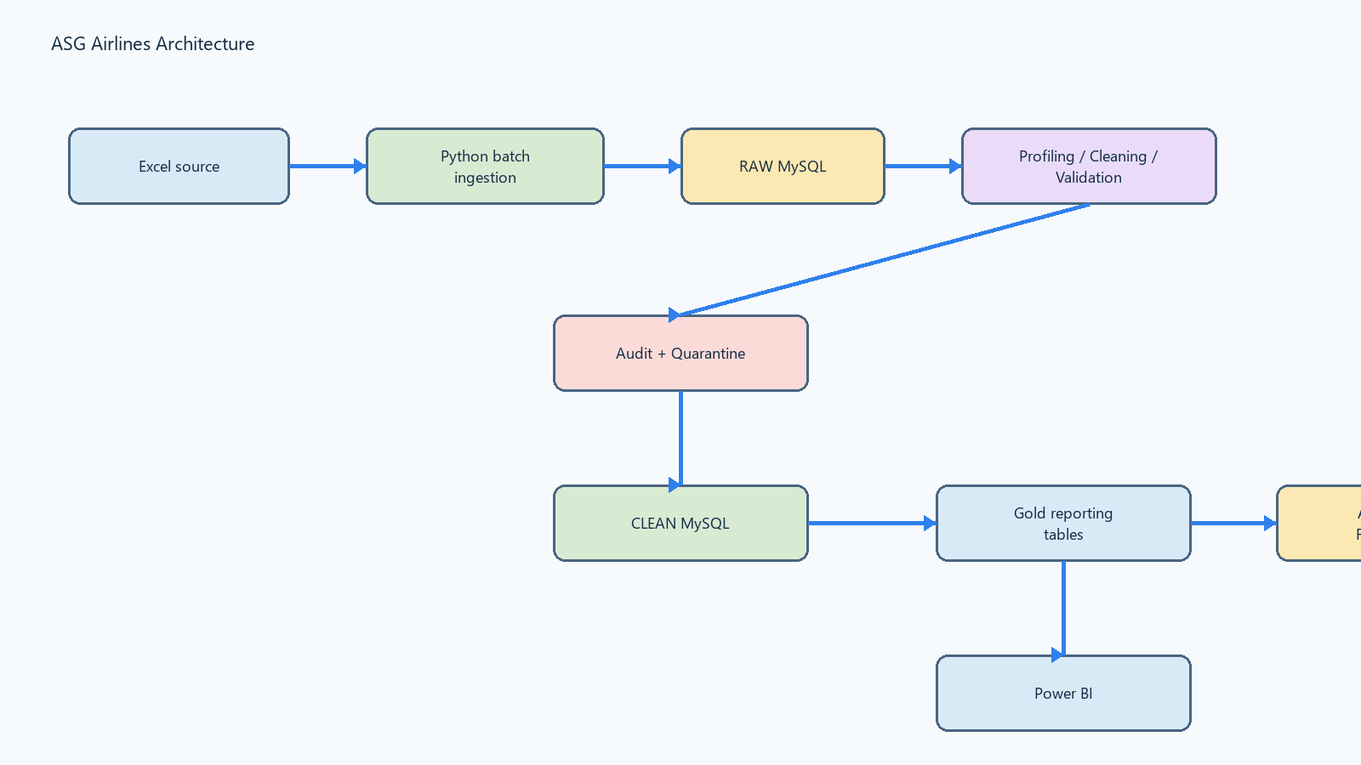
Figure 3 ? Local processing architecture and Azure target
Local processing is separated into RAW, CLEAN, governance, and Gold layers. Azure is the synchronized target for validated core and Gold data. Power BI reads Gold tables only.

6. Data Flow Diagram
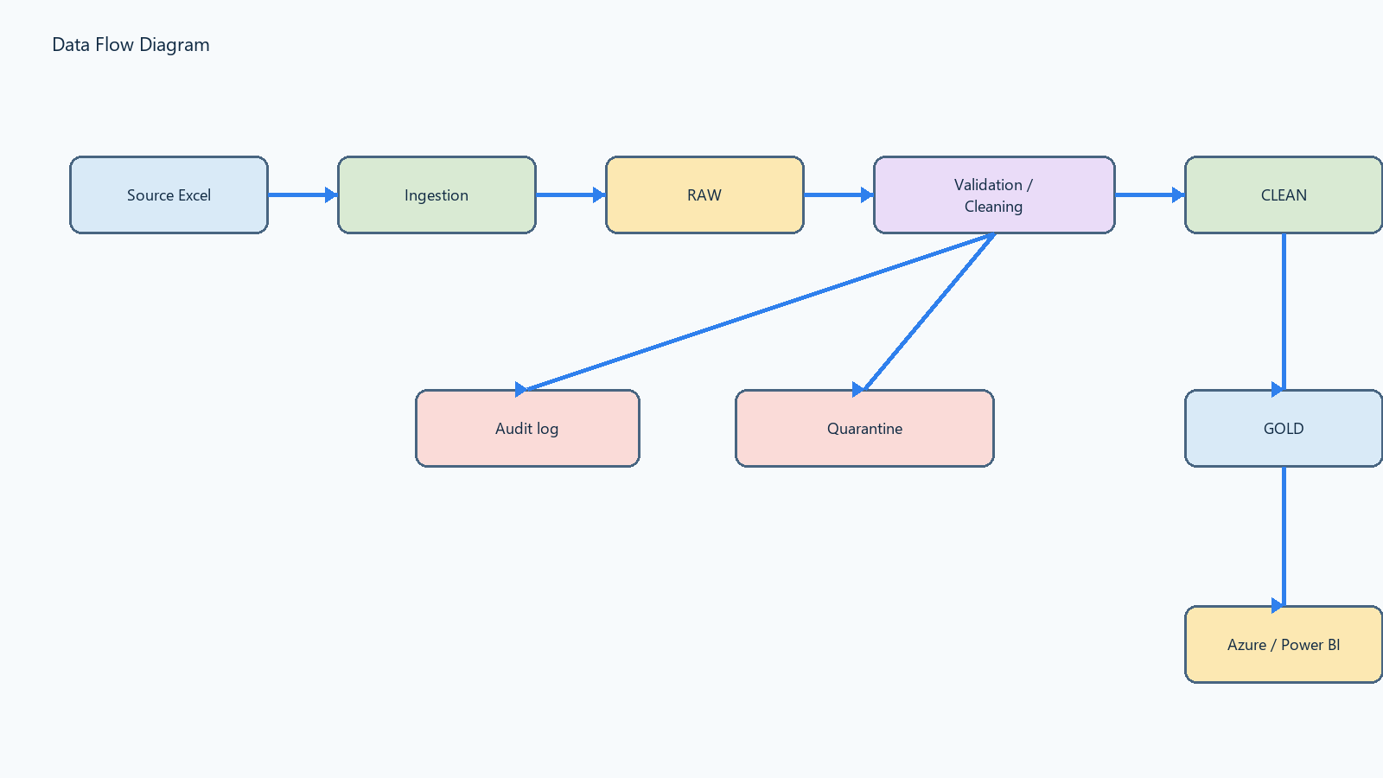
Figure 4 ? End-to-end data flow
Ingestion reads the workbook and preserves source rows. Profiling identifies issues. Cleaning applies locked business rules. Validation checks keys, relationships, payments, and traceability. Safe rows populate CLEAN; corrections and unsafe records are represented through audit and quarantine. Gold transformation creates reporting objects, which feed Azure synchronization and Power BI.

7. Data Model
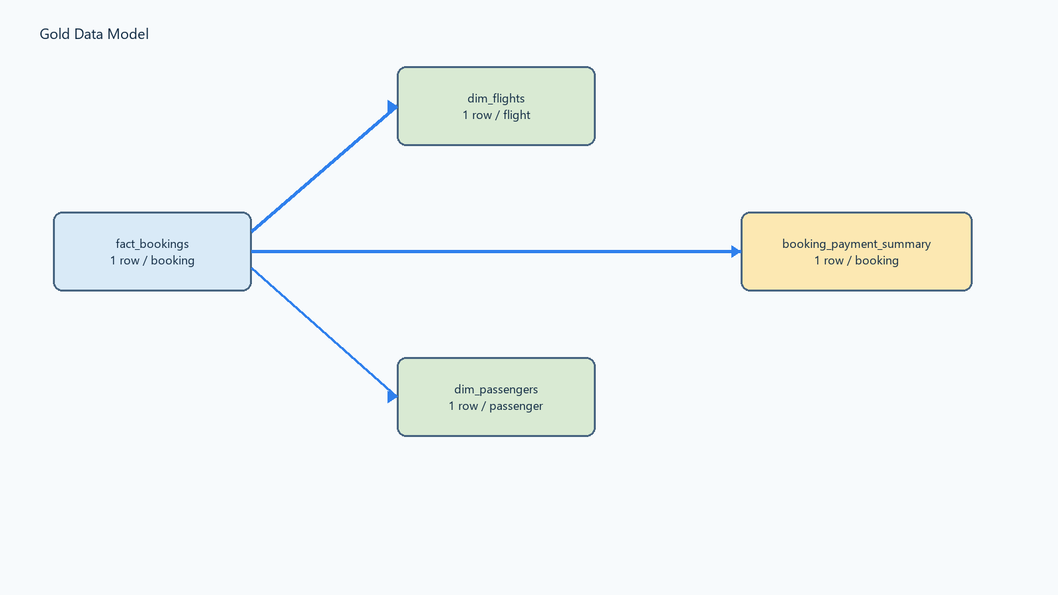
Figure 5 ? Gold reporting model
fact_bookings is one row per clean booking. It relates booking_id to booking_payment_summary.booking_id, flight_id to dim_flights.flight_id, and passenger_id to dim_passengers.passenger_id. dim_flights is one row per valid flight; dim_passengers is one row per reporting passenger; booking_payment_summary is one row per booking with payment aggregates. Control, RAW, CLEAN, audit, quarantine, and reference tables support traceability and processing.

8. Ingestion Design
src/ingest.py uses OpenPyXL, writes batches of 200 rows to RAW tables, records run and batch metadata, source Excel row numbers, record hashes, file hashes, and original payloads. SHA-256 source detection prevents repeated processing of an unchanged workbook while preserving the existing ingestion idempotency behavior.

9. Data Cleaning Strategy
src/cleaning.py processes the latest successful ingestion run transactionally. It handles duplicate and conflicting bookings, malformed IDs, missing values, timestamp parsing, duration derivation, airline handling, passenger ID validation, payment normalization, duplicate payment protection, audit logging, and deterministic quarantine. When trusted reference data is unavailable, the pipeline does not invent mappings; it retains safe UNKNOWN/NULL values or quarantines the record.

10. Flight Duration and Overnight Logic
Departure and arrival values are parsed and normalized. Same-day durations use the timestamp difference. Overnight flights are handled by respecting a next-day arrival, producing a positive duration rather than a negative value. Invalid or over-12-hour durations are quarantined. Verified metrics are: average 164.42 minutes; population standard deviation approximately 77.33 minutes; global anomaly thresholds approximately 9.75?319.08 minutes; 0 duration anomalies; 0% anomaly rate. True delay minutes cannot be calculated because scheduled-versus-actual operational timestamps are unavailable.

11. Data Quality, Audit and Quarantine
Governance metric | Verified count
audit_log | 78
quarantine_records | 107
flight_id_collision | 16
invalid_flight_time | 1
missing_airline | 39
invalid_or_duplicate_passenger_id | 39
excluded_booking_record | 12

Quarantine records retain entity, source row, run/batch metadata, issue category, reason, severity, and original payload where applicable. Audit records describe automatic corrections. Unsafe data is isolated instead of guessed.

12. Payment and Booking Logic
Zero-payment bookings: 363. Single-payment bookings: 370. Multiple-payment bookings: 267, containing 630 payment rows. Multiple payments remain valid and are aggregated by booking rather than deduplicated. Orphan payments: 0. The Gold payment total reconciles to 7,982,087.99.

13. PII and Security
Passenger source data contains direct identifiers. Gold reporting tables exclude names, passport numbers, Aadhaar IDs, email, phone, and emergency-contact fields, and Power BI consumes Gold only. Credentials are supplied outside Git through secure runtime configuration. Least-privilege access is a design principle. Encryption at rest, Key Vault, managed identity, and production RBAC are future controls, not claims of current implementation.

14. Gold Reporting Layer
Object | Grain / purpose
dim_flights | One row per valid clean flight
dim_passengers | One row per reporting passenger without direct PII
booking_payment_summary | One row per booking with payment aggregates
fact_bookings | One row per clean booking with dimensional context

Gold counts are dim_flights 964, dim_passengers 1,000, booking_payment_summary 1,000, and fact_bookings 1,000. Unmatched booking-to-flight facts: 42, intentionally retained with flight_match_status.

15. Business KPIs
KPI / analysis | Verified value or use
Total Bookings | 1,000
Total Passengers | 1,000
Total Revenue | 7,982,087.99
Total Flights | 964
Average Booking Value | approximately 7,982.09
Average Flight Duration | 164.42 minutes
Route-wise Traffic | Gold route analysis
Airline Distribution | Gold airline analysis
Duration Anomaly Rate | 0%

16. Power BI Dashboard
The report has two pages with KPI cards, interactive slicers, operational and executive visuals, and Gold-only data sources. Direct passenger PII is not exposed. Power BI Desktop refresh remains manual.
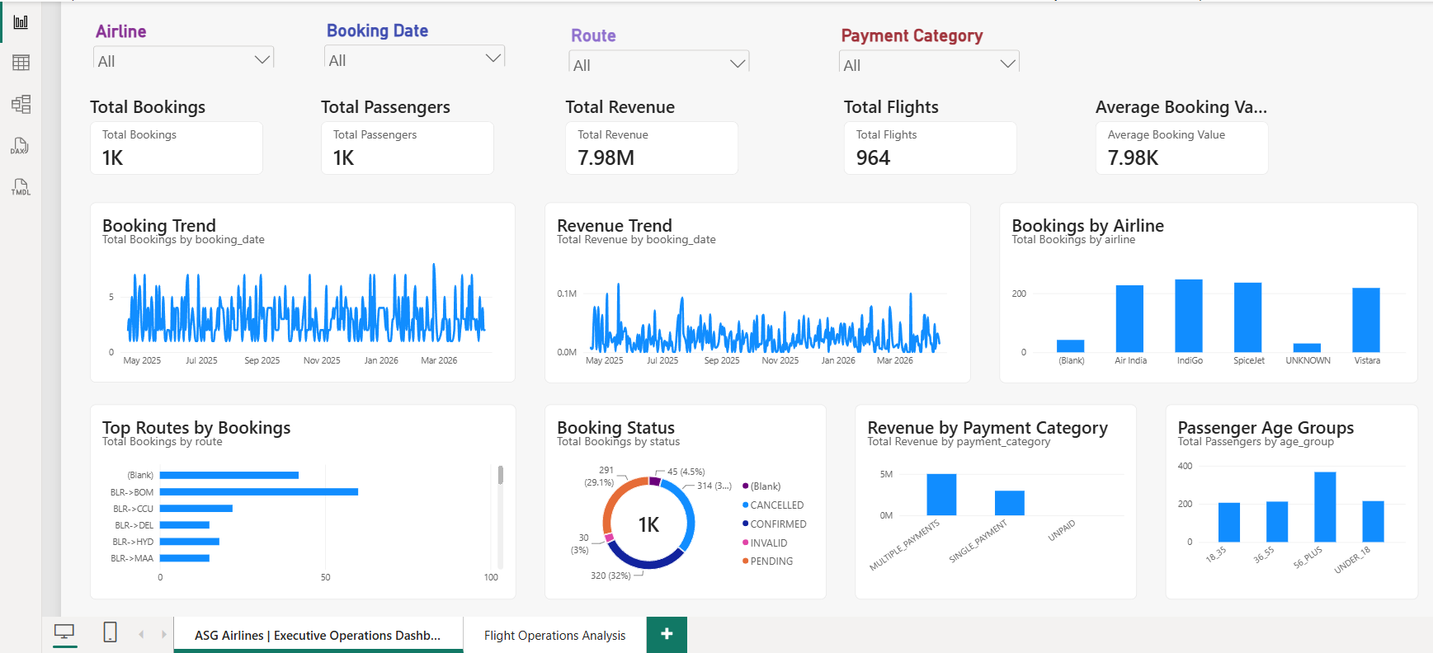
Figure 1 ? Executive Operations Dashboard
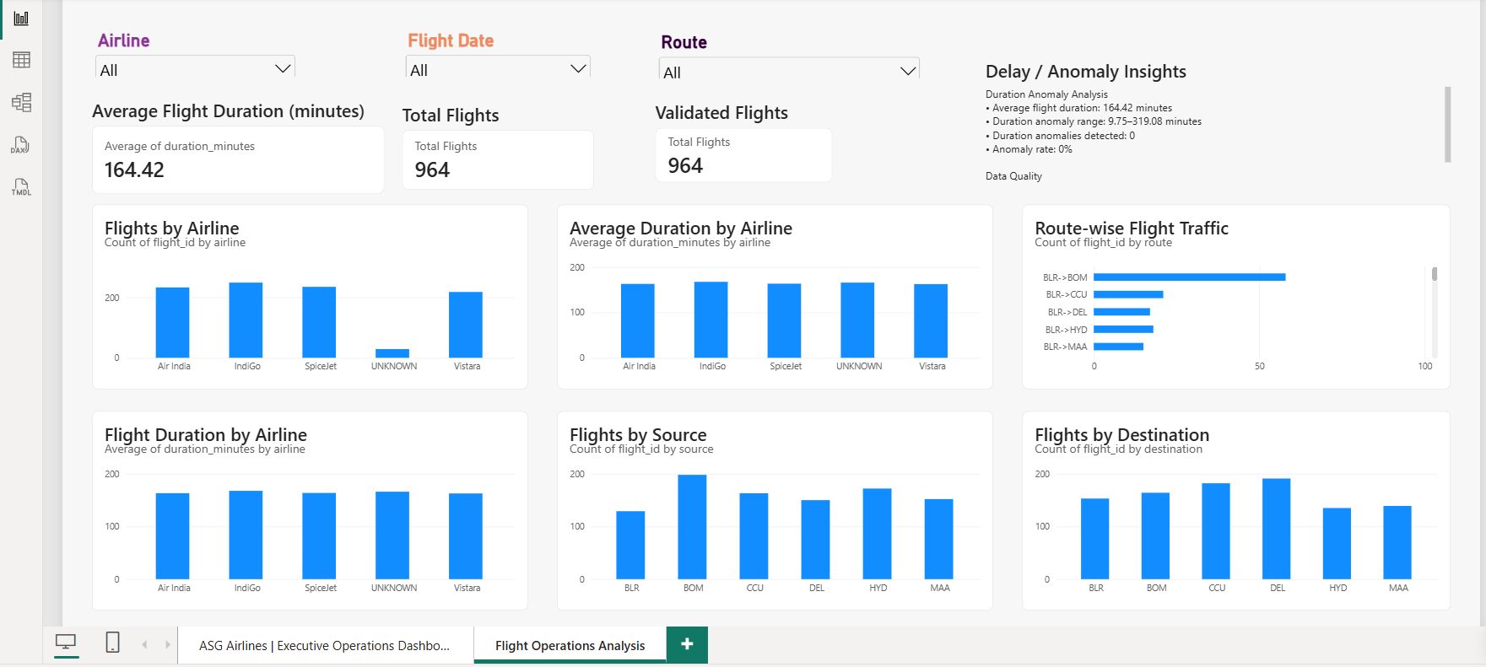
Figure 2 ? Flight Operations Analysis
Page 1 covers bookings, passengers, revenue, flights, trends, airline distribution, routes, status, payment category, age groups, and slicers. Page 2 covers duration, validated flights, airline and route analysis, source/destination analysis, operational slicers, and the Delay / Anomaly Insights section.

17. Azure Deployment
Azure Database for MySQL Flexible Server is deployed in resource group rg-neostats-airlines, server asg-airlines-mysql-2026, database asg_airlines, South India. Core and Gold synchronization were live-tested with exact local/Azure reconciliation. Incremental synchronization uses identity checks, schema checks, bounded batches, key-based upserts, deterministic governance event keys, transactions, and reconciliation. The original migration scripts remain for provisioning/recovery only; normal runs use sync_local_to_azure.py.

18. Automation
run_pipeline.py detects the workbook with SHA-256, runs ingestion, profiling, cleaning, validation, Gold transformation, Azure core sync, and Azure Gold sync, logs stages, propagates failures, and records successful state. PowerShell wrappers and a Windows Task Scheduler task run every 30 minutes. The scheduler trigger was tested separately; a full seven-stage execution was successfully logged, while later unchanged-source checks correctly skipped reprocessing.

19. Error Handling and Logging
Stage failures stop subsequent stages and return non-zero status. Timestamped logs record source hash, stage status, duration, and failure output with secret redaction. Audit and quarantine provide business-level traceability. Initial migration utilities remain available for provisioning/recovery, not normal scheduled synchronization.

20. Testing and Validation
Validation area | Evidence
Automated tests | 20 tests passed
RAW/CLEAN/Gold reconciliation | Verified counts and relationships
Gold uniqueness | Keys validated
Payment preservation | 267 multiple-payment groups; total 7,982,087.99
Quarantine traceability | 107 records; required fields present
Idempotency | Transformation and orchestration checks passed
Azure synchronization | Core/Gold live-tested with reconciliation
PBIR/model validation | Query, model, bounds, and overlap checks passed

21. Scalability and Performance
Current scalability comes from batch ingestion, layered processing, idempotent loads, source-change detection, bounded Azure writes, transactions, and reconciliation. Future scale options include Azure Data Factory, ADLS, Databricks/Spark, partitioning, monitoring, alerting, and CI/CD; these are not currently implemented claims.

22. Assumptions
- The supplied workbook is the authoritative assessment source.
- Gold tables are the reporting contract for Power BI.
- Reference mappings are used only when trusted data exists; no mappings are invented.
- Unmatched booking-flight references are retained for traceability.
- The assessment dataset is small enough for the current Python/MySQL batch design.

23. Limitations
- Scheduled-versus-actual timestamps are unavailable, so true operational delay minutes, delayed-flight count, and on-time percentage cannot be calculated.
- Some trusted airline, airport/IATA, and payment-method reference mappings are unavailable.
- The implementation is validated at assessment scale; distributed production processing is future work.
- Power BI Desktop refresh remains manual.

24. Requirement-to-Implementation Mapping
Assessment requirement | Implementation | Evidence / file
Ingestion | Batch Excel ingestion | src/ingest.py
Transformation | CLEAN-to-Gold reporting build | src/transformation.py; docs/transformation_report.md
Validation | Read-only quality and reconciliation checks | src/validation.py; docs/validation_report.md
Audit/quarantine | Correction and unsafe-record governance | sql/04_audit_quarantine.sql; src/cleaning.py
Duration logic | Overnight-safe duration analysis | src/cleaning.py; dim_flights
Gold model | Dimensions, fact, payment summary | sql/06_reporting_tables.sql
Azure synchronization | Incremental bounded key-based sync | scripts/sync_local_to_azure.py
Automation | Orchestrated seven-stage execution | scripts/run_pipeline.py
Power BI | Two-page PBIP/PBIR dashboard | powerbi/ASG-Airlines-Dashboard.pbip
PII protection | Direct passenger PII excluded from Gold | transformation report; TMDL
Documentation | README, reports, final DOCX | README.md; docs/

25. Final Submission Checklist
? GitHub repository
? Working pipeline
? Cleaned visualization dataset exports
? Power BI PBIX/PBIP
? Dashboard screenshots
? Architecture diagram
? Data flow diagram
? Data model
? Detailed documentation
? Azure synchronization
? Automation
? Automated tests
? README

