section .data
msg db 'Enter two digit number:', 0xa
msg_len equ $-msg
res db 10, 'Multiplication of elements is:'
res_len equ $-res
choice db 10, 'Enter your Choice:', 0xa
db '1. Successive Addition', 0xa
db '2. Add and Shift method', 0xa
db '3. Exit', 0xa
choice_len equ $-choice

section .bss
num resb 5 ; Buffer for input
num1 resb 2 ; Store first number
result resb 4 ; Store result
cho resb 2 ; Store menu choice

section .text
global _start
_start:
xor rax, rax
xor rbx, rbx
xor rcx, rcx
xor rdx, rdx

; Display menu
mov rax, 1
mov rdi, 1
mov rsi, choice
mov rdx, choice_len
syscall

; Get choice
mov rax, 0
mov rdi, 0
mov rsi, cho
mov rdx, 2
syscall

cmp byte[cho], '1'
je a
cmp byte[cho], '2'
je b
jmp exit

a: call Succe_addition
jmp _start

b: call Add_shift
jmp _start

exit:
mov rax, 60
mov rdi, 0
syscall

convert:
xor rbx, rbx
xor rcx, rcx
xor rax, rax

mov rcx, 2
mov rsi, num
up1:
rol bl, 4
mov al, [rsi]
cmp al, '9'
jbe p1
sub al, 7
p1: sub al, '0'
p2: add bl, al
inc rsi
loop up1
ret

display:
mov rcx, 4
mov rdi, result
dup1:
rol bx, 4
mov al, bl
and al, 0fh
cmp al, 9
jbe p3
add al, 7
p3: add al, '0'
p4: mov [rdi], al
inc rdi
loop dup1

mov rax, 1
mov rdi, 1
mov rsi, result
mov rdx, 4
syscall
ret

Succe_addition:
; Get first number
mov rax, 1
mov rdi, 1
mov rsi, msg
mov rdx, msg_len
syscall

mov rax, 0
mov rdi, 0
mov rsi, num
mov rdx, 5
syscall

call convert
mov [num1], bl

; Get second number
mov rax, 1
mov rdi, 1
mov rsi, msg
mov rdx, msg_len
syscall

mov rax, 0
mov rdi, 0
mov rsi, num
mov rdx, 5
syscall

call convert
xor rcx, rcx
xor rax, rax
mov al, [num1]

repet:
add rcx, rax
dec bl
jnz repet

mov [result], cx

; Display result
mov rax, 1
mov rdi, 1
mov rsi, res
mov rdx, res_len
syscall

mov bx, [result]
call display
ret

Add_shift:
; Get first number (fixed syscall registers)
mov rax, 1
mov rdi, 1
mov rsi, msg
mov rdx, msg_len
syscall

mov rax, 0
mov rdi, 0
mov rsi, num
mov rdx, 5
syscall

call convert
mov [num1], bl

; Get second number
mov rax, 1
mov rdi, 1
mov rsi, msg
mov rdx, msg_len
syscall

mov rax, 0
mov rdi, 0
mov rsi, num
mov rdx, 5
syscall

call convert
xor rcx, rcx
xor rdx, rdx
mov dl, 8
mov al, [num1]
mov bl, [num]

p11:
shr bl, 1
jnc p
add cx, ax
p: shl ax, 1
dec dl
jnz p11

mov [result], cx

; Display result
mov rax, 1
mov rdi, 1
mov rsi, res
mov rdx, res_len
syscall

mov bx, [result]
call display
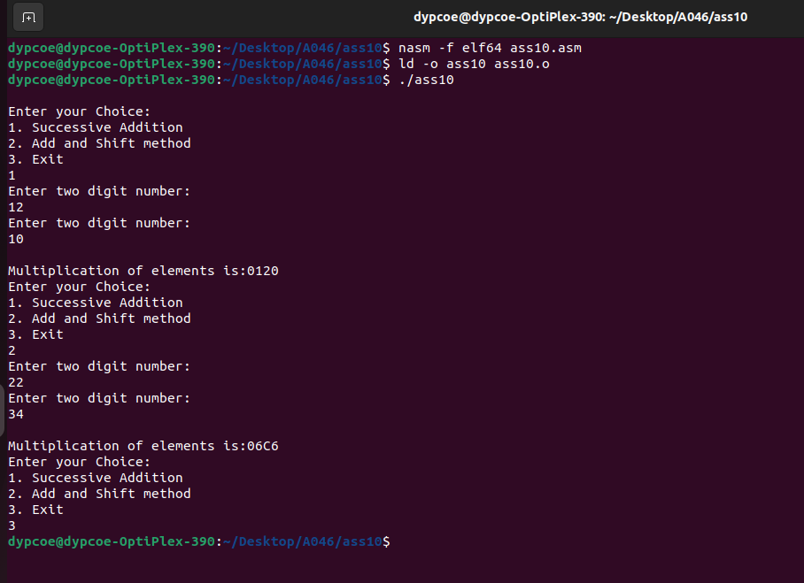
ret

