Assignment-I

Name:- Salunke Pranav
Roll-No:-SECO2425C017

AIM : Write an ALP to print “Hello World” using 32,64 bit model and segmentation.

OUTPUT :-

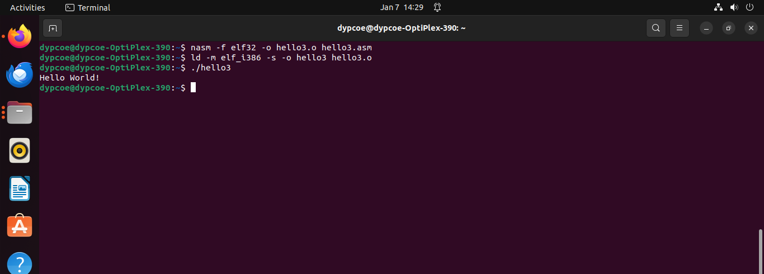
CONCLUSION :- Hence we have successfully implemented an ALP to print Hello World!.

