Assignment No:-02

Name:- Pranav Salunke
Roll No. :-SECO2425C017

Aim:-Write an ALP To accept ten 32-bit and 64-bit hexadecimal numbers from user and store them in data segment table and display the number.

Output:-
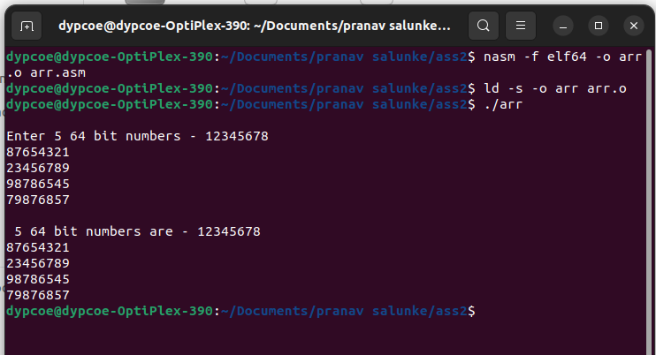

Conclusion:-In this practical, we have acccepted and displayed 32/64 bit hexadecimal numbers in ALP program.

