Aim:- Write an X86/64 Alp to accept a string and to display its length

Name:- Salunke Pranav

Roll No.:- SECO2425C017

Output:-

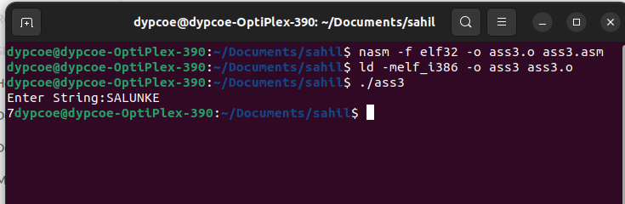

Conclusion:- Hence we found out length of string and display it using Assembly language.

