Aim:- Write an X86/64 ALP to find the largest of given Byte/Word/Dword/64 bit numbers.

Name:-Salunke Pranav

Roll No.:- SECO2425C017

Output:-

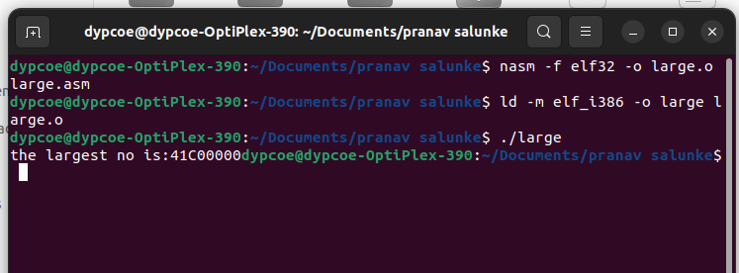

Conclusion:- Here we print the largest numbers in the array.

