ASSIGNMENT NO 6

Name : Pranav Salunke
Roll no : SECO2425C017

Aim : Write an ALP to count no. of positive and negative numbers from the array

Output :

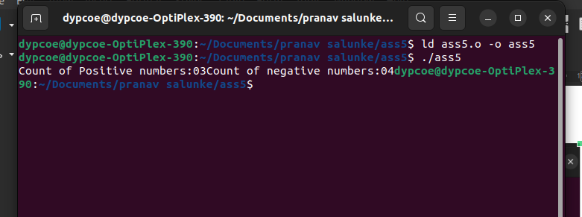

Conclusion : Here we count the 32 bit numbers of positive & negative in array in the assembly language

