# WhatsApp Image 2020-06-21 at 11.09.35 AM.jpegProject Name : SABO garbage collection trolley

## Project Motivation

The current scenario in India of garbage cleaning is not automated. From garbage collection to separation, everything is done manually. There are some automated systems of garbage cleaning vehicles in India are available only in metropolitan cities. But those are very costly and not affordable in every region in India. So there is a need of automated garbage cleaning system which also reduces human efforts and fatigue in reasonable cost in Indian conditions.

## Challenges Addressed

* Current methods of sweeping and garbage collection are under efficient.
* Current technology used is not feasible considering the local road conditions.
* Conventional garbage collection methods are not ergonomic and thus utilize unnecessary labor.
* 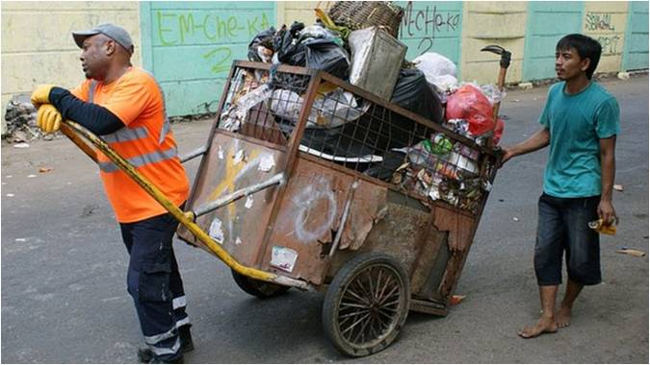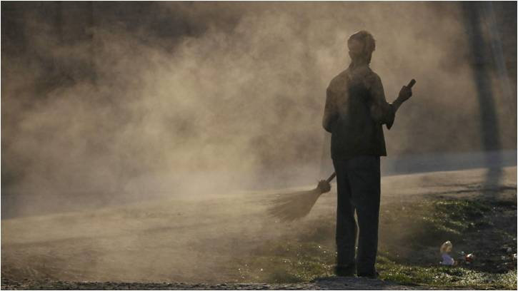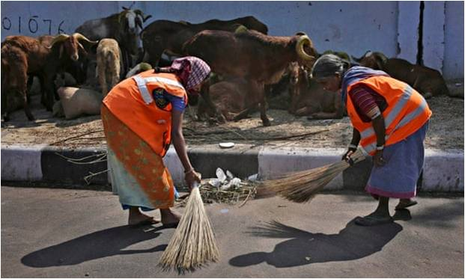Dust clouds that occur due to sweeping cause harm to operators and passers-by.

## Project Narrative

* A semi automatic battery operated (SABO) garbage sweeping machine
* It uses the same principle of reciprocating manual sweeping method but with a long continuous brush that rotates at certain RPM in an enclosed trolley.
* This trolley proves to be an effective solution to the problems faced.
* 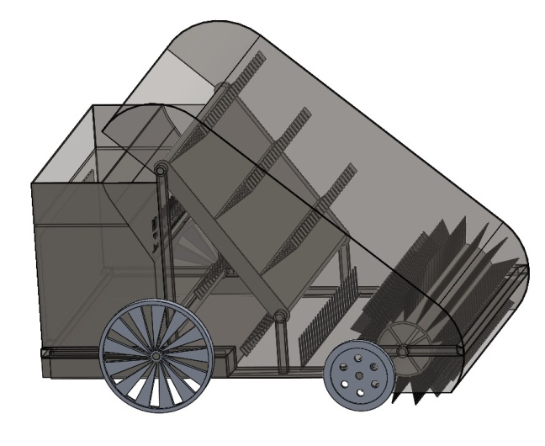It also reduces labour effort as well as reduces dust pollution, thus making the product a social and environmental advantageous by controlling dust clouds.

## Engineering Concept Applied

* 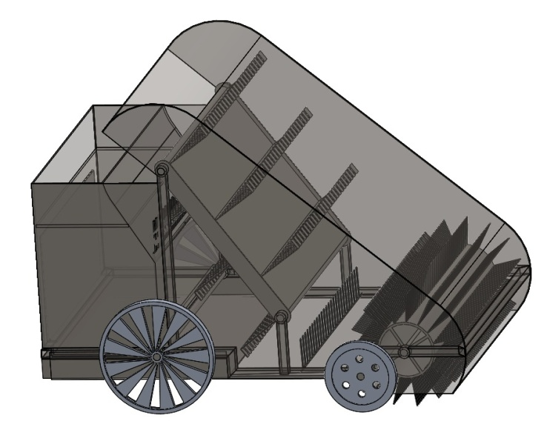A semi automatic battery operated (SABO) garbage sweeping machine uses the same principle of reciprocating manual sweeping method but with a long continuous brush that rotates at certain RPM in an enclosed trolley.
* Vibration because of road will cause sand travel on slope to Separate sand container provided in SABO garbage collection trolley

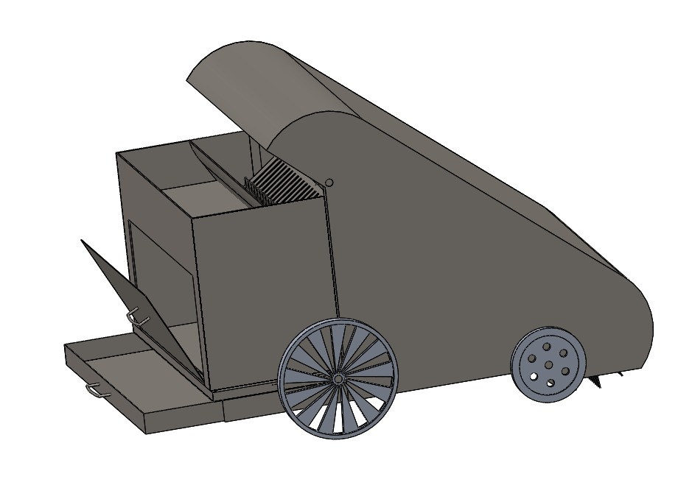

## Key Success Parameters

* The proposed solution of a SABO garbage sweeping machine theoretically solves the problems faced effectively.
* The functionality of the machine was checked using 3DEXPERIENCE software.
* The estimate of the cost structure of prototyping verifies the economic feasibility of the product.
* The product, when used extensively will prove to be environmentally advantageous.

## Estimated Cost with Breakup (Optional)

## 

## Unique Features

* Considerable increase in work output.
* Economically feasible.
* Bristles of the brush adapt to the terrain conditions.

## Technologies Used

* 3d-experience
* Solidworks

## Institute Details

Pune Vidyarthi Griha's College of Engineering and Technology, Pune

## Project ID

## LF-IACP-STP-0003

## TAGS

|  |  |  |  |
| --- | --- | --- | --- |
| Industry | Technology | Software Tools | Engineering Field |
| #IndustryEquipments | #3DSimulation | #SolidWorks | #MechanicalEngineering |
| #Automation | #GreenEnergy | #CATIA | #ElectricalEngineering |
|  | #MaterialScience | #SIMULIA | #Mechatronics |
|  | #Manufacturing | #3DEXPERIENCE | #MaterialScience |
|  | #Optimization | #ANSYS | #Instrumentation |
|  | #FEA |  |  |
|  | #CFD |  |  |
|  | #CAM |  |  |
|  |  |  |  |
|  |  |  |  |
|  |  |  |  |
|  |  |  |  |
|  |  |  |  |
|  |  |  |  |
|  |  |  |  |
|  |  |  |  |
|  |  |  |  |
|  |  |  |  |
|  |  |  |  |