Janitor User Guide
S. Hamblett

Table of Contents
1.Introduction 3
2.Installation 4
3.Welcome 5
4.Database 6
5.Backup 7
6.FTP 10
7.Logs 12
8.Upgrade 13
9.Events 14
10.Under the Hood 15
11.Security 16
12. Further development 17

Introduction
The Janitor component is intended to allow a site maintainer to perform site maintenance functions without using a plethora of external tools. Janitor aims to concentrate most site maintenance tasks into in central component.
Janitor uses a mixture of mature 3rd party components such as SQLBuddy and special to type functions specific to Revolution installs to ease site maintenance tasks.
The usage of 3rd party applications greatly reduces the complexity of this component, the code being more integration oriented than function oriented. This maximises the usage of already written, tested, used and understood applications and minimises the amount of code needed to be written, which in general is a good thing.
Although these applications are general purpose in nature they are augmented with Revolution specific functions to tailor the component as much as possible for Revolution usage.
For a further explanation of how this package is put together see section 10
For security considerations see section 11
For further development information see section 12

Installation
The Janitor package is installed as any other, download the package using package manager and install, or download the transport file into your packages directory and perform a local package installation. Any set up that needs to be performed such as the setting of file permissions are done during installation so the user has nothing to do here over and above a normal install.
The component has 7 tabs, namely Welcome, Database, Backup, FTP, Logs and Upgrades and Events.

Welcome
The Welcome tab is a simple welcome screen explaining the purpose of Janitor and quickly describing what the tabs are for, this tab contains no functionality.

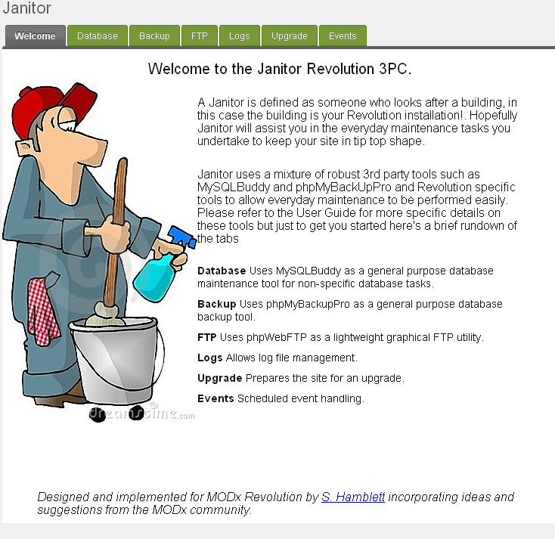

Database
The Database tab utilises the SQLBuddy web based MYSQL database administration tool. On entering the tab you are presented with a login screen, entering your MYSQL details allows access to the application.

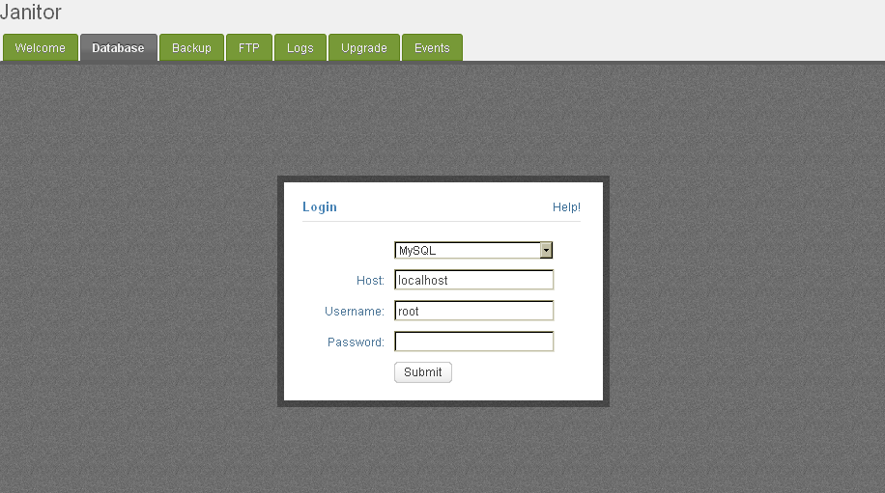
The decision to not tie this application to the database specified in your Revolution installation is a conscious one. Often the user of this database does not have sufficient privileges to perform full administration duties, so Janitor allows the user to specify any credentials he thinks appropriate for the task at hand. This also adds an additional level of security but this is not relied on, see the Security section later.
The application is a full implementation of SQLBuddy, please refer here for fuller documentation on its features etc.

Backup
The Backup tab utilises the phpMyBackupPro MYSQL backup application to allow database backups to be performed.
On first entry to the tab the following screen is displayed :-

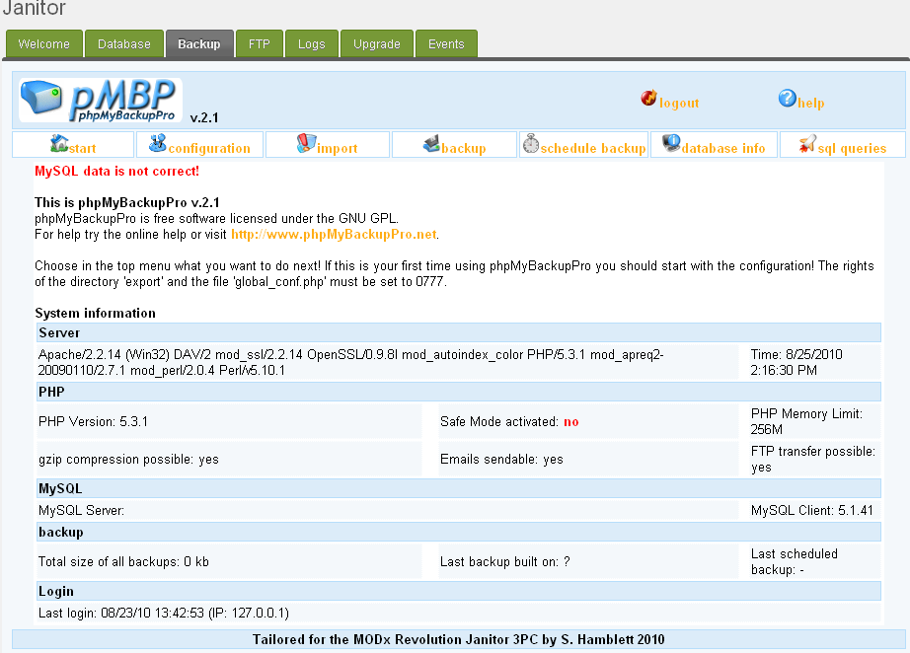

No MYSQL credentials or other information has yet been set. Select the 'Configuration' menu option to get the following display :-

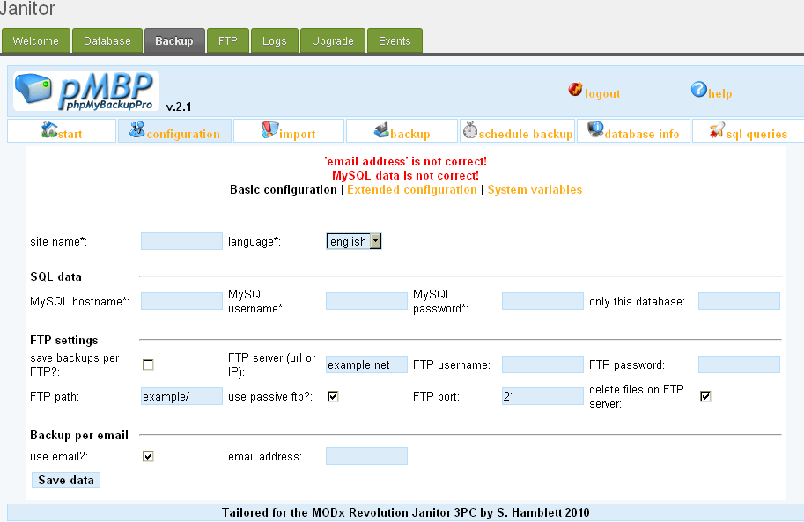
Please enter your MYSQL credentials and other information as appropriate and press the 'Save Data' button. Now press the 'logout' button at the top of the page. This returns you to the applications login screen which from now on you will be presented with when you re-enter this tab.

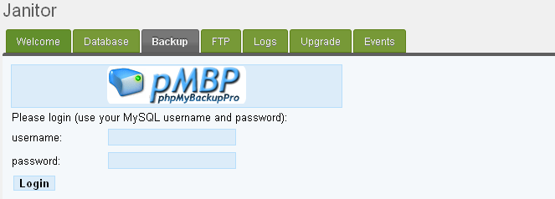

In the same manner as SQLBuddy above you are not tied to any particular MYSQL credentials. The application is a full implementation of the phpMyBackupPro web based backup utility, for further documentation please refer here
Note: the scheduled backup facility can be used if you follow the instructions in the phpMyBackupPro documentation, it is not however automatically set up and it is not yet integrated with the Events tab.

FTP
The FTP tab utilises the phpWebFTP web based graphical FTP utility. This is a lightweight application ideally suited for integration into installations such a Revolution. On entry to the tab the following screen is displayed :-

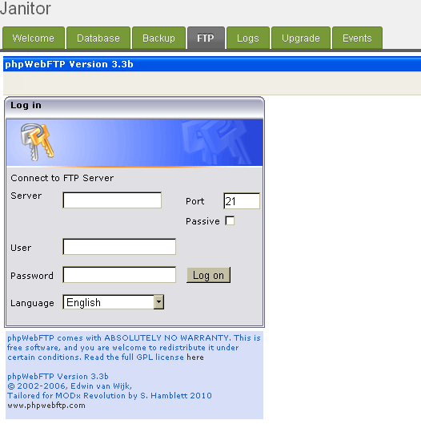
Enter the credentials of the FTP server you wish to connect to. For further documentation on this application please refer here.
Entry of your FTP login credentials gives the following kind of graphical display :-

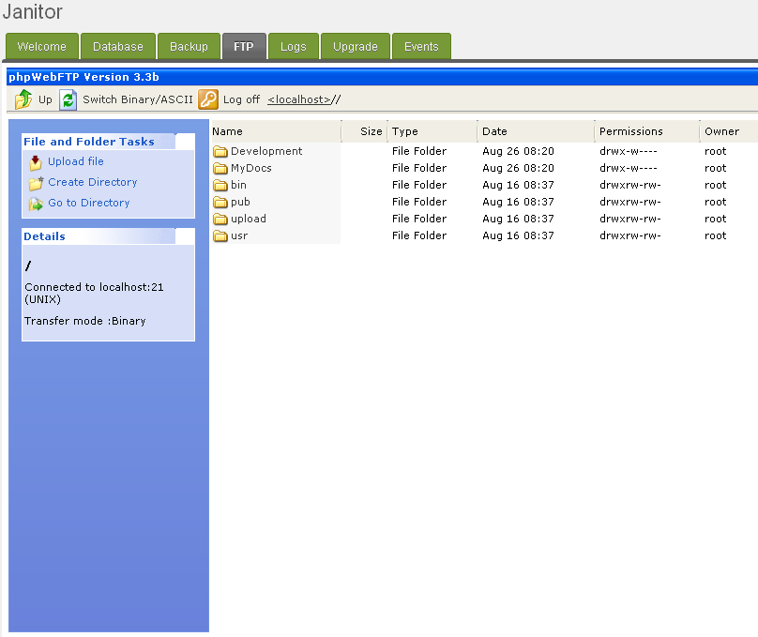
.

Note that the application utilises the browser download facility to download files, so any downloads you make will be deposited in the download directory as set in your browser, not in your Revolution installation.

Logs
The Logs tab provides log management facilities specific to Revolution installations. On entry to the tab the following page is displayed. :-

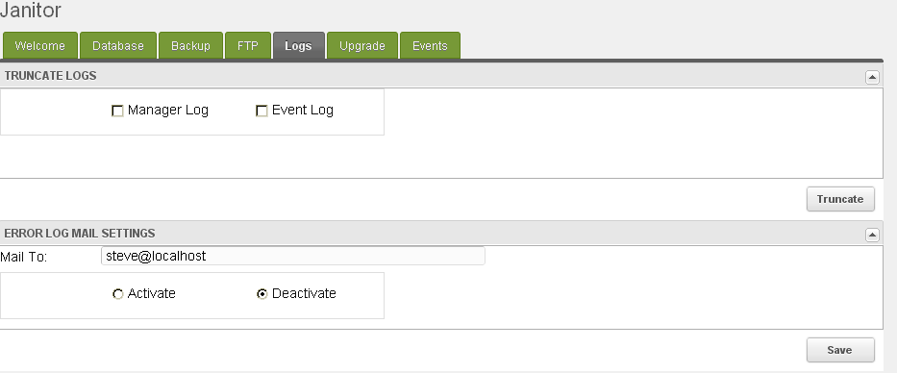
As can be seen the tab consists of two panels, the first one named 'TRUNCATE LOGS' allows both the manager and event logs to be truncated quickly.
The second panel named 'ERROR MAIL LOG SETTINGS' is a support tab for the error mail function. This function will periodically scan the Revolution log for errors and if found will automatically mail an alert to the account specified. The function can be activated and deactivated from here. If no account is specified the system setting for administrators mail is used.
In this release the panel saves and restores the settings only, the actual error log scanning functionality will be provided as part of the Event tab functionality which is not present in this release.

Upgrade
The Upgrade tab allows the user to prepare the installation for an upgrade. On entry to the tab the following screen is displayed :-

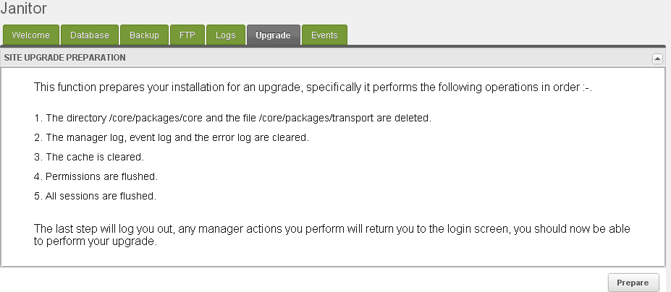
As can be seen from the above picture the steps outlined are performed in the order specified to prepare the installation for an upgrade. It should be noted that this function will always return a successful outcome. Some steps like step 1 for instance are not crucial, if this fails then this will be corrected in the setup function during upgrade, some steps can't really fail e.g. step 3 for instance.
On completion of this function please log out of the manager and perform the upgrade, you should find that execution of the last step forces this, i.e. if you try and invoke a manager function after this you should end up at the login screen.

Events
The Events tab allows the setting and maintenance of periodic tasks needed to maintain the site, an example of this is the error mail log function. User definable tasks are also available on this tab.
This tab is not implemented in this release and is still under development.

Under the Hood
The component itself is just a collection of existing 3rd party web applications and custom code.
The 3rd party applications are simply 'iframed' into the relevant tab. This method allows the full functionality of the application to be preserved without writing mammoth amounts of code to fully integrate them.
They are however integrated to a certain extent, all the applications contain a security check hook, see the Security section below, also tailoring of page sizes, layout and other minor functional elements has been carried out so the applications themselves are no longer 'drop replaceable' with their upstream projects. This is deemed a small price to pay for the functionality gained.
This approach has been adopted to leverage the use of existing code where possible, this stops 'function creep' in areas such as database management.
Taking the Database tab as an example you could write your own custom code to do this of course using extjs/modext but there is absolutely no doubt that when you publish this some users will ask for 'can you make it do this', 'this would be good' etc.
As more and more functionality is added the application becomes more and more like SQLBuddy, so why not stop writing more and more code and simply integrate an already tried and tested database management application from the start!

Security
The usage of iframes gives both advantages and disadvantages. The main advantage is quick access to a fully functioning web based application, the main disadvantage is the security aspects of this.
An iframe is simply a web link so the application has to be 'web visible' from where you are linking it to. In Janitor the code for the 3rd party applications resides in the /assets/components/janitor path of your installation. This means that anybody can go to this :-
http://yourrevohost/assets/components/janitor/sqlbuddy
and the SQLBuddy login page will appear. Not good!! Although you still need login credentials to get to the database even presenting this screen is a security nightmare.
So, how do we prevent this? Basically the 3rd party application code has been modified so that the first thing it does is hook in a MODx specific security check.
This code first starts the session(any session start code in the original applications has been removed) then gets the session id. If you are a logged in manager user this should be the session as set by your Revolution installation and thus should be present in the sessions table in your database.
This check is then made, if a valid session* is found then the application is allowed to load, if not then you are accessing the application from an unauthorised source, e.g. a browser that is not logged into manager, CURL, wget etc. In this case a non-authorised page is returned.
Note:* currently the code just looks for a session id, not any more information, we may need to lock this down more as the component is developed.
IMPORTANT – This is a beta 1.1 release, i.e. a first release, although I have tested this code as much as I can I have not exhaustively tested it from a security standpoint. I have not for instance gone into every PHP file of every application to check for correct behaviour, nor invoked all of them from a browser.

Further development
The component is fully functional in this release bar the Events tab. This is being worked on and will be developed further in future releases. Also the security hook function will probably be beefed up over time.

