LAB Logbook

Lab 1

Step 1: Create a vector using np.arrange

Determine the number of the vector elements using the following method: Take the last two digits from your SID. It should be from 00 to 99. If this number is 10 or more, it becomes the required number of the vector elements. If it is less than 10, add 100 to your number.

[ ]: import numpy as np

[ ]: sid = input("Please enter your SID: ")



[ ]: lastnums = int(sid[-2:])

[ ]: if lastnums < 10:

num = lastnums + 100

else:

num = lastnums

[ ]: vector = np.arange(num)

[ ]: print("Vector:", vector)



Step 2: Change matrix a to 2-d array with 1 row. Print the array. You should have the two sets of brackets for a 2-d array with one row.

[ ]: a = vector.reshape(1, -1)

[ ]: print("2-D array with 1 row:", a)



3) Save it in another array. Print the array.

[ ]: save = a.copy()

[ ]: print("new array:", save)



4) Check the shape attribute value.

[ ]: shape = save.shape

[ ]: print("Shape attribute value :", shape)



Lab 2

1. **Determine a number (n) equal to the last digit of your SID. If the last digit of your SID is '0', then use 10.**
2. **Group by "relationship" and "hours-per-week".**
3. **Reduce all "hours-per-week" column values ​​in the original DataFrame by subtracting the value 'n'. Use a function.**
4. **Group ​​by "relationship" and reduced "hours-per-week".**
5. **Add the code and result to your Lab Logbook.**

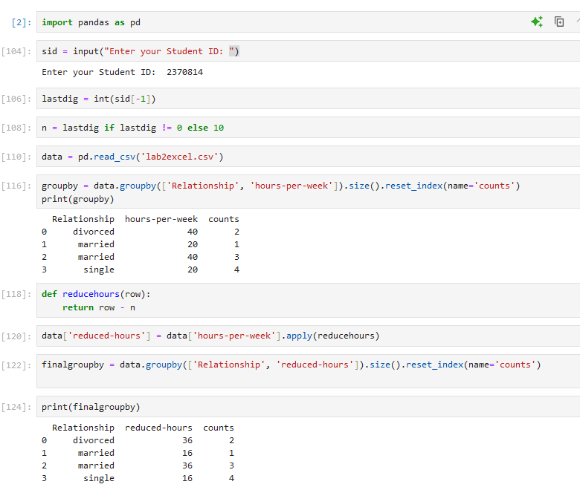

Lab 3

Lab 4

Lab 5

Lab 6

Lab 7

Lab 8

Lab 9

Lab 10

Lab 11

Lab 12