LAB Logbook

Lab 1
1. DataFrame - A two-dimensional, potentially changing in size, heterogeneous tabular data structure that holds labeled axes (rows and columns).
2. Series - A one-dimensional labeled array used to hold any data type. A Series is a way of storing either one column or one row of a DataFrame.
3. Index - An immutable sequence used to label a DataFrame or Series's axes to facilitate fast lookups and data alignment.
4. Categorical - A class for the efficient storage and manipulation of variables which take on a limited and normally fixed number of possible values (categories).
5. DatetimeIndex - An Index that is specialized for timestamps. A DatetimeIndex can be used for time-based indexing and also can be used for resampling time series data.
Lab 2
1
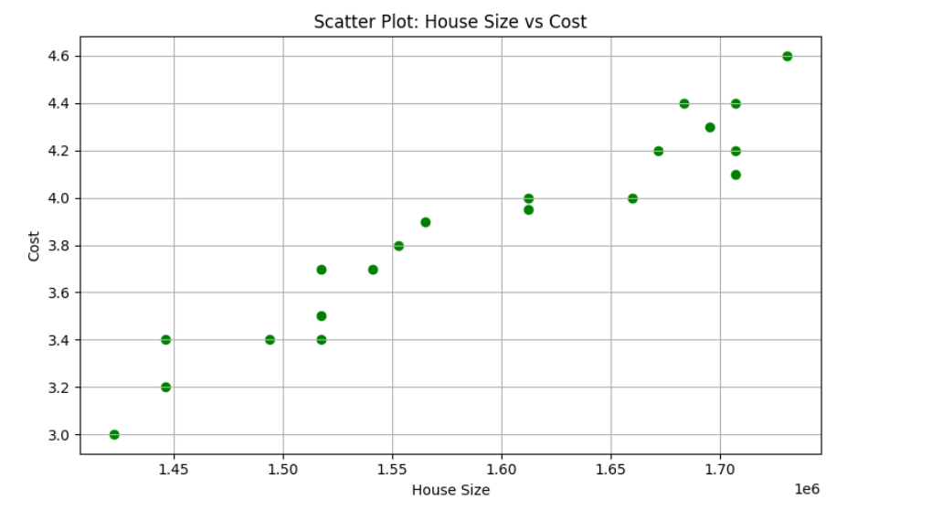
2) Size of slightly larger house(SID*0.75)=2370814*0.75= 1778110.5
Guessed cost = 4.8
Lab 3
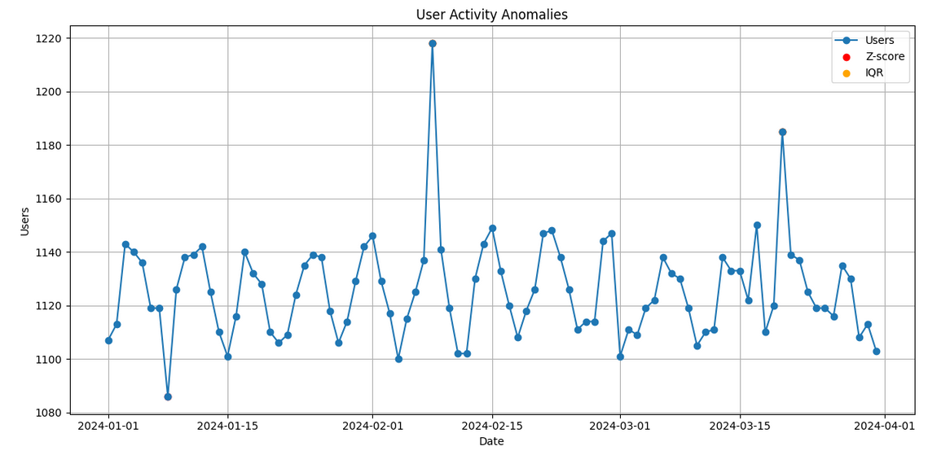
Lab 4
1)
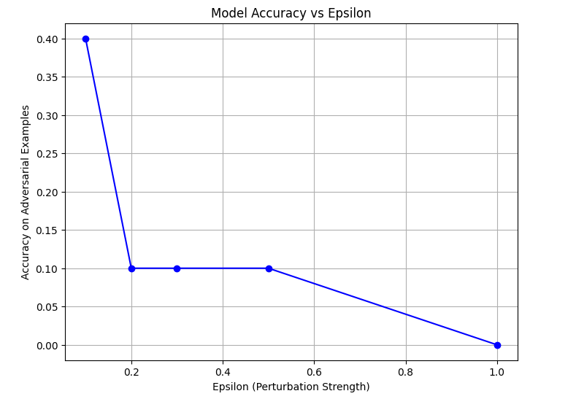

2)
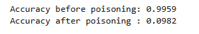
Lab 5
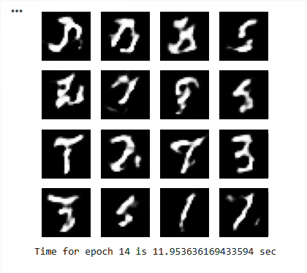
Lab 6
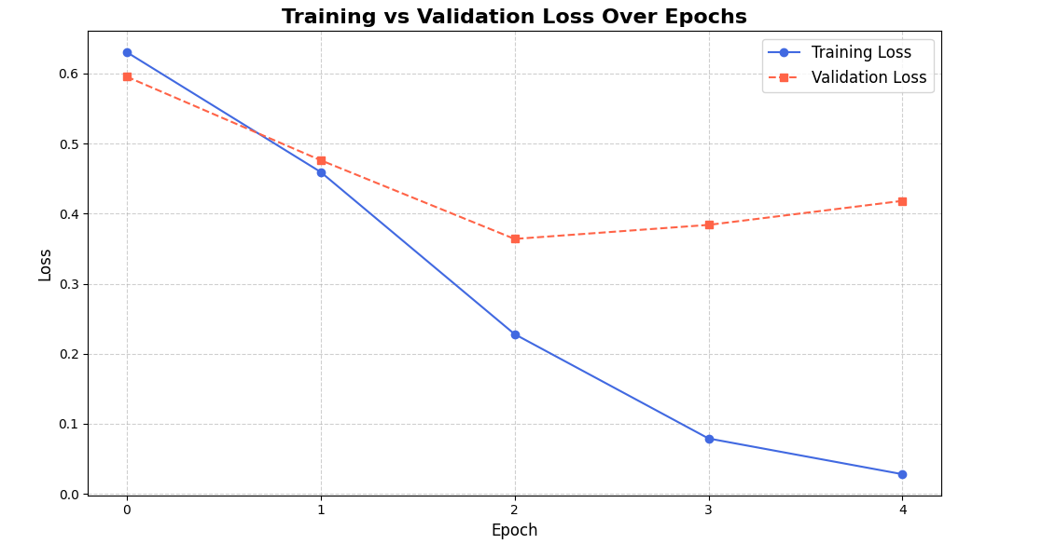
Lab 7
1)DES
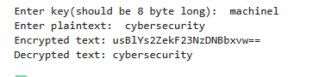
AES
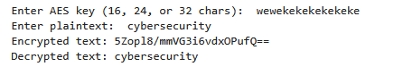
2) real image
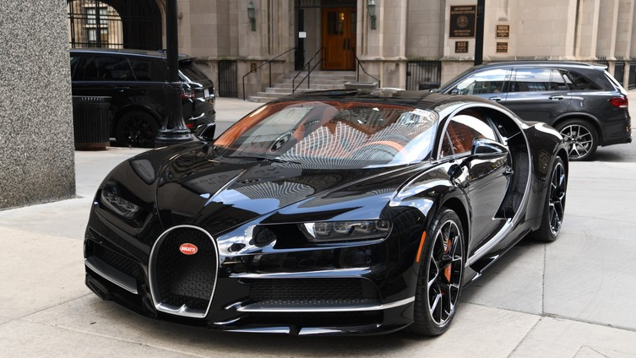
Cipher image
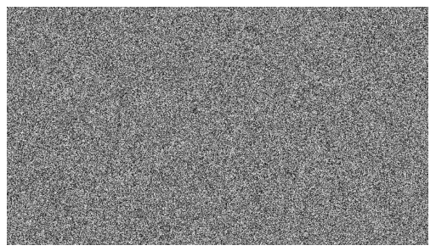
3) NO
Lab 8
1) Partner name : Noah
2) P : 5
G : 5
S : 18
Private key : (13,85)
Lab 9
1)The attack type you have chosen : Uber Data Breach (2022)
2) Any one key website or research paper link that you found was useful : upguard (https://www.upguard.com/blog/what-caused-the-uber-data-breach)
Lab 10

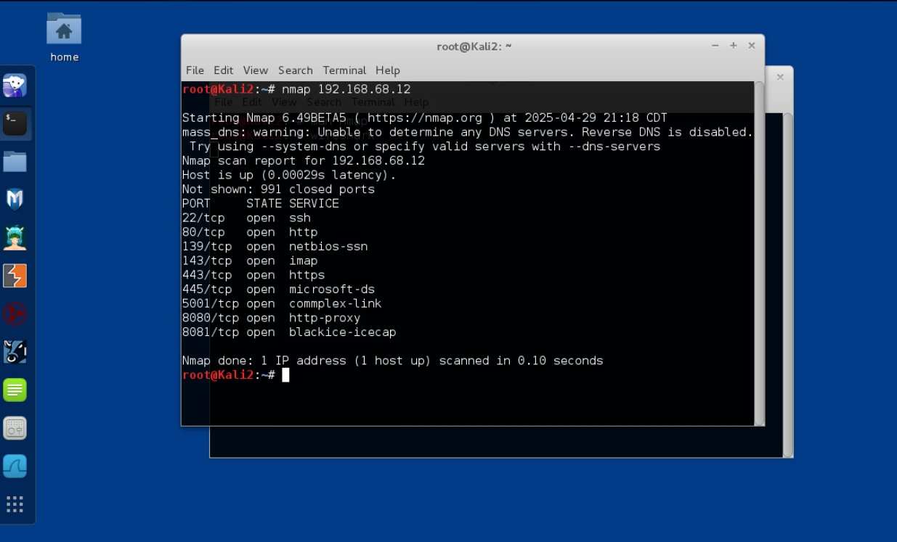
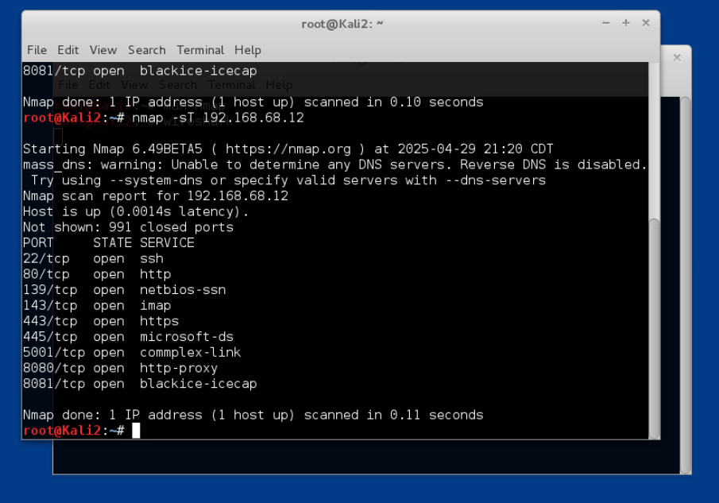
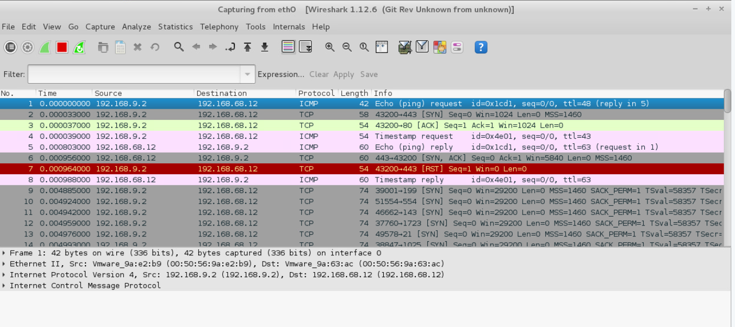
Lab 11

Lab 12
EXAM
Github link : https://github.com/shameemnoor3011/cybersecurity

