PRACTICUM WORKSHEET: THE AMDAHL REALITY GAP

Empirical Speedup Fitting, Micro-Architectural Bottlenecks, and Loop Scheduling in OpenMP

Student Full Name: Yernar Shameke | Student ID Number: 230103189
Institutional Email / Git URL:  230103189@sdu.edu.kz | Practicum Date & Time (Slot):  25.09.26 01-N
Laptop Model & OS (Linux/macOS/Win):  Win | CPU Model & Generation:  12th Gen Intel(R) Core(TM) i7-12700H
Physical Cores (P/E breakdown if hybrid):  14 | Logical SMT Threads (omp_get_max_threads):
Target Workload Size N (Derived via Formula): | L1 / L2 Cache Line Size (Typically 64 bytes):  64

LAB INTEGRITY & ANTI-PLAGIARISM PROTOCOL: STRICT INDIVIDUAL EXECUTION & ZERO-
TOLERANCE INTEGRITY NOTICE: This laboratory practicum evaluates real physical execution on your personal laptop hardware. Generative AI tools (ChatGPT, Copilot, Claude) can produce synthetic OpenMP syntax, but they CANNOT execute native code on your silicon, cannot generate valid microsecond wall-clock timings reflecting your CPU's hardware architecture, and cannot produce the exact checksum tied to your unique Student ID seed. All logs, hardware dumps, and execution timestamps will be audited automatically. Fabricated or simulated data results in immediate grade revocation (0/100). Do not work in pairs.

Overview & Theoretical Framework
Amdahl's Law models the theoretical upper bound of parallel speedup S(k) as a function of the parallelizable fraction p and the number of execution units k:
AMDAHL'S LAW: S(k) = 1 / [ (1 - p) + (p / k) ]
Where: S(k) = Speedup with k worker threads, p = Fraction of execution time strictly parallelizable (0 <= p <= 1), and (1 - p) = Strictly sequential component.

In textbooks, Amdahl's Law assumes that adding execution threads incurs zero communication latency, perfect memory bandwidth scaling, and uniform instruction latency. On real physical hardware, however, programs encounter the Amdahl Reality Gap: performance degrades below theoretical bounds due to:
  - 1. Sequential Overhead: Sequential fraction bottlenecks (1 - p) such as thread spawning, barrier waits, and reduction synchronization.
  - 2. False Sharing: Multiple cores thrashing the same 64-byte L1/L2 cache line via the MESI cache
coherence protocol.
  - 3. Workload Imbalance: Adjacent iterations consuming drastically different execution cycles, causing worker threads to idle at barriers.
  - 4. Memory & Execution Bandwidth Saturation: Memory controller saturation and Simultaneous
Multithreading (SMT) hyper-thread pipeline contention.

Laboratory Practicum Roadmap (180 Minutes Minimum Execution)
  - • Phase 1 (20 mins): System architecture probing, hardware dump, and unique seed derivation.
  - • Phase 2 (40 mins): Sequential baseline implementation, warm-up profiling, and timing verification.
  - • Phase 3 (45 mins): Multi-threaded OpenMP scaling, Amdahl curve derivation, and reality gap mapping.
  - • Phase 4 (45 mins): Micro-architectural experiments (Triggering and resolving false sharing; scheduling evaluation).
  - • Phase 5 (30 mins): Technical analysis questions, verification checksum generation, and repository
packaging.

Phase 1: Machine Probing & Workload Formulation (20 mins)
To guarantee integrity, your workload size N is tied to your Student Identification Number. Calculate your unique upper bound N before writing any code:
UNIQUE INPUT WORKLOAD FORMULA: N = 10,000,000 + ( [Last 4 Digits of Student ID] * 1,000 ) Example: If Student ID is 20240984, Last 4 Digits = 0984. N = 10,000,000 + (984 * 1,000) = 10,984,000.

Step 1.1: Capture Hardware Specification. Open your terminal and pipe your hardware configuration into a raw text file named hw_info.txt. Include this file in your final submission:

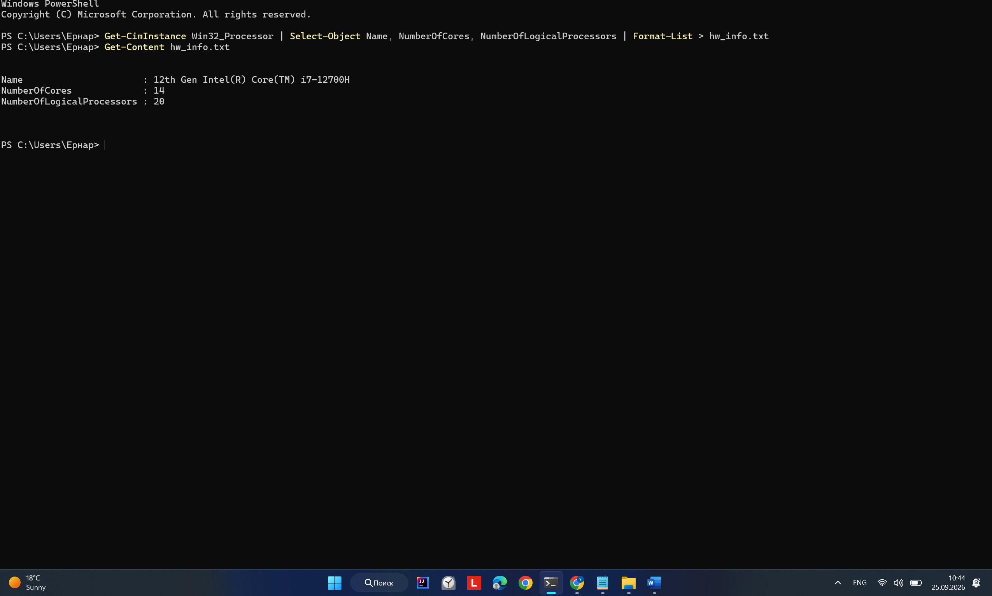
# Linux Systems:
lscpu > hw_info.txt

# macOS (Darwin):
sysctl -a | grep -E "machdep.cpu|hw.ncpu|hw.l" > hw_info.txt

# Windows (PowerShell):
Get-CimInstance Win32_Processor | Select-Object Name, NumberOfCores, NumberOfLogicalProcessors | Format-List > hw_info.txt

Step 1.2: Computational Kernel — The Collatz Stopping Time. For each integer i in [1, N], calculate its stopping time (the number of steps required to reach 1 under the 3x + 1 rules). Track the maximum stopping time observed across the entire range.

// Collatz Stopping Time Kernel
static inline uint32_t collatz_steps(uint64_t n) { uint32_t steps = 0;
while (n > 1) {
if ((n & 1) == 0) n >>= 1;
else n = 3 * n + 1; steps++;
}
return steps;
}
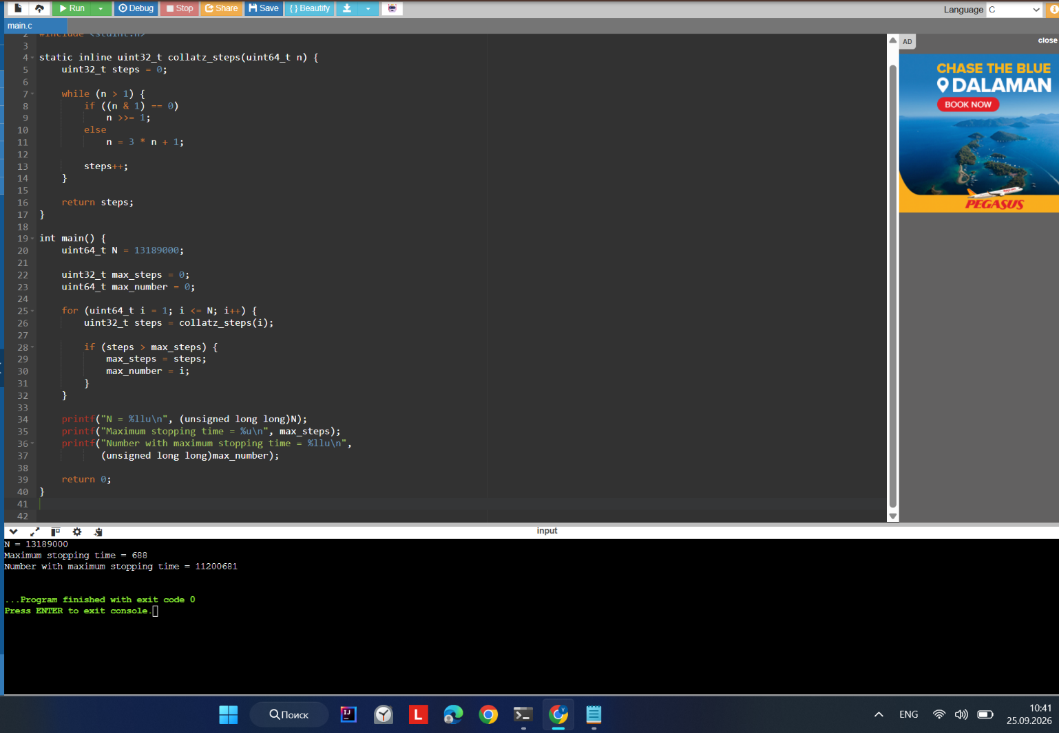

Phase 2: Sequential Baseline & Precision Timing (40 mins)
Step 2.1: Implement collatz_seq.c. Your sequential program must iterate through i = 1 to N, calculate collatz_steps(i), find the maximum steps, and sum all stopping times modulo 1,000,000,007 (to serve as an anti-cheat checksum).

Step 2.2: Benchmarking Rules & Warmup Invalidation. High-performance computing requires careful measurement:
  - • Warmup Rule: Discard Run 1 (Cold cache / OS page allocation penalty).
  - • Timing Rule: Execute Run 2 and Run 3 under identical machine state. Compute T_seq = (Run 2 + Run 3)
/ 2.0.
  - • Isolation: Close web browsers, streaming audio, and background IDEs during benchmarks to avoid core migration.
  - • Clock Precision: Use omp_get_wtime() for sub-microsecond wall-clock timing precision. Do NOT use
clock().
# Compile with standard optimization flags (-O2) gcc -O2 -fopenmp collatz_seq.c -o collatz_seq
./collatz_seq

Phase 3: Multi-Thread Scaling & Empirical Amdahl Fitting (45 mins)
Parallelize your sequential loop using OpenMP (#pragma omp parallel for). You will evaluate the parallel runtime T_k across thread counts k in {1, 2, 4, 8, 16 (if supported)}.

Analytical Derivation of Parallel Fraction (p)
Using your empirical speedup at k = 2 threads (S_emp(2) = T_seq / T_2), solve algebraically for the parallel fraction p:
DERIVATION OF p FROM DUAL-CORE SPEEDUP: S(2) = 1 / [ (1 - p) + (p / 2) ] 1 / S(2) = 1 - p + 0.5p = 1 - 0.5p
0.5p = 1 - (1 / S(2))
p = 2 * [ 1 - (1 / S_emp(2)) ]

Once p is derived, calculate the theoretical speedup S_theo(k) for all other k values using Amdahl's Law, and calculate the Reality Gap: Delta(k) = S_theo(k) - S_emp(k).
Empirical Measurement Log: Record your raw benchmarks in Table 1 below:

Threads (k) | Run 1 (Cold) | Run 2 (s) | Run 3 (s) | Avg T_k (s) | S_emp(k) | S_theo(k) | Delta (k)
k = 1 (T_1) | --- | --- | --- | --- | --- | --- | ---
k = 2 | --- | --- | --- | --- | --- | --- | ---
k = 4 | --- | --- | --- | --- | --- | --- | ---
k = 8 | --- | --- | --- | --- | --- | --- | ---
k = 16 (or max) | --- | --- | --- | --- | --- | --- | ---

Phase 4: Hardware Penalties & Micro-Architectural Experiments (45 mins)
Amdahl's model treats all parallel work as linear and uniform. In this phase, you will intentionally expose your code to two real-world hardware failure modes.

Experiment A: The False Sharing Penalty (Cache Invalidation)

Task: In addition to finding the maximum sequence length, count how many numbers in [1, N] require more than 100 stopping steps.
Implementation 1 (Naive Array - Triggers False Sharing): Declare an array int hit_count[MAX_THREADS] outside the parallel region. Inside the loop, each thread executes: hit_count[omp_get_thread_num()]++.
Implementation 2 (Mitigated - OpenMP Reduction or Padded Struct): Implement either an OpenMP reduction variable (#pragma omp parallel for reduction(+:total_hits)) or a padded structure that forces each thread's counter onto a separate 64-byte cache line (struct Padded { int count; char pad[60]; };).
Execute both implementations using your CPU's maximum physical thread count. Record the results below:

Implementation Variant | Thread Count | Execution Time (s) | Effective Throughput (iter/sec) | Speedup Penalty Ratio
Variant 1: Naive hits[tid]++ (False Sharing) | Max Physical: | --- | --- | ---
Variant 2: Reduction / Cache-Padded | Max Physical: | --- | --- | ---

Experiment B: Loop Scheduling & Workload Imbalance
Collatz sequence trajectories exhibit extreme non-uniformity: integer 26 terminates in 10 steps, whereas integer 27 requires 111 steps. Evaluate how OpenMP scheduling clauses impact thread tail latency at your maximum thread count:

OpenMP Scheduling Clause | Chunk Size | Execution Time (s) | Observed Behavior & CPU Load Distribution
schedule(static) | Default (N / k) | --- | Baseline static partitioning across threads.
schedule(static, 1000) | 1,000 | --- | Round-robin chunk distribution.
schedule(dynamic, 100) | 100 | --- | Fine-grained dynamic work queue.
schedule(dynamic, 10000) | 10,000 | --- | Coarse-grained dynamic work queue.
schedule(guided) | Exponential decay | --- | Adaptive scheduling (starts large, reduces size).

Phase 5: Technical Analysis & Defense Questions (30 mins)
Answer the following questions concisely based on your empirical benchmark outputs:
Q1: Micro-Architectural Root Cause of False Sharing
Explain why Variant 1 in Experiment A caused massive execution degradation. Specifically reference your CPU's L1 cache line size (in bytes), the MESI/MOESI cache protocol, and bus invalidation traffic.

Q4: The Scheduling Trade-Off Dilemma
Compare dynamic(100) versus dynamic(10000) and static scheduling. At what chunk size did lock-queue contention outweigh the benefits of workload balancing on your machine?
Q3: Empirical vs. Theoretical Amdahl Discrepancy
State your derived parallel fraction p (from k=2). Why did the theoretical curve S_theo(k) diverge from your empirical S_emp(k) as k increased to 8 or 16? Identify two real physical factors omitted by Amdahl's equation.
Q2: Hyperthreading (SMT) Saturation & Physical Core Ceilings
Did your speedup continue to scale linearly when thread count k increased from your physical core count to your logical thread count? Why or why not? What hardware execution resources are shared between SMT threads?

Phase 6: Deliverables Checklist & Packaging Instructions (15 mins)
Package all lab assets into a compressed archive named lab1_[StudentID].tar.gz or push to a private Git repository with instructor access:
  - 1. Hardware Specification: hw_info.txt — Verbatim system output from lscpu, sysctl, or PowerShell.
  - 2. Source Code: collatz.c / collatz.cpp — Full C/C++ source code with compilation instructions in header comments.
  - 3. Benchmark Dataset: results.csv — Raw machine timing logs matching Table 1, Table 2, and Table 3.
  - 4. Scalability Graph: speedup_plot.png — High-resolution graph plotting k vs. S_emp(k), S_theo(k), and Linear Ideal.
  - 5. Written Defense: analysis.pdf or written responses on this worksheet — Completed technical questions
Q1 to Q4.
# How to create your submission archive:
mkdir lab1_20240984
cp hw_info.txt collatz.c results.csv speedup_plot.png lab1_20240984/ tar -czvf lab1_20240984.tar.gz lab1_20240984/
# Verify integrity before submission: tar -tvf lab1_20240984.tar.gz

Evaluation & Grading Rubric (100 Points Total)

Assessment Category | Target Points | Proficient Criteria (Full Marks) | Deficiency Penalties (-10 to - 25 pts)
Compilation & Correctness | 20 pts | Clean compilation with -O2 - fopenmp. Verification checksum correctly matches the student ID workload N. | Compiler warnings, incorrect reduction, or checksum mismatch (-20 pts).
Empirical Timing Quality | 30 pts | Realistic wall-clock benchmark data with warmup runs discarded; believable variance across runs; hw_info matches results. | Synthetic/simulated numbers, zero run variance, missing hardware specs (-30 pts).
Amdahl Fitting & Plotting | 25 pts | Correct algebraic derivation of p from S(2); accurate projection of S_theo(k); clear plot showing the Reality Gap. | Incorrect derivation of p, missing speedup plot, or non-convergent curves (-15 pts).
Hardware Penalty Analysis | 25 pts | Complete implementation of false sharing experiment; correct technical analysis of MESI protocol and scheduling trade-offs. | Superficial or incorrect explanation of cache invalidation; failure to mitigate false sharing (-15 pts).

