Hibernate Set-up

In this chapter we will configure the Hibernate, We will configure Hibernate on Windows Environment.

To configure Hibernate on Windows we require the following Softwares.

**Java:** Download Java8 from <http://www.oracle.com/technetwork/java/javase/downloads/jdk8-downloads-2133151.html>.

Now install the java installer

After Installing Please follow the steps mentioned below

1. Create an Environment variable called JAVA_HOME
2. Add path to java installation folder

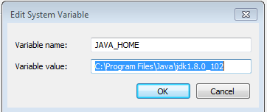

C. Now in PATH variable add “**;%JAVA_HOME%\bin;**” phrase

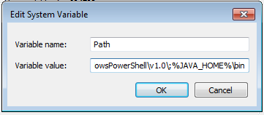

D. Open console paste this command “**java -version”.** If it shows java path then you configure java perfectly.



**Eclipse Oxygen**: Download Eclipse Oxygen from here ,

<http://www.eclipse.org/downloads/packages/eclipse-ide-java-ee-developers/oxygenm3>

1. Based on computer operation system download 32 bit or 64 bit version.

Right click on My Computer and in the System section check System type.



b.. Extract the zip file . and click on eclipse.exe.

C. create a folder under C: name it hibernate, path C:\\hibernate

D. Set workspace location to C:\\hibernate.

E. Create a Maven project from File->New Project->Maven Project

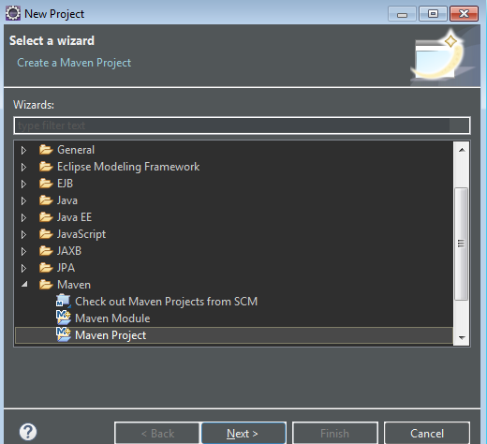

F. Provide project name “**hibernateTutorial**”

G. Provide Group Id as **com.example**

H. provide Artifactid as **hibernate.**

1. Project Structure will be

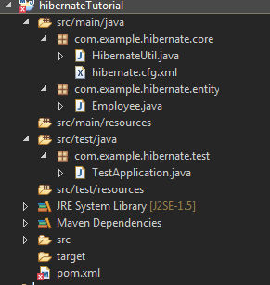

**Maven** : Please copy and paste following entry in pom.xml

a.

<project xmlns="http://maven.apache.org/POM/4.0.0" xmlns:xsi="http://www.w3.org/2001/XMLSchema-instance" xsi:schemaLocation="http://maven.apache.org/POM/4.0.0 http://maven.apache.org/xsd/maven-4.0.0.xsd">

<modelVersion>4.0.0</modelVersion>

<groupId>com.example</groupId>

<artifactId>hibernateTutorial</artifactId>

<version>0.0.1-SNAPSHOT</version>

<build>

<sourceDirectory>src</sourceDirectory>

<plugins>

<plugin>

<artifactId>maven-compiler-plugin</artifactId>

<version>2.3.2</version>

<configuration>

<source>1.7</source>

<target>1.7</target>

</configuration>

</plugin>

</plugins>

</build>

<dependencies>

<dependency>

<groupId>org.hibernate</groupId>

<artifactId>hibernate-core</artifactId>

<version>4.3.6.Final</version>

</dependency>

<!-- for JPA, use hibernate-entitymanager instead of hibernate-core -->

<dependency>

<groupId>org.hibernate</groupId>

<artifactId>hibernate-entitymanager</artifactId>

<version>4.3.6.Final</version>

</dependency>

<!-- optional -->

<dependency>

<groupId>org.hibernate</groupId>

<artifactId>hibernate-osgi</artifactId>

<version>4.3.6.Final</version>

</dependency>

<dependency>

<groupId>org.hibernate</groupId>

<artifactId>hibernate-envers</artifactId>

<version>4.3.6.Final</version>

</dependency>

<dependency>

<groupId>org.hibernate</groupId>

<artifactId>hibernate-c3p0</artifactId>

<version>4.3.6.Final</version>

</dependency>

<dependency>

<groupId>org.hibernate</groupId>

<artifactId>hibernate-proxool</artifactId>

<version>4.3.6.Final</version>

</dependency>

<dependency>

<groupId>org.hibernate</groupId>

<artifactId>hibernate-infinispan</artifactId>

<version>4.3.6.Final</version>

</dependency>

<dependency>

<groupId>org.hibernate</groupId>

<artifactId>hibernate-ehcache</artifactId>

<version>4.3.6.Final</version>

</dependency>

<dependency>

<groupId>antlr</groupId>

<artifactId>antlr</artifactId>

<version>2.7.6</version>

</dependency>

<dependency>

<groupId>commons-collections</groupId>

<artifactId>commons-collections</artifactId>

<version>3.1</version>

</dependency>

<dependency>

<groupId>dom4j</groupId>

<artifactId>dom4j</artifactId>

<version>1.6.1</version>

</dependency>

<dependency>

<groupId>javassist</groupId>

<artifactId>javassist</artifactId>

<version>3.4.GA</version>

</dependency>

<dependency>

<groupId>javax.transaction</groupId>

<artifactId>jta</artifactId>

<version>1.1</version>

</dependency>

<dependency>

<groupId>org.slf4j</groupId>

<artifactId>slf4j-api</artifactId>

<version>1.5.6</version>

</dependency>

<dependency>

<groupId>org.slf4j</groupId>

<artifactId>slf4j-log4j12</artifactId>

<version>1.5.6</version>

</dependency>

<dependency>

<groupId>hsqldb</groupId>

<artifactId>hsqldb</artifactId>

<version>1.8.0.10</version>

</dependency>

</dependencies>

</project>

Snap:

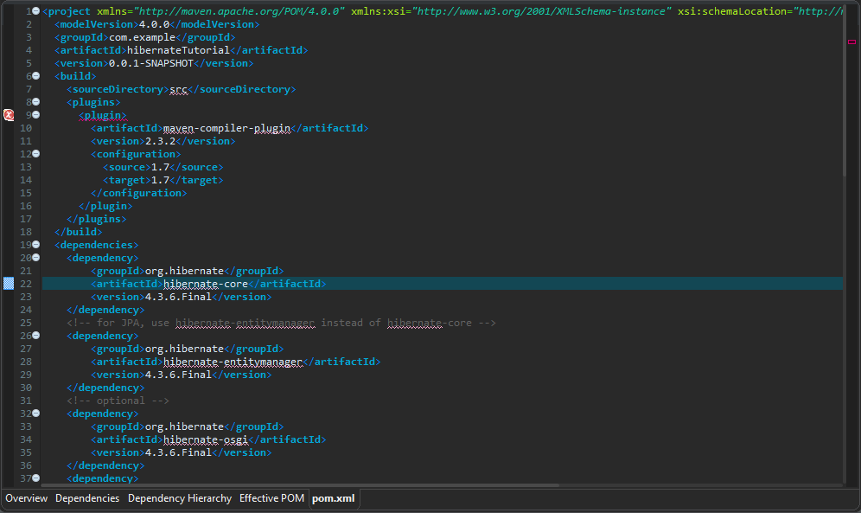

B. Now RunAS->Maven build it will download necessary jars and add it to dependencies

Settings is completed in next chapter we will run our first Hibernate Example.

