**Let take a closer look at Spring bean XML file.**

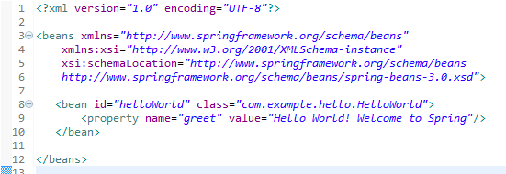

**Prolog:**

**<?xml version="1.0" encoding="UTF-8"?>,**

We call it XML prolog; it is the first line of Xml which tells about xml version.

**beans Tag:**

**<beans xmlns="http://www.springframework.org/schema/beans"**

**xmlns:xsi="http://www.w3.org/2001/XMLSchema-instance"**

**xsi:schemaLocation="http://www.springframework.org/schema/beans**

**http://www.springframework.org/schema/beans/spring-beans-3.0.xsd">**

Here we mention the XSD file for configuration XML. XSD stands for XML Schema Definition it is a World Wide Web Consortium (W3C) recommendation that specifies how to formally describe the elements in an Extensible Markup Language (XML) document. In a simple word, it says about which possible tags and it's attribute, we can use in this configuration file

**schemLocation** says where to found that XSD on Internet,

**bean Tag:**

**<bean id="helloWorld" class="com.example.hello.HelloWorld">**

bean tag has two important attributes id and class, id is the identifier of the bean, you can think it as the primary key of a table, or SSN of an American citizen. Class attribute provides fully qualified class name, internally Spring container load this bean using java reflection,

So always provide an exact class name and unique id for a bean.

**Property Tag:**

**<property name="greet" value="Hello World! Welcome to Spring"/>**

In each bean tag we define properties which are same as java attributes, so if an Employee class have two properties say the name, address so we have to define two property tags under Employee bean and name of the property should match with java property. And in Java bean please provide a setter for that property as Spring injects value attribute using that setter.