**Step by step guide for Spring configuration**

Here are the steps to configure Spring core with eclipse IDE

1. Install JDK (greater or equal JDK 1.6) from http://www.oracle.com/technetwork/java/javase/downloads/index.html

2. Install eclipse from https://eclipse.org/downloads/

3. create a java project in eclipse called SpringAssignment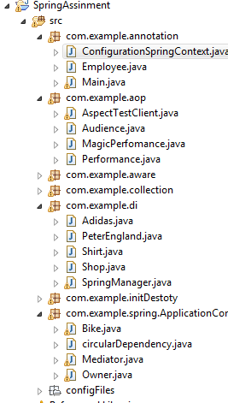

3. create a folder lib under SpringAssignment \lib

4. Download commonLoggin1.2.jar from here http://commons.apache.org/proper/commons-logging/download_logging.cgi

5. extract it and put jars into lib folder earlier created (SpringAssignment \lib).

6. Download spring from here

http://repo.spring.io/release/org/springframework/spring/4.1.6.RELEASE/

7. extract it and put all jars into the lib SpringAssignment\lib folder.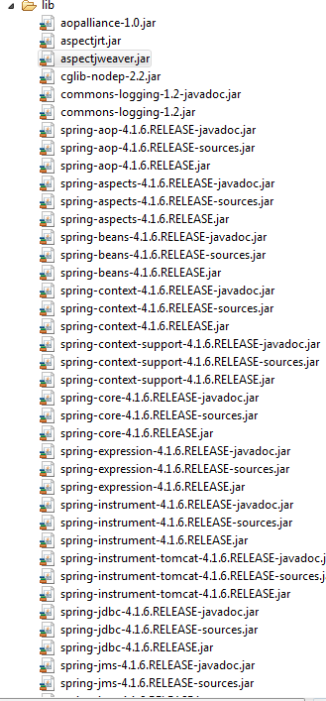

8. Right click on SpringAssignment ->properties->java build path

9. click on add external jar and add all jars under lib folder

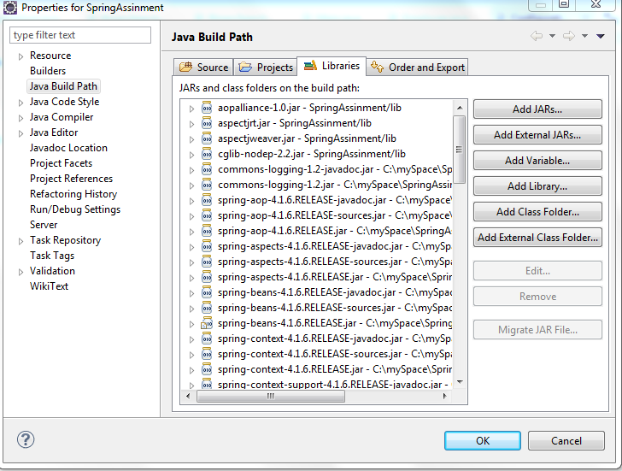

Well done setup is complete, now we will test it with a basic application in next chapter.