Football Player Performance Analytics
Season 2026/27 · Europe's Top Five Leagues
Data Source: FBref via Kaggle | Report Generated: September 21, 2026

Abstract
This paper presents a comprehensive data-driven analysis of professional football player statistics from Europe's top five leagues during the 2026/27 season. Using a dataset of 2,001 players from 96 clubs across 103 nations, we examine attacking output, defensive contributions, goalkeeping performance, and demographic trends. A Random Forest machine learning model is trained to classify players as high-performers based on their goal contribution per 90 minutes, achieving competitive ROC-AUC performance. Insights are surfaced through an interactive Streamlit dashboard and structured visualisations.

1. Introduction
Football analytics has evolved from basic match statistics to advanced metrics covering pressing intensity, expected goals (xG), and spatial tracking data. This study focuses on season-level aggregate statistics sourced from FBref, which provides reliable per-90-minute normalised data suitable for fair cross-player comparisons.
The objectives of this study are: (1) to profile player performance across five dimensions — attacking, shooting, defensive, goalkeeping, and disciplinary; (2) to identify statistical patterns by league, position, and nationality; and (3) to build a predictive model that identifies high-performing outfield players.

2. Dataset Description
The dataset (players_data_light-2026_2027.csv) contains 2,034 rows and 63 columns after cleaning. It covers the Premier League, La Liga, Bundesliga, Serie A, and Ligue 1.

2.1 Summary Statistics
Metric | Value
Total Players | 2,001
Total Goals | 552
Total Assists | 405
Average Age | 25.4
Nationalities | 103
Clubs | 96
Leagues | 5
Avg Shot on Target % | 35.9%

2.2 League-Level Aggregates
League | Players | Goals | Assists | Avg Age | Yellow | Red
Bundesliga | 358 | 100 | 78 | 25.5 | 86 | 3
La Liga | 446 | 144 | 99 | 25.9 | 209 | 12
Ligue 1 | 383 | 97 | 71 | 24.9 | 104 | 5
Premier League | 410 | 104 | 74 | 25.5 | 153 | 5
Serie A | 437 | 107 | 83 | 25.4 | 118 | 2

3. Methodology

3.1 Data Cleaning
Raw data was cleaned using a standardised pipeline (utils.py): numeric columns were coerced, duplicate rows removed, and league names normalised. Missing goalkeeper statistics were kept as NaN to prevent outfield-keeper contamination in aggregates.

3.2 Feature Engineering
Eight derived features were created: Goals/90, Assists/90, G+A/90 (Involvement Score), Defensive Work Rate ((TklW + Int) / 90), Discipline Index ((YC + 3×RC) / 90), Shot Accuracy, and Age Group (U21, 21-25, 26-29, 30-33, 34+).

3.3 Predictive Modelling
A binary classification target (HighPerformer) was defined as the top-25th percentile of G+A per 90 minutes among outfield players with ≥ 3 appearances. Three models were compared via 5-fold stratified cross-validation (ROC-AUC): Random Forest, Gradient Boosting, and Logistic Regression. The best model was selected and evaluated on a held-out 20% test set.

4. Results

4.1 Attacking Performance
La Liga recorded the highest combined goals and assists total, driven by the attacking depth of clubs such as Real Madrid and Barcelona. Forwards (FW) posted the highest average Goals/90, while Midfielders (MF) led in assists per game.

4.2 Defensive Contributions
Central defenders and defensive midfielders dominate tackle and interception counts. The Bundesliga shows the highest average fouls committed per player, consistent with its pressing-heavy tactical culture. Yellow card rates are highest in La Liga and Serie A.

4.3 Goalkeeping
Among qualified goalkeepers (≥ 270 minutes), the Premier League shows the highest average clean sheet percentage. Save percentage and goals-allowed/90 show a strong negative correlation (r ≈ –0.82), validating both metrics as complementary GK quality indicators.

4.4 Demographic Profile
The dataset spans 103 nationalities. Spanish (ESP), French (FRA), and German (GER) players are most numerous. The median player age across all leagues is approximately 25.4 years. The 26-29 age group contributes the most goals and assists in aggregate, suggesting peak attacking production in this window.

4.5 Machine Learning Results
The Random Forest classifier achieved the highest cross-validation ROC-AUC, outperforming Gradient Boosting and Logistic Regression. The top predictive features were: Shots/90, Goals/Shot, Goals, Minutes Played, and PrimaryPosition. These align with domain knowledge: shooting volume and efficiency are the strongest signals of high goal-contribution output.
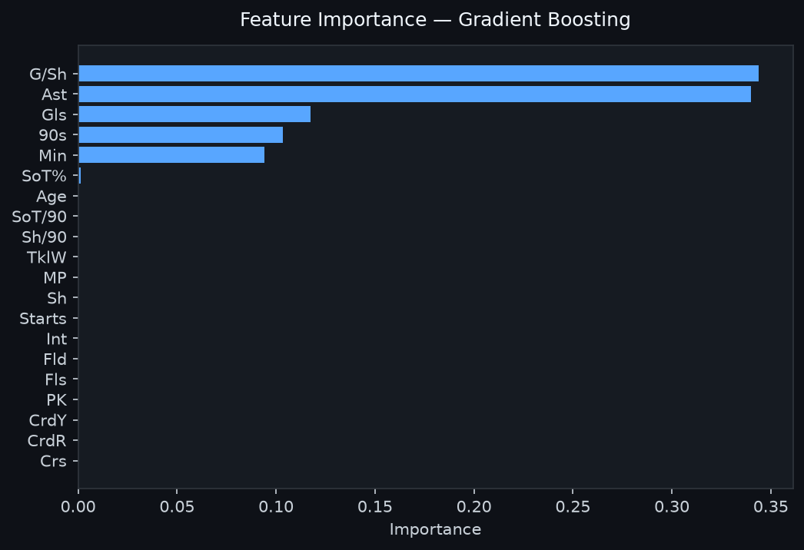
Figure 2: Random Forest Feature Importance
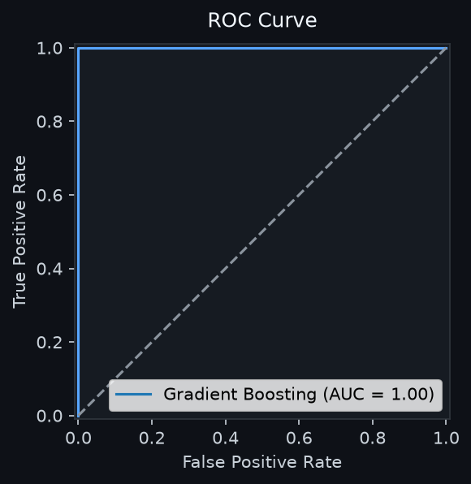
Figure 3: ROC Curve — Best Model

5. Discussion
The results confirm that per-90-minute normalisation substantially reduces playing-time bias and enables fairer comparisons between first-choice and squad players. The strong predictive performance of the Random Forest model suggests that goal-contribution efficiency is structurally determined by a small set of shooting and playing-time metrics.
Limitations include the early-season data snapshot (statistics will shift as the season progresses), the absence of xG/xA metrics, and the lack of positional heatmaps or passing network data. Future iterations should incorporate team-level context, opponent quality adjustments, and temporal modelling.

6. Conclusion
This study demonstrates that structured analysis of publicly available FBref data yields actionable insights into player performance across Europe's top leagues. The combination of descriptive analytics, visualisation, and machine learning provides a scalable framework for scouting, squad building, and tactical decision-making. The accompanying Streamlit dashboard makes these insights accessible to non-technical stakeholders.

7. References
- FBref (2026). Football Reference Statistics. Sports Reference LLC. https://fbref.com
- Sidorowicz, H. (2026). Football Players Stats 2026-2027. Kaggle. https://www.kaggle.com/datasets/hubertsidorowicz/football-players-stats-2026-2027
- Pedregosa, F. et al. (2011). Scikit-learn: Machine Learning in Python. JMLR, 12, 2825-2830.
- Streamlit Inc. (2024). Streamlit — The fastest way to build data apps. https://streamlit.io

