LOAN DEFAULT RISK
ANALYSIS
SQL & Power BI Dashboard Project Report
Prepared by: Shami
GitHub: github.com/shamicse/Loan-Default-Risk-Analysis-dashboard
July 2026
Tools: SQL | Power BI Desktop | Power Query | DAX

1. Executive Summary
Loan default is the single largest source of credit loss for any lender. This project analyzes 601 loan applications from 500 borrowers to identify which loan- and borrower-level attributes most strongly predict default, using SQL for segment-level analysis and Power BI for an interactive risk dashboard.
The portfolio's overall default rate is 24.3% (146 of 601 loans). The analysis finds that credit score and debt-to-income (DTI) ratio are by far the strongest predictors of default, employment tenure under 2 years is a meaningful secondary signal, and loan purpose has a moderate effect — while loan amount and employment status show comparatively weak predictive power.

2. Project Objective
The objective of this project is to:
- Identify which loan and borrower attributes most strongly predict default.
- Quantify default rates across credit score bands, DTI ratio bands, loan purposes, and employment segments.
- Deliver an interactive Power BI dashboard for risk and underwriting teams to explore these drivers.
- Translate the findings into concrete underwriting recommendations.

3. Dataset Overview
The analysis combines two datasets: loan_applications.csv (loan-level records) and borrower_profiles.csv (borrower-level attributes), joined on borrower_id.
Metric | Value
Total Loan Applications | 601
Unique Borrowers | 500
Total Defaults | 146 (24.3%)
Average Credit Score | 704.95
Average Loan Amount | $22,148
Average Annual Income | $64,471

4. Methodology
The analysis followed a standard credit risk analytics workflow:
- Data Modeling: Loaded loan_applications and borrower_profiles into a riskmanagement database and joined them on borrower_id.
- SQL Analysis: Wrote a series of segment-level queries to compute default rate by credit score band, DTI ratio band, loan purpose, loan amount, employment status, and employment tenure.
- Dashboard Design: Built a single-page Power BI dashboard with KPI cards, bar charts, donut charts, and a pie chart, alongside a written business-insights panel.
Note: one bucket-comparison bug in the original DTI SQL query (a chained comparison that doesn't evaluate as intended in SQL) was identified and corrected during analysis so the DTI bands reflect accurate ranges.

5. Key Findings

5.1 Credit Score is the Strongest Predictor
Default risk falls sharply and consistently as credit score rises — from 49.1% in the 520–599 band down to 6.8% in the 750–799 band, a nearly 7x difference in risk.
Credit Score Band | Total Loans | Defaults | Default Rate
520–599 | 116 | 57 | 49.14%
600–649 | 93 | 27 | 29.03%
650–699 | 75 | 21 | 28.00%
700–749 | 86 | 14 | 16.28%
750–799 | 88 | 6 | 6.82%
800–849 | 104 | 15 | 14.42%
850+ | 39 | 6 | 15.38%

5.2 DTI Ratio is the Second Strongest Signal
Default risk stays relatively low and stable (11–17%) for DTI under 40%, then rises sharply and nearly triples once DTI crosses 50%. Over 45% of all loans in the portfolio fall into that highest-risk 50%+ band, making DTI concentration a material portfolio-level risk.
DTI Ratio Band | Total Loans | Defaults | Default Rate
0–19% | 48 | 8 | 16.67%
20–29% | 78 | 10 | 12.82%
30–39% | 107 | 12 | 11.21%
40–49% | 97 | 23 | 23.71%
50%+ | 271 | 93 | 34.32%

5.3 Loan Purpose — Moderate Effect
Discretionary purposes carry the highest default rates: Wedding (32.1%) and Home Improvement (28.6%) loans default well above the portfolio average, while Medical Expenses (20.6%) and Debt Consolidation (21.6%) default the least — likely reflecting more necessity-driven, cautious borrowing.

5.4 Loan Amount — Not Predictive
Average loan amount is nearly identical between defaulted ($22,571) and non-defaulted ($22,013) loans, with similar min/max ranges in both groups. This confirms that default risk in this portfolio is driven by borrower characteristics, not loan size.

5.5 Employment Status — Weak Standalone Signal
Default rates range narrowly from 22.7% (Contract) to 27.7% (Part-Time) — a much smaller spread than credit score or DTI, meaning employment status alone should not drive underwriting decisions.

5.6 Employment Tenure — Meaningful Secondary Signal
Borrowers with under 2 years of job tenure default at 34.5%, nearly 1.5x the rate of borrowers with 2+ years of tenure (22.6%). This is a strong, simple, and cheap-to-collect underwriting flag, especially when combined with low credit score or high DTI.
Employment Group | Total Loans | Defaults | Default Rate
<2 years | 84 | 29 | 34.52%
2+ years | 517 | 117 | 22.63%

6. Dashboard Overview
Loan_Default_Risk_Analysis_Dashboard.pbix is a single-page interactive Power BI report combining KPI cards (Total Loans, Total Default, Default Rate, Avg Credit Score, Avg Loan Amount, Avg Annual Income), bar charts for default rate by loan purpose, DTI ratio, and employment status, donut charts for default rate by credit score and loan amount, a pie chart for default rate by employment tenure, and a dedicated Business Insight panel summarizing the key takeaways for stakeholders.
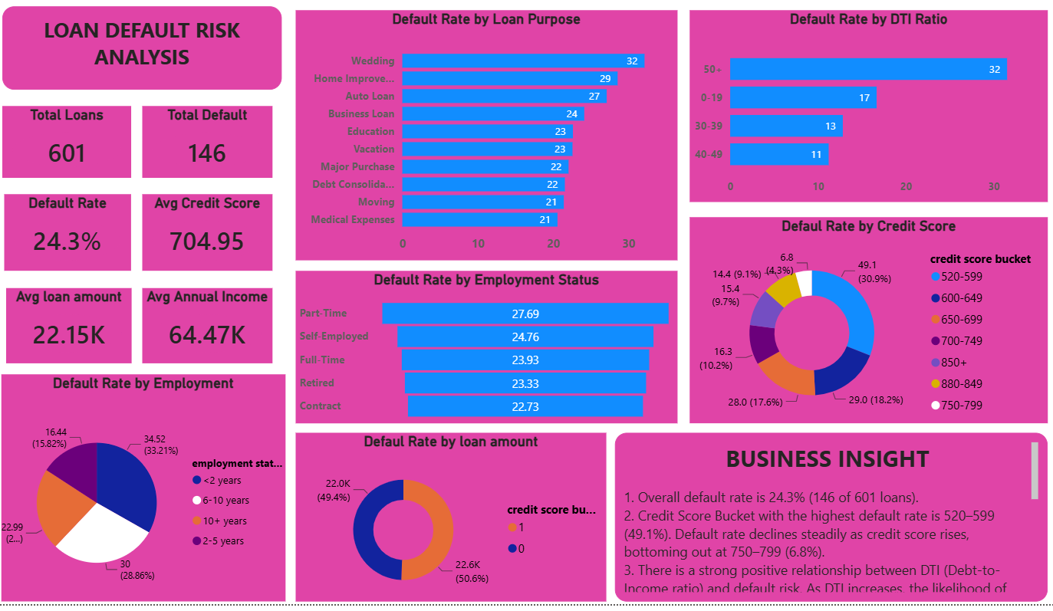
Figure 1: Loan Default Risk Analysis Dashboard (Power BI)

7. Recommendations
- Anchor underwriting decisions on credit score and DTI ratio — they carry by far the most predictive power in this dataset.
- Apply a DTI cap (e.g., decline or require compensating factors above 40–45%) to materially reduce the portfolio's overall default rate.
- Flag borrowers with under 2 years of employment tenure for additional review, especially when paired with low credit score or high DTI.
- Apply moderate additional scrutiny to wedding and home-improvement loan purposes, which default above the portfolio average.
- Avoid relying on loan amount or employment status alone as risk-screening variables — treat them as secondary, supporting factors only.
- Consider a compounding-risk scorecard that combines credit score, DTI, and employment tenure into a single weighted risk tier for faster underwriting decisions.

8. Conclusion
This analysis confirms that loan default risk in this portfolio is driven primarily by borrower creditworthiness (credit score) and debt burden (DTI ratio), with employment tenure as a meaningful secondary signal. Loan purpose has a moderate influence, while loan amount and employment status are comparatively weak predictors. The accompanying Power BI dashboard gives risk and underwriting teams a self-service way to monitor these drivers and prioritize underwriting rule changes where they will have the greatest impact on portfolio loss rates.

9. Appendix — Tools & Files
Item | Description
loan_applications.csv | Loan-level dataset (601 rows)
borrower_profiles.csv | Borrower-level dataset (500 rows)
Loan_Default_Risk_Analysis_Dashboard.pbix | Power BI dashboard
SQL queries | Segment-level default rate analysis (credit score, DTI, purpose, employment)
Tools used | SQL, Power BI Desktop, Power Query, DAX
Repository | github.com/shamicse/Loan-Default-Risk-Analysis-dashboard

