BLINKIT GROCERY DATA
ANALYSIS
SQL & Power BI Dashboard Project Report
Prepared by: Shami
GitHub: github.com/shamicse/blinkit-analysis-dashboard-By-PowerBi
July 2026
Tools: SQL | Power BI Desktop | Power Query | DAX

1. Executive Summary
Blinkit, India's last-minute grocery delivery app, generates high-volume, item-level sales data across a wide network of outlets. This project analyzes 8,523 item records to evaluate sales performance, customer satisfaction, and inventory distribution, using SQL for data cleaning and KPI validation and Power BI for an interactive, brand-styled dashboard.
The dataset shows total sales of 1.20M across 9,000 items, an average sale value of 140.99, and a consistently high average customer rating of 3.92. The analysis finds that Low Fat items, Tier 3 locations, medium-sized outlets, and Supermarket Type1 stores are the strongest performers, while customer satisfaction remains stable across all outlet segments.

2. Business Requirement
To conduct a comprehensive analysis of Blinkit's sales performance, customer satisfaction, and inventory distribution to identify key insights and opportunities for optimization using various KPIs and visualizations in Power BI.
Core KPI requirements:
- Total Sales — the overall revenue generated from all items sold.
- Average Sales — the average revenue per sale.
- Number of Items — the total count of different items sold.
- Average Rating — the average customer rating for items sold.
Granular requirements: Total Sales by Fat Content, Total Sales by Item Type, Fat Content by Outlet for Total Sales, Total Sales by Outlet Establishment, Percentage of Sales by Outlet Size, Sales by Outlet Location, and All Metrics by Outlet Type.

3. Dataset Overview
The dataset (BlinkIT Grocery Data) contains 8,523 item-level records spanning item attributes (fat content, type, weight, visibility) and outlet attributes (establishment year, location tier, size, and type).
Metric | Value
Total Items | 8,523
Total Sales | 1.20M
Average Sales | 140.99
Average Rating | 3.92
Outlet Location Tiers | 3 (Tier 1, Tier 2, Tier 3)
Outlet Types | 4 (Grocery Store, Supermarket Type1/2/3)

4. Data Cleaning & Methodology
Data Cleaning: The Item_Fat_Content field contained inconsistent category labels ('LF', 'low fat', 'reg') that were standardized in SQL to 'Low Fat' and 'Regular' to ensure accurate aggregation and reporting.
- SQL Analysis: KPIs and breakdowns (fat content, item type, outlet establishment year, outlet size percentage, outlet type) were computed and validated directly in SQL before being built into the dashboard.
- Dashboard Design: Built a single-page, Blinkit-branded Power BI dashboard with KPI cards, donut charts, a trend line, bar charts, a data table, and interactive slicers.

5. Key Findings

5.1 Fat Content: Low Fat Nearly Doubles Regular
Low Fat items generate 776.3K in sales (64.6%) compared to 425.4K (35.1%) for Regular items — showing a clear customer and demand skew toward lower-fat products.

5.2 Item Type Performance
Fruits & Vegetables and Snack Foods are the top two categories by total sales, together contributing roughly 30% of total revenue. Seafood, Breakfast, and Starchy Foods are the lowest-performing categories.
Item Type | Total Sales
Fruits and Vegetables | 178.1K
Snack Foods | 175.4K
Household | 136.0K
Frozen Foods | 118.6K
Dairy | 101.3K
Canned | 90.7K
Baking Goods | 81.9K
Health and Hygiene | 68.0K
Meat | 59.4K
Soft Drinks | 58.5K

5.3 Outlet Location Tier
Tier 3 locations generate the highest total sales (472.1K, 39.3%), ahead of Tier 2 (393.2K, 32.7%) and Tier 1 (336.4K, 28.0%). This indicates smaller/emerging markets are outperforming larger Tier 1 cities in this dataset.

5.4 Outlet Size
Medium-sized outlets contribute the largest share of sales (42.3%), followed by Small outlets (37.0%) and High (large) outlets (20.7%) — outlet count and market reach appear to matter more than individual outlet size.

5.5 Outlet Establishment Year
Outlets established in 1998 significantly outperform all other cohorts, generating 204.5K in sales, while every other establishment year clusters tightly between 129K and 133K. This suggests the 1998 outlets have benefited from a longer operating history and stronger customer loyalty.

5.6 Outlet Type
Supermarket Type1 dominates the outlet mix, generating 787.5K in sales from 5,577 items — more than 5x any other outlet type. Grocery Stores post the fewest items (1,083) but a comparable average sale value (140.29) and rating (3.93) to the larger formats.
Outlet Type | Total Sales | No. of Items | Avg Sales | Avg Rating
Supermarket Type1 | 787,549.89 | 5,577 | 141.21 | 3.92
Grocery Store | 151,939.15 | 1,083 | 140.29 | 3.93
Supermarket Type3 | 130,714.67 | 935 | 139.80 | 3.91
Supermarket Type2 | 131,477.78 | 928 | 141.68 | 3.93

5.7 Customer Satisfaction
Average rating is remarkably stable across all outlet types, ranging narrowly from 3.91 to 3.99 (overall average 3.92). This indicates customer satisfaction is consistent regardless of outlet format or size, and is not a meaningful differentiator of sales performance in this dataset.

6. Dashboard Overview
Blinkit_Grocery_Data_Analysis_Dashboard.pbix is a single-page, brand-styled Power BI report combining KPI cards (Total Sales, Average Sales, No. of Items, Avg Rating), donut charts (Total Sales vs Outlet Size, Fat Content, Fat Content by Outlet Tier), a trend line for Outlet Establishment, a switchable bar chart for Item Type (Total Sales / Average Sales / No. of Items), a horizontal bar chart for Outlet Location, a detailed data table by Outlet Type, and Outlet Location slicers with Reset and Home navigation.
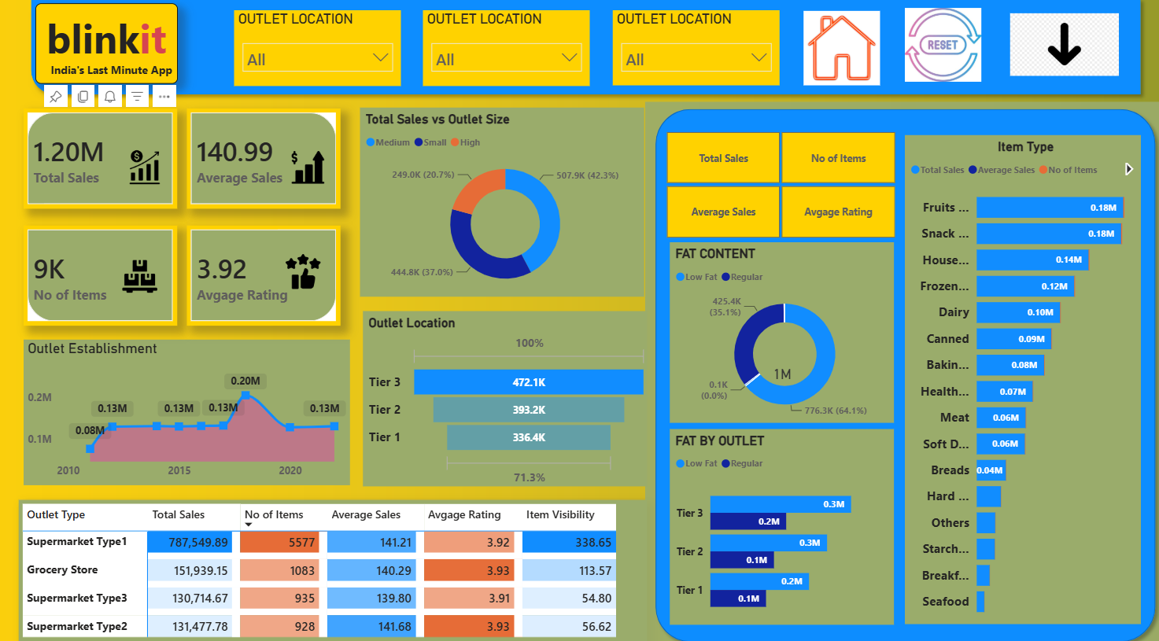
Figure 1: Blinkit Grocery Data Analysis Dashboard (Power BI)

7. Recommendations
- Expand Low Fat product ranges further, given they already drive nearly 2x the sales of Regular items and reflect clear customer preference.
- Prioritize inventory and marketing investment in Fruits & Vegetables and Snack Foods, the two highest-revenue item types.
- Investigate and replicate the 1998-cohort outlet success factors (location, customer base, loyalty programs) when planning new outlet openings.
- Continue investment in Tier 3 and Tier 2 markets, which are outperforming Tier 1 in total sales share — expansion capital may be better spent there than in saturated Tier 1 markets.
- Review underperforming item types (Seafood, Breakfast, Starchy Foods) for possible assortment, pricing, or placement optimization.
- Since ratings are uniformly high across outlet types, use sales and inventory mix — not satisfaction scores — as the primary lever for outlet performance improvement.

8. Conclusion
This analysis shows that Blinkit's sales performance is shaped primarily by product mix (Low Fat vs Regular, item type), outlet location tier, and outlet establishment history, while customer satisfaction remains consistently strong across all segments. The accompanying Power BI dashboard gives stakeholders a self-service way to monitor these drivers and prioritize inventory, marketing, and expansion decisions where they will have the greatest impact on revenue.

9. Appendix — Tools & Files
Item | Description
BlinkIT_Grocery_Data.xlsx | Source dataset (8,523 item-level records)
Blinkit_Grocery_Data_Analysis_Dashboard.pbix | Power BI dashboard
Query Doc.docx | Annotated SQL queries with explanations
Blinkit Analysis.pptx | Business requirements & KPI specification deck
Tools used | SQL, Power BI Desktop, Power Query, DAX
Repository | github.com/shamicse/blinkit-analysis-dashboard-By-PowerBi

