BearingBench
Window Size Analysis & Model Input Design Report
XJTU-SY Rolling Element Bearing Dataset
CNN vs LSTM vs BiLSTM vs Transformer — Fault Classification

1. Dataset Overview

The XJTU-SY dataset consists of 15 rolling element bearings run to failure under three working conditions. Each 1.28-second snapshot is captured every minute at a fixed sampling frequency of 25,600 Hz, producing 32,768 samples per CSV file.

Condition | RPM | Load (kN) | Bearings | Total CSVs
WC1 | 2100 | 12 | 4 used (B1_1 to B1_4) | 564
WC2 | 2250 | 11 | 5 used (B2_1 to B2_5) | 1,566
WC3 | 2400 | 10 | 5 used (B3_1 to B3_5) | 7,034
Total | — | — | 14 bearings | 9,164 files

Note: Bearing1_5 (combined Inner+Outer fault) was excluded due to ambiguous labeling. Bearing3_2 (combined fault) was retained and labeled as Outer Race (dominant fault type).

2. Signal Properties

Property | Value
Sampling frequency | 25,600 Hz (25.6 kHz)
Duration per CSV | 1.28 seconds
Samples per CSV | 32,768 rows + 1 header = 32,769 lines
Channels | 2 (Horizontal + Vertical vibration)
Snapshot interval | Every 1 minute
Hardware | National Instruments USB-3250

3. Window Size Derivation

3.1 Chosen Parameters
Parameter | Value | Rationale
Window size | 1,024 points | ~1.5 shaft revolutions
Stride | 512 points | 50% overlap
Duration | 40 ms | 1024 / 25600 Hz

3.2 Windows Per CSV Calculation
windows = floor((32,768 - 1,024) / 512) + 1 = 63 windows per CSV
Total windows = 9,164 files × 63 = 577,332 samples

4. Model-Specific Input Design

Model | Input Shape | Transformation | Feature Extraction | Key Strength
CNN | (B,32,32,2) | Reshape | Conv2D spatial filters | Full curve shape at once
LSTM | (B,1024,2) | None | Hidden state memory | Temporal order preserved
BiLSTM | (B,256,2) | None | Bidirectional hidden state | Forward + backward context
Transformer | (B,256,64) | Linear + Pos. Enc. | Multi-Head Self-Attention | Global timestep relationships

5. Fault Label Assignment (4 Classes)

Label | Class | Bearings | Assignment Rule
0 | Normal | All bearings | First 80% of CSV files
1 | Inner Race | Bearing2_1, Bearing3_3, Bearing3_4 | Last 20% of CSV files
2 | Outer Race | B1_1-4, B2_2/4/5, B3_1/2/5 | Last 20% of CSV files
3 | Cage | Bearing1_4, Bearing2_3 | Last 20% of CSV files

6. Benchmark Results

6.1 Final Comparison Table
Model | Accuracy | Macro F1 | Cage Recall | Cage AUC | Time
LSTM | 96.6% | 0.964 | 1.000 | 1.000 | 12.9 hrs
CNN | 96.2% | 0.959 | 1.000 | 1.000 | 1.2 hrs
BiLSTM | 90.9% | 0.916 | 0.986 | 0.999 | 9.7 hrs
Transformer | 63.8% | 0.634 | 0.918 | 0.986 | 5.2 hrs

Key Finding: LSTM outperforms CNN on the large XJTU-SY dataset (~190K samples). Bearing vibration signals contain periodic fault impacts — a fundamentally sequential pattern that LSTM captures better than spatial 2D image filters.

7. Confusion Matrices

7.1 LSTM — Best Model (96.6% Accuracy)
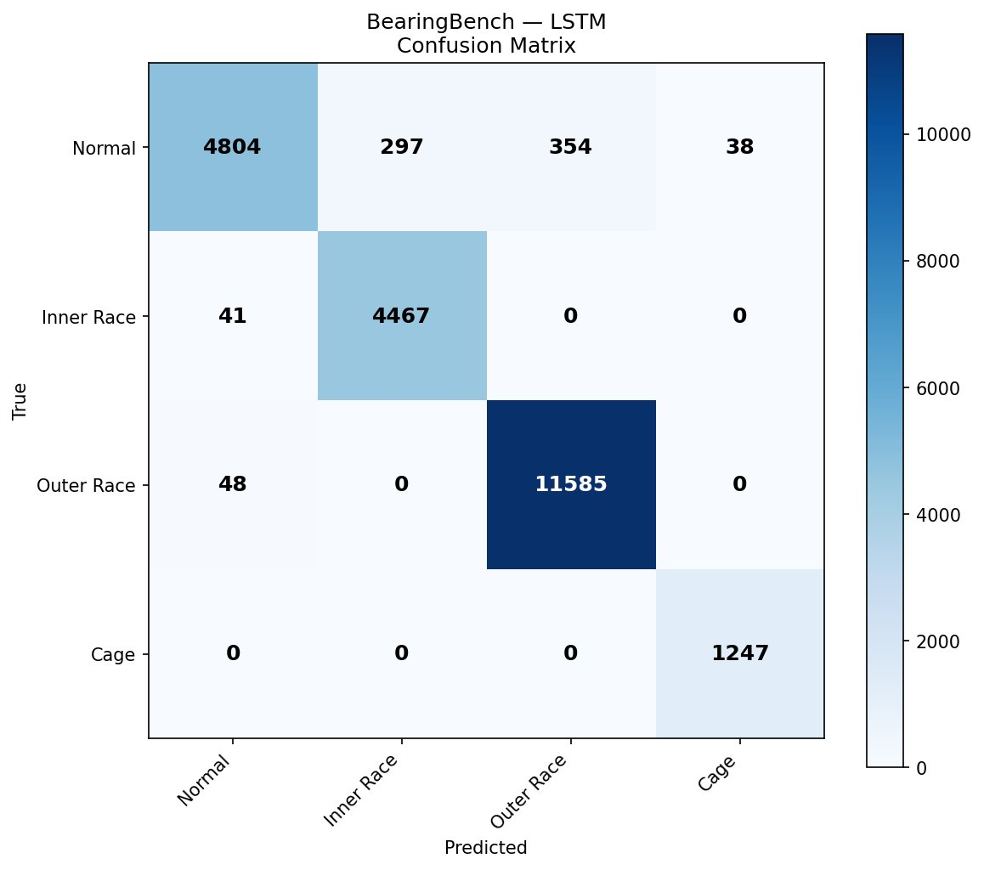
Figure 1: LSTM Confusion Matrix — Zero cross-fault confusion. Cage recall = 1.00.

7.2 CNN (96.2% Accuracy)
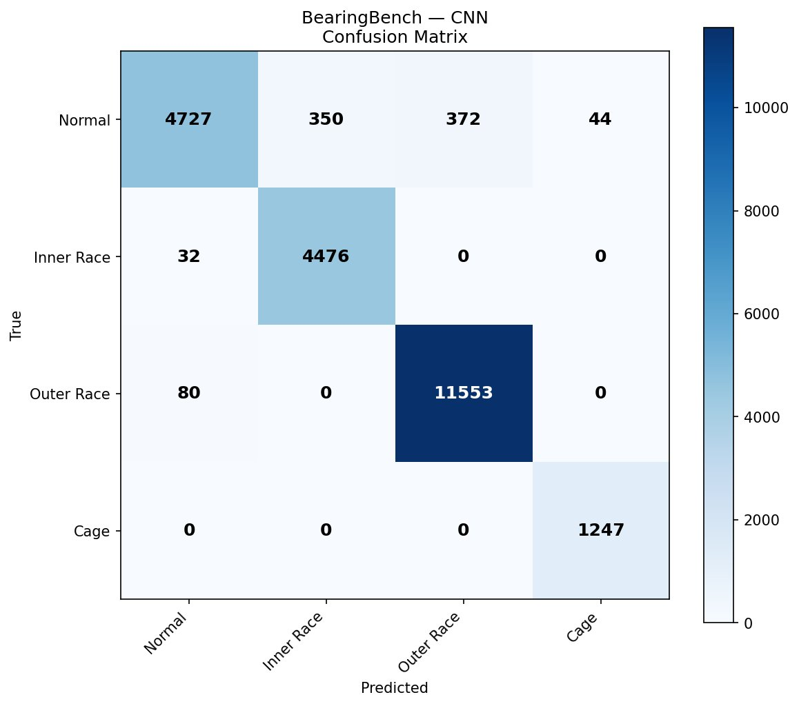
Figure 2: CNN Confusion Matrix — Cage recall = 1.00. All errors are Normal misclassifications.

7.3 BiLSTM (90.9% Accuracy)
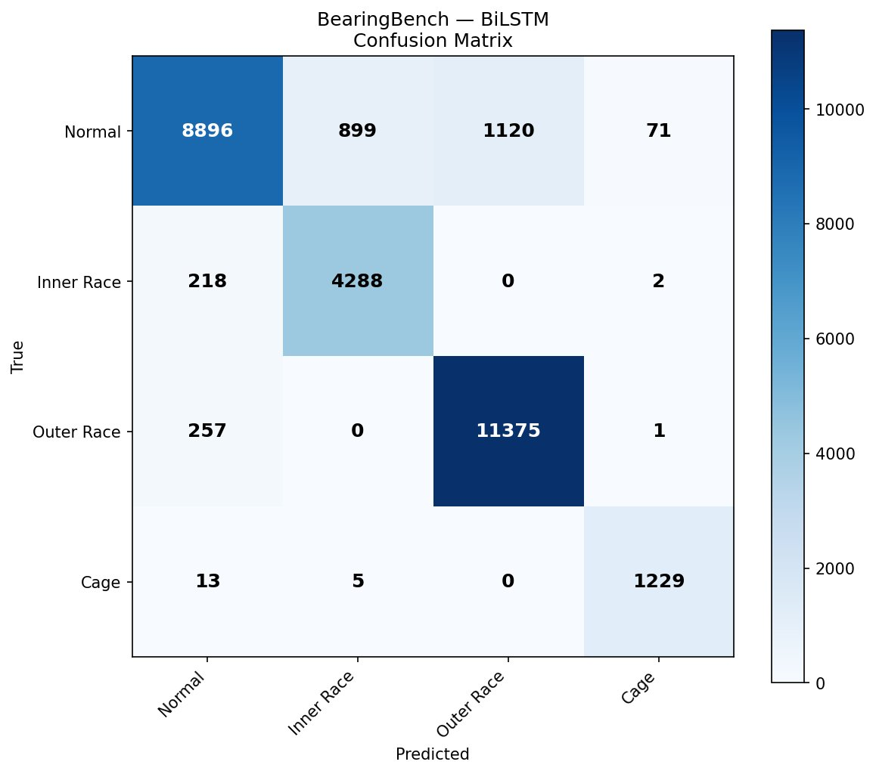
Figure 3: BiLSTM Confusion Matrix — Cage recall = 0.986. Trained with SEQ_LEN=256.

7.4 Transformer (63.8% Accuracy)
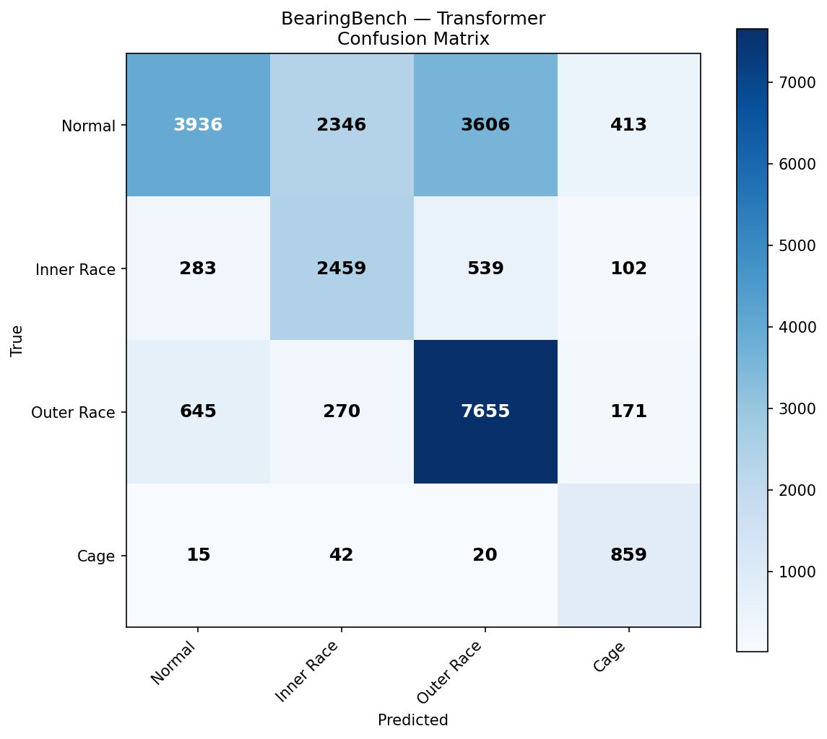
Figure 4: Transformer Confusion Matrix — Significant Normal misclassification. Needs larger dataset or pretraining.

8. ROC Curves — LSTM

The LSTM ROC curves demonstrate near-perfect separation for all 4 fault classes. The Cage class achieves AUC=1.000 despite being the rarest class (1.4% of files), confirming that CLASS_WEIGHT=15.0 successfully compensated for class imbalance.

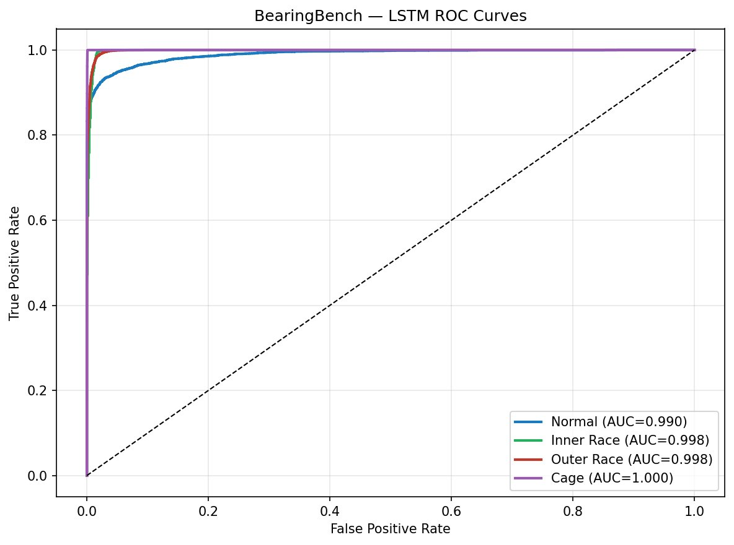
Figure 5: LSTM ROC Curves — Normal (0.990), Inner Race (0.998), Outer Race (0.998), Cage (1.000).

9. Interactive Dashboard

The BearingBench Flask dashboard provides real-time visualization of bearing data from MySQL and live fault prediction from uploaded CSV files. All 4 trained models are available for inference.

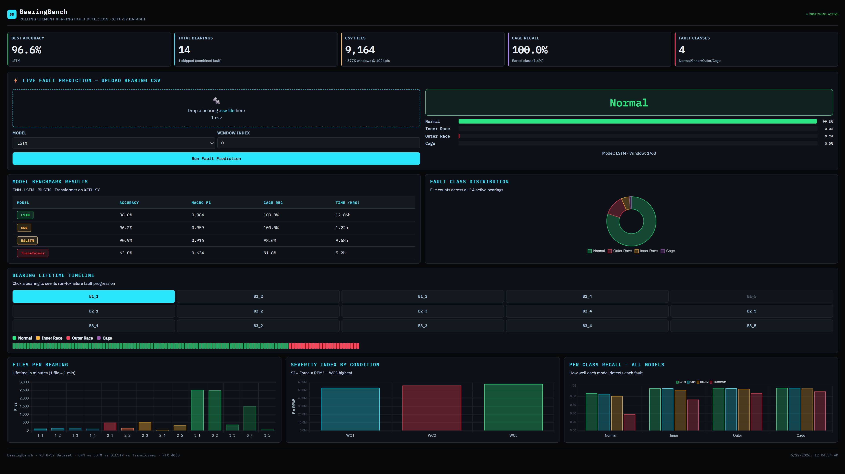
Figure 6: BearingBench Dashboard — Live prediction showing Normal (99.0% confidence) on Bearing1_1 file 1.csv using LSTM model.

Dashboard features:
- Metric cards: Best accuracy · Total bearings · CSV files · Cage recall
- Live fault prediction: Upload any CSV → select model → confidence bars for all 4 classes
- Model benchmark table: All 4 models with color-coded performance badges
- Bearing lifetime timeline: Click any bearing to see run-to-failure fault progression
- Severity index chart: WC1/WC2/WC3 comparison (F × RPM²)
- Per-class recall: All 4 models × 4 classes side by side

BearingBench · XJTU-SY Dataset · CNN vs LSTM vs BiLSTM vs Transformer · RTX 4060 GPU

