PostgreSQL DBA Activities

Autonomous AI DBA Operations Platform — User Guide and Configuration/Installation Manual
Document version: 1.0
Platform baseline: Windows host, Oracle VirtualBox, Ubuntu Server 26.04 LTS, PostgreSQL, SSH, TLS 1.2+
Intended audience: Platform administrators, database administrators, security engineers, operators, auditors

Current-State Verification Evidence
The following screenshots document the verified Windows host and Ubuntu/PostgreSQL VM configuration. Passwords and private keys are excluded.

System and connectivity
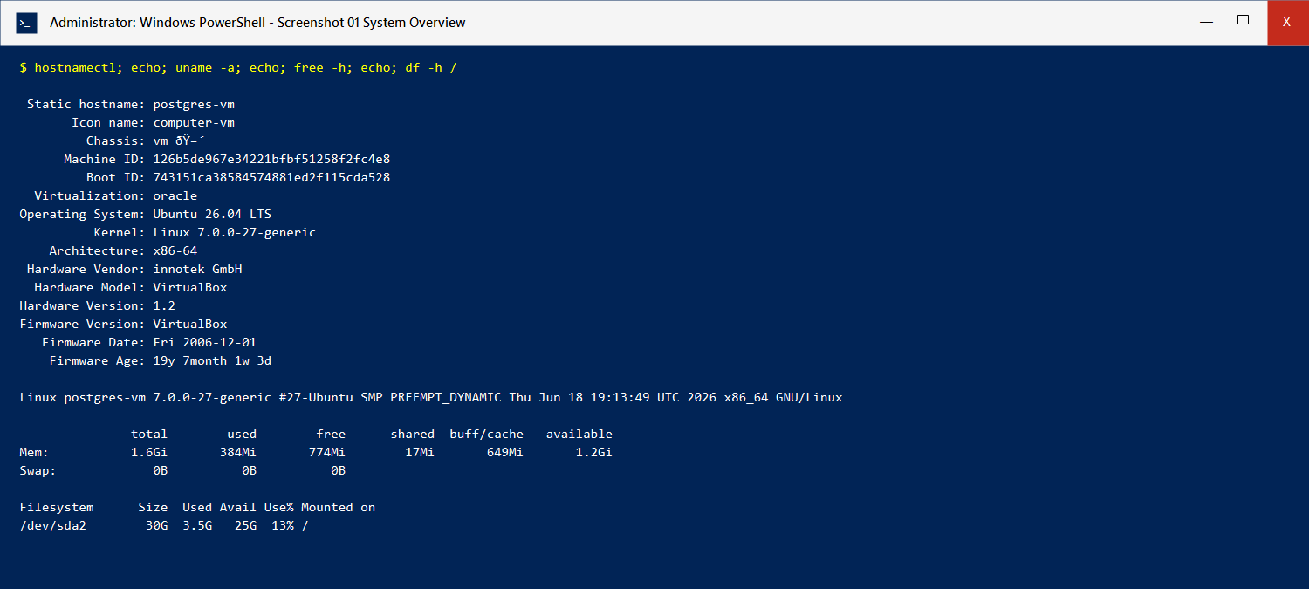
Ubuntu system overview
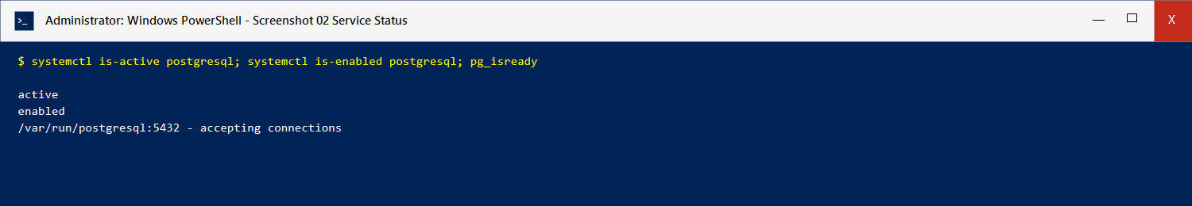
PostgreSQL service status
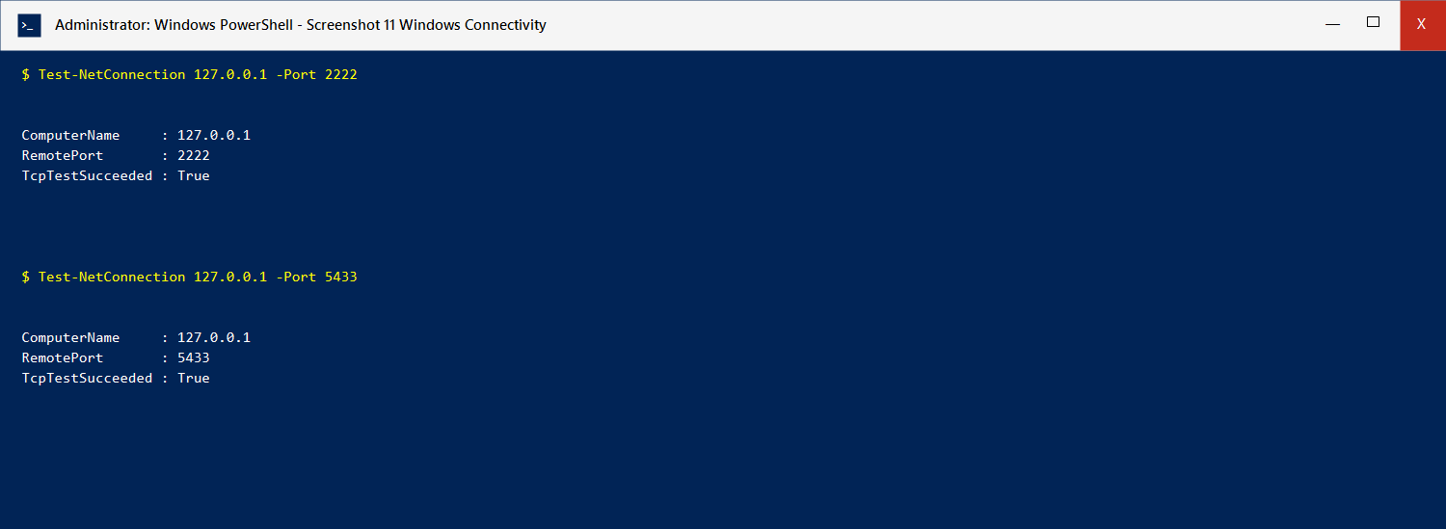
Windows SSH and PostgreSQL connectivity

Security configuration
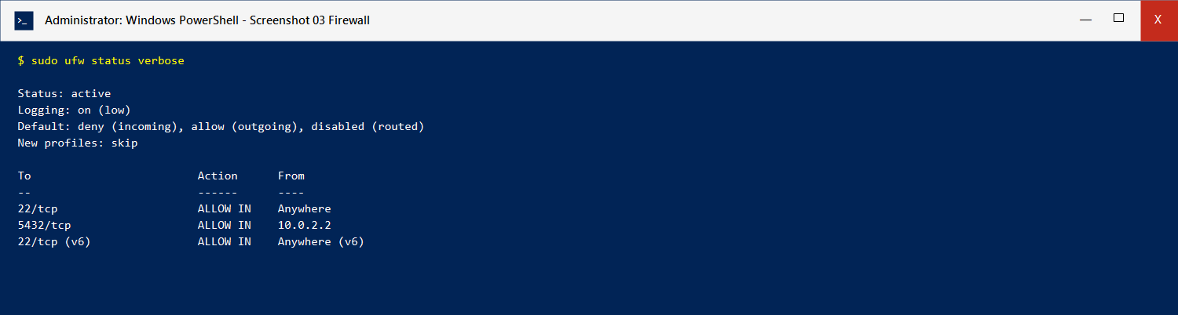
Ubuntu firewall configuration
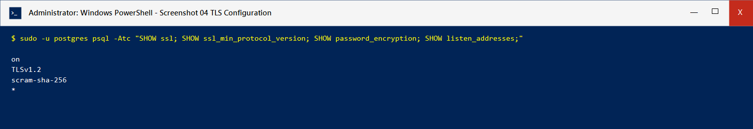
PostgreSQL TLS and authentication configuration
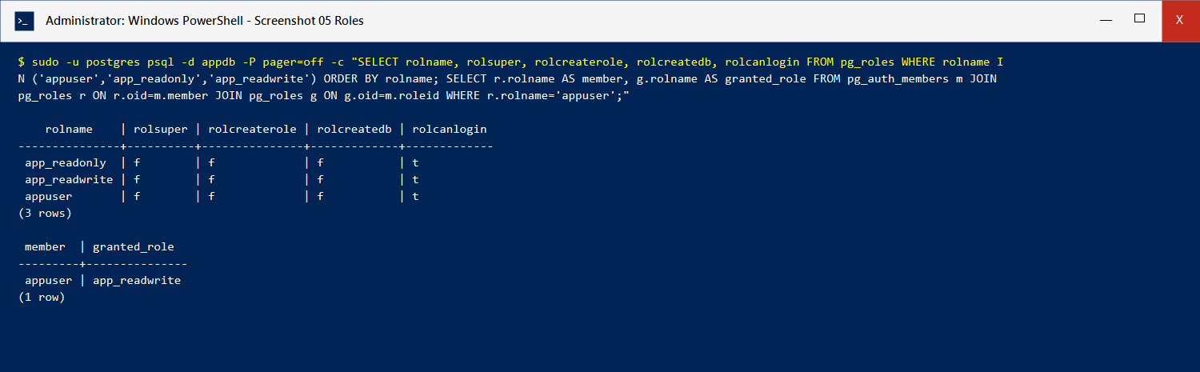
PostgreSQL roles and memberships
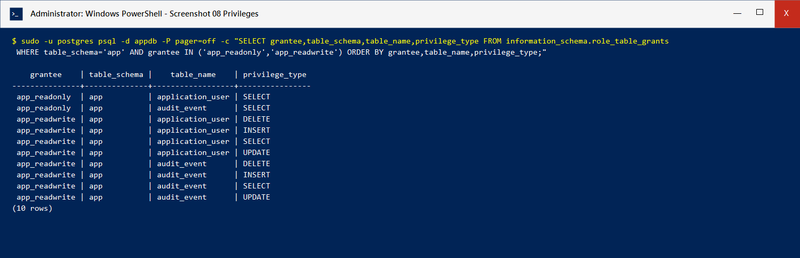
PostgreSQL role privileges

Database objects and health
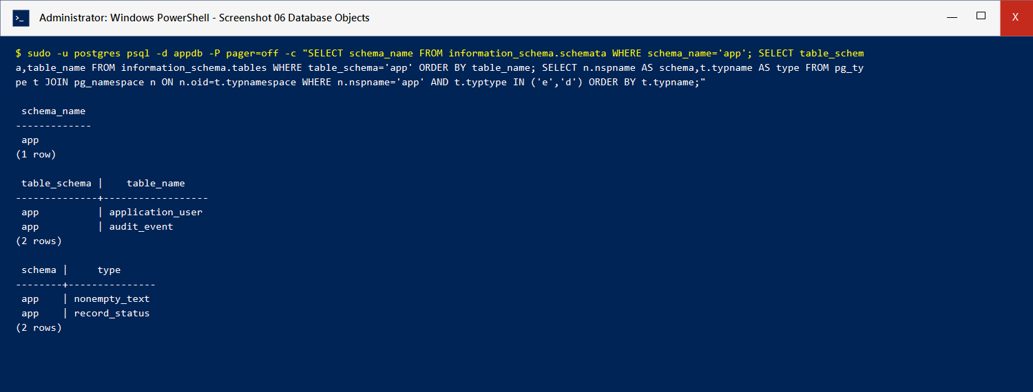
Application schema, tables, and custom data types
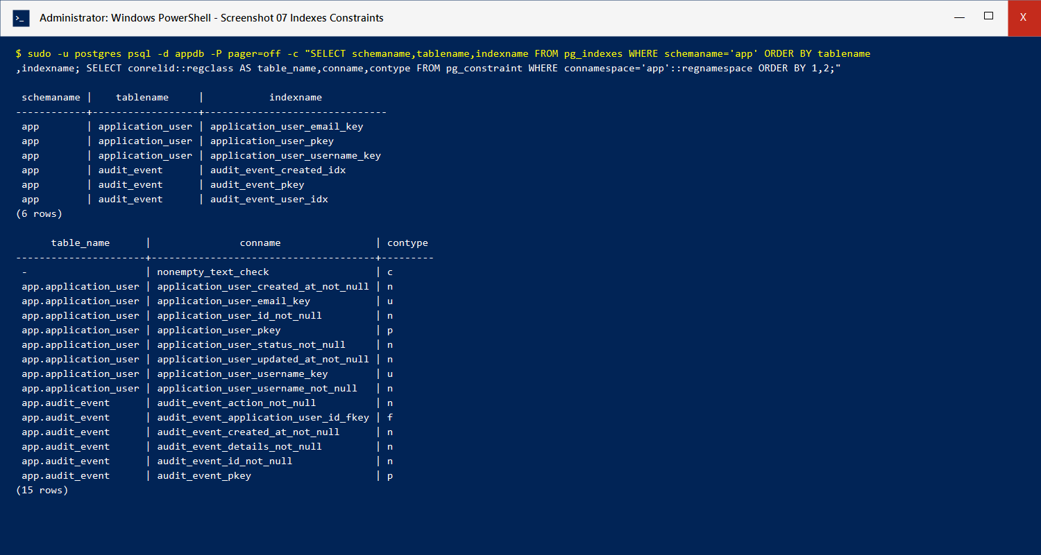
Indexes and constraints
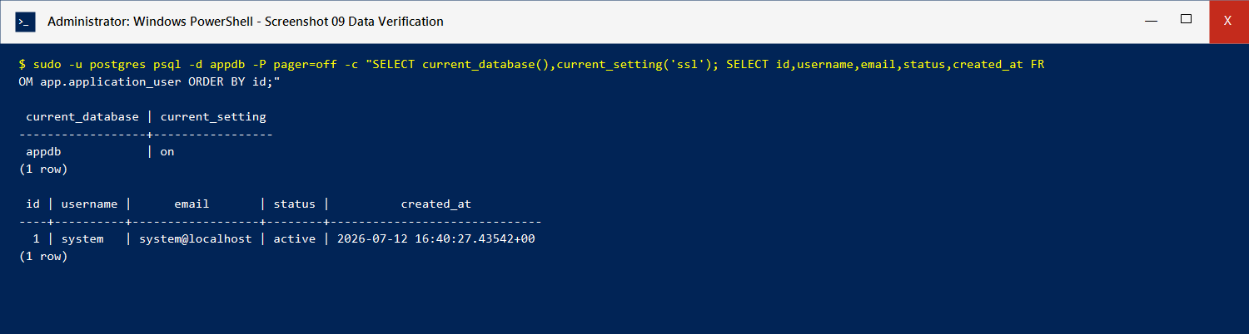
Database and baseline data verification
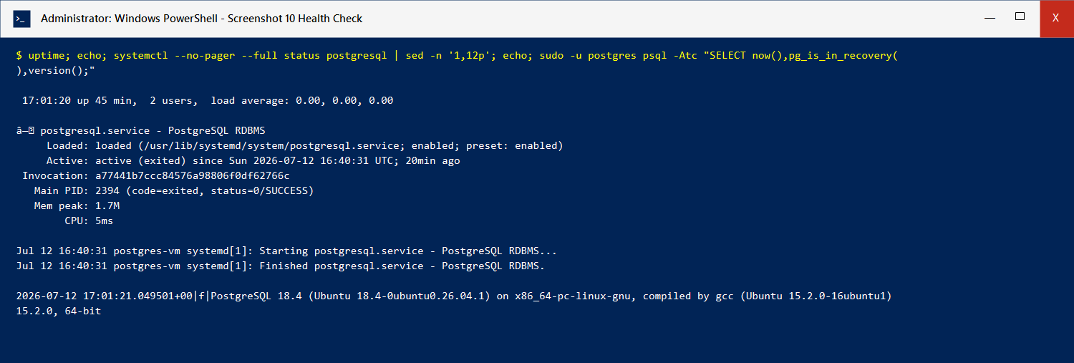
PostgreSQL operational health check

1. Purpose and Scope
This manual defines the installation, security configuration, operation, verification, and troubleshooting procedures for the Autonomous AI DBA Operations Platform. The documented reference implementation runs PostgreSQL inside an Ubuntu Server virtual machine hosted by VirtualBox on Windows.
The manual supports two operating methods:
- CLI method: PowerShell, SSH, Bash, and psql.
- GUI method: VirtualBox Manager and an optional PostgreSQL client such as pgAdmin.
The current reference deployment uses these endpoints:
Service | Host address | Host port | Guest port | Purpose
SSH | 127.0.0.1 | 2222 | 22 | Secure Ubuntu administration
PostgreSQL | 127.0.0.1 | 5433 | 5432 | Database client connectivity

Passwords must be obtained from the private credential record. Do not place passwords in screenshots, tickets, source control, chat messages, or documentation.

2. System Architecture

2.1 Logical architecture
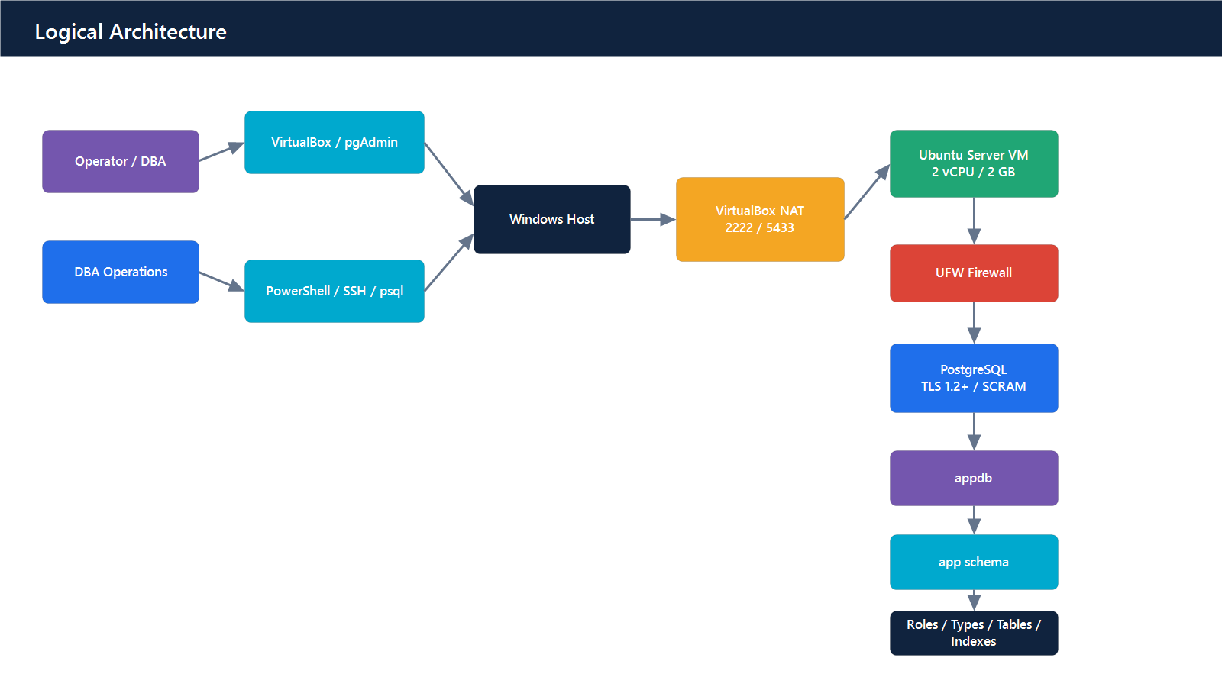
Logical architecture

2.2 Security boundaries
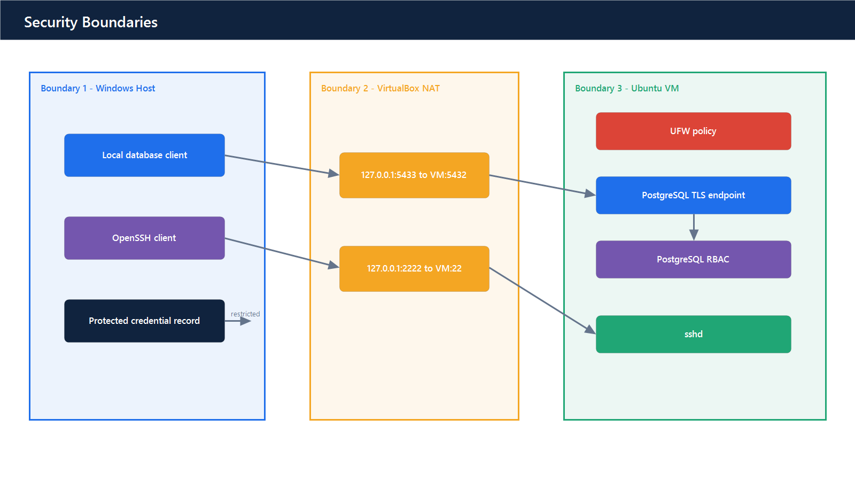
Security boundaries

2.3 Operational request flow
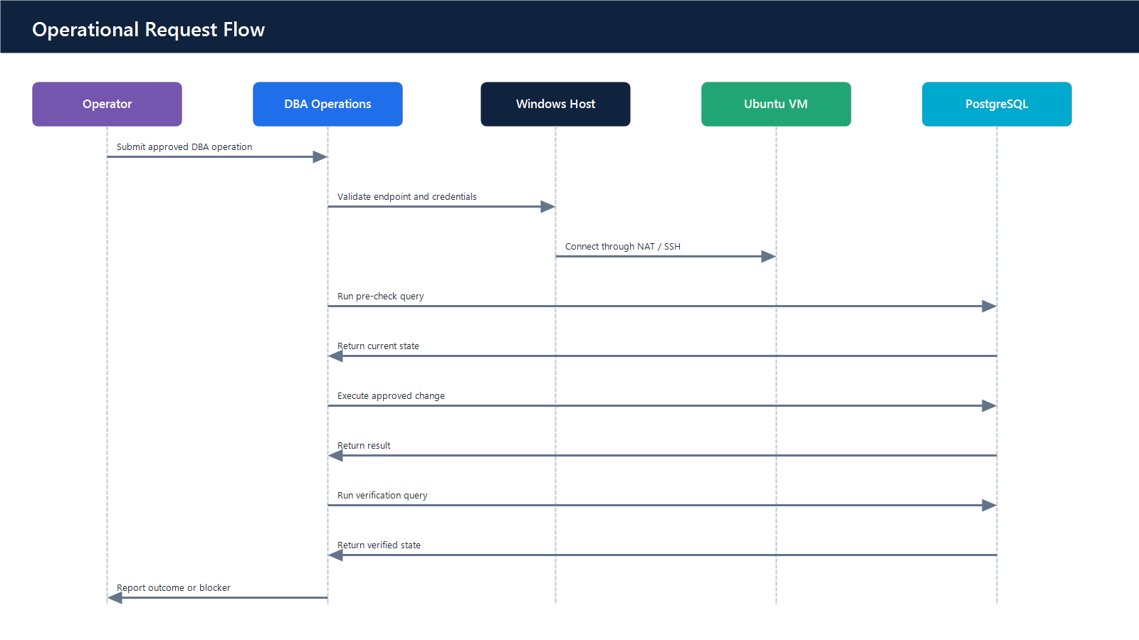
Operational request flow

3. System Requirements and Permissions Matrix

3.1 Host requirements
Component | Minimum | Recommended | Verification
Host OS | Windows 10 64-bit | Supported Windows 10/11 64-bit | systeminfo
CPU | x86_64, virtualization support | 4 logical CPUs or more | Task Manager → Performance → CPU
RAM | 4 GB host total | 8 GB or more | Task Manager → Performance → Memory
Free disk | 35 GB | 50 GB or more | File Explorer → This PC
Virtualization | Intel VT-x or AMD-V enabled | Enabled in firmware | Task Manager shows Virtualization: Enabled
Hypervisor | VirtualBox 7.x | Current supported VirtualBox release | VBoxManage --version
Guest ISO | Ubuntu Server 26.04 LTS AMD64 | Checksum-verified ISO | Get-FileHash
Host SSH client | OpenSSH client | Current Windows OpenSSH | ssh -V
Database client | psql or pgAdmin | Current compatible release | Client connection test

3.2 VM requirements
Resource | Baseline allocation | Notes
VM name | Ubuntu-PostgreSQL | Use a controlled naming standard in production
Guest OS | Ubuntu Server 26.04 LTS x86_64 | Minimal server installation
vCPU | 2 | Increase after measuring CPU saturation
RAM | 2 GB | Increase for larger databases or agent workloads
Disk | 30 GB dynamically allocated | Production requires capacity monitoring and backup storage
Network | NAT | Host bindings restricted to loopback
SSH mapping | Host 2222 → Guest 22 | Local administration only
PostgreSQL mapping | Host 5433 → Guest 5432 | Local database access only

3.3 Software requirements
Layer | Required software | Purpose
Host | VirtualBox | VM lifecycle and NAT port forwarding
Guest | Ubuntu Server | Operating system
Guest | PostgreSQL and contrib packages | Database service and extensions
Guest | OpenSSH Server | Remote administration
Guest | UFW | Host firewall policy
Guest | OpenSSL | TLS certificate generation and inspection
Optional GUI | pgAdmin | Graphical PostgreSQL administration

3.4 Role-based permissions matrix
Role | Platform scope | Allowed operations | Prohibited by default
Windows Administrator | Host | Install VirtualBox, configure host prerequisites | Routine database queries
VirtualBox Operator | VM | Start, stop, inspect, snapshot VM | Change database objects without DBA authorization
vmadmin | Ubuntu | sudo, package/service/firewall administration | Sharing credentials; untracked production changes
postgres | PostgreSQL instance | Cluster administration and emergency recovery | Application use and routine integrations
appuser | Application database | Inherits app_readwrite; owns application schema | Cluster administration and OS access
app_readwrite | appdb/app | SELECT, INSERT, UPDATE, DELETE, sequence use | Role creation, server configuration, OS access
app_readonly | appdb/app | CONNECT, schema USAGE, table SELECT | Data mutation and DDL
Auditor | Evidence | Read redacted logs, reports, configuration snapshots | Credentials and write access

3.5 Change authorization matrix
Change | Minimum authorization | Backup required | Maintenance window
Start/stop VM | VirtualBox Operator | No | Recommended for stop
Restart PostgreSQL | DBA/Platform Admin | No | Recommended
Add user or role | DBA | No | No
Schema migration | DBA + application owner | Yes | Recommended
Drop table/database | DBA + data owner | Yes, verified | Required
Change firewall/NAT | Platform Admin + Security | Configuration export | Recommended
Rotate TLS certificates | Platform Admin + DBA | Existing cert/key backup | Recommended

4. CLI Configuration and Installation Guide

Step 1: Validate host virtualization and resources
Requirement: Windows host with sufficient memory, disk, and firmware virtualization.
Action: Open PowerShell as Administrator and run:
systeminfo
Get-PSDrive C
Verification: Confirm sufficient free disk and that virtualization is enabled. If systeminfo does not expose the firmware state, inspect Task Manager → Performance → CPU.
Blocker: Virtualization is disabled.
Resolution: Restart into BIOS/UEFI, enable Intel VT-x or AMD-V/SVM, save changes, and repeat verification.

Step 2: Verify VirtualBox
Requirement: VirtualBox installed on Windows.
Action: Run:
& "C:\Program Files\Oracle\VirtualBox\VBoxManage.exe" --version
Verification: A 7.x version is returned without an error.
Blocker: VBoxManage.exe is not found.
Resolution: Repair or reinstall VirtualBox, then reopen PowerShell.

Step 3: Verify the Ubuntu ISO
Requirement: Ubuntu Server ISO downloaded from an official Ubuntu source.
Action: Run:
Get-FileHash "$env:USERPROFILE\Downloads\ubuntu-26.04-live-server-amd64.iso" -Algorithm SHA256
Verification: Compare the returned hash to Ubuntu's published SHA256SUMS. The reference ISO used for this deployment was verified before installation.
Blocker: Hash mismatch.
Resolution: Delete the ISO, download it again from Ubuntu, and verify the new copy. Do not install from an unverified image.

Step 4: Verify VM creation and runtime state
Requirement: VM created and registered as Ubuntu-PostgreSQL.
Action: Run:
& "C:\Program Files\Oracle\VirtualBox\VBoxManage.exe" showvminfo "Ubuntu-PostgreSQL"
Verification: Confirm 2 CPUs, 2048 MB RAM, NAT networking, and the expected virtual disk.
Blocker: VM is not registered.
Resolution: Open VirtualBox Manager and add the existing .vbox file, or recreate the VM using the approved provisioning script.

Step 5: Validate NAT port forwarding
Requirement: SSH and PostgreSQL accessible only from the Windows loopback interface.
Action: Run:
Test-NetConnection 127.0.0.1 -Port 2222
Test-NetConnection 127.0.0.1 -Port 5433
Verification: Both commands return TcpTestSucceeded : True while the VM is running.
Blocker: Port test fails.
Resolution: Confirm the VM is running, then inspect NAT rules:
& "C:\Program Files\Oracle\VirtualBox\VBoxManage.exe" showvminfo "Ubuntu-PostgreSQL" | Select-String "Rule"

Step 6: Connect to Ubuntu through SSH
Requirement: VM running and host port 2222 reachable.
Action: Run:
ssh -p 2222 vmadmin@127.0.0.1
Use the Linux password from the private credential record.
Verification: The shell prompt displays vmadmin@postgres-vm.
Blocker: Remote host identification changed after installation.
Resolution: Remove only the obsolete loopback/port key and reconnect:
ssh-keygen -R "[127.0.0.1]:2222"

Step 7: Verify Ubuntu and PostgreSQL services
Requirement: Active SSH session as vmadmin.
Action: Run:
uname -a
lsb_release -a
sudo systemctl is-active postgresql
sudo systemctl is-enabled postgresql
Verification: Ubuntu reports x86_64, PostgreSQL returns active, and service enablement returns enabled.
Blocker: sudo authentication fails.
Resolution: Use the Linux password, not a database password. Password input is intentionally invisible.

Step 8: Verify firewall policy
Requirement: UFW installed and enabled.
Action: Run:
sudo ufw status verbose
Verification: Default incoming policy is deny; SSH is allowed; PostgreSQL is restricted to the VirtualBox NAT host path.
Blocker: UFW is inactive.
Resolution: Review SSH access first, then run sudo ufw --force enable. Never enable a restrictive firewall remotely without an SSH allow rule.

Step 9: Verify PostgreSQL TLS and authentication
Requirement: PostgreSQL running with the TLS files readable by the postgres service account.
Action: Run:
sudo -u postgres psql -Atc "SHOW ssl; SHOW ssl_min_protocol_version; SHOW password_encryption; SHOW listen_addresses;"
Verification: Expected values include on, TLSv1.2, scram-sha-256, and *.
Blocker: PostgreSQL fails after enabling TLS.
Resolution: Inspect logs and key permissions:
sudo journalctl -u postgresql -n 100 --no-pager
sudo ls -l /etc/postgresql/tls
The private key must be owned by postgres, must not be group/world readable, and normally uses mode 600.

Step 10: Verify roles and memberships
Requirement: Administrative access through the local postgres OS account.
Action: Run:
sudo -u postgres psql -c "\du"
Verification: Confirm appuser, app_readonly, and app_readwrite. Confirm appuser is a member of app_readwrite. Application roles must not have superuser, replication, or bypass-RLS privileges.
Blocker: A role is missing.
Resolution: Create it as postgres, assign a unique password with \password role_name, and apply the documented grants.

Step 11: Verify database objects and privileges
Requirement: appdb exists and contains the app schema.
Action: Run:
sudo -u postgres psql -d appdb -c "\dn+ app"
sudo -u postgres psql -d appdb -c "\dt+ app.*"
sudo -u postgres psql -d appdb -c "\dT+ app.*"
sudo -u postgres psql -d appdb -c "\di+ app.*"
Verification: Confirm:
- Schema: app
- Tables: app.application_user, app.audit_event
- Custom types: app.record_status, app.nonempty_text
- Indexes for primary keys, unique constraints, audit user lookup, and audit time ordering

Step 12: Test role separation
Requirement: Passwords available from the protected credential record.
Action: Connect as app_readonly and attempt an approved read. Then confirm a write is rejected. Repeat as app_readwrite and confirm an approved write succeeds inside a transaction that is rolled back.
psql "host=127.0.0.1 dbname=appdb user=app_readonly sslmode=require"
Within psql:
SELECT count(*) FROM app.application_user;
INSERT INTO app.audit_event(action) VALUES ('permission_test');
The insert must fail for app_readonly. For a nonpersistent write test as app_readwrite:
BEGIN;
INSERT INTO app.audit_event(action) VALUES ('permission_test');
ROLLBACK;
Verification: Read-only can select but cannot insert. Read-write can insert inside the test transaction.

5. GUI Configuration and Installation Guide

Step 1: Inspect the VM in VirtualBox Manager
Requirement: VirtualBox Manager installed and the VM registered.
Action: Open VirtualBox Manager and select Ubuntu-PostgreSQL.
Verification: The Summary panel shows the expected operating system, memory, CPUs, storage, and network adapter.
Blocker: VM status is Aborted.
Resolution: Inspect Logs/VBox.log, confirm adequate host disk/RAM, close stale VirtualBox processes, and start the VM again.

Step 2: Inspect VM system resources
Requirement: VM powered off before changing CPU or memory.
Action: Select Settings → System.
Verification: Base Memory is 2048 MB and Processors is 2. Allocation indicators must remain in the safe range.
Blocker: Controls are disabled.
Resolution: Shut down the guest normally. Saved-state and running VMs cannot accept all hardware changes.

Step 3: Inspect virtual storage
Requirement: Virtual disk attached to the VM.
Action: Open Settings → Storage.
Verification: Confirm a dynamically allocated VDI of approximately 30 GB is attached. Confirm the installation ISO is no longer required after installation.
Blocker: VM boots back into the installer.
Resolution: Remove the ISO from the virtual optical drive or place the virtual disk before the optical drive in boot order.

Step 4: Inspect NAT forwarding rules
Requirement: Adapter 1 attached to NAT.
Action: Open Settings → Network → Adapter 1 → Advanced → Port Forwarding.
Verification: Confirm:
Name | Protocol | Host IP | Host Port | Guest Port
SSH | TCP | 127.0.0.1 | 2222 | 22
PostgreSQL | TCP | 127.0.0.1 | 5433 | 5432

Blocker: Host port already in use.
Resolution: Identify the listener:
Get-NetTCPConnection -LocalPort 2222,5433 -ErrorAction SilentlyContinue
Stop the conflicting service or use another approved host port and update client documentation.

Step 5: Monitor the Ubuntu console
Requirement: VM running.
Action: Double-click the VM to open its console.
Verification: The guest reaches the Ubuntu login prompt without filesystem, kernel, or service failure messages.

Step 6: Register PostgreSQL in pgAdmin
Requirement: pgAdmin installed, VM running, and port 5433 reachable.
Action: In pgAdmin, select Register → Server and enter:
General tab
- Name: Autonomous AI DBA - Local
Connection tab
- Host: 127.0.0.1
- Port: 5433
- Maintenance database: appdb
- Username: appuser
- Password: obtain from the private credential record
SSL tab
- SSL mode: Require
Do not select Save password unless endpoint credential storage is approved.
Verification: The server connects and appdb appears in the Browser tree.
Blocker: Connection timeout or refusal.
Resolution: Verify the VM state, Windows port 5433, NAT rule, UFW rule, PostgreSQL service, and listen_addresses in that order.

Step 7: Inspect objects through pgAdmin
Requirement: Successful pgAdmin connection as appuser.
Action: Expand Databases → appdb → Schemas → app → Tables.
Verification: Confirm application_user and audit_event. Inspect columns, constraints, and indexes from the Properties panels.

Step 8: Run a GUI query
Requirement: Query Tool opened against appdb.
Action: Execute:
SELECT current_database(), current_user, current_setting('ssl');
SELECT * FROM app.application_user ORDER BY id;
Verification: The first result reports appdb, the connected role, and on. The second returns the baseline system record.

6. Operational User Guide

6.1 Start the platform
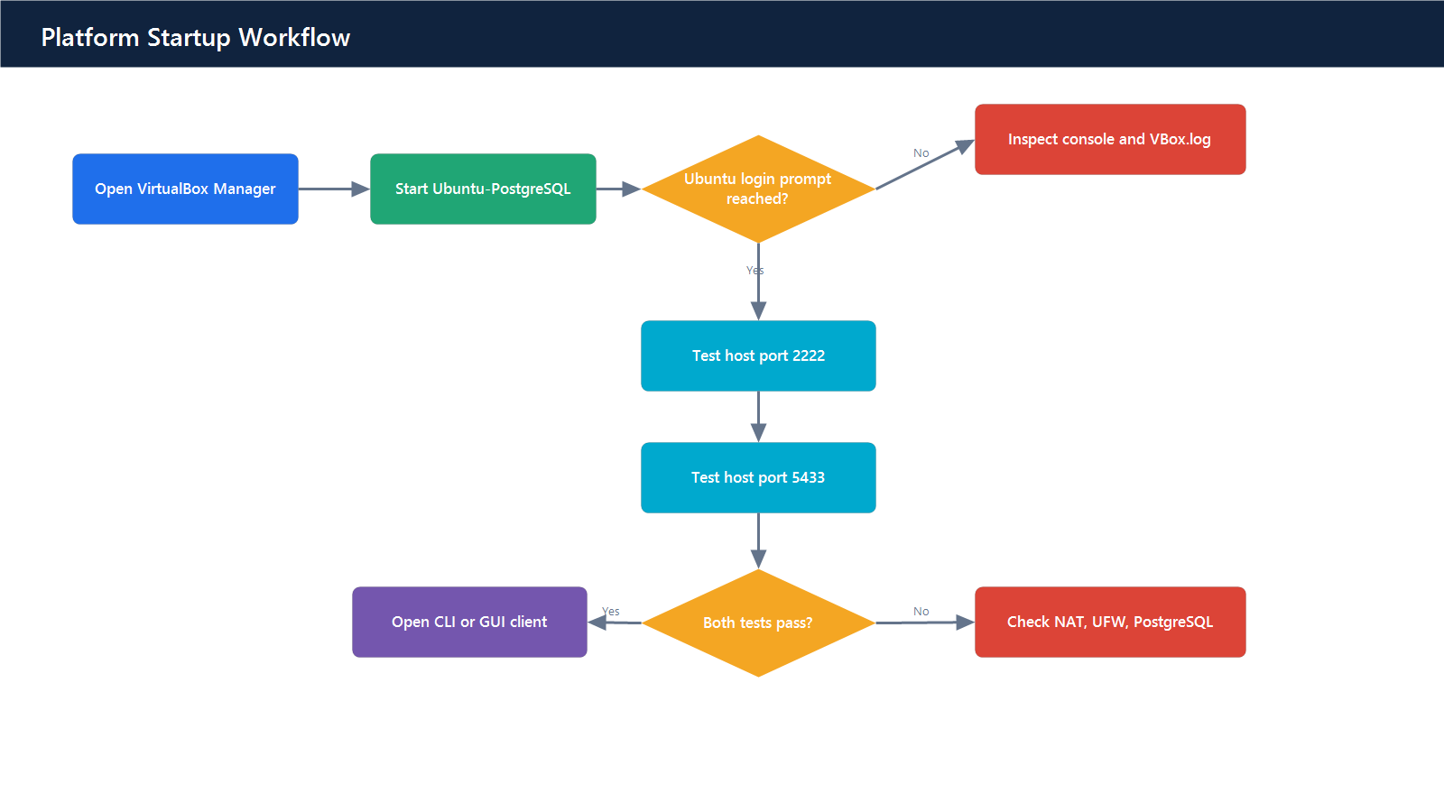
Platform startup workflow
Action: Start the VM from VirtualBox Manager or CLI:
& "C:\Program Files\Oracle\VirtualBox\VBoxManage.exe" startvm "Ubuntu-PostgreSQL" --type gui
Verification: Test ports 2222 and 5433.

6.2 Stop the platform safely
Action: Connect through SSH and run:
sudo shutdown -h now
Alternatively, use VirtualBox Machine → ACPI Shutdown. Do not use Power Off except for unrecoverable hangs.
Verification: VirtualBox reports Powered Off.

6.3 Routine health check
Run:
sudo systemctl --no-pager --full status postgresql
sudo -u postgres psql -Atc "SELECT now(), pg_is_in_recovery(), version();"
df -h /
free -h
sudo journalctl -u postgresql --since "24 hours ago" --no-pager
Healthy criteria:
- PostgreSQL service is active.
- pg_is_in_recovery() is f for this standalone primary.
- Root filesystem has at least 20% free space.
- No recurring PostgreSQL errors exist in the last 24 hours.

6.4 Create an application user
Connect as an authorized administrator:
sudo -u postgres psql
Create the role without placing a password in shell history:
CREATE ROLE reporting_user LOGIN IN ROLE app_readonly;
\password reporting_user
Verification:
\du reporting_user

6.5 Change a database password
sudo -u postgres psql
\password appuser
Update the protected credential store immediately. Test the new password before ending the maintenance session.

6.6 Create or modify schema objects
Use a transaction for reversible DDL where supported:
BEGIN;
CREATE TABLE app.example (
id bigint GENERATED ALWAYS AS IDENTITY PRIMARY KEY,
name app.nonempty_text NOT NULL,
created_at timestamptz NOT NULL DEFAULT now()
);
-- Perform verification here.
COMMIT;
Use ROLLBACK instead of COMMIT if verification fails.

6.7 Review database activity
SELECT pid, usename, datname, client_addr, state,
wait_event_type, wait_event,
now() - query_start AS query_age,
left(query, 120) AS query_sample
FROM pg_stat_activity
WHERE pid <> pg_backend_pid()
ORDER BY query_start;
Do not terminate sessions without change approval and workload-owner confirmation.

7. Troubleshooting and Blocker Resolution Guide
Symptom/blocker | Likely cause | Diagnostic action | Resolution | Verification
VirtualBox will not start VM | VT-x/AMD-V disabled | Check Task Manager CPU panel | Enable virtualization in BIOS/UEFI | VM reaches Ubuntu login
VERR_NEM_NOT_AVAILABLE | Hypervisor conflict or firmware issue | Review VBox error dialog/log | Enable firmware virtualization; review Hyper-V configuration | VM starts normally
VM reports no bootable medium | Disk/ISO attachment issue | Inspect Settings → Storage | Attach VDI or ISO and correct boot order | Ubuntu boot begins
SSH port 2222 fails | VM stopped, NAT rule absent, sshd unavailable | Test port; inspect NAT and console | Start VM, restore rule, start SSH | SSH login succeeds
SSH host key changed | Installer/recreated VM generated a new key | Compare expected rebuild event | ssh-keygen -R "[127.0.0.1]:2222"; reconnect and accept verified key | SSH connects without warning
sudo authentication fails | Database password used instead of Linux password | Confirm credential label | Use Linux password; reset from VM console if lost | sudo -v succeeds
PostgreSQL port 5433 fails | Service, NAT, UFW, or listen setting | Check each layer in order | Start service; correct NAT/UFW/listen settings | Port test succeeds
password authentication failed | Wrong password or role | Review role existence without exposing secrets | Run \password role_name; update credential store | New login succeeds
no pg_hba.conf entry | Client/subnet/SSL rule missing | sudo -u postgres psql -Atc 'show hba_file' | Add a narrowly scoped hostssl rule; reload | TLS login succeeds
SSL connection rejected | Certificate, key permission, or HBA issue | Inspect PostgreSQL log and TLS files | Correct owner/mode/path; restart service | SHOW ssl returns on
appdb missing | Post-install creation did not finish | sudo -u postgres psql -c '\l' | Create database owned by appuser | \l appdb succeeds
Role lacks table access | Grants/default privileges incomplete | Use has_table_privilege | Apply explicit grants and default privileges | Permission test passes
Disk usage above 80% | Logs/data growth | df -h; inspect large directories | Archive logs, expand VDI/filesystem, review retention | Free space exceeds threshold
PostgreSQL service repeatedly restarts | Invalid config or resource pressure | journalctl -u postgresql | Restore last known config; correct failing setting | Stable active service
GUI cannot connect but CLI can | GUI connection/SSL profile incorrect | Compare host, port, user, SSL mode | Set host 127.0.0.1, port 5433, SSL Require | GUI query succeeds
Port already in use | Another local listener | Get-NetTCPConnection -LocalPort 5433 | Stop conflict or change approved host port | Port belongs to VirtualBox
VM is slow | Host memory/CPU pressure or disk contention | Task Manager and guest top/iostat | Stop competing workloads; resize VM conservatively | Health metrics normalize

7.1 Layered connection diagnosis
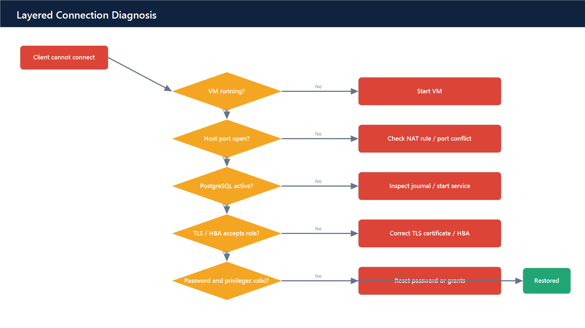
Layered connection diagnosis

8. Verification and Acceptance Checklist
ID | Acceptance criterion | Expected evidence | Result
INF-01 | VM starts and reaches Ubuntu | VM console/login screenshot | Verified
INF-02 | SSH available on 127.0.0.1:2222 | Successful port test and login | Verified
INF-03 | PostgreSQL available on 127.0.0.1:5433 | Successful port test | Verified
SEC-01 | UFW active with default deny incoming | ufw status verbose | Verified
SEC-02 | PostgreSQL TLS enabled, minimum TLS 1.2 | SHOW settings | Verified
SEC-03 | SCRAM password encryption configured | SHOW password_encryption | Verified
SEC-04 | Least-privilege roles present | \du output | Verified
SEC-05 | Read-only write attempt rejected | Permission test | Pending role enforcement test
DB-01 | appdb exists | Database listing | Verified
DB-02 | app schema exists | Schema listing | Verified
DB-03 | Required tables exist | Table listing | Verified
DB-04 | Custom types exist | Type listing | Verified
DB-05 | Required indexes/constraints exist | Object descriptions | Verified
OPS-01 | Start/stop procedures verified | Lifecycle screenshots | Partially verified
OPS-02 | Health-check procedure verified | Health evidence | Verified

9. Credential and Evidence Handling
- Store the credential record outside source control.
- Restrict it to the authorized Windows account.
- Do not attach it to support tickets.
- Rotate credentials after suspected disclosure.
- Do not capture password entry, private-key contents, or connection URIs containing passwords.
- Use redacted screenshots for audit evidence.
- Treat VM snapshots as sensitive because they may contain database data and secrets.
- Remove temporary setup scripts after acceptance if they contain embedded credentials.

10. Completion Record
The reference deployment was verified with:
- SSH host endpoint reachable on port 2222.
- PostgreSQL host endpoint reachable on port 5433.
- PostgreSQL SSL enabled with minimum protocol TLS 1.2.
- Roles appuser, app_readonly, and app_readwrite present.
- Tables app.application_user and app.audit_event present.
- Private credentials stored separately from this manual.

