Lab 3: Component Modelling & Architectural Pattern Selection
Disaster Relief Supply & Volunteer Coordinator
Name: Shamika Mahesh
SRN: PES1UG24AM259
Domain: Sustainability & Green Tech Actors: Relief Volunteer, Disaster Manager
1. Component Diagram
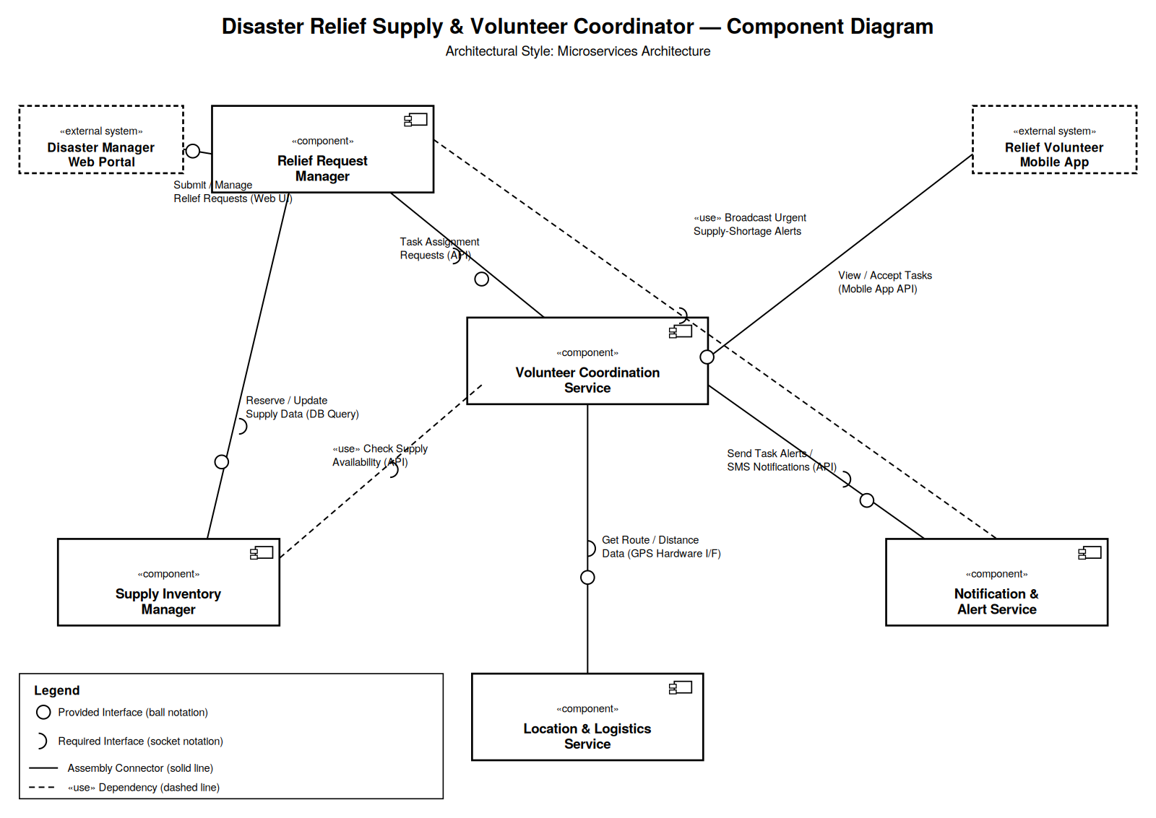
2. Written Justification
Architecture Selection
We chose Microservices Architecture for the Disaster Relief Supply & Volunteer Coordinator system.
Architectural Choice
The system is decomposed into independently deployable services — Relief Request Manager, Volunteer Coordination Service, Supply Inventory Manager, Notification & Alert Service, and Location & Logistics Service — each communicating through well-defined APIs rather than shared internal state.
Reason 1 — Fault Isolation During Active Disasters
Relief operations cannot afford a single point of failure. If the Notification & Alert Service becomes overloaded or fails during a crisis, the Relief Request Manager and Supply Inventory Manager continue operating independently, so disaster managers can still log requests and track stock while only the alerting channel is degraded.
Reason 2 — Independent Scaling Under Sudden Load
Volunteer sign-ups and task requests spike unpredictably right after a disaster is declared. Microservices let the Volunteer Coordination Service and Location & Logistics Service scale horizontally on demand, without over-provisioning lower-traffic services such as Supply Inventory Manager, keeping infrastructure cost-efficient — an important consideration for a resource-constrained, sustainability-focused deployment.
Security Advantage
Each microservice enforces its own authentication and access-control boundary. Sensitive volunteer personal data held in the Volunteer Coordination Service can be locked down with stricter permissions than the public-facing Relief Request Manager, so a breach of one service does not automatically expose data held by another.
Performance Benefit
High-urgency services — Notification & Alert Service and Location & Logistics Service — can be deployed on dedicated, low-latency infrastructure and updated independently, so critical alerts and route calculations for volunteers are not slowed down by less time-sensitive operations such as historical reporting.

