MICROGOAL

Thunder Client API Testing Results
This section demonstrates the testing of REST APIs using Thunder Client in VS Code. The following screenshots show successful API execution and MongoDB database updates.

1. Signup(post)
API Endpoint: http://localhost:8000/login
Method: POST
Status: 200 Ok
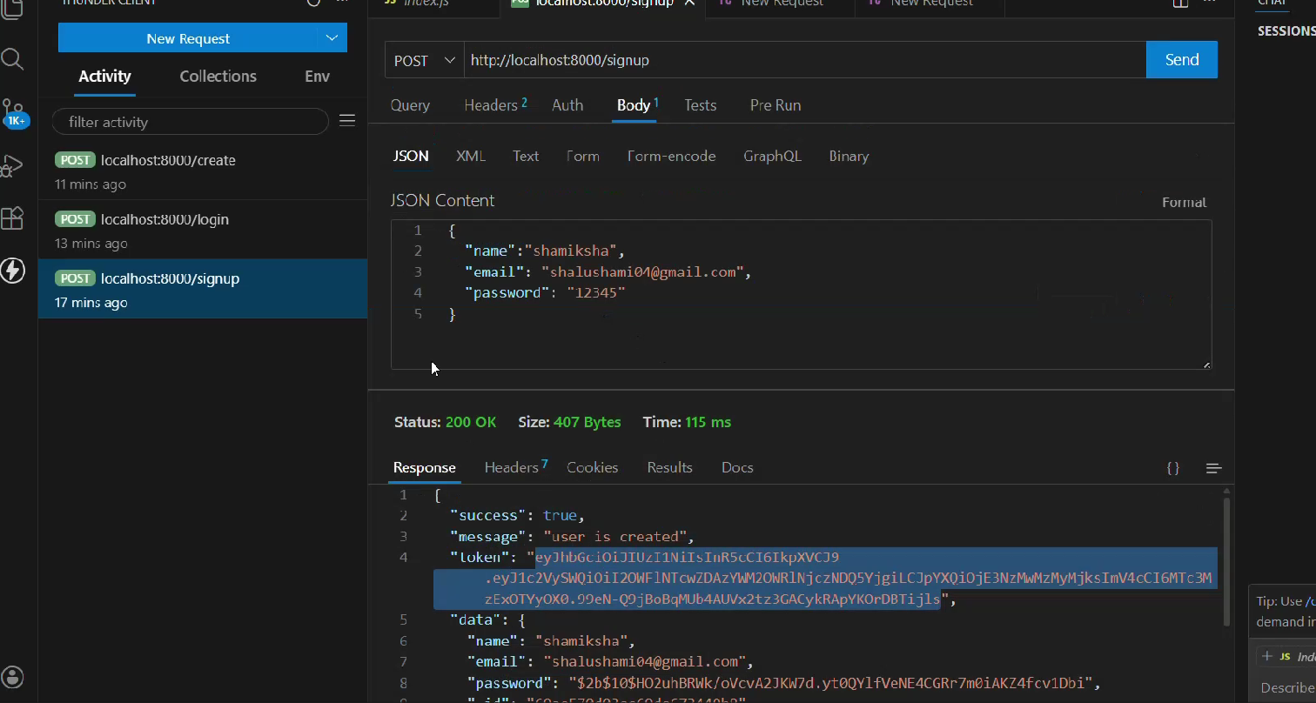

2. Login
API Endpoint: http://localhost:8000/login
Method: Post
Status: 200 OK
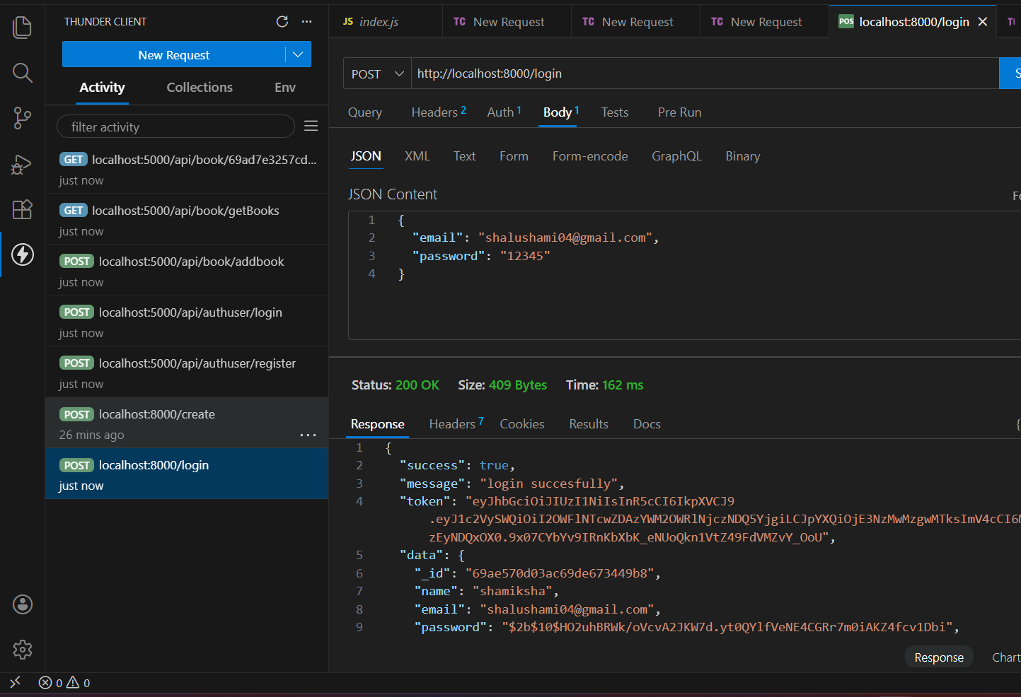

3. Create
API Endpoint: http://localhost:8000/create
Method: post
Status: 200 OK
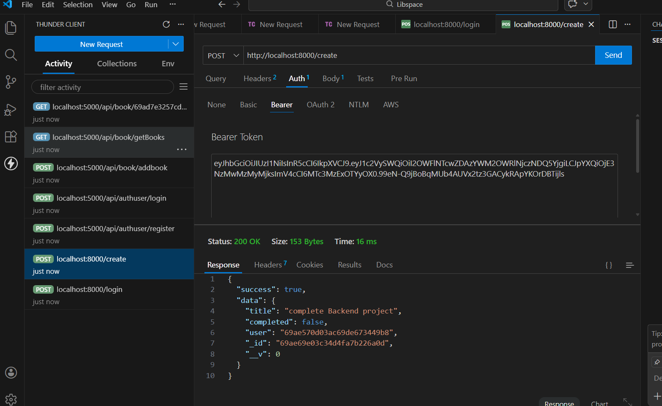

4. MongoDB Database – login user
The following screenshot shows the Login MongoDB Compass after performing API operations.
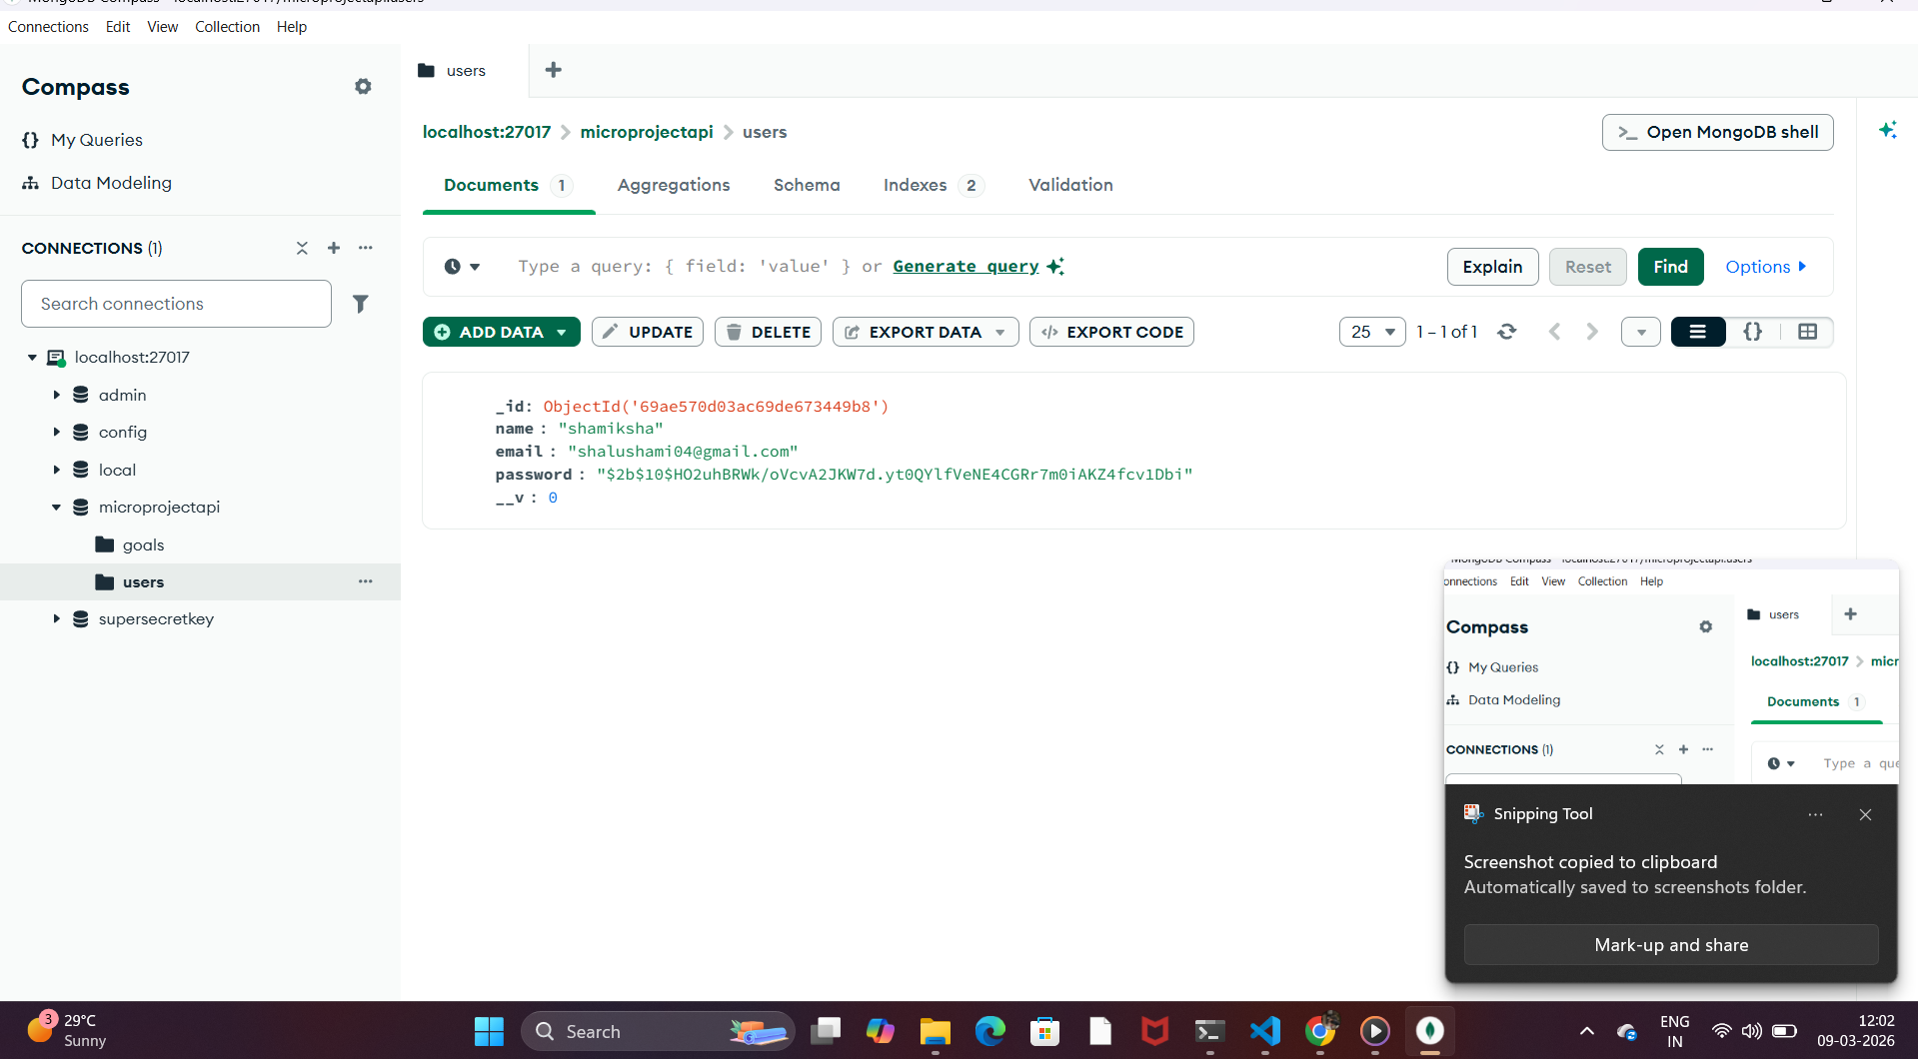

5. MongoDB Database – goals
This screenshot displays the goals of project.
