Analysis and Prediction Using Machine Learning Techniques
Employee Promotion Prediction
Techolas Technologies, Calicut
Name: [Your Name]
Date: [Date]

1. Introduction

Problem Statement
Manually deciding which employees deserve a promotion is time-consuming for HR teams and can be inconsistent across reviewers. In this project we build a machine learning model that predicts whether an employee will be promoted (is_promoted = 1) or not (0), using features such as department, education, training scores, service length, and previous performance ratings.

Importance
- Speeds up HR decisions and reduces manual review time.
- Applies the same criteria to every employee, improving fairness.
- Helps management plan succession, training, and internal mobility earlier.

2. Dataset Overview

Source
HR Analytics dataset — employee.csv (publicly available HR promotion dataset).

Description
- Number of samples: 54,808 employees
- Number of features: 12 (plus the target is_promoted)
- Task type: Binary classification
- Target: is_promoted (0 = Not Promoted, 1 = Promoted)

3. Data Understanding
The following pandas methods were used to understand the dataset:
- head() / tail() — view first and last rows
- shape — (54808, 13)
- size — 712,504 total values
- columns — list of all 13 column names
- unique() and value_counts() — explore categorical variables
- info() — data types and non-null counts
- dtypes — 5 object (categorical), 7 numeric int/float
- describe() — summary statistics for numeric columns
- corr() — correlation matrix for numeric features
Missing values were found in two columns: education (2,409 missing) and previous_year_rating (4,124 missing). All other columns were complete.

4. Exploratory Data Analysis

Insights
- The target is heavily imbalanced — only ~8.5% of employees were promoted.
- avg_training_score is the strongest signal: promoted employees score noticeably higher.
- previous_year_rating and awards_won? also correlate strongly with promotion.
- Sales & Marketing and Operations are the largest departments, so they show the most promotions in raw counts.
- Age alone is a weak predictor — most employees cluster between 28 and 40.

Visualizations
Correlation Heatmap:
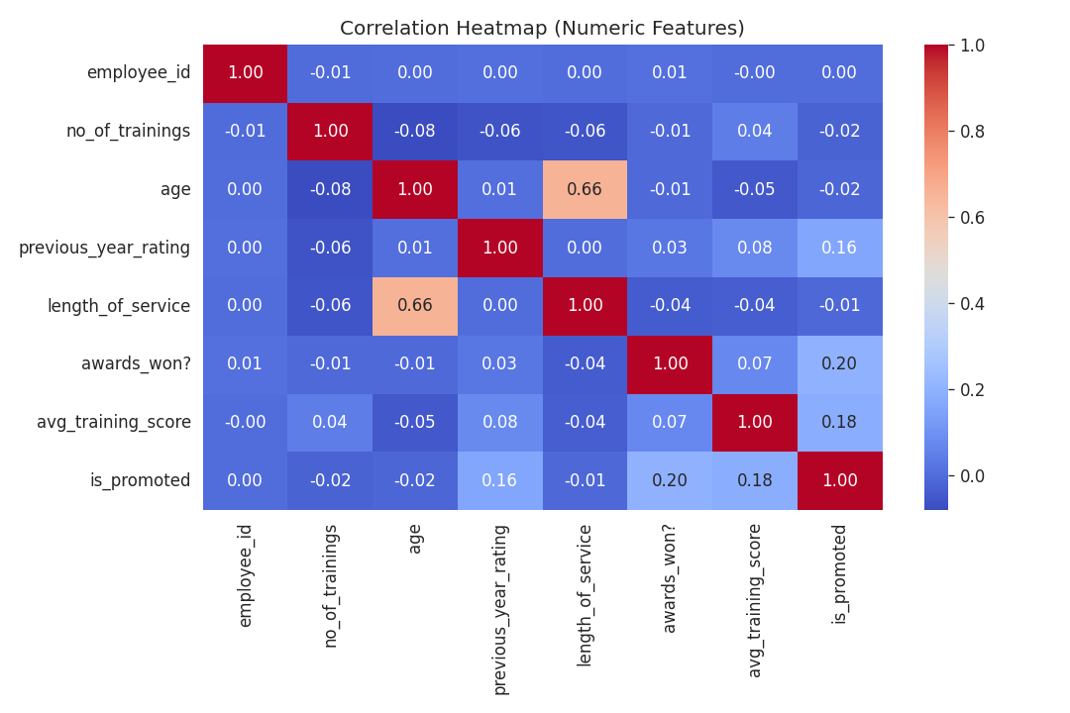
Target Distribution (shows class imbalance):
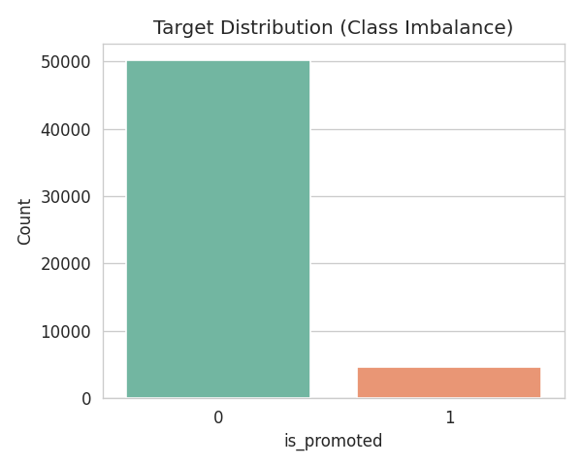
Promotions by Department (count plot):
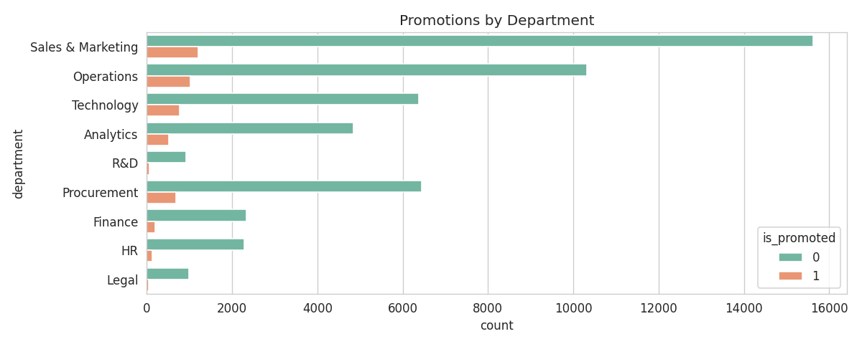
Age Distribution (histogram):
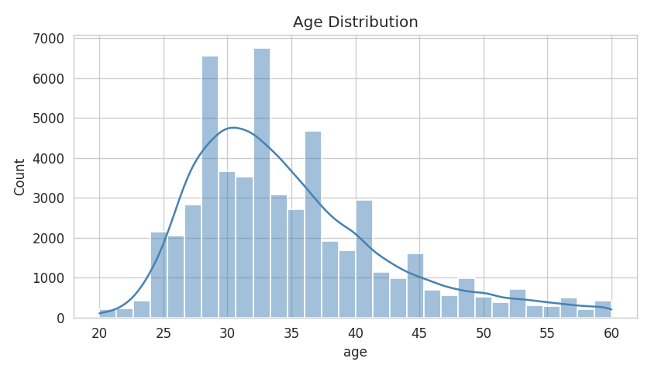
Avg Training Score vs Promotion (box plot):
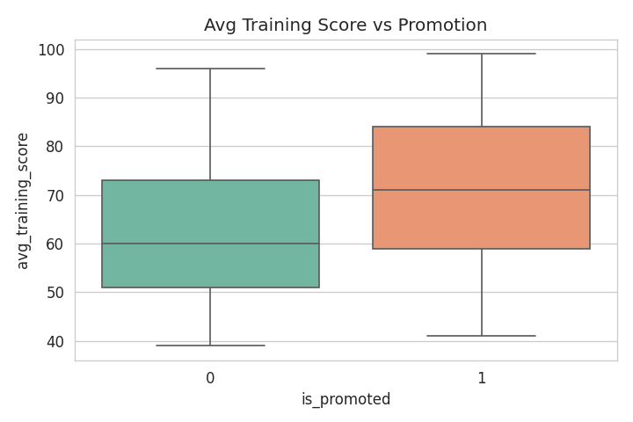

5. Data Preprocessing

Steps Taken
- Dropped employee_id (identifier, not predictive).
- Filled missing education with the mode; filled missing previous_year_rating with the median.
- Encoded all categorical columns (department, region, education, gender, recruitment_channel) using LabelEncoder.
- Standardized all features with StandardScaler so that distance-based models (KNN) work correctly.
- Split into 80% train / 20% test using stratified sampling to preserve class ratio.
- Addressed class imbalance using SMOTE — oversampled the minority class in the training set only (from 3,734 to 40,112 samples).

6. Hyperparameter Tuning and Cross-Validation

Concepts
Hyperparameters are settings chosen before training (e.g., n_neighbors for KNN, max_depth for a tree). The right values make a large difference in performance.
Cross-validation splits the training data into K folds, trains on K-1 folds, and validates on the remaining fold — rotating through each fold. This gives a far more reliable score than a single validation split.

GridSearchCV
We used GridSearchCV with 3-fold StratifiedKFold cross-validation, scoring on F1 (the right metric for imbalanced classification). It tries every hyperparameter combination and returns the best one.

7. Model Building
Four classification models were trained:

Logistic Regression
A linear model that predicts the probability of promotion. Good baseline, easy to interpret.

K-Nearest Neighbors (KNN)
Predicts the class of a new employee based on the K most similar employees in the training data.

Decision Tree
Builds a tree of if/else rules by repeatedly splitting the data on the feature that best separates the classes.

Random Forest
An ensemble of many decision trees. Each tree sees a random subset of data and features; the final prediction is a majority vote. Typically more accurate and less prone to overfitting than a single tree.

8. Model Evaluation

Metrics
- Accuracy — overall correctness (can mislead on imbalanced data).
- Precision — of predicted promotions, how many were real.
- Recall — of real promotions, how many we caught.
- F1-score — harmonic mean of precision and recall.
- ROC-AUC — how well the model separates the two classes.
- Confusion Matrix — actual vs predicted counts.

Results
Model | Accuracy | Precision | Recall | F1 | ROC-AUC
Logistic Regression | 0.6829 | 0.1621 | 0.6531 | 0.2598 | 0.7432
KNN | 0.7691 | 0.1792 | 0.4775 | 0.2606 | 0.6723
Decision Tree | 0.8712 | 0.3091 | 0.4143 | 0.3541 | 0.7283
Random Forest | 0.9274 | 0.6278 | 0.3630 | 0.4600 | 0.7668

Model Comparison Chart:
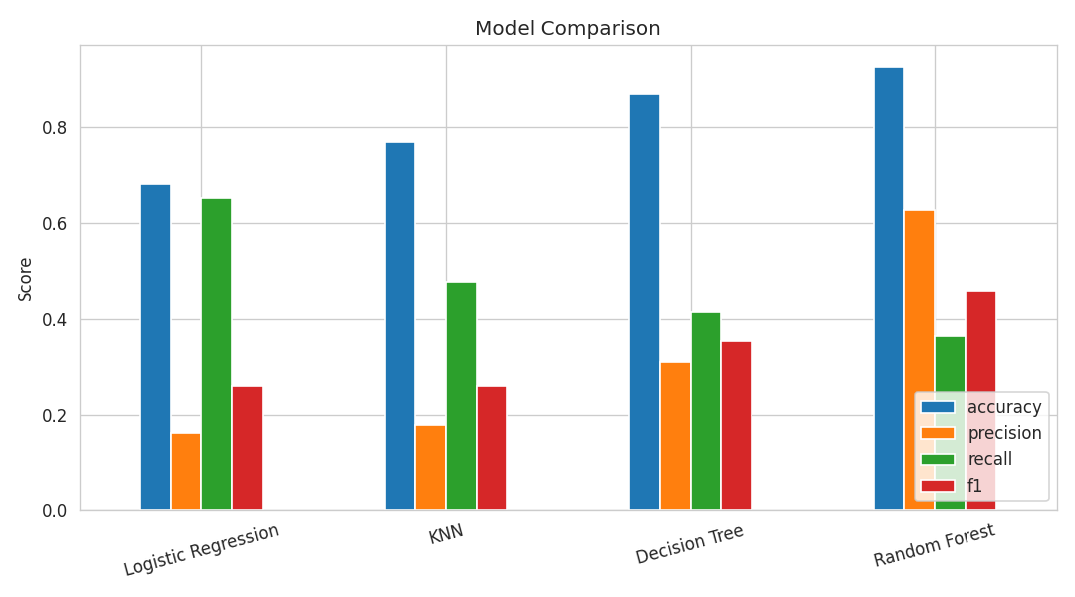
Confusion Matrix — Random Forest (best model):
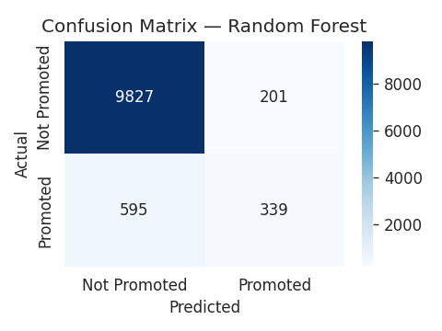
Confusion Matrix — Logistic Regression:
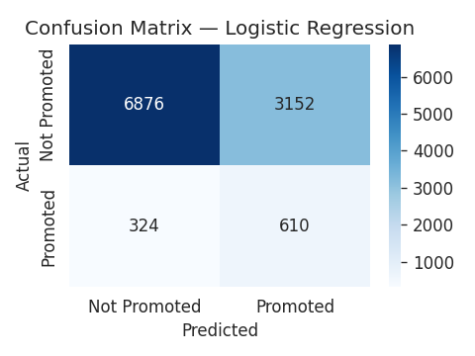
Confusion Matrix — KNN:
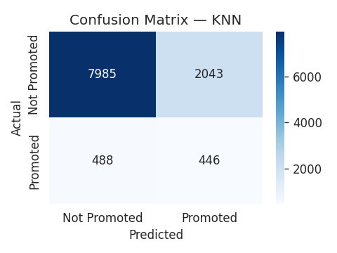
Confusion Matrix — Decision Tree:
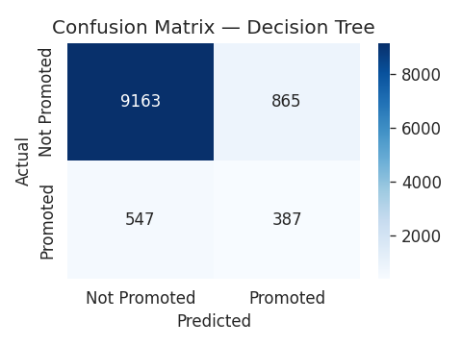

9. Conclusion

Key Findings
- Random Forest was the best-performing model with 92.74% accuracy, the highest F1 (0.46), and the highest ROC-AUC (0.767).
- avg_training_score, previous_year_rating, and awards_won? are the strongest predictors of promotion.
- SMOTE was essential — without it, models would default to predicting 'not promoted' every time and still hit 91% accuracy while being useless in practice.
- Logistic Regression had the highest recall but very low precision — it generates too many false positives.

Limitations and Improvements
- Label encoding treats department and region as ordered categories, which isn't accurate — one-hot encoding would be better.
- The dataset is from a single company and may not generalize to other organizations.
- Recall for the 'promoted' class is still modest (~36%) — the model misses many real promotions.
- Future work: try XGBoost, Gradient Boosting, and AdaBoost (all listed in the guidelines); use one-hot encoding; tune the decision threshold; engineer features like score_per_training.

10. References
- Scikit-learn documentation — https://scikit-learn.org
- imbalanced-learn (SMOTE) — https://imbalanced-learn.org
- Pandas documentation — https://pandas.pydata.org
- Seaborn documentation — https://seaborn.pydata.org
- HR Analytics employee promotion dataset

